**一、效果演示**

**1、制作如下图所示的界面**

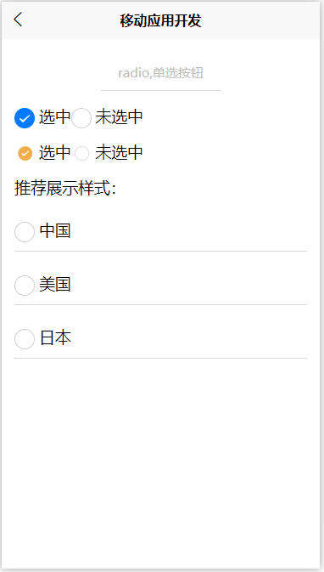

<template>

<view>

**<view class="smart-page-head">**

**<view class="smart-page-head-title">checkbox复选框</view>**

**</view>**

**<view class="smart-padding-wrap">**

**<view class="item">**

**<radio checked="true"></radio>**

**选中**

**<radio></radio>**

**未选中**

**</view>**

**<view class="item">**

**<radio checked="true" color="#F0AD4E" style="transform: scale(0.7);"></radio>**

**选中**

**<radio color="#F0AD4E" style="transform: scale(0.7);"></radio>**

**未选中**

**</view>**

**<view class="item">**

**推荐展示样式：**

**<radio-group>**

**<label class="list">**

**<view>**

**<radio></radio>**

**中国**

**</view>**

**</label>**

**<label class="list">**

**<view>**

**<radio></radio>**

**美国**

**</view>**

**</label>**

**<label class="list">**

**<view>**

**<radio></radio>**

**日本**

**</view>**

**</label>**

**</radio-group>**

**</view>**

**</view>**

</view>

</template>

<script>

export default {

data() {

return {};

},

methods: {}

};

</script>

<style>

**.item {**

**margin-bottom: 30rpx;**

**}**

**.list {**

**justify-content: flex-start;**

**padding: 22rpx 30rpx;**

**}**

**.list view {**

**padding-bottom: 20rpx;**

**border-bottom: 1px solid #d8d8d8;**

**}**

</style>

**2、增加按钮点击加载动作**

BtnSave(){

uni.showLoading({

Title:’加载….’;

});

SetInterval(()=>{

uni.hideLoading();

},3000)

}