**一、picker选择列表**

**制作如下图所示的界面**

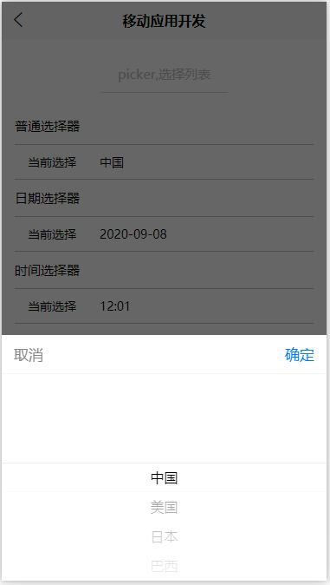

<template>

<view>

**<view class="smart-page-head">**

**<view class="smart-page-head-title">picker,选择列表</view>**

**</view>**

**<view class="smart-padding-wrap">**

**<view class="uni-title">普通选择器</view>**

**<view class="uni-list">**

**<view class="uni-list-cell">**

**<view class="uni-list-cell-left">当前选择</view>**

**<view class="uni-list-cell-db">**

**<picker @change="bindPickerChange" :range="array" :value="index" range-key="name">**

**<view class="uni-input">{{ array[index].name }}</view>**

**</picker>**

**</view>**

**</view>**

**</view>**

**<view class="uni-title uni-common-pl">日期选择器</view>**

**<view class="uni-list">**

**<view class="uni-list-cell">**

**<view class="uni-list-cell-left">当前选择</view>**

**<view class="uni-list-cell-db">**

**<picker mode="date" :value="date" :start="startDate" :end="endDate" @change="bindDateChange">**

**<view class="uni-input">{{ date }}</view>**

**</picker>**

**</view>**

**</view>**

**</view>**

**<view class="uni-title uni-common-pl">时间选择器</view>**

**<view class="uni-list">**

**<view class="uni-list-cell">**

**<view class="uni-list-cell-left">当前选择</view>**

**<view class="uni-list-cell-db">**

**<picker mode="time" :value="time" start="09:01" end="21:01" @change="bindTimeChange">**

**<view class="uni-input">{{ time }}</view>**

**</picker>**

**</view>**

**</view>**

**</view>**

**</view>**

</view>

</template>

<script>

**function getDate(type) {**

**const date = new Date();**

**let year = date.getFullYear();**

**let month = date.getMonth() + 1;**

**let day = date.getDate();**

**if (type === 'start') {**

**year = year - 60;**

**} else if (type === 'end') {**

**year = year + 2;**

**}**

**month = month > 9 ? month : '0' + month;**

**day = day > 9 ? day : '0' + day;**

**return `${year}-${month}-${day}`;**

**}**

export default {

data() {

return {

**array: [{ name: '中国' }, { name: '美国' }, { name: '日本' }, { name: '巴西' }],**

**index: 0,**

**date: getDate({**

**format: true**

**}),**

**startDate: getDate('start'),**

**endDate: getDate('end'),**

**time: '12:01'**

};

},

methods: {

**bindPickerChange: function(e) {**

**this.index = e.detail.value;**

**},**

**bindDateChange: function(e) {**

**this.date = e.detail.value;**

**},**

**bindTimeChange: function(e) {**

**this.time = e.detail.value;**

**}**

}

};

</script>

<style>

**.uni-title {**

**font-size: 30rpx;**

**font-weight: 500;**

**padding: 20rpx 0;**

**line-height: 1.5;**

**}**

**.uni-list {**

**background-color: #ffffff;**

**position: relative;**

**width: 100%;**

**display: flex;**

**flex-direction: column;**

**}**

**.uni-list-cell {**

**position: relative;**

**display: flex;**

**flex-direction: row;**

**justify-content: space-between;**

**align-items: center;**

**border-top: 1px solid #bebebe;**

**border-bottom: 1px solid #bebebe;**

**}**

**.uni-list-cell-db,**

**.uni-list-cell-right {**

**flex: 1;**

**}**

**.uni-list-cell-left {**

**white-space: nowrap;**

**font-size: 28rpx;**

**padding: 0 30rpx;**

**}**

**.uni-input {**

**height: 50rpx;**

**padding: 15rpx 25rpx;**

**line-height: 50rpx;**

**font-size: 28rpx;**

**background: #fff;**

**flex: 1;**

**}**

</style>

**二、slider滑块**

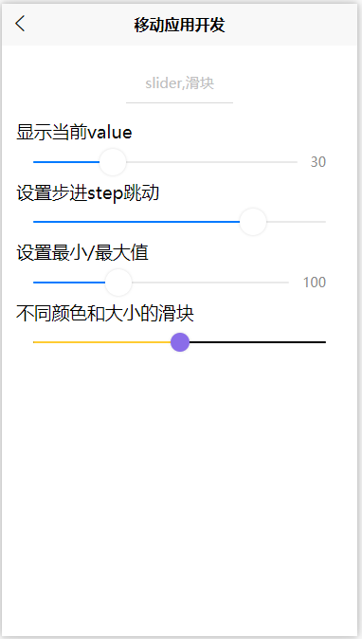

<template>

<view>

**<view class="smart-page-head">**

**<view class="smart-page-head-title">slider,滑块</view>**

**</view>**

**<view class="smart-padding-wrap">**

**<view class="uni-title">显示当前value</view>**

**<view>**

**<slider value="50" @change="sliderChange" show-value />**

**</view>**

**<view class="uni-title">设置步进step跳动</view>**

**<view>**

**<slider value="60" @change="sliderChange" step="5" />**

**</view>**

**<view class="uni-title">设置最小/最大值</view>**

**<view>**

**<slider value="100" @change="sliderChange" min="50" max="200" show-value />**

**</view>**

**<view class="uni-title">不同颜色和大小的滑块</view>**

**<view>**

**<slider value="50" @change="sliderChange" activeColor="#FFCC33" backgroundColor="#000000" block-color="#8A6DE9" block-size="20" />**

**</view>**

**</view>**

</view>

</template>

<script>

export default {

data() {

return {};

},

methods: {

**sliderChange(e) {**

**console.log('value 发生变化：' + e.detail.value)**

**}**

}

};

</script>

<style>

</style>