**一、课堂作业效果演示**

**1、制作APP启动广告**

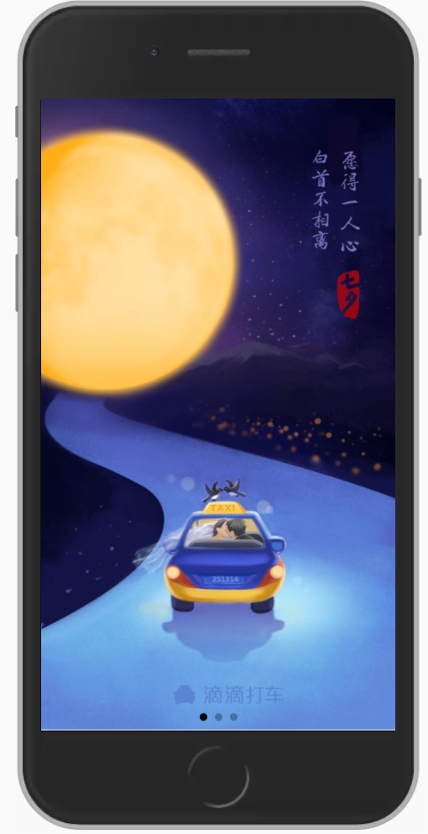 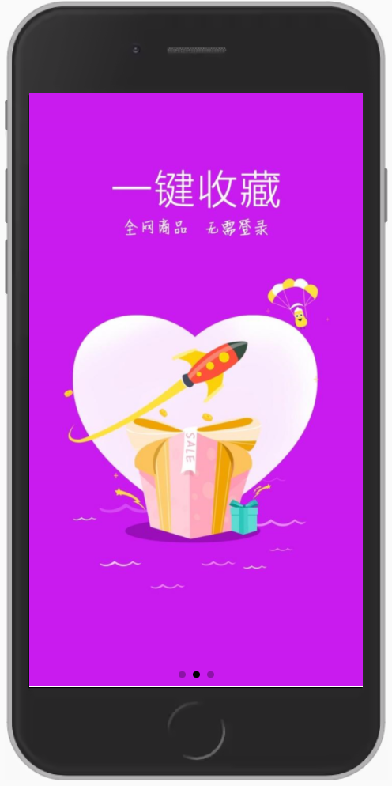 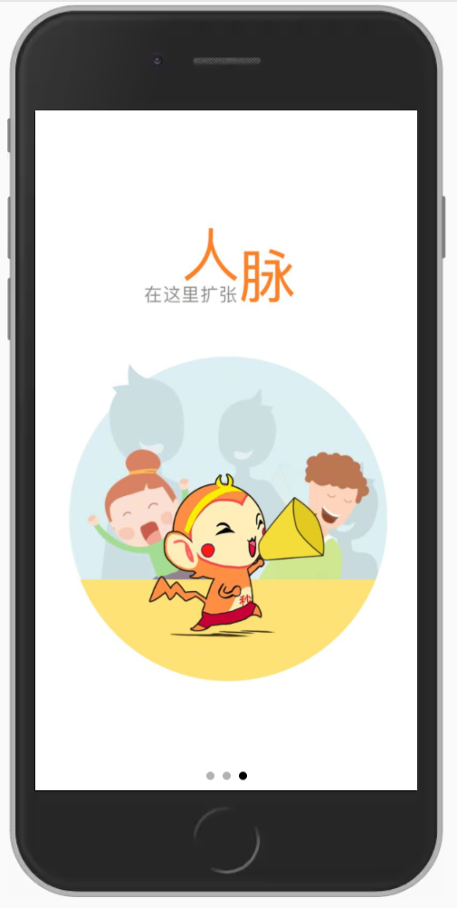

**核心代码如下：**

**<template>**

**<view class="content">**

**<view style="ad">**

**<swiper style="width: 100%;" :style="{height:windowHeight}" indicator-dots="true" autoplay="true"**

**interval="3000">**

**<swiper-item class="ad1"></swiper-item>**

**<swiper-item class="ad2"></swiper-item>**

**<swiper-item class="ad3"></swiper-item>**

**</swiper>**

**</view>**

**</view>**

**</template>**

**<script>**

**export default {**

**data() {**

**return {**

**windowHeight: "200px"**

**}**

**},**

**onLoad() {**

**uni.getSystemInfo({**

**success: (res) => {**

**this.windowHeight = res.windowHeight + "px";**

**}**

**})**

**},**

**methods: {**

**}**

**}**

**</script>**

**<style>**

**.ad1 {**

**margin: 0;**

**padding: 0;**

**background-repeat: no-repeat;**

**background-size: 100% 100%;**

**background-attachment: fixed;**

**background-image: url(../../static/1.png);**

**}**

**.ad2 {**

**margin: 0;**

**padding: 0;**

**background-repeat: no-repeat;**

**background-size: 100% 100%;**

**background-attachment: fixed;**

**background-image: url(../../static/2.png);**

**}**

**.ad3 {**

**margin: 0;**

**padding: 0;**

**background-repeat: no-repeat;**

**background-size: 100% 100%;**

**background-attachment: fixed;**

**background-image: url(../../static/3.png);**

**}**

**.content {**

**position: relative;**

**}**

**.ad {position:absolute; left:30px; top:30px;}**

**.jump {**

**position:absolute; left:30px; top:30px;**

**top: 20upx;**

**right: 120upx;**

**z-index: 0;**

**}**

**</style>**

**2、制作在线播放器界面**

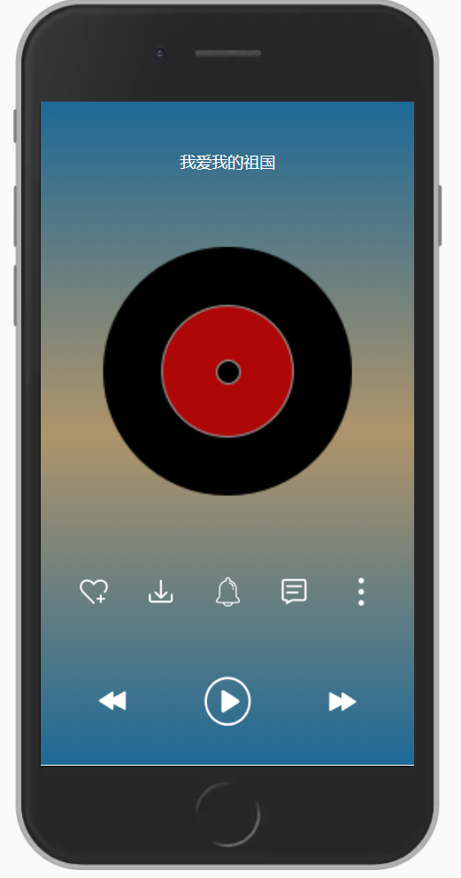

**<template>**

**<view class="content" :style="{height:windowHeight}">**

**<view class="word">**

**<text>我爱我的祖国</text>**

**</view>**

**<!-- videodisc -->A**

**<view class="player-videodisc">**

**<image src="../../static/images/videodisc.png" mode=""></image>**

**</view>**

**<!-- optBar -->**

**<view class="play-opt-bar">**

**<image class="opt" src="../../static/like.png"></image>**

**<image class="opt" src="../../static/download.png"></image>**

**<image class="opt" src="../../static/ling.png"></image>**

**<image class="opt" src="../../static/msg.png"></image>**

**<image class="opt" src="../../static/more.png"></image>**

**</view>**

**<!-- playbar -->**

**<view class="play-bar">**

**<image class="opt" src="../../static/back.png"></image>**

**<image class="opt2" src="../../static/play.png"></image>**

**<image class="opt" src="../../static/next.png"></image>**

**</view>**

**</view>**

**</template>**

**<script>**

**export default {**

**data() {**

**return {**

**windowHeight: "200px"**

**}**

**},**

**onLoad() {**

**uni.getSystemInfo({**

**success: (res) => {**

**this.windowHeight = res.windowHeight + "px";**

**}**

**})**

**},**

**methods: {**

**}**

**}**

**</script>**

**<style>**

**.content {**

**background-image: linear-gradient(to bottom, #1e6997, #af946a, #1e6997);**

**display: flex;**

**flex-direction: column;**

**align-items: center;**

**}**

**.status-bar {**

**width: 100%;**

**}**

**.player-videodisc image {**

**width: 500upx;**

**height: 500upx;**

**margin-top: 50upx;**

**}**

**.play-opt-bar {**

**width: 80%;**

**height: 60upx;**

**display: flex;**

**align-items: center;**

**justify-content: space-between;**

**padding: 0 70upx;**

**font-size: 34px;**

**position: absolute;**

**bottom: 320upx;**

**}**

**.play-bar {**

**width: 70%;**

**display: flex;**

**align-items: center;**

**justify-content: space-between;**

**padding: 0 70upx;**

**font-size: 30px;**

**position: absolute;**

**bottom: 80upx;**

**}**

**.opt {**

**width: 64upx;**

**height: 64upx;**

**}**

**.opt2 {**

**width: 100upx;**

**height: 100upx;**

**}**

**.player {**

**width: 650upx;**

**height: 50upx;**

**display: flex;**

**align-items: center;**

**justify-content: space-between;**

**position: absolute;**

**bottom: 220upx;**

**}**

**.word{**

**color: #FFFFFF;**

**margin: 100upx;**

**}**

**</style>**