用户关联角色操作-流程分析
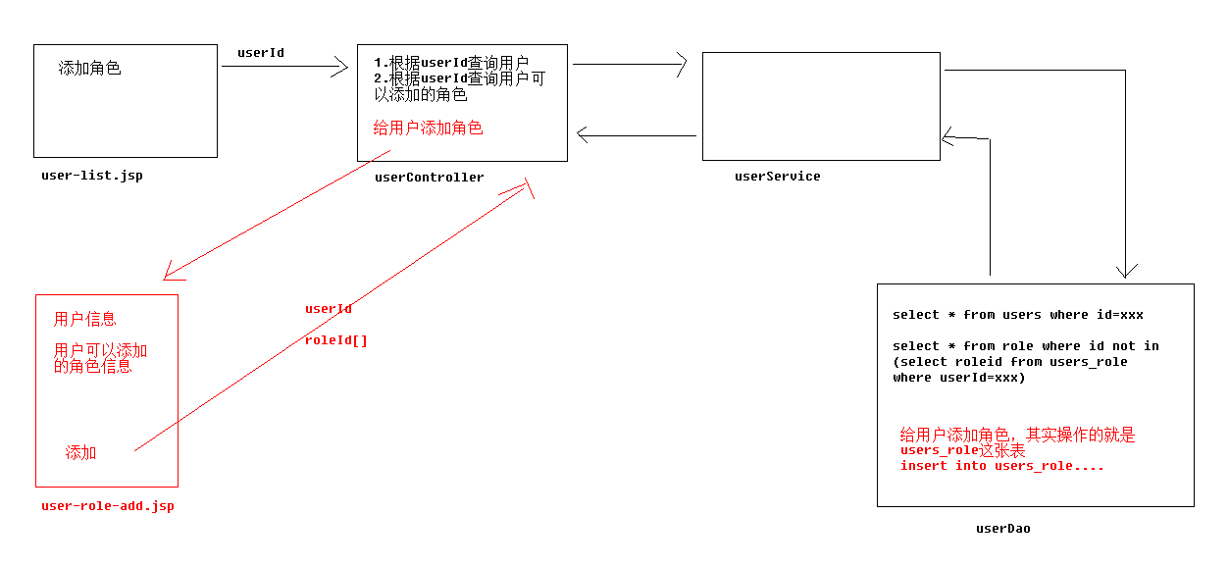

用户关联角色操作-代码实现1
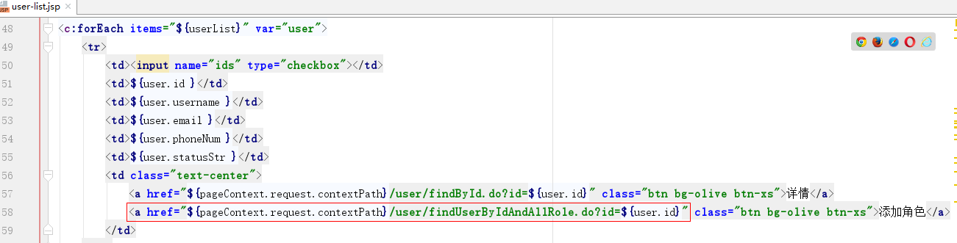
- Dao层代码
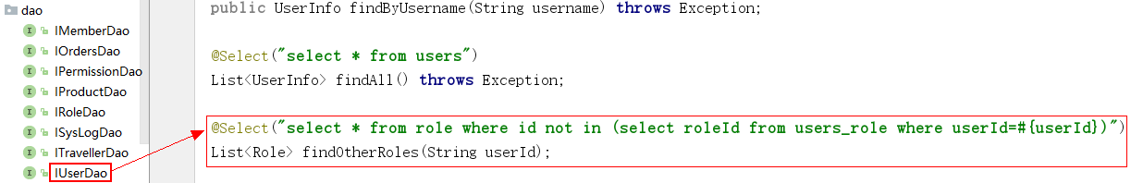

在IUserDao添加findOtherRoles方法

public interface IUserDao {
@Select("select * from role where id not in (select roleId from users_role where userId=#{userId})")
List<Role> findOtherRoles(String userId);
}

- Service层代码
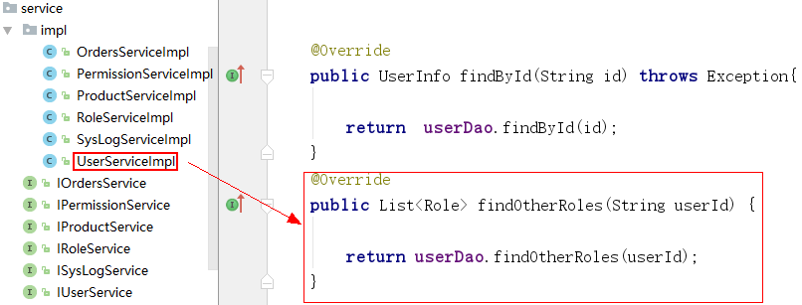
@Service("userService")
public class UserServiceImpl implements IUserService {
@Autowired
private IUserDao userDao;
@Override
public List<Role> findOtherRoles(String userId) {
return userDao.findOtherRoles(userId);
}
}
- web层代码
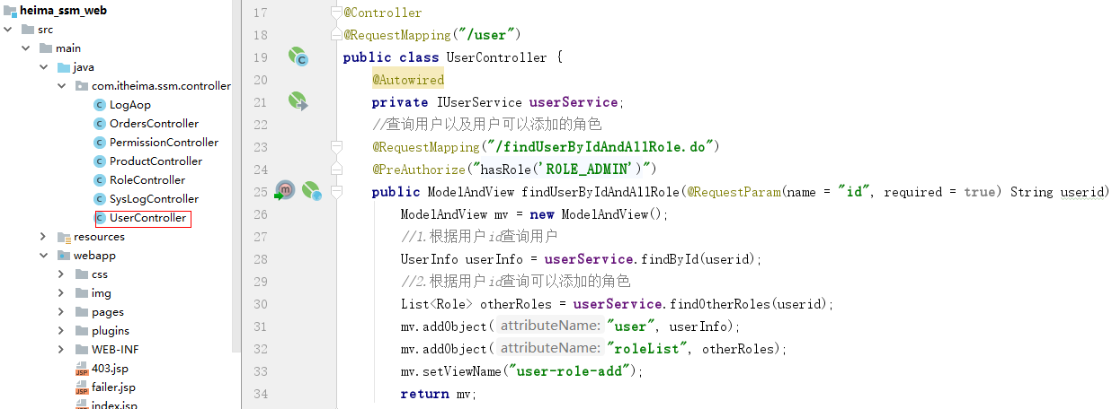
@Controller
@RequestMapping("/user")
public class UserController {
@Autowired
private IUserService userService;
//查询用户以及用户可以添加的角色
@RequestMapping("/findUserByIdAndAllRole.do")
public ModelAndView findUserByIdAndAllRole(@RequestParam(name = "id", required = true) String userid) throws Exception {
ModelAndView mv = new ModelAndView();
//1.根据用户id查询用户
UserInfo userInfo = userService.findById(userid);
//2.根据用户id查询可以添加的角色
List<Role> otherRoles = userService.findOtherRoles(userid);
mv.addObject("user", userInfo);
mv.addObject("roleList", otherRoles);
mv.setViewName("user-role-add");
return mv;
}
}
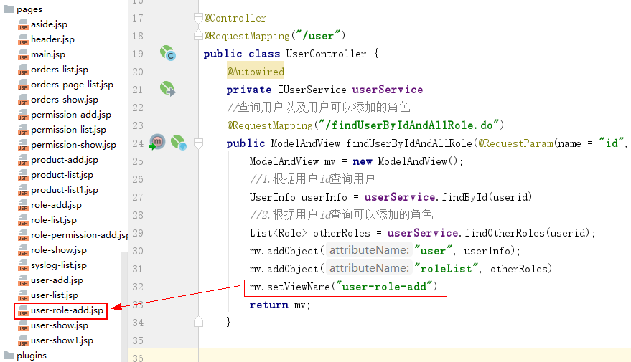

记得从视频资料拷贝user-role-add.jsp

用户关联角色操作-代码实现2

用户关联角色操作-代码实现3
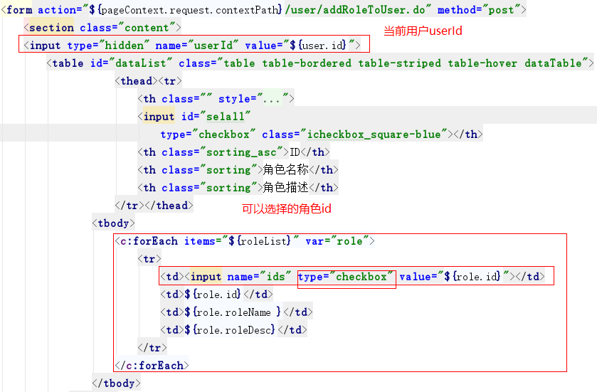
- dao层代码
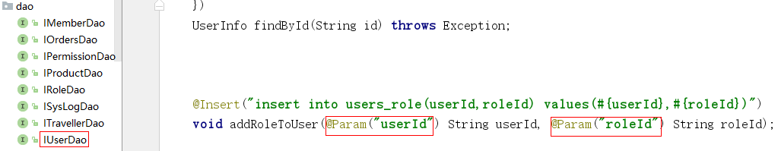
public interface IUserDao {
@Insert("insert into users_role(userId,roleId) values(#{userId},#{roleId})")
void addRoleToUser(@Param("userId") String userId, @Param("roleId") String roleId);
}
- Service层代码
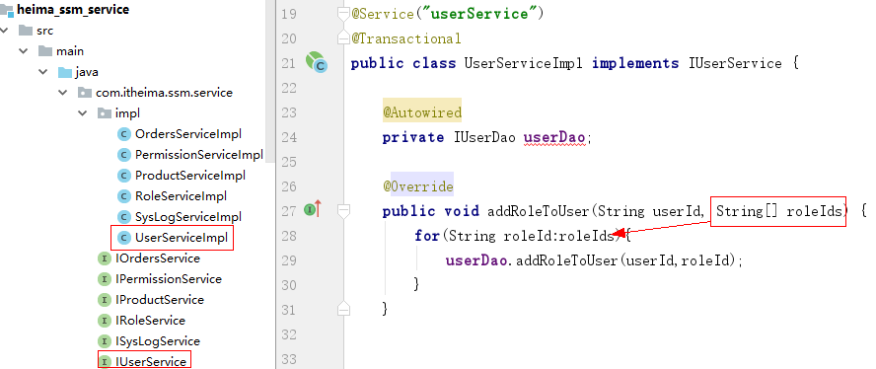

@Service("userService")
public class UserServiceImpl implements IUserService {
@Autowired
private IUserDao userDao;
@Override
public void addRoleToUser(String userId, String[] roleIds) {
for(String roleId:roleIds){
userDao.addRoleToUser(userId,roleId);
}
}
}
- web层代码
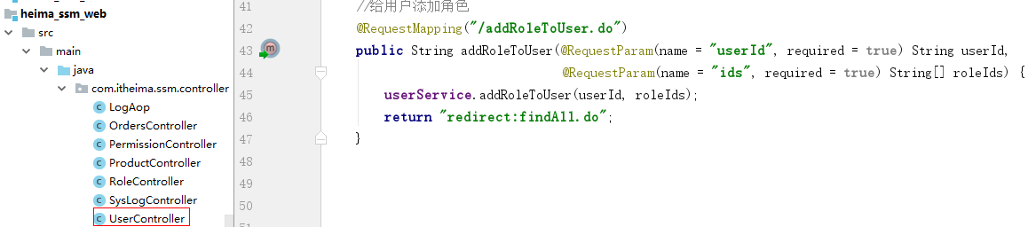

@Controller
@RequestMapping("/user")
public class UserController {
@Autowired
private IUserService userService;
//给用户添加角色
@RequestMapping("/addRoleToUser.do")
public String addRoleToUser(@RequestParam(name = "userId", required = true) String userId,
@RequestParam(name = "ids", required = true) String[] roleIds) {
userService.addRoleToUser(userId, roleIds);
return "redirect:findAll.do";
}
}

提交表单传入的数据
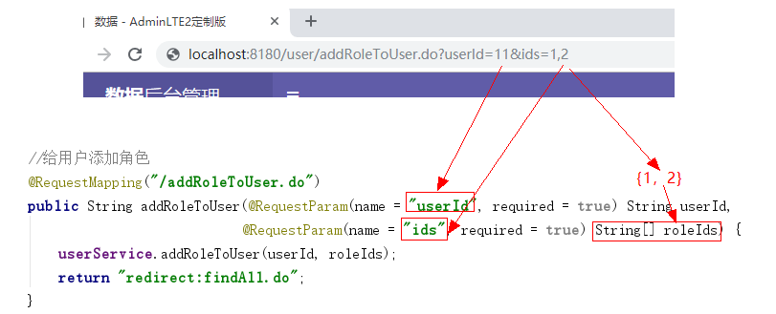

角色关联权限操作-代码实现1
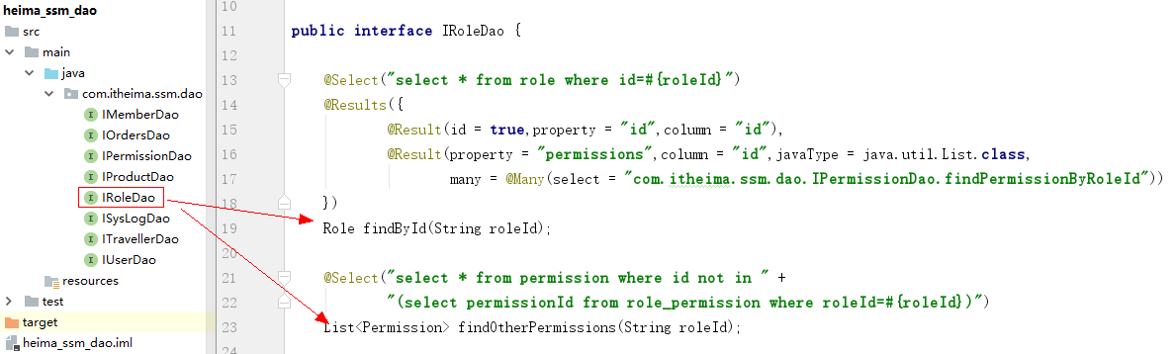

- Dao层代码
public interface IRoleDao {
@Select("select * from role where id=#{roleId}")
@Results({
@Result(property = "id",column = "id"),
@Result(property = "permissions",column = "id",
many = @Many(select = "com.itheima.ssm.dao.IPermissionDao.findPermissionByRoleId"))
})
Role findById(String roleId);
@Select("select * from permission where id not in " +
"(select permissionId from role_permission where roleId=#{roleId})")
List<Permission> findOtherPermissions(String roleId);
}

- Service层代码
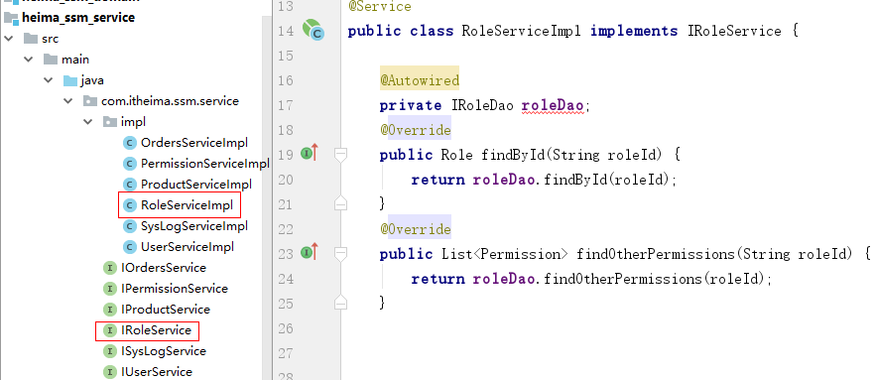
@Service
public class RoleServiceImpl implements IRoleService {
@Autowired
private IRoleDao roleDao;
@Override
public Role findById(String roleId) {
return roleDao.findById(roleId);
}
@Override
public List<Permission> findOtherPermissions(String roleId) {
return roleDao.findOtherPermissions(roleId);
}
}

- web层代码
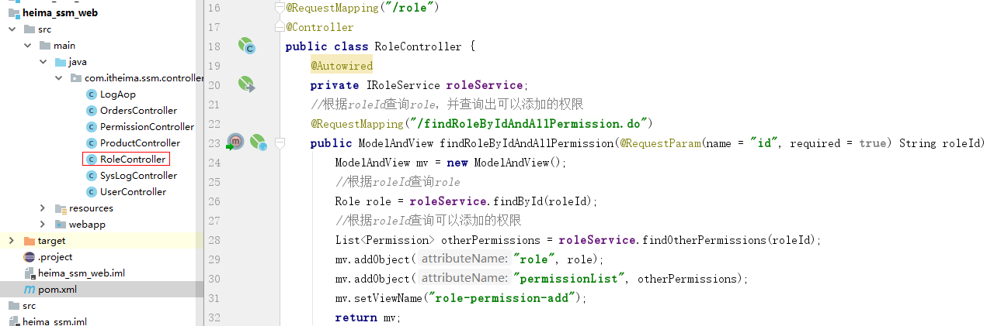
@RequestMapping("/role")
@Controller
public class RoleController {
@Autowired
private IRoleService roleService;
//根据roleId查询role，并查询出可以添加的权限
@RequestMapping("/findRoleByIdAndAllPermission.do")
public ModelAndView findRoleByIdAndAllPermission(@RequestParam(name = "id", required = true) String roleId) throws Exception {
ModelAndView mv = new ModelAndView();
//根据roleId查询role
Role role = roleService.findById(roleId);
//根据roleId查询可以添加的权限
List<Permission> otherPermissions = roleService.findOtherPermissions(roleId);
mv.addObject("role", role);
mv.addObject("permissionList", otherPermissions);
mv.setViewName("role-permission-add");
return mv;
}
}
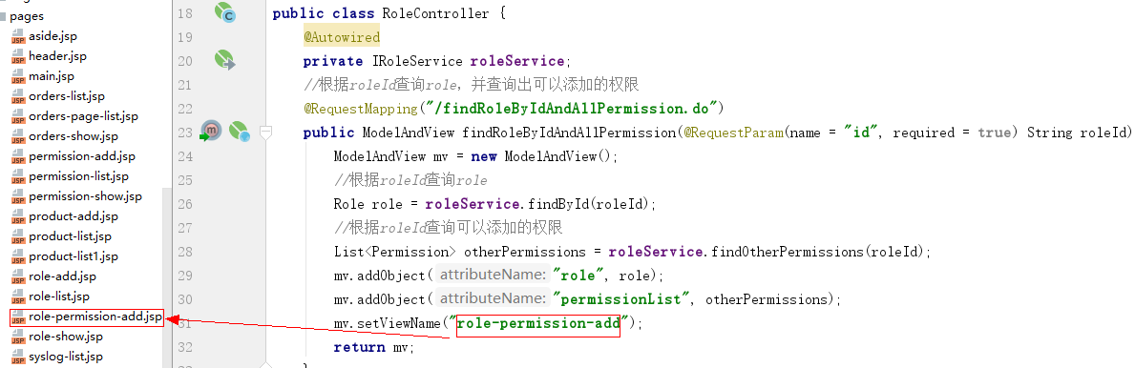

记得从资料拷贝role-permission-add.jsp页面

角色关联权限操作-代码实现2
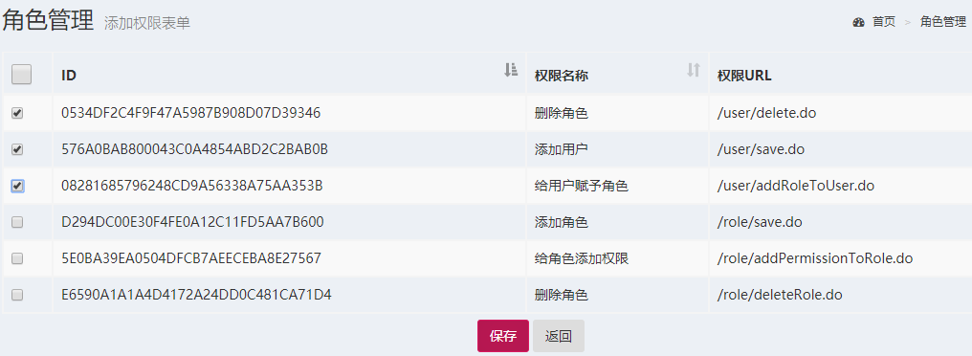
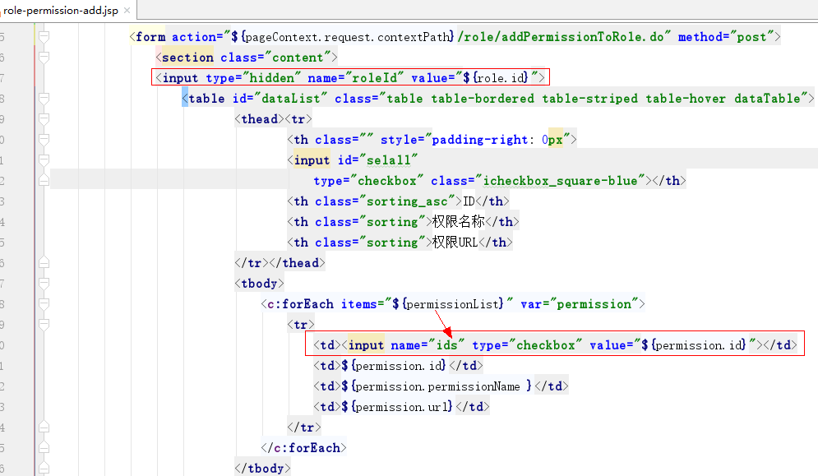
1、Dao层代码
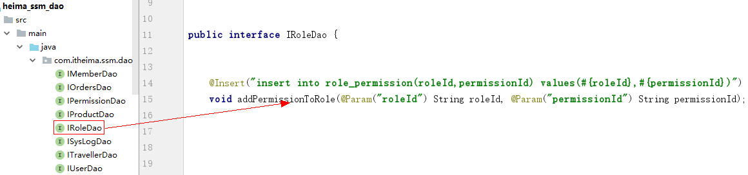
public interface IRoleDao {
@Insert("insert into role_permission(roleId,permissionId) values(#{roleId},#{permissionId})")
void addPermissionToRole(@Param("roleId") String roleId, @Param("permissionId") String permissionId);
}
2、Service层代码
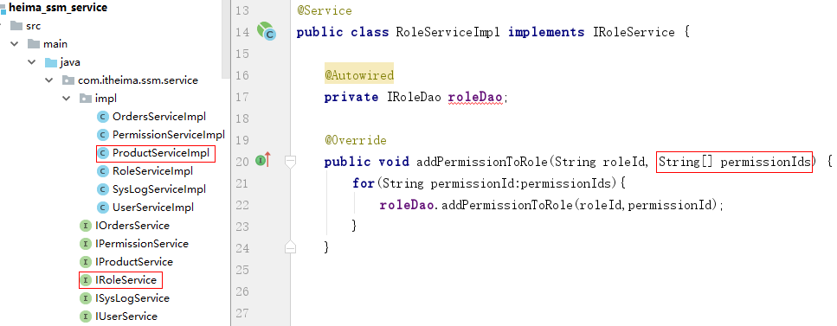
public interface IRoleService {
void addPermissionToRole(String roleId, String[] permissionIds) throws Exception;
}
@Service
public class RoleServiceImpl implements IRoleService {
@Autowired
private IRoleDao roleDao;
@Override
public void addPermissionToRole(String roleId, String[] permissionIds) {
for(String permissionId:permissionIds){
roleDao.addPermissionToRole(roleId,permissionId);
}
}
}
3、web层代码
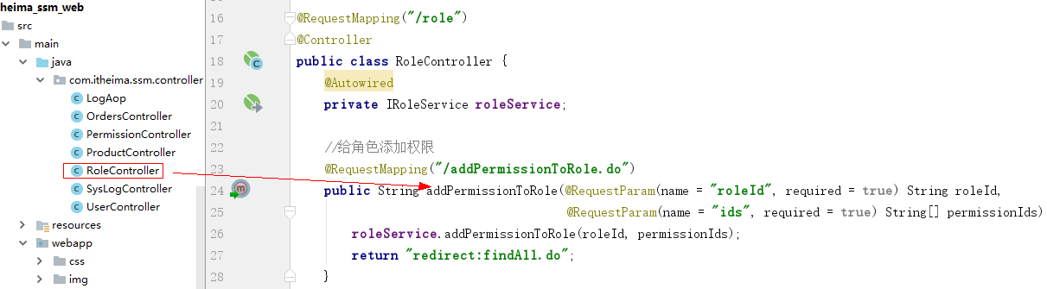
@RequestMapping("/role")
@Controller
public class RoleController {
@Autowired
private IRoleService roleService;
//给角色添加权限
@RequestMapping("/addPermissionToRole.do")
public String addPermissionToRole(@RequestParam(name = "roleId", required = true) String roleId,
@RequestParam(name = "ids", required = true) String[] permissionIds)
throws Exception {
roleService.addPermissionToRole(roleId, permissionIds);
return "redirect:findAll.do";
}
}
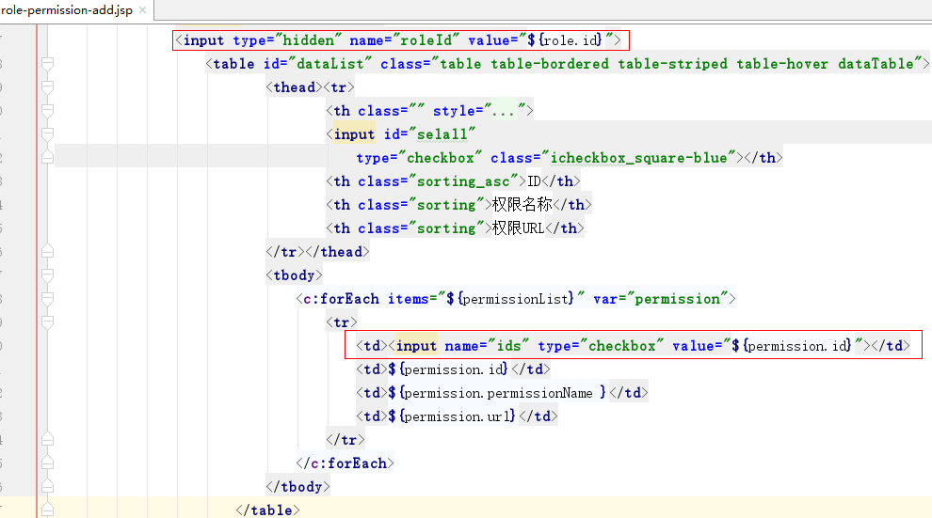

方法级别权限控制-基本介绍与JSR250注解使用（了解）
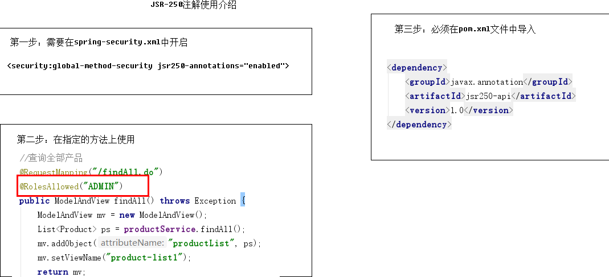

方法级权限控制-@Secured注解使用（了解）
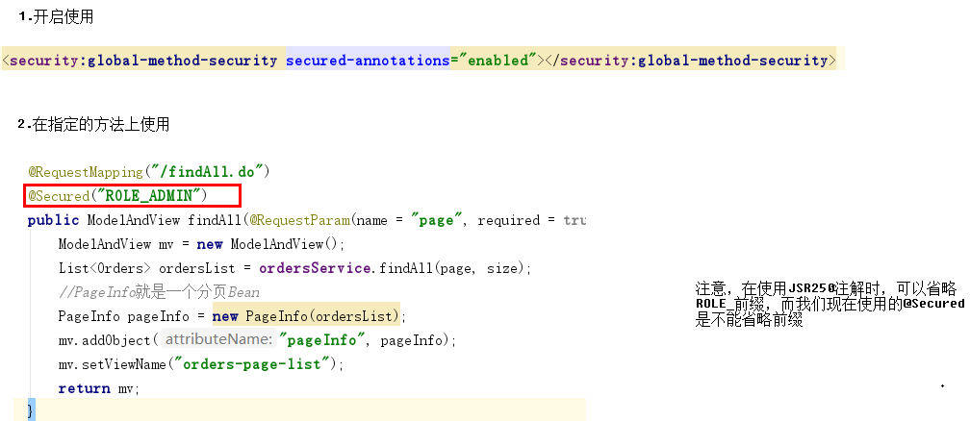

方法级权限控制-基于表达式操作（掌握）
beans,core,context,el
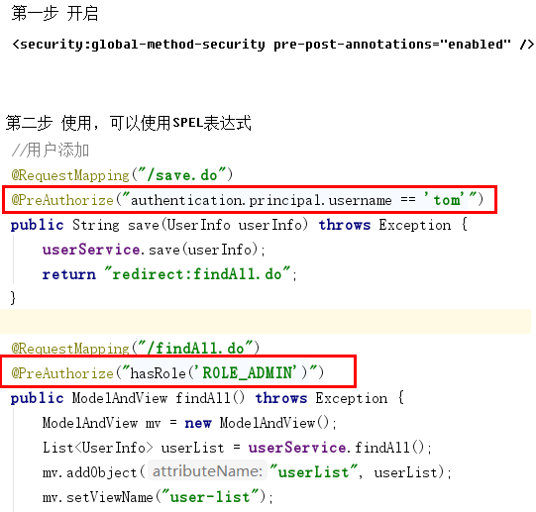
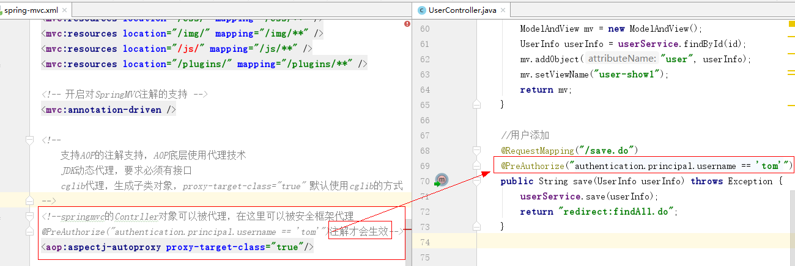

页面端权限控制介绍
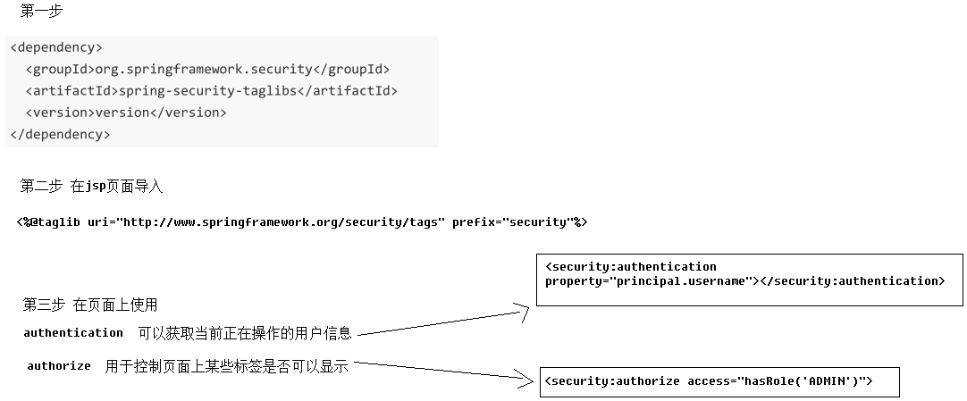
<%@taglib prefix="security" uri="http://www.springframework.org/security/tags" %>

获取用户名:
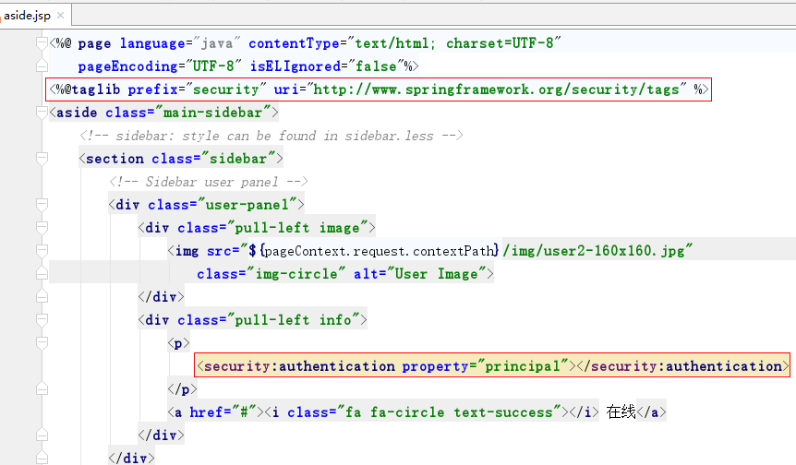

<security:authentication property="principal.username"></security:authentication>

控制具有ADMIN权限的用户登录才显示某个标签:
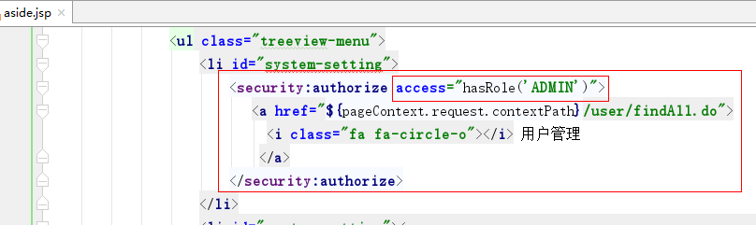

1、显示用户名
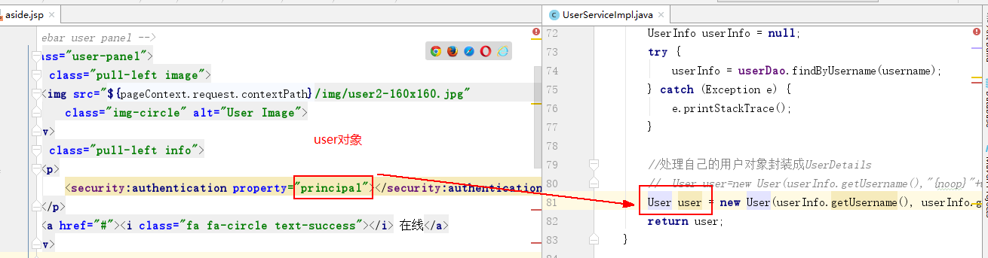
2、控制页面标签的显示，注意必须在配置开启表达式支持不然页面会报错
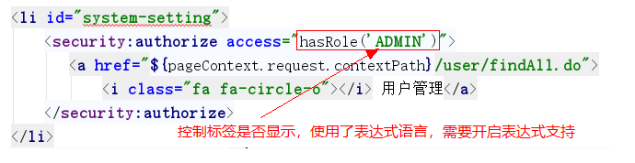
spring-security.xml开启表达式支持两种方式：
方式一：
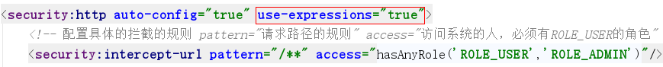
方式二：
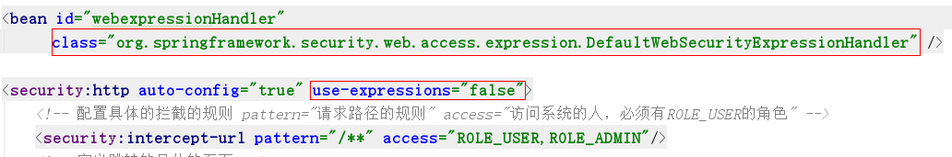
<bean id="webexpressionHandler"
class="org.springframework.security.web.access.expression.DefaultWebSecurityExpressionHandler" />

AOP日志-域对象创建与基本操作介绍
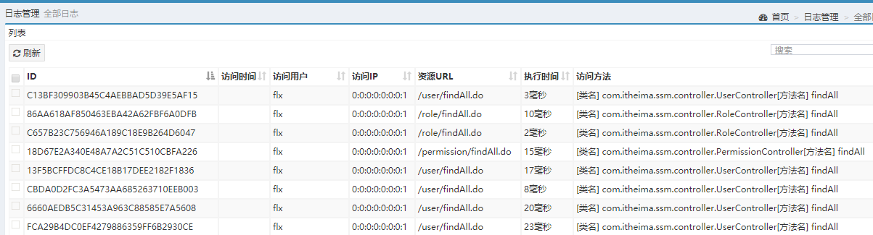
实体类
public class SysLog {
private String id;
private Date visitTime;
private String visitTimeStr;
private String username;
private String ip;
private String url;
private Long executionTime;
private String method;
//getter/setter
}

AOP日志-前置通知操作
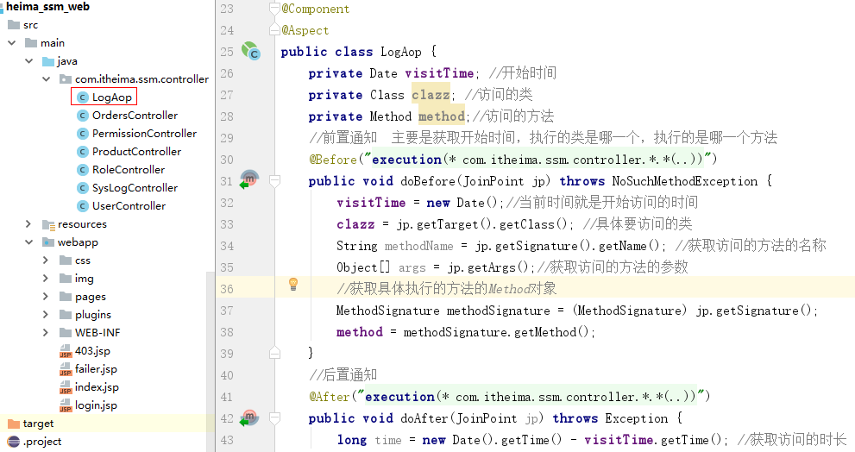
前置通知获取访问起始时间、访问方法Method
@Component
@Aspect
public class LogAop {
private Date visitTime; //开始时间
private Class clazz; //访问的类
private Method method;//访问的方法
//前置通知 主要是获取开始时间，执行的类是哪一个，执行的是哪一个方法
@Before("execution(* com.itheima.ssm.controller.*.*(..))")
public void doBefore(JoinPoint jp) throws NoSuchMethodException {
visitTime = new Date();//当前时间就是开始访问的时间
clazz = jp.getTarget().getClass(); //具体要访问的类
String methodName = jp.getSignature().getName(); //获取访问的方法的名称
Object[] args = jp.getArgs();//获取访问的方法的参数
//获取具体执行的方法的Method对象
MethodSignature methodSignature = (MethodSignature) jp.getSignature();
method = methodSignature.getMethod();
}

//后置通知
@After("execution(* com.itheima.ssm.controller.*.*(..))")
public void doAfter(JoinPoint jp) throws Exception {
long time = new Date().getTime() - visitTime.getTime(); //获取访问的时长
}
}

AOP日志-后置通知1
获取IP和URL
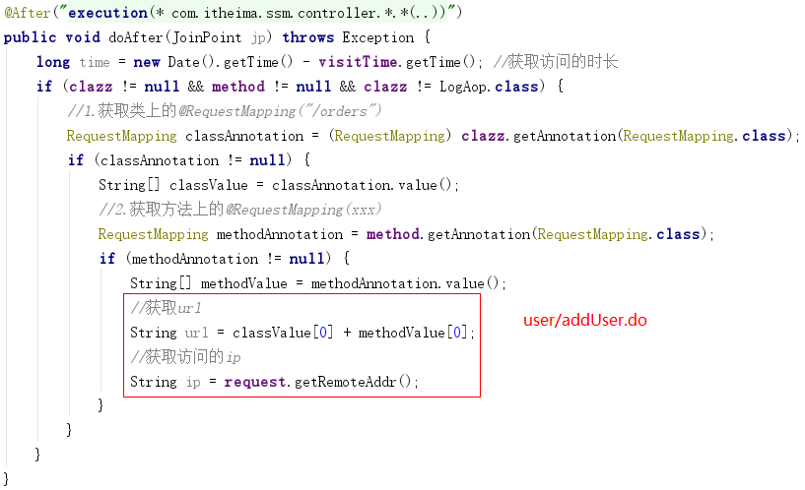
@Component
@Aspect
public class LogAop {
@Autowired
private HttpServletRequest request;
//后置通知
@After("execution(* com.itheima.ssm.controller.*.*(..))")
public void doAfter(JoinPoint jp) throws Exception {
long time = new Date().getTime() - visitTime.getTime(); //获取访问的时长
if (clazz != null && method != null && clazz != LogAop.class) {
//1.获取类上的@RequestMapping("/orders")
RequestMapping classAnnotation = (RequestMapping) clazz.getAnnotation(RequestMapping.class);
if (classAnnotation != null) {
String[] classValue = classAnnotation.value();
//2.获取方法上的@RequestMapping(xxx)
RequestMapping methodAnnotation = method.getAnnotation(RequestMapping.class);
if (methodAnnotation != null) {
String[] methodValue = methodAnnotation.value();
//获取url
String url = classValue[0] + methodValue[0];
//获取访问的ip
String ip = request.getRemoteAddr();
}
}
}
}
}

AOP日志-后置通知2
获取当前登陆的用户
@Component
@Aspect
public class LogAop {
@Autowired
private HttpServletRequest request;
//后置通知
@After("execution(* com.itheima.ssm.controller.*.*(..))")
public void doAfter(JoinPoint jp) throws Exception {
long time = new Date().getTime() - visitTime.getTime(); //获取访问的时长
if (clazz != null && method != null && clazz != LogAop.class) {
//1.获取类上的@RequestMapping("/orders")
RequestMapping classAnnotation = (RequestMapping) clazz.getAnnotation(RequestMapping.class);
if (classAnnotation != null) {
String[] classValue = classAnnotation.value();
//2.获取方法上的@RequestMapping(xxx)
RequestMapping methodAnnotation = method.getAnnotation(RequestMapping.class);
if (methodAnnotation != null) {
String[] methodValue = methodAnnotation.value();
//获取url
String url = classValue[0] + methodValue[0];
//获取访问的ip
String ip = request.getRemoteAddr();
//获取当前操作的用户
SecurityContext context = SecurityContextHolder.getContext();
//从上下文中获了当前登录的用户
String username = context.getAuthentication().getName();
}
}
}
}
}

AOP日志-日志添加操作
1、Dao层代码
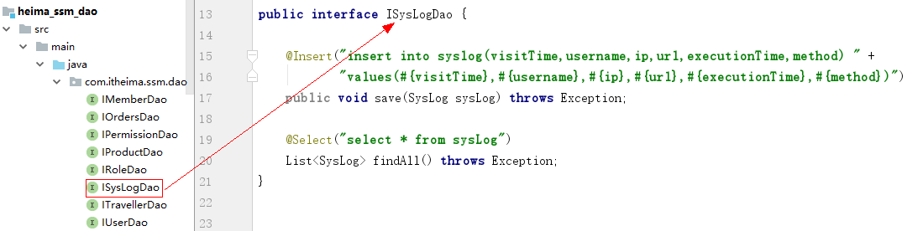
public interface ISysLogDao {
@Insert("insert into syslog(visitTime,username,ip,url,executionTime,method) " +
"values(#{visitTime},#{username},#{ip},#{url},#{executionTime},#{method})")
public void save(SysLog sysLog) throws Exception;
@Select("select * from sysLog")
List<SysLog> findAll() throws Exception;
}
2、Service层代码
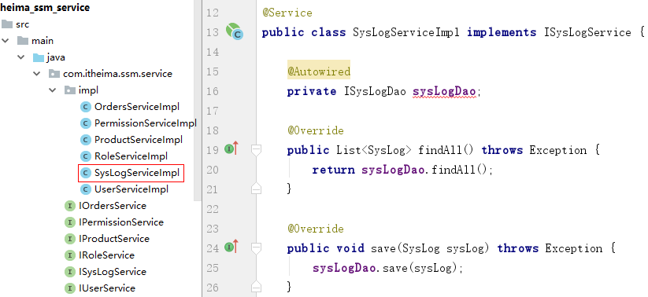
public interface ISysLogService {
public void save(SysLog sysLog) throws Exception;
List<SysLog> findAll() throws Exception;
}
@Service
public class SysLogServiceImpl implements ISysLogService {
@Autowired
private ISysLogDao sysLogDao;
@Override
public List<SysLog> findAll() throws Exception {
return sysLogDao.findAll();
}
@Override
public void save(SysLog sysLog) throws Exception {
sysLogDao.save(sysLog);
}
}

3、调用ISysLogService保存日志
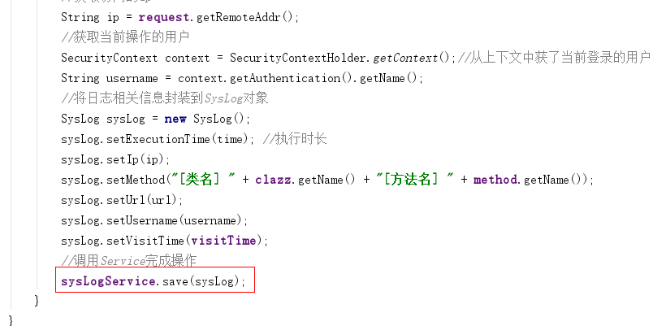

AOP日志-问题处理

AOP日志-查询日志流程分析
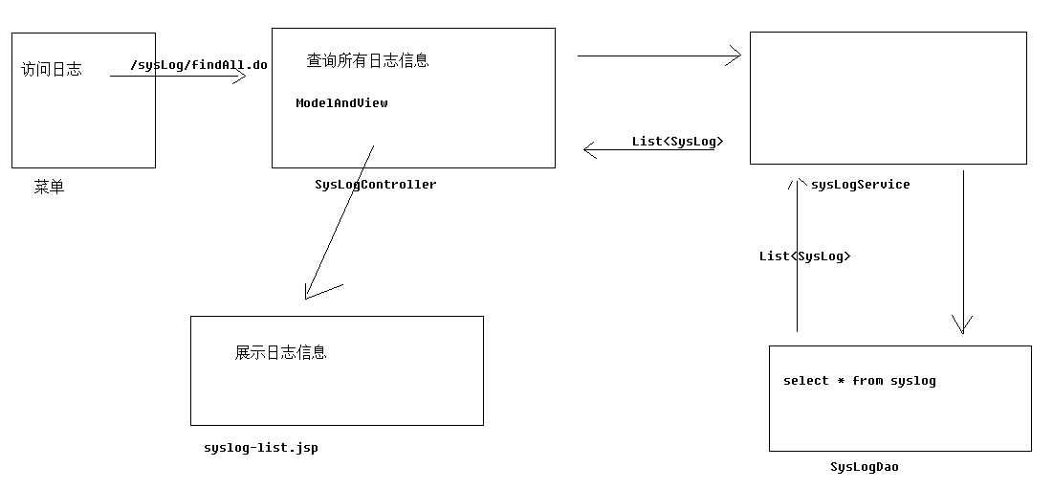

AOP日志-查询日志代码实现
- Dao层代码
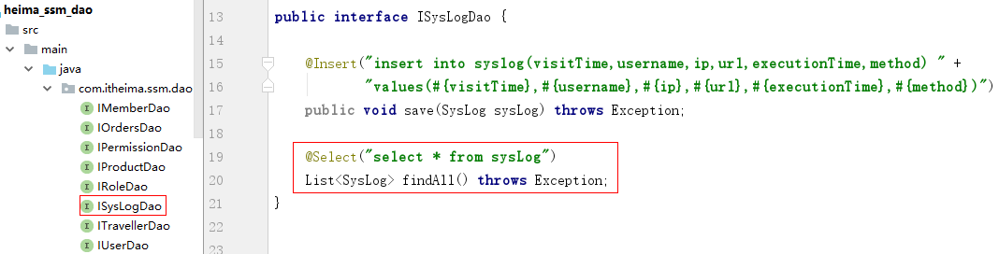
- Service层代码
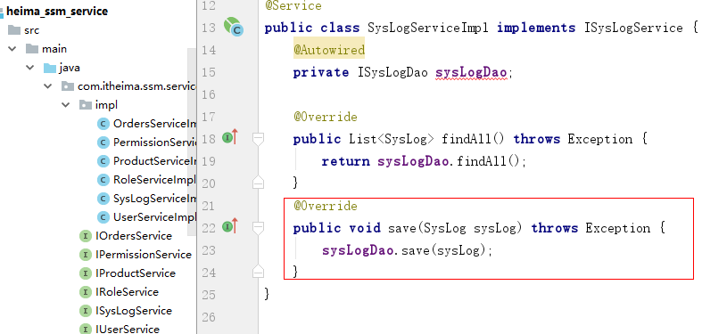
- web层代码
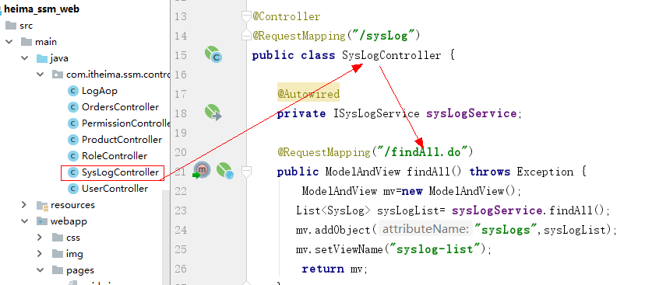
@Controller
@RequestMapping("/sysLog")
public class SysLogController {
@Autowired
private ISysLogService sysLogService;
@RequestMapping("/findAll.do")
public ModelAndView findAll() throws Exception {
ModelAndView mv=new ModelAndView();
List<SysLog> sysLogList= sysLogService.findAll();
mv.addObject("sysLogs",sysLogList);
mv.setViewName("syslog-list");
return mv;
}
}

