1、订单操作-订单详情查询流程分析.avi
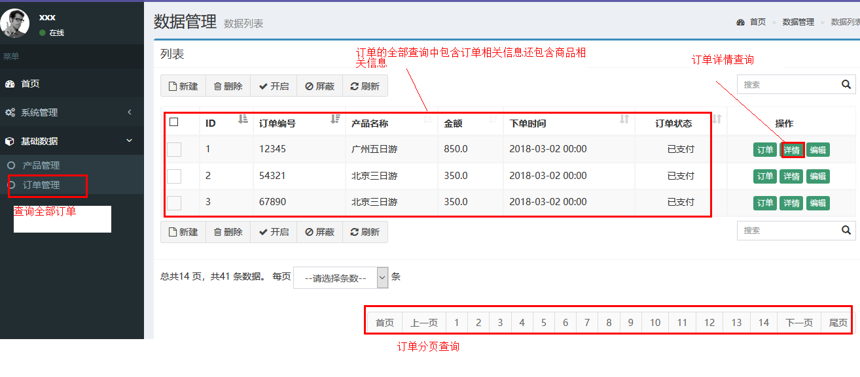
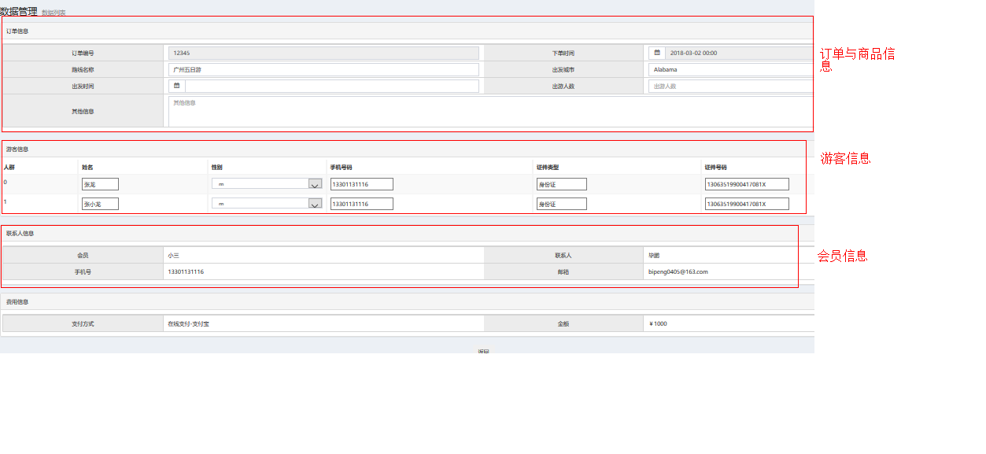
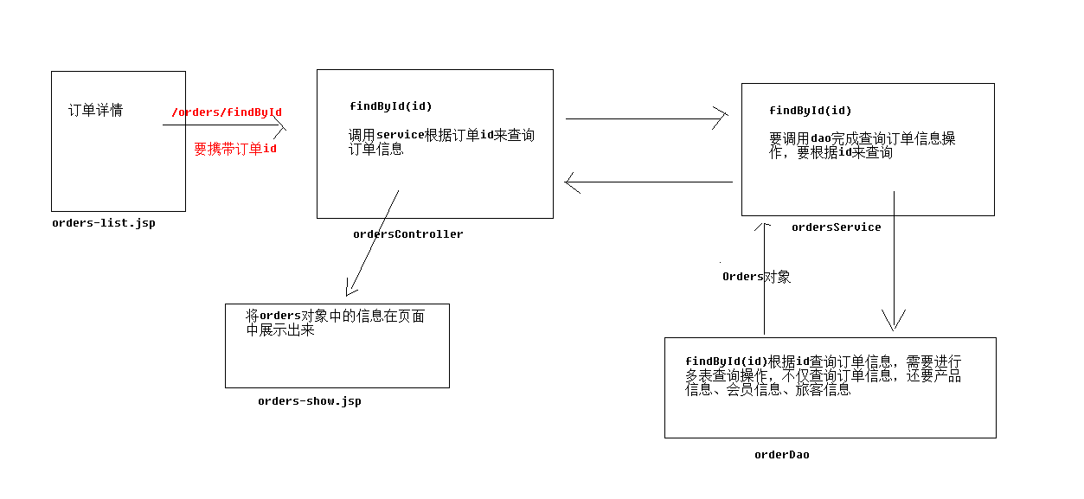

2、订单操作-订单详情查询代码实现1.avi
1、OrdersController类添加findById方法
@RequestMapping("/findById.do")
public ModelAndView findById(@RequestParam(name = "id", required = true) String ordersId) throws Exception {
ModelAndView mv = new ModelAndView();
Orders orders = ordersService.findById(ordersId);
mv.addObject("orders",orders);
mv.setViewName("orders-show");
return mv;
}
2、IOrdersService接口添加findById方法

Orders findById(String ordersId) throws Exception;

3、OrdersServiceImpl类实现findById方法
@Override
public Orders findById(String ordersId) throws Exception{
return ordersDao.findById(ordersId);
}

4、IOrdersDao接口添加findById方法
//多表操作
@Select("select * from orders where id=#{ordersId}")
@Results({
@Result(property = "product",column = "productId", one = @One(select = "com.itheima.ssm.dao.IProductDao.findById")),
@Result(property = "member",column = "memberId",one = @One(select = "com.itheima.ssm.dao.IMemberDao.findById"))
})
public Orders findById(String ordersId) throws Exception;

5、 添加IMemberDao接口添加findById方法
@Select("select * from member where id=#{id}")
public Member findById(String id) throws Exception;

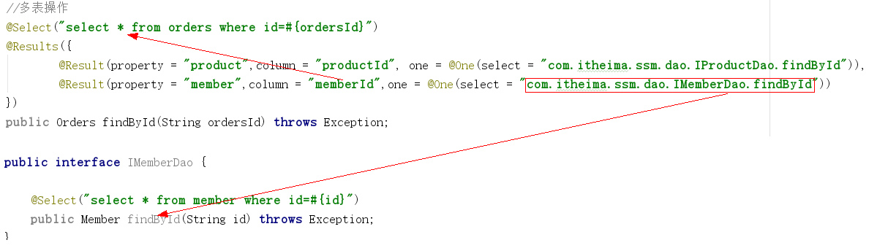

3、订单操作-订单详情查询代码实现2.avi
1、IOrdersDao接口findById方法添加查询游客信息的sql语句
//多表操作
@Select("select * from orders where id=#{ordersId}")
@Results({
@Result(property = "id", column = "id"),
@Result(property = "product",column = "productId", one = @One(select = "com.itheima.ssm.dao.IProductDao.findById")),
@Result(property = "member",column = "memberId",one = @One(select = "com.itheima.ssm.dao.IMemberDao.findById")),
@Result(property = "travellers",column = "id",many = @Many(select = "com.itheima.ssm.dao.ITravellerDao.findByOrdersId"))
})
public Orders findById(String ordersId) throws Exception;

2、添加ITravellerDao接口
public interface ITravellerDao {
@Select("select * from traveller where id in (select travellerId from order_traveller where orderId=#{ordersId})")
public List<Traveller> findByOrdersId(String ordersId) throws Exception;
}

3、根据orderId查询游客的sql语句:
select * from traveller where id in (select travellerId from order_traveller where orderId='0E7231DC797C486290E8713CA3C6ECCC');

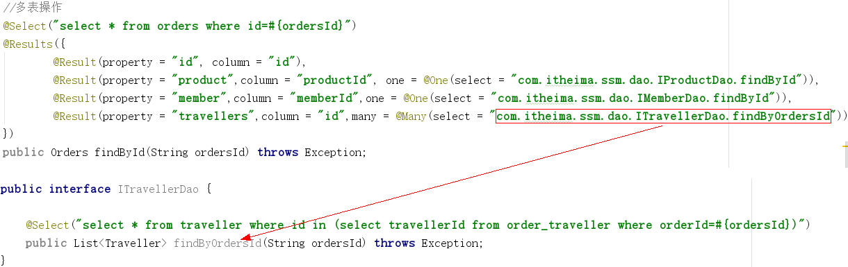

4、订单操作-订单详情查询代码实现3.avi
1、从资料拷贝orders-show.jsp页面填充订单数据

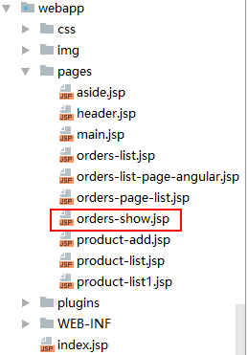

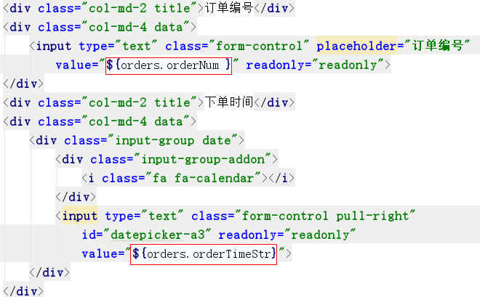

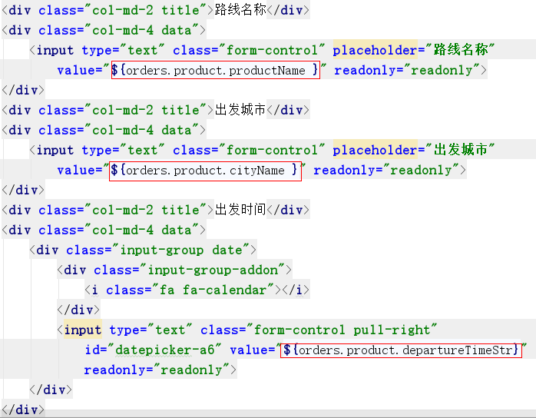
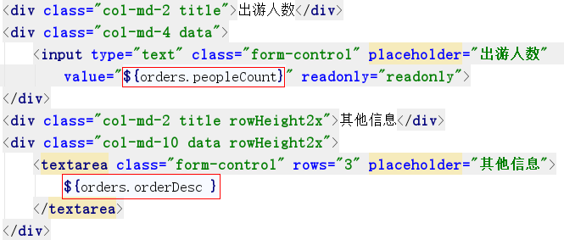

2、展示游客信息

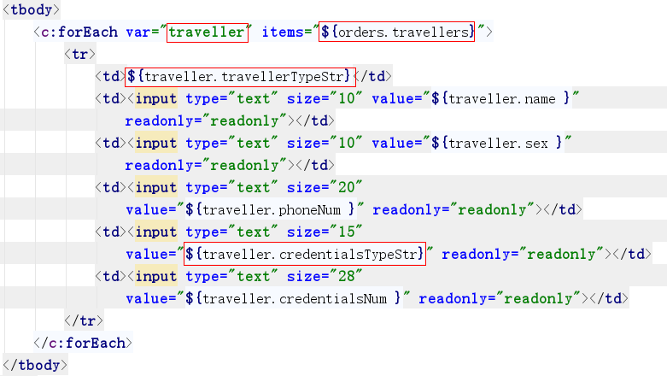

3、Traveller类改造getCredentialsTypeStr方法
public String getCredentialsTypeStr() {
//证件类型 0身份证 1护照 2军官证
if (credentialsType != null) {
if (credentialsType == 0) {
credentialsTypeStr = "身份证";
} else if (credentialsType == 1) {
credentialsTypeStr = "护照";
} else if (credentialsType == 2) {
credentialsTypeStr = "军官证";
}
}
return credentialsTypeStr;
}

4、Traveller类改造getTravellerTypeStr方法
public String getTravellerTypeStr() {
////旅客类型(人群) 0 成人 1 儿童
if (travellerType != null) {
if (travellerType == 0) {
travellerTypeStr = "成人";
} else if (travellerType == 1) {
travellerTypeStr = "儿童";
}
}
return travellerTypeStr;
}

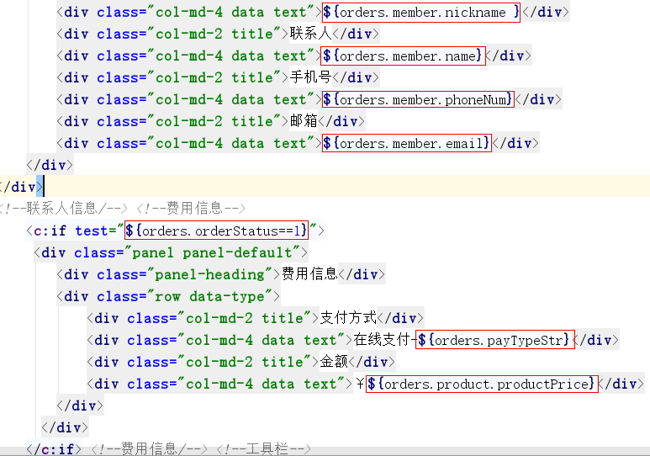

5、权限操作-表结构分析与创建表.avi
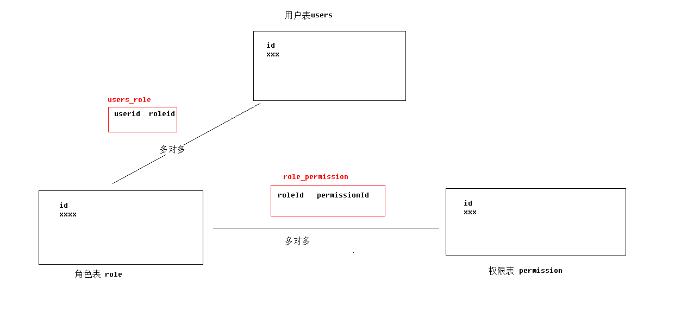

6、权限操作-springSecurity概述及快速入门步骤分析.avi
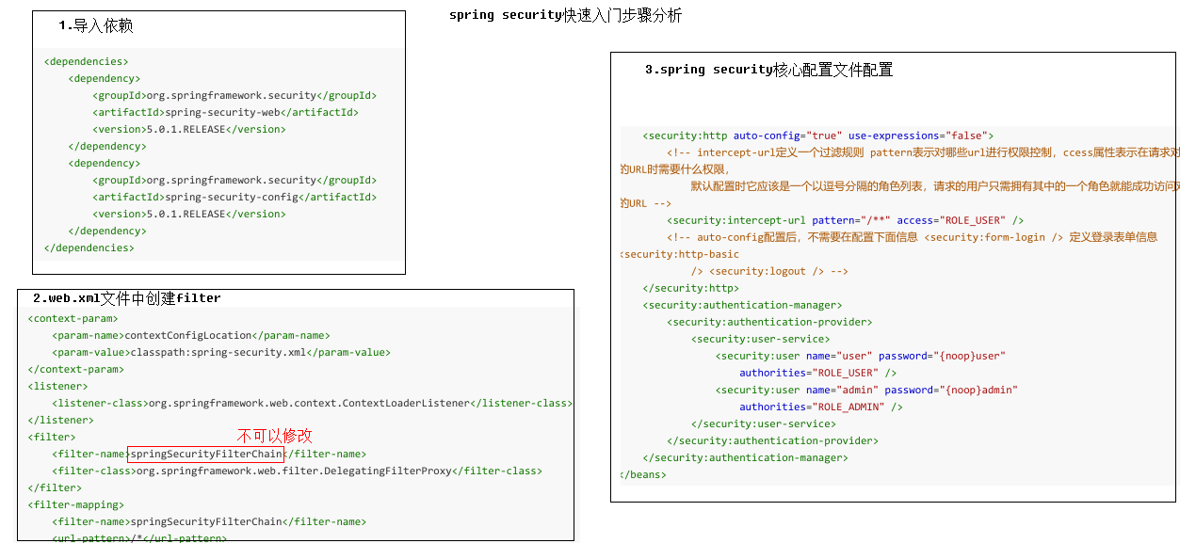

7、权限操作-springSecurity快速入门.avi

8、权限操作-springSecurity快速入门-使用自定义页面.avi

9、用户操作-登录流程分析.avi
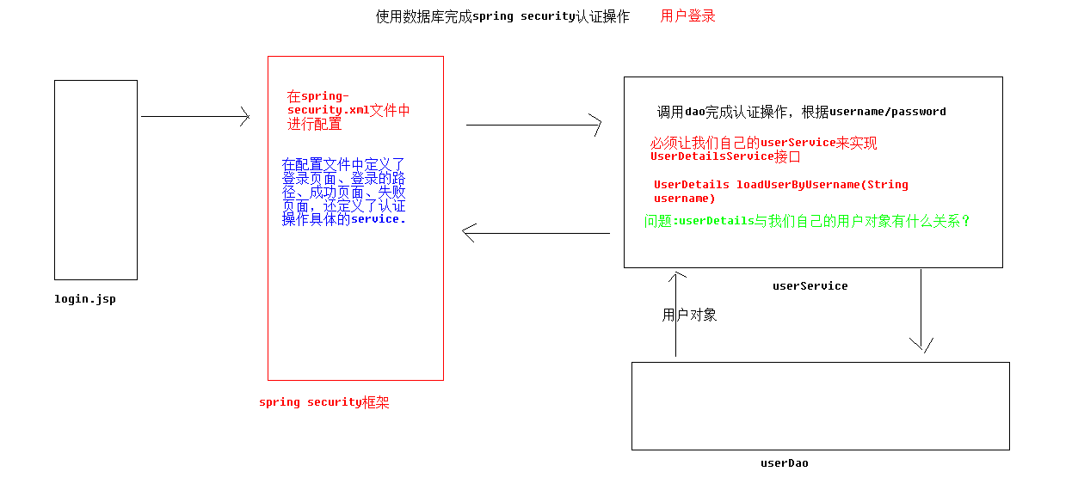

10、用户操作-登录代码实现1.avi
第一步、web.xml中配置过滤器和加载spring-security.xml文件

<filter>
<filter-name>springSecurityFilterChain</filter-name>
<filter-class>org.springframework.web.filter.DelegatingFilterProxy</filter-class>
</filter>
<filter-mapping>
<filter-name>springSecurityFilterChain</filter-name>
<url-pattern>/*</url-pattern>
</filter-mapping>
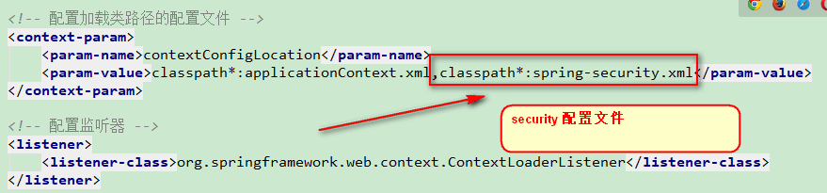

第二步、在resources创建spring-security.xml, 为url分配它需要权，为用户指定拥有权限

指定不需要拦截的东西
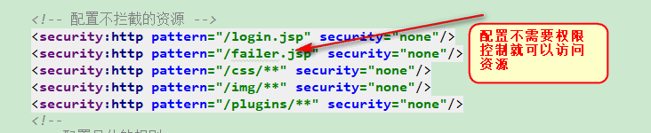
指定url需要什么权限，一些指定特定页面的地址
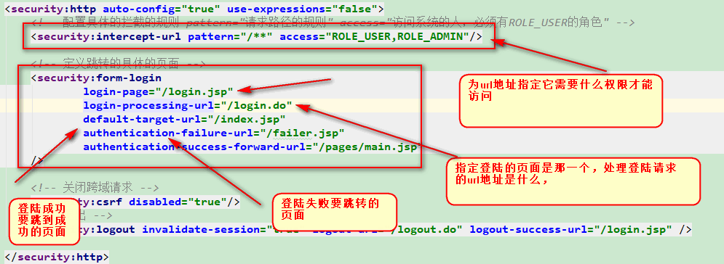
为用户指定用户拥有的权限
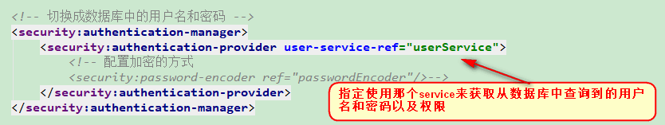

<?xml version="1.0" encoding="UTF-8"?>
<beans xmlns="http://www.springframework.org/schema/beans"
xmlns:security="http://www.springframework.org/schema/security"
xmlns:xsi="http://www.w3.org/2001/XMLSchema-instance"
xsi:schemaLocation="http://www.springframework.org/schema/beans
http://www.springframework.org/schema/beans/spring-beans.xsd
http://www.springframework.org/schema/security
http://www.springframework.org/schema/security/spring-security.xsd">
<!-- 配置不拦截的资源 -->
<security:http pattern="/login.jsp" security="none"/>
<security:http pattern="/failer.jsp" security="none"/>
<security:http pattern="/css/**" security="none"/>
<security:http pattern="/img/**" security="none"/>
<security:http pattern="/plugins/**" security="none"/>
<security:http auto-config="true" use-expressions="false">
<!-- 配置具体的拦截的规则 pattern="请求路径的规则" access="访问系统的人，必须有ROLE_USER的角色" -->
<security:intercept-url pattern="/**" access="ROLE_USER,ROLE_ADMIN"/>
<!-- 定义跳转的具体的页面 -->
<security:form-login
login-page="/login.jsp"
login-processing-url="/login.do"
default-target-url="/index.jsp"
authentication-failure-url="/failer.jsp"
authentication-success-forward-url="/pages/main.jsp"
/>
<!-- 关闭跨域请求 -->
<security:csrf disabled="true"/>
<!-- 退出 -->
<security:logout invalidate-session="true" logout-url="/logout.do" logout-success-url="/login.jsp"/>
</security:http>
<!-- 切换成数据库中的用户名和密码 -->
<security:authentication-manager>
<security:authentication-provider user-service-ref="userService"></security:authentication-provider>
</security:authentication-manager>
</beans>

第三步、编写userService返回数据中用户名密码和角色信息
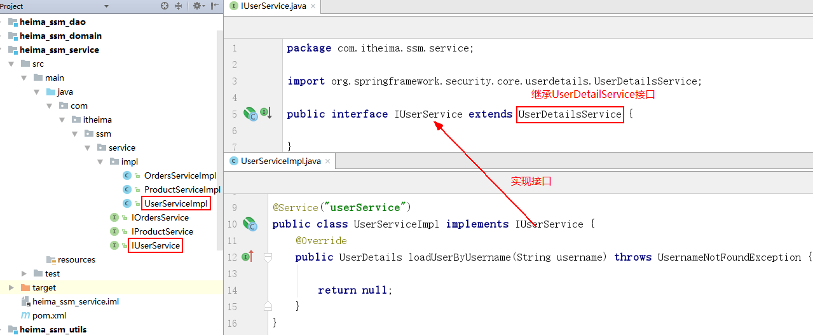

package com.itheima.ssm.service;
import org.springframework.security.core.userdetails.UserDetailsService;
public interface IUserService extends UserDetailsService {
}

@Service("userService")
public class UserServiceImpl implements IUserService {
@Override
public UserDetails loadUserByUsername(String username) throws UsernameNotFoundException {
return null;
}
}

11、用户操作-登录代码实现2.avi
1、domain层代码
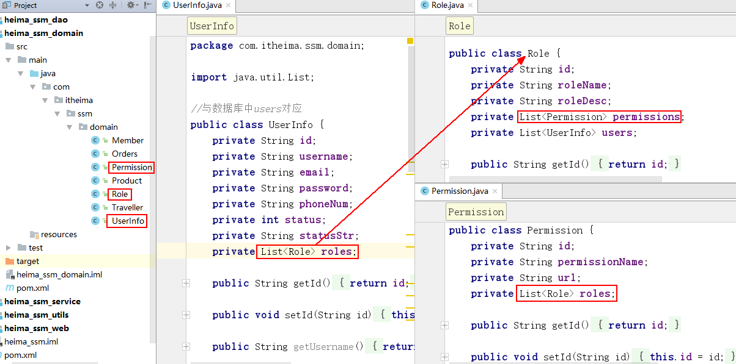
//与数据库中users对应
public class UserInfo {
private String id;
private String username;
private String email;
private String password;
private String phoneNum;
private int status;
private String statusStr;
private List<Role> roles;
//setter/getter
}
public class Role {
private String id;
private String roleName;
private String roleDesc;
private List<Permission> permissions;
private List<UserInfo> users;
//setter/getter
}
public class Permission {
private String id;
private String permissionName;
private String url;
private List<Role> roles;
//setter/getter
}

2、dao层
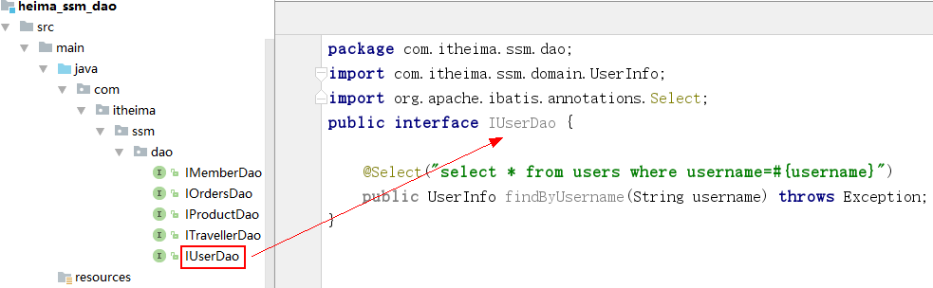

public interface IUserDao {
@Select("select * from users where username=#{username}")
public UserInfo findByUsername(String username) throws Exception;
}

3、实现UserServiceImpl的loadUserByUsername方法

@Service("userService")
public class UserServiceImpl implements IUserService {
@Autowired
private IUserDao userDao;
@Override
public UserDetails loadUserByUsername(String username) throws UsernameNotFoundException {
UserInfo userInfo = null;
try {
userInfo = userDao.findByUsername(username);
} catch (Exception e) {
e.printStackTrace();
}
//处理自己的用户对象封装成UserDetails,这里返回的User对象会和表单提交的用户密码比对
User user=new User(userInfo.getUsername(),userInfo.getPassword(),null);
return user;
}
}

12、用户操作-登录代码实现3.avi

输入用户名及密码，登录失败了
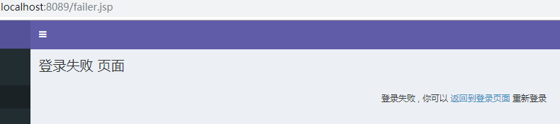
查看日志：当前登录用户没有权限
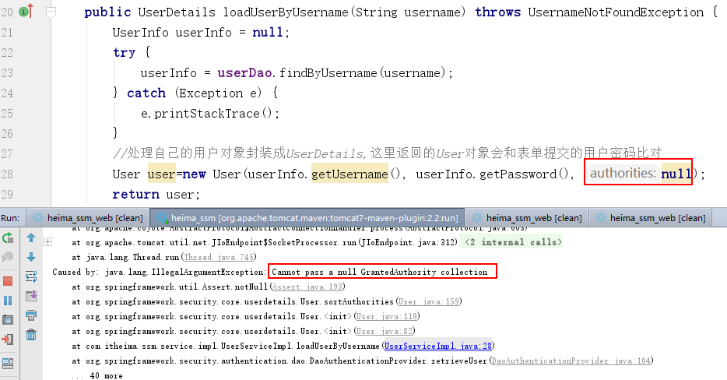
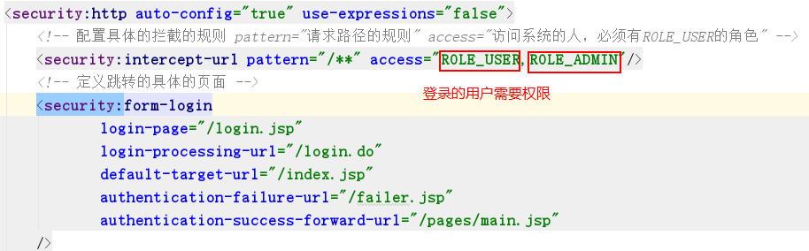

解决：给当前的登录用户授予权限
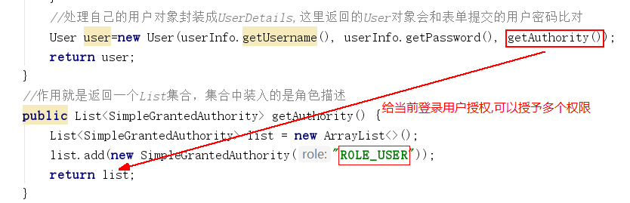

@Service("userService")
public class UserServiceImpl implements IUserService {
@Autowired
private IUserDao userDao;
@Override
public UserDetails loadUserByUsername(String username) throws UsernameNotFoundException {
UserInfo userInfo = null;
try {
userInfo = userDao.findByUsername(username);
} catch (Exception e) {
e.printStackTrace();
}
//处理自己的用户对象封装成UserDetails,这里返回的User对象会和表单提交的用户密码比对
User user=new User(userInfo.getUsername(), userInfo.getPassword(), getAuthority());
return user;
}
//作用就是返回一个List集合，集合中装入的是角色描述
public List<SimpleGrantedAuthority> getAuthority() {
List<SimpleGrantedAuthority> list = new ArrayList<>();
list.add(new SimpleGrantedAuthority("ROLE_USER"));
return list;
}
}
登录之后发现又报错了
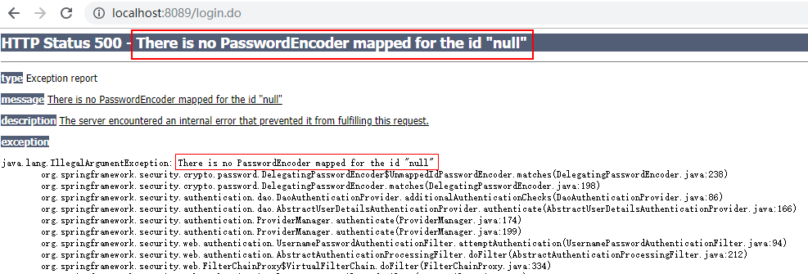
查看日志发现原因是：没有对密码进行加密处理，所有报错了

解决：

方案一：对表单进行密码检验，数据库存放的密码必须是加密后的密文

方案二：不加密检验，但是需要告诉框架，我们没有做加密处理，在密码前拼接{noop}

13、用户操作-登录代码实现4.avi
用户所具有的角色应该来自数据库，而不是list.add(new SimpleGrantedAuthority("ROLE_USER"))在代码里面固定了

- Dao层代码
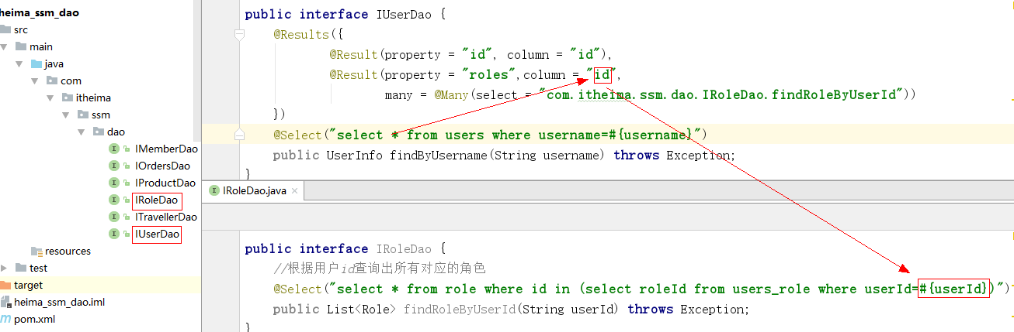

public interface IUserDao {
@Results({
@Result(property = "id", column = "id"),
@Result(property = "roles",column = "id",
many = @Many(select = "com.itheima.ssm.dao.IRoleDao.findRoleByUserId"))
})
@Select("select * from users where username=#{username}")
public UserInfo findByUsername(String username) throws Exception;
}

public interface IRoleDao {
//根据用户id查询出所有对应的角色
@Select("select * from role where id in (select roleId from users_role where userId=#{userId})")
public List<Role> findRoleByUserId(String userId) throws Exception;
}
2.service层
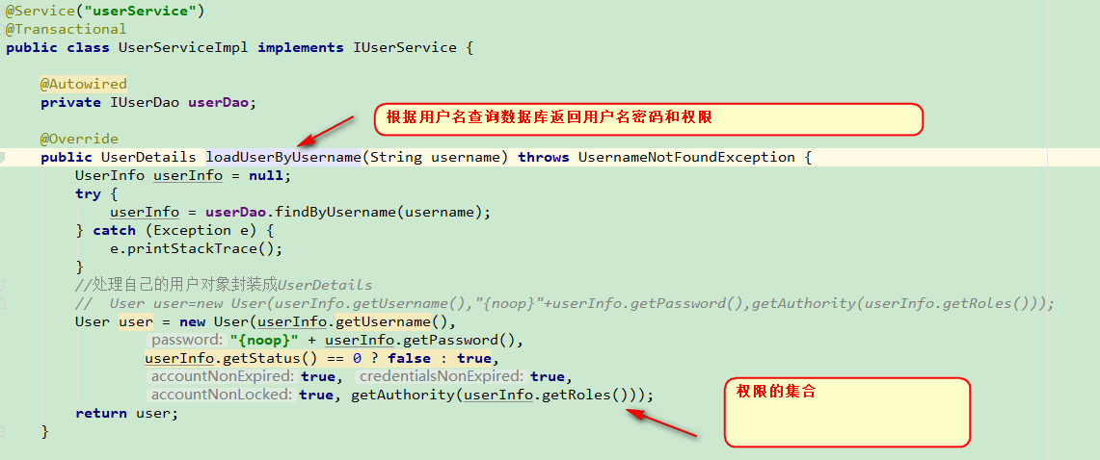
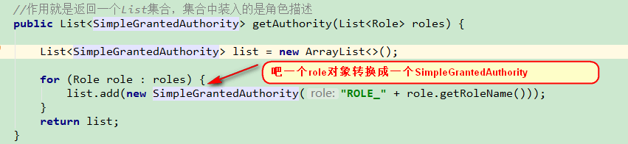
@Service("userService")
public class UserServiceImpl implements IUserService {
@Autowired
private IUserDao userDao;
@Override
public UserDetails loadUserByUsername(String username) throws UsernameNotFoundException {
UserInfo userInfo = null;
try {
userInfo = userDao.findByUsername(username);
} catch (Exception e) {
e.printStackTrace();
}
//处理自己的用户对象封装成UserDetails
// User user=new User(userInfo.getUsername(),"{noop}"+userInfo.getPassword(),getAuthority(userInfo.getRoles()));
//User user = new User(userInfo.getUsername(), "{noop}" + userInfo.getPassword(), userInfo.getStatus() == 0 ? false : true, true, true, true, getAuthority(userInfo.getRoles()));
User user = new User(userInfo.getUsername(), "{noop}" + userInfo.getPassword(), getAuthority(userInfo.getRoles()));
return user;
}
//作用就是返回一个List集合，集合中装入的是角色描述
public List<SimpleGrantedAuthority> getAuthority(List<Role> roles) {
List<SimpleGrantedAuthority> list = new ArrayList<>();
for (Role role : roles) {
list.add(new SimpleGrantedAuthority("ROLE_" + role.getRoleName()));
}
return list;
}
}

14、用户操作-退出.avi
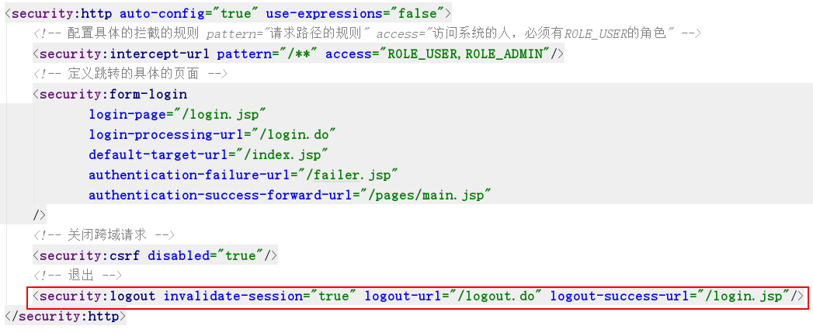

<security:logout invalidate-session="true" logout-url="/logout.do" logout-success-url="/login.jsp"/>

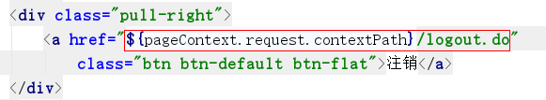

15、springSecurity源码分析-springSecurityFilterChain.avi

16、springSecurity源码分析-spring-security.xml文件配置.avi

