1、用户操作-查询所有用户操作
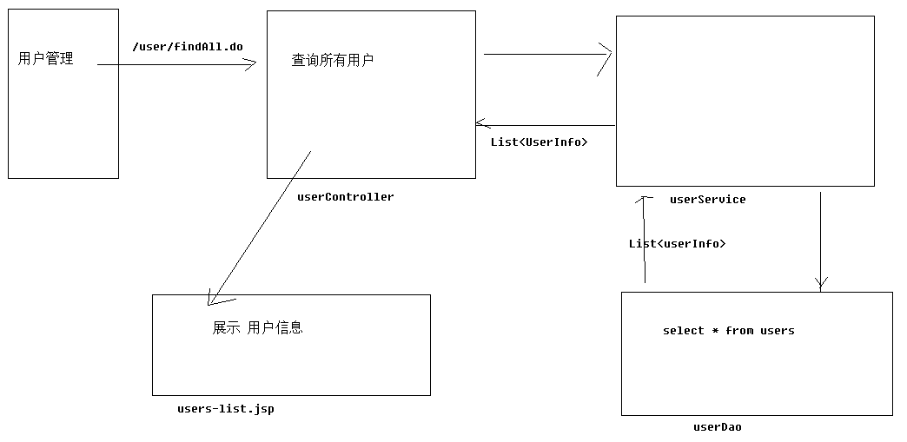
1、Dao层代码
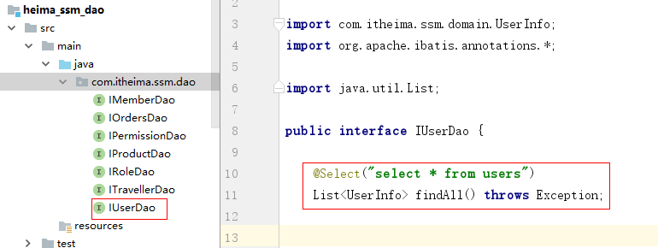

public interface IUserDao {
@Select("select * from users")
List<UserInfo> findAll() throws Exception;
}
2、Service层代码
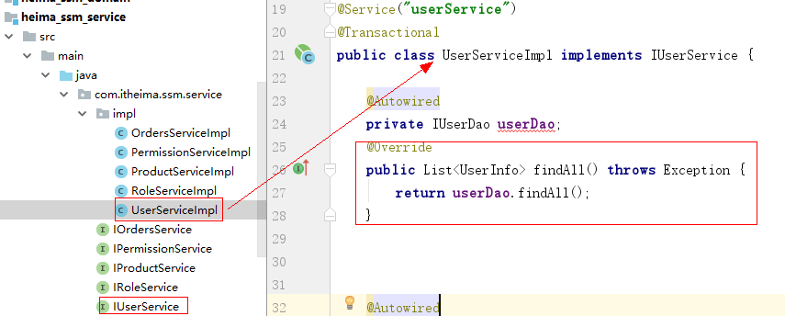
IUserService接口添加findAll方法
public interface IUserService extends UserDetailsService {
List<UserInfo> findAll() throws Exception;
}

@Service("userService")
public class UserServiceImpl implements IUserService {
@Autowired
private IUserDao userDao;
@Override
public List<UserInfo> findAll() throws Exception {
return userDao.findAll();
}
}
3、web层
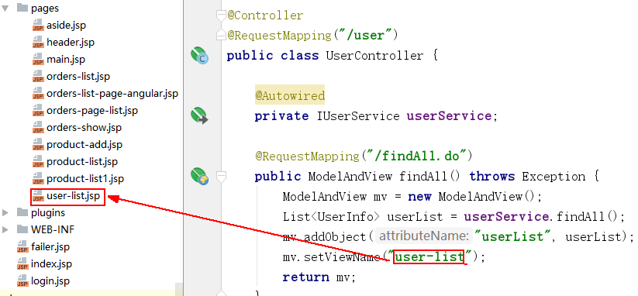
@Controller
@RequestMapping("/user")
public class UserController {
@Autowired
private IUserService userService;
@RequestMapping("/findAll.do")
public ModelAndView findAll() throws Exception {
ModelAndView mv = new ModelAndView();
List<UserInfo> userList = userService.findAll();
mv.addObject("userList", userList);
mv.setViewName("user-list");
return mv;
}
}
UserInfo处理
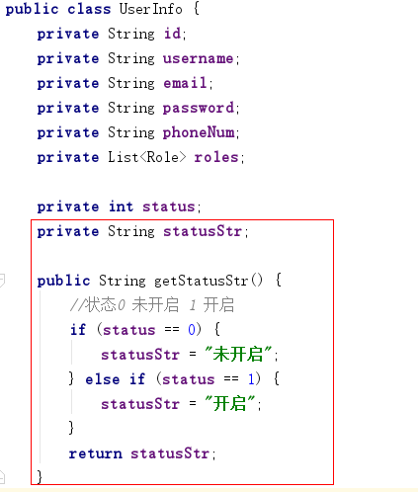
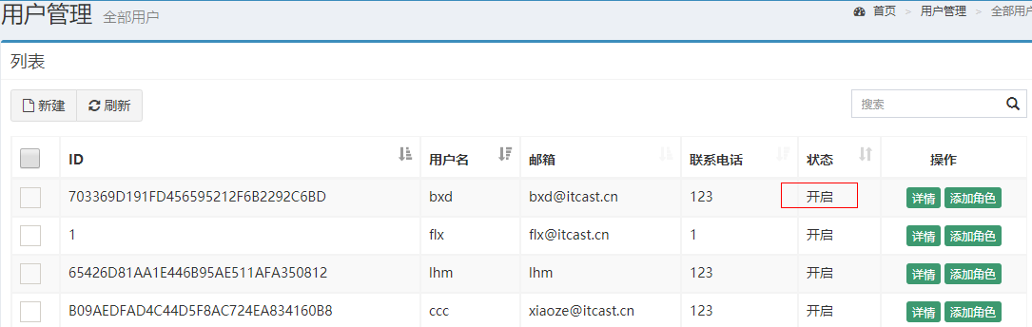

2、用户操作-用户添加流程分析
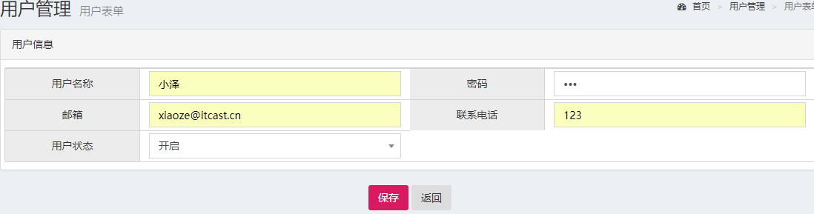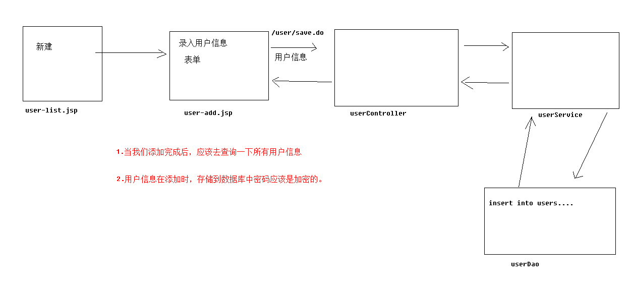

3、用户操作-用户添加操作代码实
1、dao层
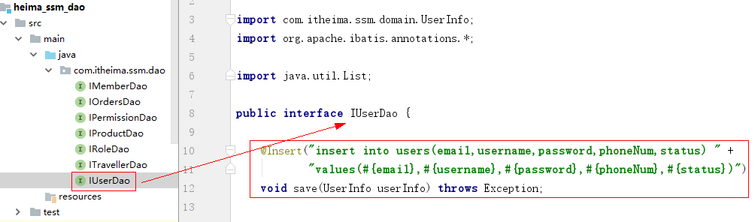
public interface IUserDao {
@Insert("insert into users(email,username,password,phoneNum,status) values(#{email},#{username},#{password},#{phoneNum},#{status})")
void save(UserInfo userInfo) throws Exception;
}
2、service层代码
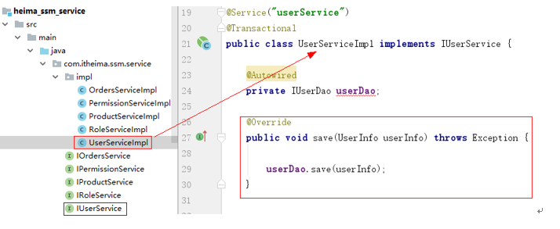
public interface IUserService extends UserDetailsService {
List<UserInfo> findAll() throws Exception;
void save(UserInfo userInfo) throws Exception;
}

@Service("userService")
public class UserServiceImpl implements IUserService {
@Autowired
private IUserDao userDao;
@Override
public void save(UserInfo userInfo) throws Exception {
userDao.save(userInfo);
}
}
3、web层代码

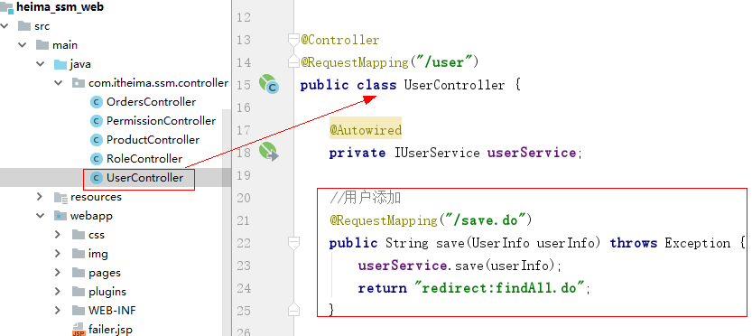

@Controller
@RequestMapping("/user")
public class UserController {
@Autowired
private IUserService userService;
//用户添加
@RequestMapping("/save.do")
public String save(UserInfo userInfo) throws Exception {
userService.save(userInfo);
return "redirect:findAll.do";
}
}

4、用户操作-密码加密后用户登录问题解决
1、注入BCryptPasswordEncoder对密码进行加密
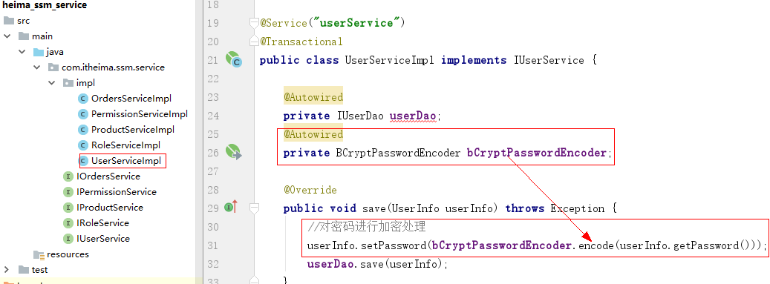
用户表的密码通常使用 MD5 等不可逆算法加密后存储，为防止彩虹表破解更会先使用一个特定的字符串（如域名）加密，然后再使用一个随机的 salt（盐值）加密。 特定字符串是程序代码中固定的，salt 是每个密码单独随机，一般给用户表加一个字段单独存储，比较麻烦。 BCrypt 算法将 salt 随机并混入最终加密后的密码，验证时也无需单独提供之前的 salt，从而无需单独处理 salt 问题。
@Service("userService")
public class UserServiceImpl implements IUserService {
@Autowired
private IUserDao userDao;
@Autowired
private BCryptPasswordEncoder bCryptPasswordEncoder;
@Override
public void save(UserInfo userInfo) throws Exception {
//对密码进行加密处理
userInfo.setPassword(bCryptPasswordEncoder.encode(userInfo.getPassword()));
userDao.save(userInfo);
}
}
2、去掉UserServiceImpl类loadUserByUsername User对象密码的{loop}告诉框架对密码加密验证
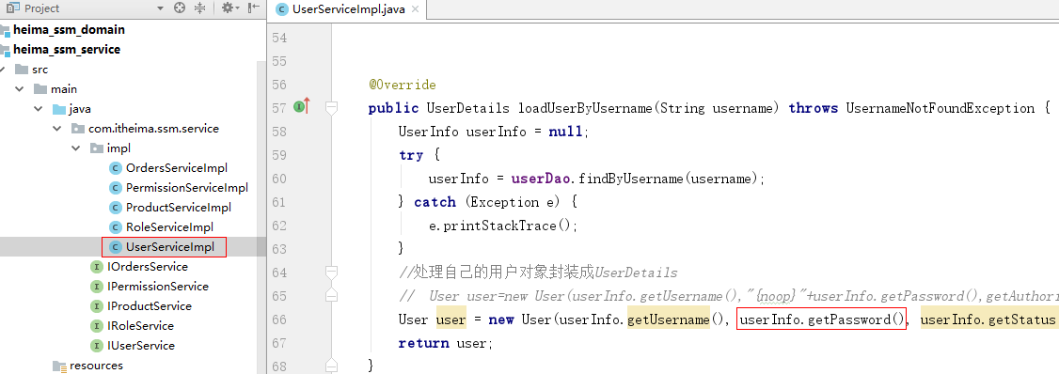
3、在spring-security.xml配置文件指定加密方式
提交表单的明文要加密之后和new User(username, password)比较

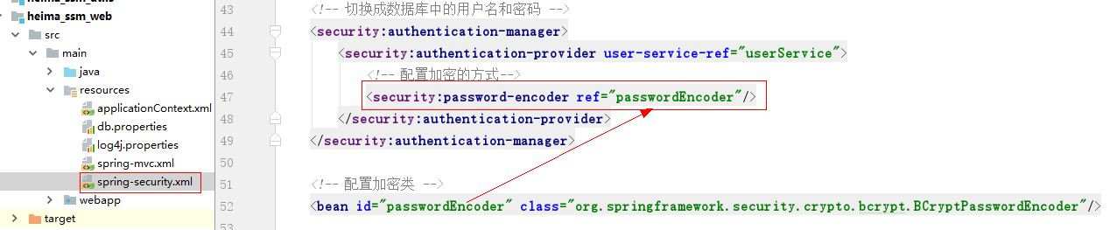

用户操作-用户详情查询流程分析
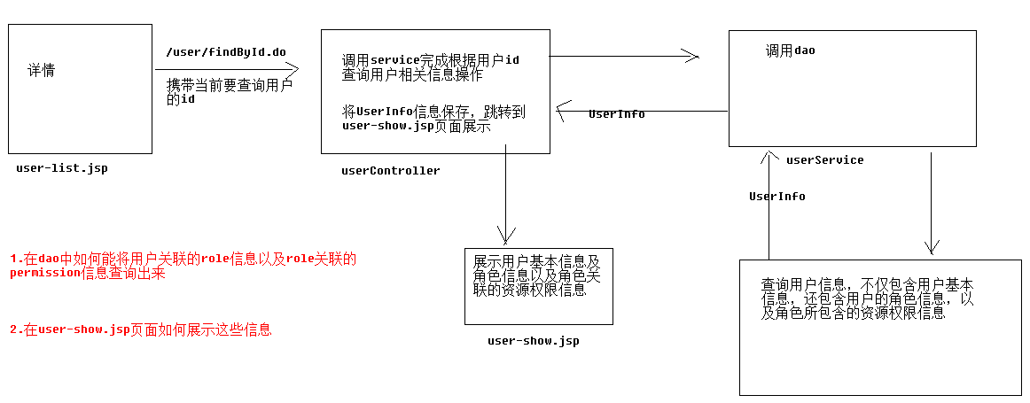

6、用户操作-用户详情服务器端代码实现
1、dao层代码实现
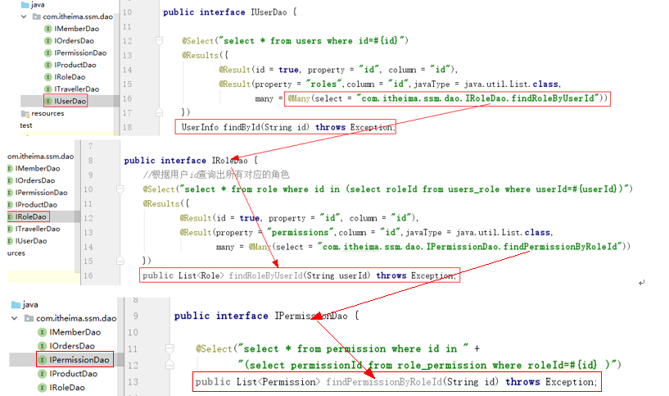
public interface IUserDao {
@Select("select * from users where id=#{id}")
@Results({
@Result(id = true, property = "id", column = "id"),
@Result(property = "roles",column = "id",
many = @Many(select = "com.itheima.ssm.dao.IRoleDao.findRoleByUserId"))
})
UserInfo findById(String id) throws Exception;
}

public interface IRoleDao {
//根据用户id查询出所有对应的角色
@Select("select * from role where id in (select roleId from users_role where userId=#{userId})")
@Results({
@Result(property = "id", column = "id"),
@Result(property = "permissions",column = "id",
many = @Many(select = "com.itheima.ssm.dao.IPermissionDao.findPermissionByRoleId"))
})
public List<Role> findRoleByUserId(String userId) throws Exception;
}

public interface IPermissionDao {
@Select("select * from permission where id in (select permissionId from role_permission where roleId=#{id})")
public List<Permission> findPermissionByRoleId(String id) throws Exception;
}

2、service层代码
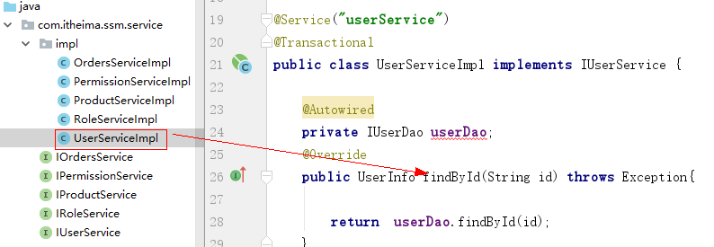
public interface IUserService extends UserDetailsService {
List<UserInfo> findAll() throws Exception;
void save(UserInfo userInfo) throws Exception;
UserInfo findById(String id) throws Exception;
}

@Service("userService")
public class UserServiceImpl implements IUserService {
@Autowired
private IUserDao userDao;
@Override
public UserInfo findById(String id) throws Exception{
return userDao.findById(id);
}
}
3、web层
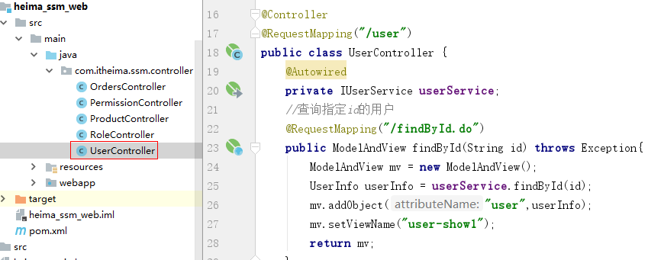
@Controller
@RequestMapping("/user")
public class UserController {
@Autowired
private IUserService userService;
//查询指定id的用户
@RequestMapping("/findById.do")
public ModelAndView findById(String id) throws Exception{
ModelAndView mv = new ModelAndView();
UserInfo userInfo = userService.findById(id);
mv.addObject("user",userInfo);
mv.setViewName("user-show");
return mv;
}
}
拷贝资料user-show.jsp页面到pages
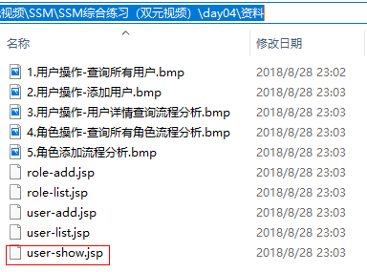

7、用户操作-用户详情效果演示
http://192.168.25.168:8280/ssm/user/findById.do?id=1
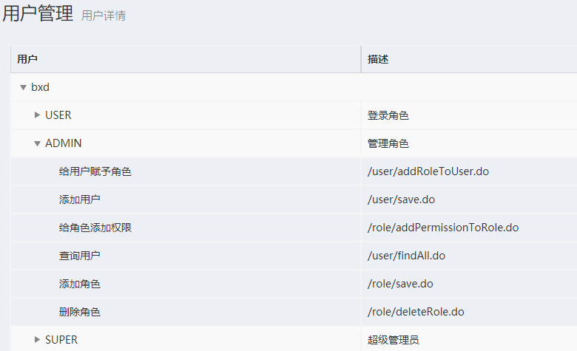

8、用户操作-用户详情页面代码实现
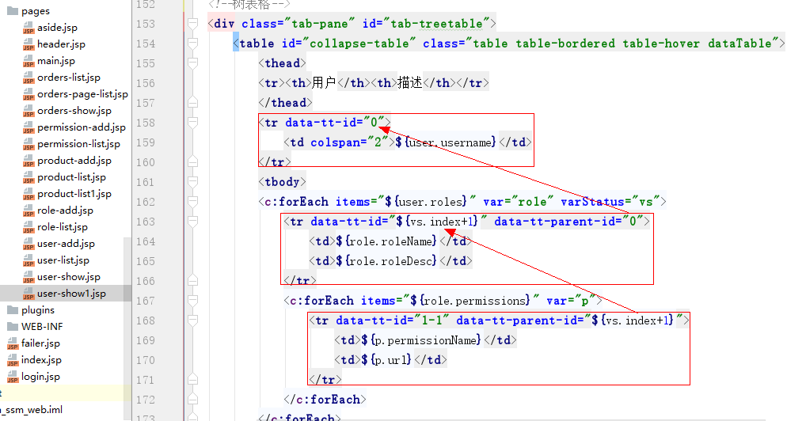
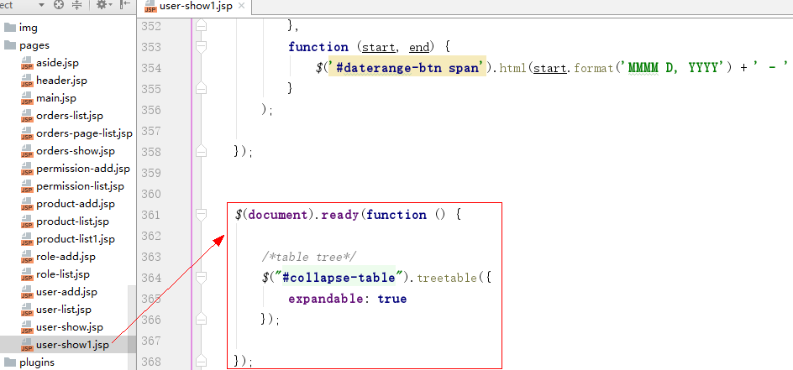
<!--树表格-->
<div class="tab-pane" id="tab-treetable">
<table id="collapse-table" class="table table-bordered table-hover dataTable">
<thead>
<tr><th>用户</th><th>描述</th></tr>
</thead>
<tr data-tt-id="0">
<td colspan="2">${user.username}</td>
</tr>
<tbody>
<c:forEach items="${user.roles}" var="role" varStatus="vs">
<tr data-tt-id="${vs.index+1}" data-tt-parent-id="0">
<td>${role.roleName}</td>
<td>${role.roleDesc}</td>
</tr>
<c:forEach items="${role.permissions}" var="p">
<tr data-tt-id="1-1" data-tt-parent-id="${vs.index+1}">
<td>${p.permissionName}</td>
<td>${p.url}</td>
</tr>
</c:forEach>
</c:forEach>
</tbody>
</table>
</div>
<!--树表格/-->

$(document).ready(function () {
/*table tree*/
$("#collapse-table").treetable({
expandable: true
});
});

9、角色操作-查询所有角色流程分析
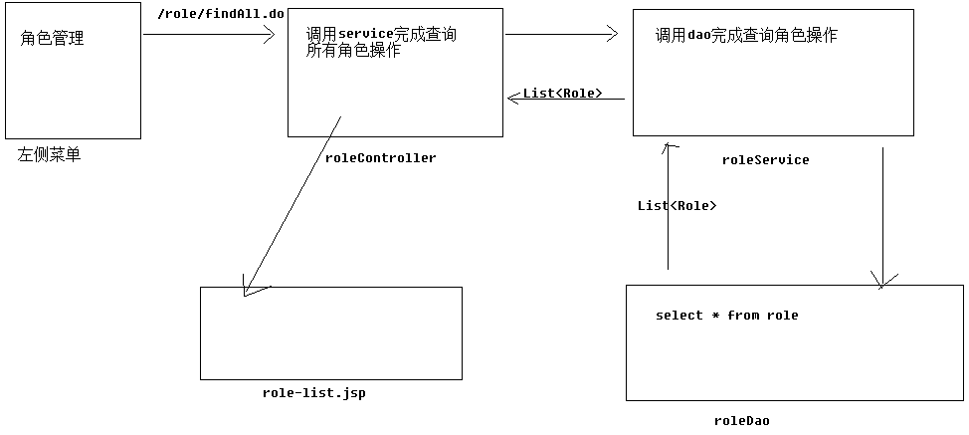

10、角色操作-查询所有角色代码实现
- Dao层代码
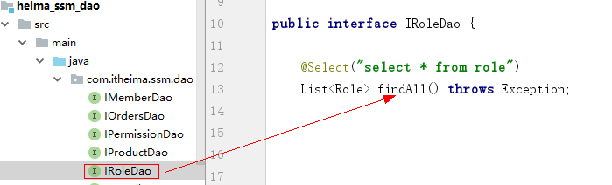
public interface IRoleDao {
@Select("select * from role")
List<Role> findAll() throws Exception;
}
- service层代码
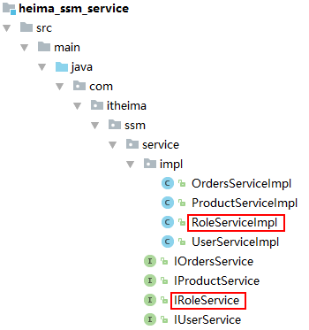
public interface IRoleService {
public List<Role> findAll() throws Exception;
}
@Service
public class RoleServiceImpl implements IRoleService {
@Autowired
private IRoleDao roleDao;
@Override
public List<Role> findAll() throws Exception{
return roleDao.findAll();
}
}
- web层代码
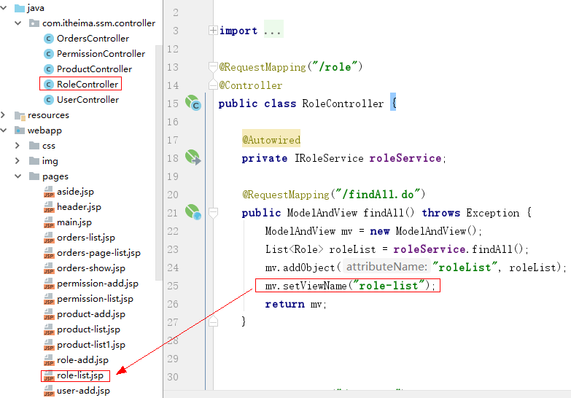
@RequestMapping("/role")
@Controller
public class RoleController {
@Autowired
private IRoleService roleService;
@RequestMapping("/findAll.do")
public ModelAndView findAll() throws Exception {
ModelAndView mv = new ModelAndView();
List<Role> roleList = roleService.findAll();
mv.addObject("roleList", roleList);
mv.setViewName("role-list");
return mv;
}
}

11、角色操作-角色添加流程分析
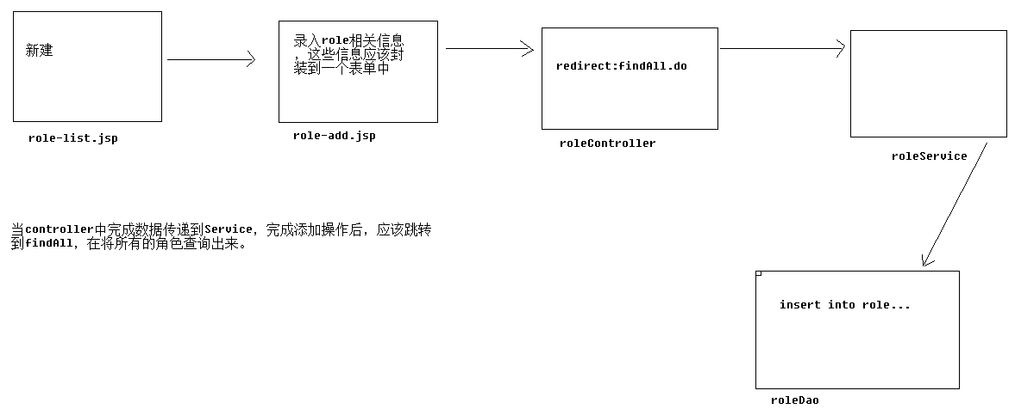

12、角色操作-角色添加代码实现
1、dao层代码
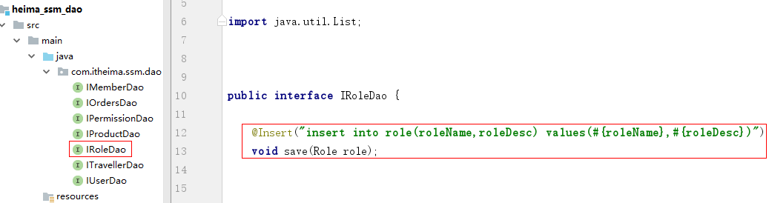
public interface IRoleDao {
@Insert("insert into role(roleName,roleDesc) values(#{roleName},#{roleDesc})")
void save(Role role);
}
2、service层代码
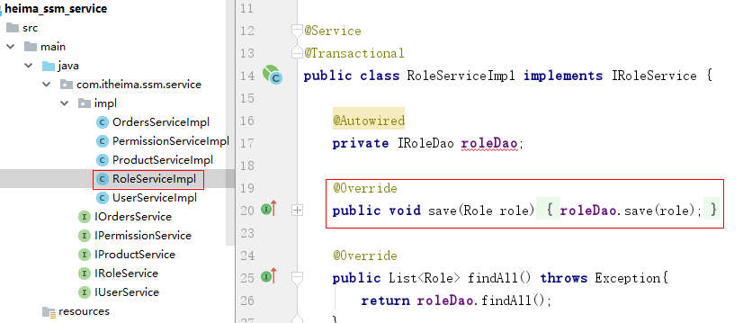
public interface IRoleService {
public List<Role> findAll() throws Exception;
void save(Role role) throws Exception;
}

@Service
public class RoleServiceImpl implements IRoleService {
@Autowired
private IRoleDao roleDao;
@Override
public void save(Role role) {
roleDao.save(role);
}
@Override
public List<Role> findAll() throws Exception{
return roleDao.findAll();
}
}

- web层代码
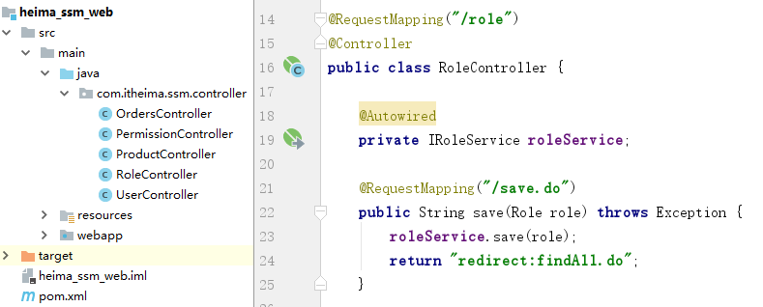
@RequestMapping("/role")
@Controller
public class RoleController {
@Autowired
private IRoleService roleService;
@RequestMapping("/save.do")
public String save(Role role) throws Exception {
roleService.save(role);
return "redirect:findAll.do";
}
}

13、资源权限操作-查询所有资源权限
1、Dao层代码
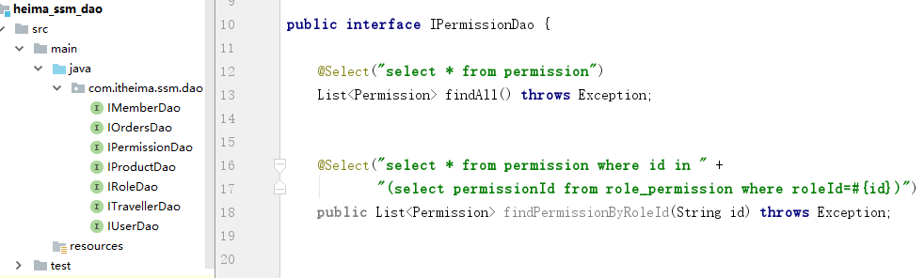
public interface IPermissionDao {
@Select("select * from permission")
List<Permission> findAll() throws Exception;
}
2、Service层代码
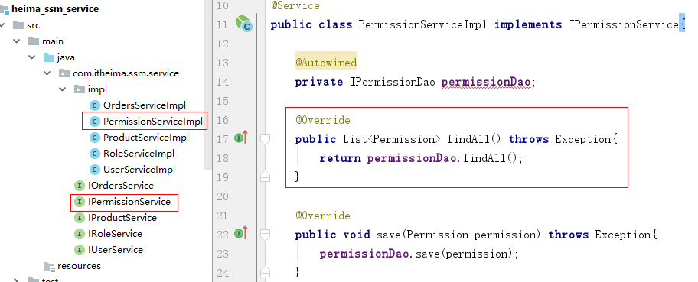
public interface IPermissionService {
public List<Permission> findAll() throws Exception;
}
@Service
public class PermissionServiceImpl implements IPermissionService{
@Autowired
private IPermissionDao permissionDao;
@Override
public List<Permission> findAll() throws Exception{
return permissionDao.findAll();
}
}
- web层代码
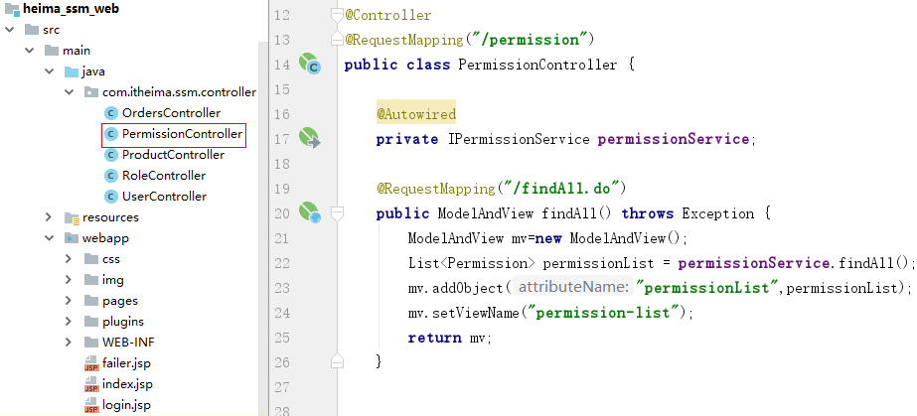
@Controller
@RequestMapping("/permission")
public class PermissionController {
@Autowired
private IPermissionService permissionService;
@RequestMapping("/findAll.do")
public ModelAndView findAll() throws Exception {
ModelAndView mv=new ModelAndView();
List<Permission> permissionList = permissionService.findAll();
mv.addObject("permissionList",permissionList);
mv.setViewName("permission-list");
return mv;
}
}

14、资源权限操作-添加资源权限
1、Dao层代码
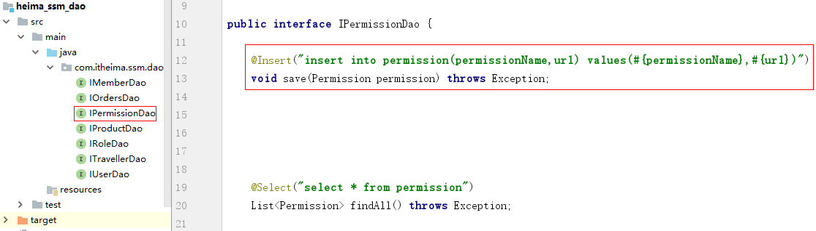
public interface IPermissionDao {
@Insert("insert into permission(permissionName,url) values(#{permissionName},#{url})")
void save(Permission permission) throws Exception;
}
2、Service层代码
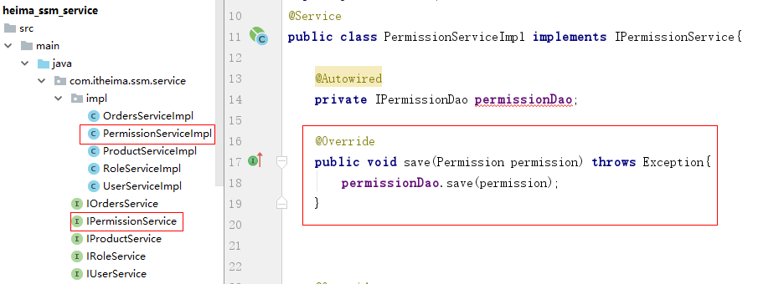
public interface IPermissionService {
public List<Permission> findAll() throws Exception;
void save(Permission permission) throws Exception;
}
@Service
public class PermissionServiceImpl implements IPermissionService{
@Autowired
private IPermissionDao permissionDao;
@Override
public void save(Permission permission) throws Exception{
permissionDao.save(permission);
}
}
- web层代码
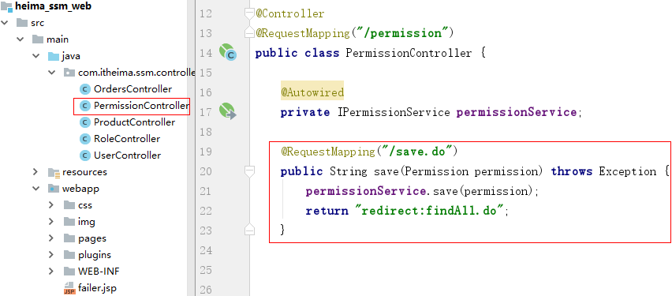
@Controller
@RequestMapping("/permission")
public class PermissionController {
@Autowired
private IPermissionService permissionService;
@RequestMapping("/save.do")
public String save(Permission permission) throws Exception {
permissionService.save(permission);
return "redirect:findAll.do";
}
}

