一、环境准备

1、创建用户与授权
--1.创建表空间

create TABLESPACE ssm_tabespace
DATAFILE 'ssm.dbf'
SIZE 10m AUTOEXTEND ON NEXT 10k;
---2.创建用户

create user ssm
identified by ssm;

---3.授权
GRANT dba to ssm;

2、导入数据库数据
ssm.sql

3、创建多模块的maven聚合工程

4、创建domain模块编写实体类
public class Product {
private String id; // 主键
private String productNum; // 编号 唯一
private String productName; // 名称
private String cityName; // 出发城市
private Date departureTime; // 出发时间
private String departureTimeStr;
private double productPrice; // 产品价格
private String productDesc; // 产品描述
private Integer productStatus; // 状态 0 关闭 1 开启
private String productStatusStr;
}

5、创建dao模块编写持久层接口
public interface IProductDao {
@Select("select * from product")
List<Product> findAll() throws Exception;
}

6、创建service模块编写业务层接口
public interface IProductService {
List<Product> findAll() throws Exception;
}

二、SSM整合与产品查询

1、Spring管理持久层(与MyBatis整合)
Spring配置文件applicationContext-dao.xml
1、连接池配置
2、配置SqlSessionFactoryBean(由Spring创建SqlSessionFactory)
3、配置MapperScannerConfigurer(自动扫描所有Dao接口生成Mapper代理)

2、Spring管理业务层
Spring配置文件applicationContext-service.xml ，
1、注解扫描业务层

2、使用注解配置业务层

@Service
public class ProductServiceImpl implements IProductService{
@Override
public List<Product> findAll() throws Exception {
return null;
}
}

3、配置Spring的声明式事务管理

3、Spring管理web层(MVC 环境搭建)
1、web.xml配置Spring MVC核心控制器及解决中文乱码过滤器

2、配置文件springmvc.xml

3、编写Controller

@Controller
@RequestMapping("/product")
public class ProductController {
@Autowired
private IProductService productService;
@RequestMapping("/findAll.do")
public ModelAndView findAll() {
return null;
}
}

4、Spring整合dao,service,web层
<!-- 配置加载类路径的配置文件 -->
<context-param>
<param-name>contextConfigLocation</param-name>
<param-value>classpath*:applicationContext*.xml</param-value>
</context-param>
<!-- 配置监听器 -->
<listener>
<listener-class>org.springframework.web.context.ContextLoaderListener</listener-class>
</listener>

5、完善代码及页面显示
1、copy adminLTE资源
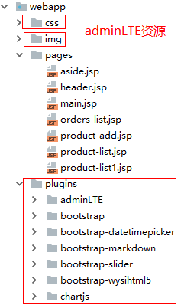

2、copy请求发起页面 index.jsp
<%@ page language="java" contentType="text/html; charset=UTF-8"
pageEncoding="UTF-8"%>
<!DOCTYPE html PUBLIC "-//W3C//DTD HTML 4.01 Transitional//EN"
"http://www.w3.org/TR/html4/loose.dtd">
<html>
<head>
<meta http-equiv="Content-Type" content="text/html; charset=UTF-8">
<title>主页</title>
</head>
<body>
<a href="${pageContext.request.contextPath}/product/findAll">查询产品信息</a>
</body>
</html>

3、copy显示产品页面 product-list.jsp
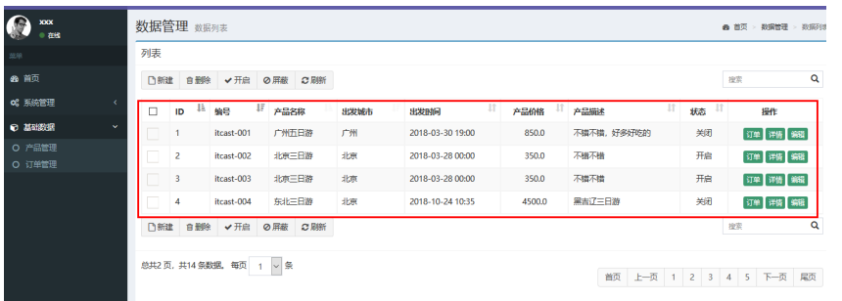
4、完善代码
@Controller
@RequestMapping("/product")
public class ProductController {
@Autowired
private IProductService productService;
@RequestMapping("/findAll")
public ModelAndView findAll() throws Exception {
ModelAndView mv = new ModelAndView();
List<Product> products = productService.findAll();
mv.addObject("productList", products);
mv.setViewName("product-list");
return mv;
}
}

三、商品添加
1、copy商品添加页面 product-add.jsp

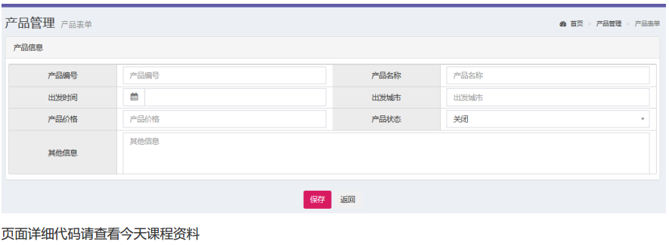

2、Controller

@Controller
@RequestMapping("/product")
public class ProductController {
@Autowired
private IProductService productService;
//产品添加
@RequestMapping("/save.do")
public String save(Product product) throws Exception {
productService.save(product);
return "redirect:findAll.do";
}
}

3、Dao
@Insert("insert into product(productNum,productName,cityName,departureTime,productPrice,productDesc,productStatus) values(#{productNum},#{productName},#{cityName},#{departureTime},#{productPrice},#{productDesc},#{productStatus})")
void save(Product product);
4、日期类型转换问题解决,三种方式 ,推荐使用

实体类中加日期格式化注解

@DateTimeFormat(pattern="yyyy-MM-dd HH:mm")
private Date creationTime;

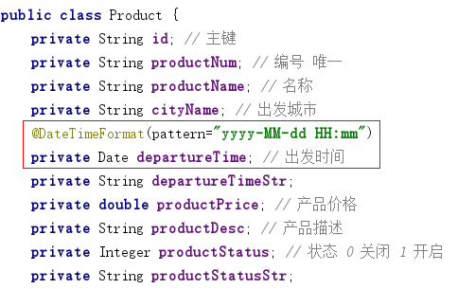

四、SSM订单操作
1、订单表信息描述 orders

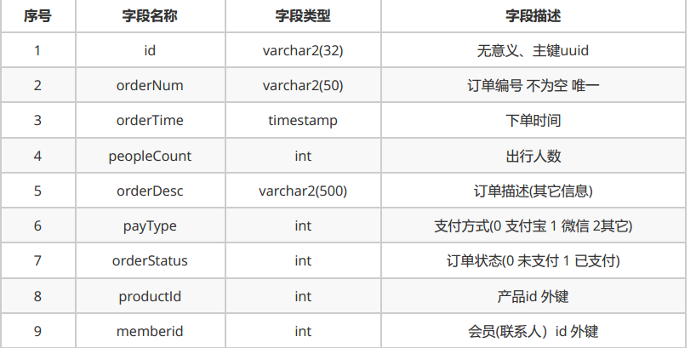
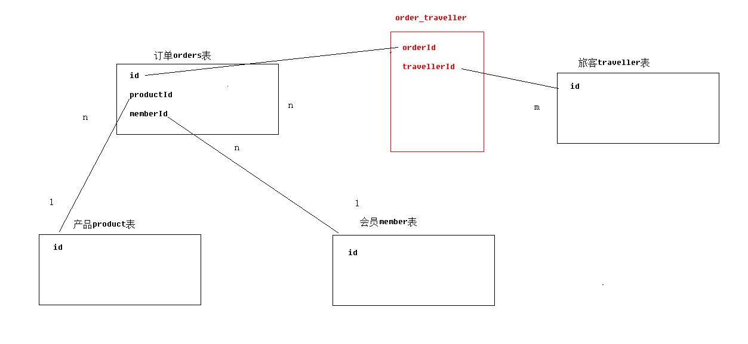
CREATE TABLE orders(
id varchar2(32) default SYS_GUID() PRIMARY KEY,
orderNum VARCHAR2(20) NOT NULL UNIQUE,
orderTime timestamp,
peopleCount INT,
orderDesc VARCHAR2(500),
payType INT,
orderStatus INT,
productId varchar2(32),
memberId varchar2(32),
FOREIGN KEY (productId) REFERENCES product(id),
FOREIGN KEY (memberId) REFERENCES member(id)
)
2、实体类
public class Orders {
private String id;
private String orderNum;
private Date orderTime;
private String orderTimeStr;
private int orderStatus;
private String orderStatusStr;
private int peopleCount;
private Product product;
private List<Traveller> travellers;
private Member member;
private Integer payType;
private String payTypeStr;
private String orderDesc;
}
public class Member {
private String id;
private String name;
private String nickname;
private String phoneNum;
private String email;
//省略getter/setter
}

public class Traveller {
private String id;
private String name;
private String sex;
private String phoneNum;
private Integer credentialsType;
private String credentialsTypeStr;
private String credentialsNum;
private Integer travellerType;
private String travellerTypeStr;
//省略getter/setter
}
3、Dao

public interface IOrdersDao {
@Select("select * from orders")
@Results({
@Result(id=true,property = "id",column = "id"),
@Result(property = "orderNum",column = "orderNum"),
@Result(property = "orderTime",column = "orderTime"),
@Result(property = "orderStatus",column = "orderStatus"),
@Result(property = "peopleCount",column = "peopleCount"),
@Result(property = "peopleCount",column = "peopleCount"),
@Result(property = "payType",column = "payType"),
@Result(property = "orderDesc",column = "orderDesc"),
@Result(property = "product",column = "productId",javaType = Product.class,one = @One(select = "com.itheima.ssm.dao.IProductDao.findById")),
})
public List<Orders> findAll() throws Exception;
}

public interface IProductDao {
//根据id查询产品
@Select("select * from product where id=#{id}")
public Product findById(String id) throws Exception;
}
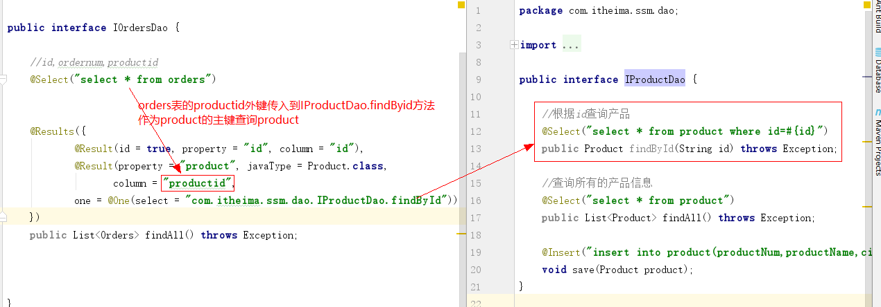

4、OrdersServiceImpl

public class OrdersServiceImpl implements IOrdersService {
@Autowired
private IOrdersDao ordersDao;
@Override
public List<Orders> findAll() throws Exception{
return ordersDao.findAll();
}
}
5、OrdersController

@Controller
@RequestMapping("/orders")
public class OrdersController {
@Autowired
private IOrdersService ordersService;
@RequestMapping("/findAll.do")
public ModelAndView findAll() throws Exception {
ModelAndView mv=new ModelAndView();
List<Orders> ordersList = ordersService.findAll();
mv.addObject("ordersList",ordersList);
mv.setViewName("orders-list");
return mv;
}
}

6、copy订单查询页面 order-list.jsp显示

五、订单分页查询

PageHelper使用

1、在 pom.xml 中添加如下依赖：
<dependency>
<groupId>com.github.pagehelper</groupId>
<artifactId>pagehelper</artifactId>
<version>5.1.2</version>
</dependency>

2、在 Spring 配置文件中配置拦截器插件
<bean id="sqlSessionFactory" class="org.mybatis.spring.SqlSessionFactoryBean">
<property name="dataSource" ref="dataSource"/>
<!-- 传入PageHelper的插件 -->
<property name="plugins">
<array>
<!-- 传入插件的对象 -->
<bean class="com.github.pagehelper.PageInterceptor">
<property name="properties">
<props>
<prop key="helperDialect">oracle</prop>
<prop key="reasonable">true</prop>
</props>
</property>
</bean>
</array>
</property>
</bean>

helperDialect ：分页插件会自动检测当前的数据库链接，自动选择合适的分页方式。 你可以配置
helperDialect 属性来指定分页插件使用哪种方言。配置时，可以使用下面的缩写值：
oracle , mysql , mariadb , sqlite , hsqldb , postgresql , db2 , sqlserver , informix , h2 , sqlserver201

reasonable ： 分页合理化参数，默认值为 false 。当该参数设置为 true 时， pageNum<=0 时会查询第一页， pageNum>pages （超过总数时），会查询最后一页。默认 false 时，直接根据参数进行查询

3、PageHelper.startPage 静态方法调用
public class OrdersServiceImpl implements IOrdersService {
@Autowired
private IOrdersDao ordersDao;
@Override
public List<Orders> findAll(int page, int size) throws Exception {
//参数pageNum 是页码值 参数pageSize 代表是每页显示条数
PageHelper.startPage(page, size);
return ordersDao.findAll();
}
、}
Controller改造

@RequestMapping("/findAll.do")
public ModelAndView findAll(@RequestParam(name = "page", required = true, defaultValue = "1") int page, @RequestParam(name = "size", required = true, defaultValue = "4") int size) throws Exception {
ModelAndView mv = new ModelAndView();
List<Orders> ordersList = ordersService.findAll(page, size);
//PageInfo就是一个分页Bean
PageInfo pageInfo=new PageInfo(ordersList);
mv.addObject("pageInfo",pageInfo);
mv.setViewName("orders-page-list");
return mv;
}

订单分页查询页面order-list.jsp页面改造

1、菜单页面改造
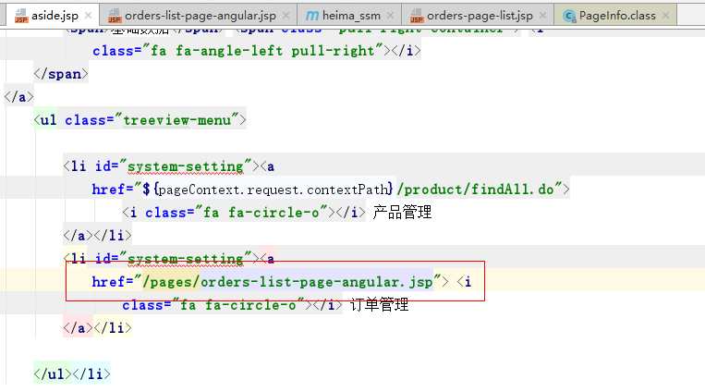
2、返回分页的json数据
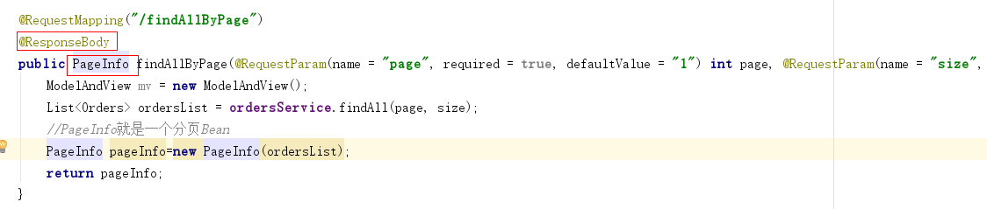
3、引入angularjs插件
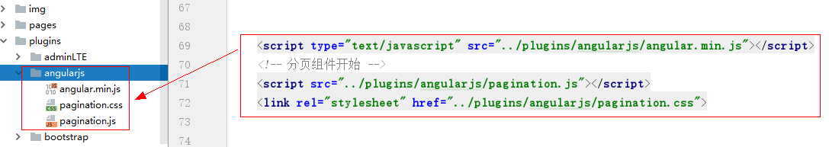

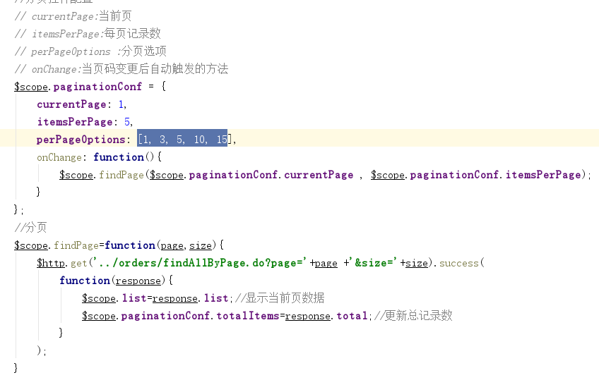

4、页面分页角标
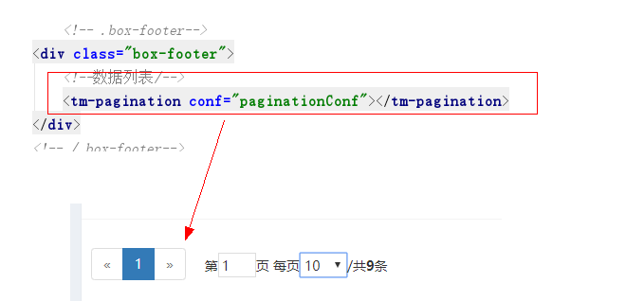

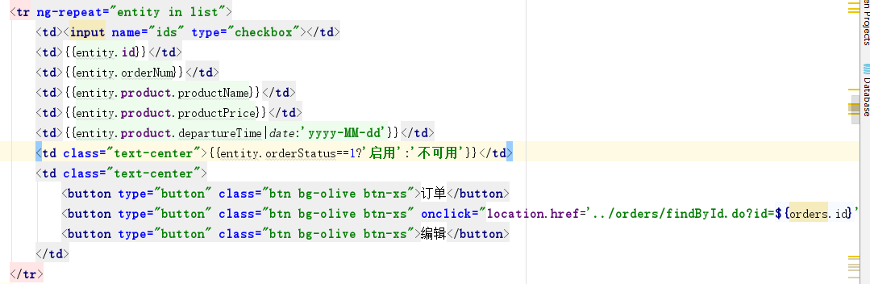

<a ng-href="../orders/findById.do?id={{entity.id}}" class="btn bg-olive btn-xs">详情</a>

