The files within this directory are for my Masters Thesis. I am writing a software package using Python and QGIS that will locate suitable study areas for my project. The .py script is having issues where Group 2 is returning non-zero values where it should return all zero values. I have included the .m script that I wrote last semester which works correctly, then encountered errors in the translation from MatLab to Python.

The process starts with loading geologic maps, land cover, and elevation layers into QGIS. A Python script that is still in early development performs the initial site suitability. Geologic maps, land cover, and elevation data are loaded into QGIS. Carbonate, mafic, and felsic rocks are buffered by 5 km, the buffers are intersected, and then the intersect is buffered again by 5 km to locate areas where the rocks are in close proximity. Within that window, land cover data is extracted, reclassified to simplify vegetative type, and developed areas are buffered by distances suitable to development intensity and eliminated. The remaining undeveloped land is analyzed for heterogeneity, and only areas of uniform vegetative cover are retained. Within the same window, stream locations are calculated using hydrology tools and only headwater streams are retained as polyline file types. The rock types are then buffered again by 2 km, the buffers intersected, and the intersect buffered again. The larger window is used to reduce edge effects for the hydro calculations, then the small window is used for final analysis as I am interested in areas with the rocks as close to each other as possible. The streamlines are clipped by the small window and converted to a series of points. The points are sampled against the elevation data to add and elevation column to the attribute table and exported as a .xls file and loaded into a Python script for elevation processing, as I need points at self-similar elevations across the three rock types.

*Figure 1. Example of stream locations within a study site. The blue, green, and purple shaded areas represent carbonate, mafic, and felsic regions respectively. The cross-hatched area demarcates uniform undeveloped land cover within 2 km of the intersection of the 3 rock types. Dots represent points along the stream which lie within the elevation window. Data created by hand in ArcMap, elevation processed in MatLab.*

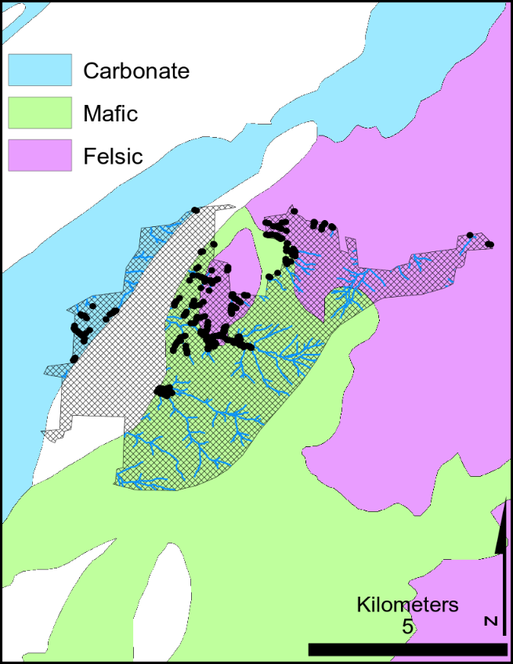

The standalone Python script calculates hypsometric curves with 10 m elevation bins for each of the three rock types within each site located by the QGIS process. Within a site, the hypsometries are multiplied against each other, so that only elevation bins with non-zero values are retained, if one rock type has a zero in that bin, then the intersect shows a zero in that bin, indicating that the elevation is not useful. The min and max elevation of the non-zero bins are returned, and the usable elevation window is defined as that range. All points with elevaion window are selected, given new unique ObjectIDs and StreamIDs, and exported as .csv files. The .csv files are loaded back into QGIS to create a site map as in Figure 1.