There have been numerous studies published previously investigating interaction effects between temperature and air pollution but they lack consistency in temperature definition, modeling approach and actual findings

"C:\Users\wgodwin\Desktop\thesis\Gasparrini_slides_background.pdf"

Input data notes:

* Of the 16 districts, 12 of the districts have some weather station that takes measurements.
* Missing any kind of pollutant measurement for 4747 of 5484 total admin2/days in 1998
  + 4712/5451 for 1999
  + 4779/5532 for 2000
  + 4103/5974 in 2014
  + 1437/5657
  + Seems to be due to a few weather stations consistently not reporting but actually not too sure of that. Partially due to fact that I’m merging on all 16 admin 2s when the pollutant variables are only in 12 of the admin2s
* Temperature measurements seem to happen every day (ie very little temporal missingness)
* Substantial missingness for PM 2.5 measurements (22063 not missing vs 3520 missing)

<https://www.ncbi.nlm.nih.gov/pubmed/8916289> - looks at ozone/mortality in mexico city

**Abstract**

This study sought to investigate the relationship between temperature and all-cause mortality in Mexico City from 1998-2016. Additionally, we investigated potential interactive effects of air pollution, specifically ozone concentration and particulate matter less than 2.5 microns in diameter (PM 2.5), on the temperature-mortality relationship and vice versa. Generalized additive models (GAMs) were employed to characterize these relationship and interactions. The initial model assessed the main effects of both temperature and air pollution on mortality, generating a two-dimensional response surface. Subsequent models iterated through combinations of temperature, ozone, and PM 2.5 variables as categorical variables, assessing beta coefficients across the categories for each exposure variable. Talk about results and draw inferences

**Intro**

Ambient particulate matter pollution killed ____ million people in 2017 around the world. Many types of air pollution, including ozone and particulate matter less than 2.5 microns in diameter (PM 2.5), are well established risk factors, linked to outcomes including cardiovascular disease, respiratory illness, and ocular disease (cite). As low and middle income countries industrialize and grow economically, these populations will likely face rising exposure to air pollution due to increased carbon and nitrogen emissions. Rapidly developing urban areas in particular, with dense population and concentrated sources of pollution, will face the greatest challenges in reducing air pollution-related death and disease. Mexico City, the most populous city in North America with __ million people according to the 2015 census, has had immense economic growth alongside steady rise in air pollution in the last few decades. The range of air pollution exposure experienced by Mexico City residents is a motivating factor to conduct this study.

Ambient temperature has been linked to mortality numerous times preciously.

**Methods**

Full time series from 1998-2016 of ozone, PM 2.5 concentration, and temperature variables were downloaded from BLAH. The data were subsetted to only include weather stations located in municipalities of Mexico City. For days were missing from the full time series for a given location in the mortality database, those days were assumed to have 0 deaths. For days missing from the environmental variables database, those days were added to the dataset but the values remained missing.

**Results**

*Environmental variable Missingness (spatial and temporal)*

Pollutant data was available for 14 of the 16 municipalities in Mexico City. However, before 2011, only 6 municipalities had weather stations reporting pollutant data.

**Discussion**

*Limitations*

Extensive data missingness. The assumption that 0 deaths occurred on days missing from the mortality database could have introduced bias. Other approaches could involve data imputation techniques to fill in missing data for environmental variables. Maybe there are only operating weather stations in wealthier municipalities, biasing our sample of Mexico city. Sensitivity analysis looking at just post 2011 data?

*Future directions*

Assess the role that humidity plays when defining temperature since the effect of temperature on mortality is known to be modified by humidity.

Figures:

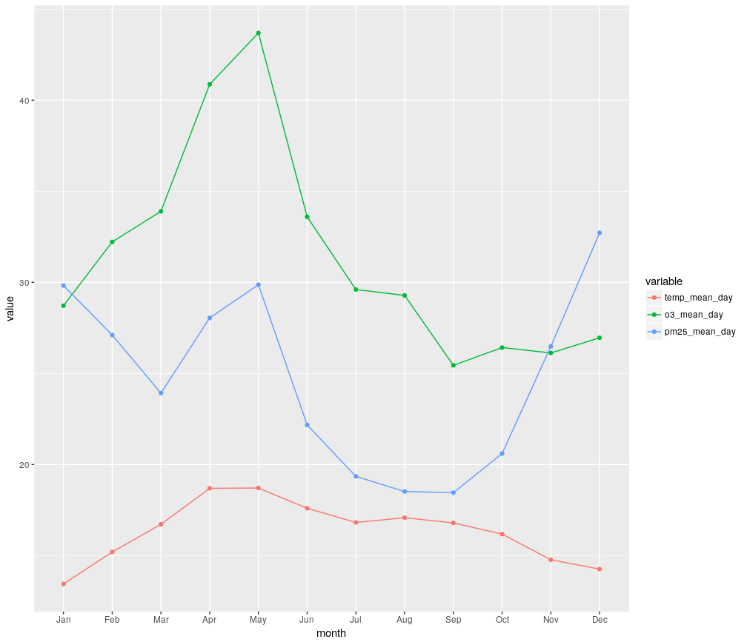

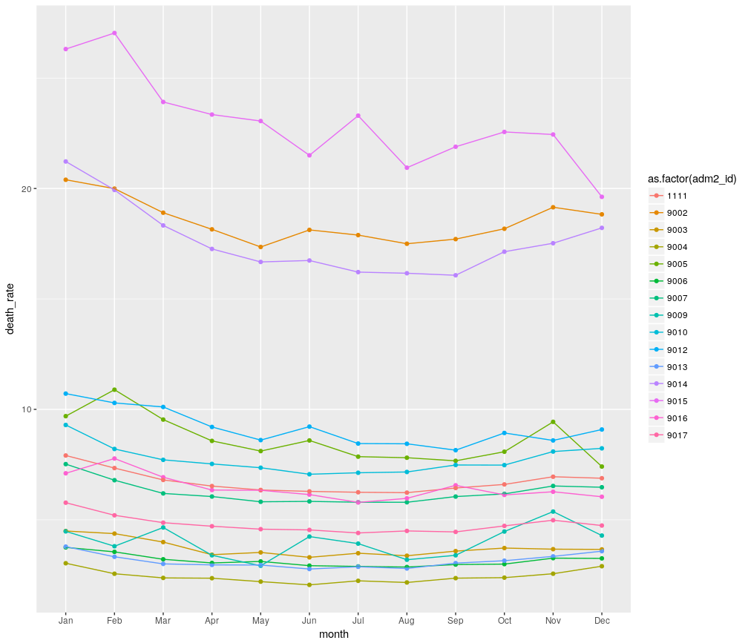

Maybe just include the mean death rate on one y axis and the environmental variables on the other y-axis.

