Day04 Templates 03

part 1 – Install JWT and create User Collection

1. Copy the folder called **Day04-Deployment-01** from **Day04** paste it and rename it to **Day04-Templates-03**.
2. Run **mpn install** **FIRST** on the new folder then run the following command to install Pug

**npm install pug --save**

1. Let the Express app know that we will be using Pug by using the set() method. This is done in the http_server.js file

|  |
| --- |
| **const port = 8000;**  **const app = express();**  **app.use(bodyParser.urlencoded({extended:false}));**  **app.set('view engine', 'pug');**  **const router = express.Router();**  **const routes = require('./routes/routes');** |

1. Express expects that a **views** folder exists which will store all the templates, so create that folder now and inside of that folder create a text file named **layout** with a file extension of .**pug** (so the name of the file is layout.pug)
2. Start building the layout inside of layout.pug using similar syntax to HTML

|  |
| --- |
| **html**  **head**  **title**  **body**  **header**  **h1**  **nav**  **ul**  **li**  **a(href='index.html') home**  **div#container**  **block content**  **footer** |

1. Add some content so that we can test this layout.pug file

|  |
| --- |
| **doctype html**  **html**  **head**  **title Skillsoft Weight Tracker**  **body**  **header**  **h1**  **a(href='index.html') Skillsoft Weight Tracker**  **nav**  **ul**  **li**  **a(href='index.html') home**  **div#container**  **block content**  **footer**  **hr**  **| Copyright 2019. All rights reserved** |

1. Create a new route in routes.js to point to a pug test

|  |
| --- |
| **app.route('/updatedoc').put(controller. updatedoc);**  **app.route('/getbyformname').post(controller.getbyformname);**  **app.route('/pugtest').get(controller.pugtest);**  **//**  **};** |

1. Then in the controllers.js file, add a method to handle this test route, just copy the **aboutus** function and comment the code that’s already there:

|  |
| --- |
| **//**  **exports.pugtest=function(req, res){**  **//res.send('You are on the about us route.');**    **};** |

1. Now simply call the *render* method instead of the *send* method and pass in the name of the pug file (without the .pug extension)

|  |
| --- |
| **exports.pugtest=function(req, res){**  **//res.send('You are on the about us route.');**  **res.render(**  **'layout'**  **)**  **};** |

1. Test the template by navigating to the route  
     
    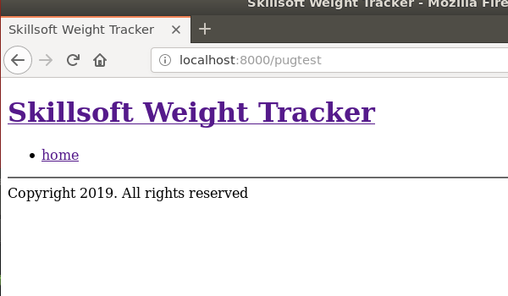

part 2 – completing the pug Layout template

1. Complete the layout template to include the entire navigation, css and script tags

|  |
| --- |
| **doctype html**  **html**  **head**  **title Skillsoft Weight Tracker**  **link(rel='stylesheet', type='text/css', href='styles/styles.css')**  **body**  **header**  **h1**  **a(href='index.html') Skillsoft Weight Tracker**  **nav**  **ul**  **li**  **a(href='index.html') home**  **li**  **a(href='enterweight.html') enter weight**  **li**  **a(href='myweights.html') my weight**  **li**  **a(href='teamweights.html') team weights**  **li**  **a(href='winnerloser.html') winner/loser**  **div#container**  **block content**  **footer**  **hr**  **| Copyright 2019. All rights reserved**  **script(src='scripts/scripts.js')** |

Test the layout route again. Note, angular.js will give an error, but we will fixt this.

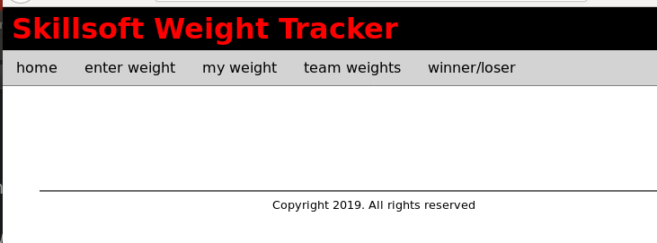

1. In order to demonstrate how this layout will be helpful, we would now simulate the creation of a new web page for our website. We will create a new .pug file in the views folder and call it pugtest.pug for now. When we create new pages from now on, we simply include the wrapper or layout template by extending it.

|  |
| --- |
| **extends layout** |

1. Change the controller.js function call to point to pugtest.pug. Also remove the commented line.

|  |
| --- |
| **exports.pugtest=function(req, res){**  **res.render(**  **'pugtest'**  **)**  **};** |

This will produce something like this:  
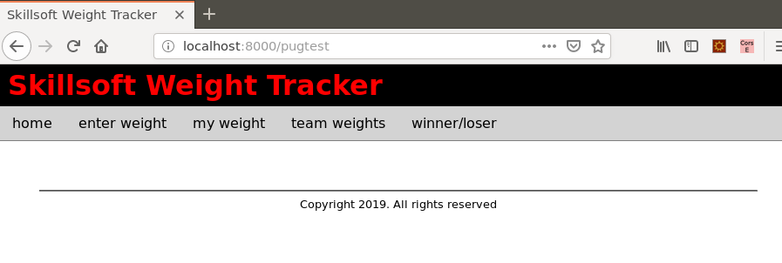

1. Remember the template had a block content area, this is where we insert new content, for example take a look at this next bit of code in the browser

|  |
| --- |
| **extends layout**  **block content**  **p Hello from Skillsoft** |

This would produce the following image  
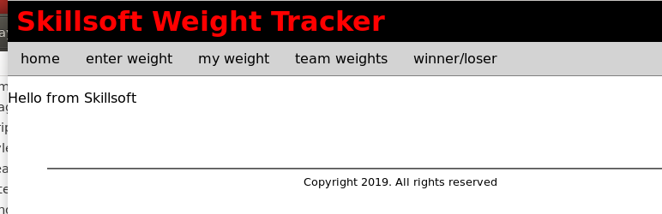

1. Now all we have to do is build our page, but for this example we will simply borrow a page we already have, the teamweights.html page content. Since this page depends heavily on the AngularJS CDN, include it in the appropriate places, both in the layout.pug file as well as any new pages we build. First amend the layout.pug file to include the appropriate AngularJS directives:

|  |
| --- |
| **doctype html**  **html**  **head**  **title Skillsoft Weight Tracker**  **link(rel='stylesheet', type='text/css', href='styles/styles.css')**  **<script src="https://ajax.googleapis.com/ajax/libs/angularjs/1.7.5/angular.min.js"></script>**  **body(ng-app="SkillsApp")**  **header**  **h1** |

1. Now include AngularJS directives in the appropriate places in the new file being built, so pugtest.pug.

|  |
| --- |
| **extends layout**  **block content**  **main(ng-controller="Weights")**  **h2 Showing records for team** |

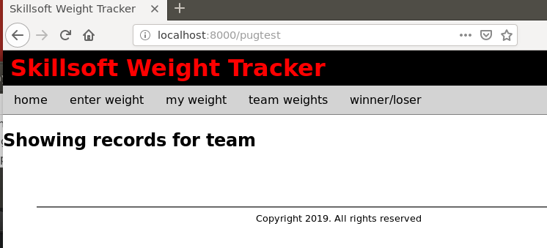

1. Now we are in a position to including the repeating lines, remember spacing and refer to the documentation for specific situations

|  |
| --- |
| **extends layout**  **block content**  **main(ng-controller="Weights")**  **h2 Showing records for team**  **div#showRecords**  **div#records(ng-repeat="emp in allWeights").**  **{{$index + 1}} {{emp.empName}} weighed in at {{emp.empWeight}} Kgs** |

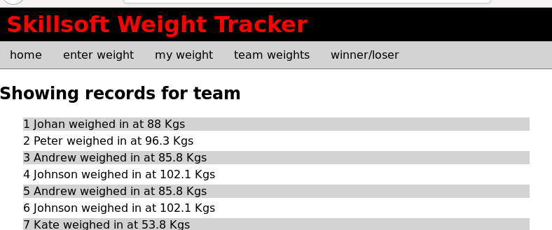

part 3 – Including the Aside

1. Just like we built the layout and other web pages with template we can also put the **aside** area of the page into a template, call it aside.pug

|  |
| --- |
| **aside**  **section**  **h4 Health News**  **p**  **| Lorem ipsum dolor sit amet, consectetur adipiscing elit, sed do eiusmod tempor incididunt ut labore et dolore magna aliqua.**  **section**  **h4 Healthy Recipes**  **a(href='') grilled chicken**  **a(href='') minced beef patties**  **a(href='') potato pancakes**  **a(href='') fish stew** |

1. Now we can simply include the aside into our pug test page

|  |
| --- |
| **extends layout**  **block content**  **main(ng-controller="Weights")**  **h2 Showing records for team**  **div#showRecords**  **div#records(ng-repeat="emp in allWeights").**  **{{$index + 1}} {{emp.empName}} weighed in at {{emp.empWeight}} Kgs**  **include includes/aside** |

