Tools to Clip MP3 Audio Files
Here are some effective options to clip your MP3 audio files:

Online Tools:
- AudioTrimmer: Simple and user-friendly, with a focus on trimming.
1. Audio Trimmer | Wave.video

wave.video
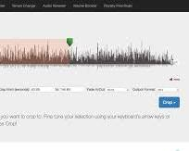 Opens in a new window audiotrimmer.com
AudioTrimmer website
- Clideo: Offers high-quality output and additional features like ringtone making.
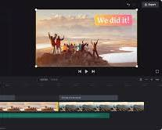 Opens in a new window clideo.com
Clideo website
- VEED: Provides more advanced editing options beyond clipping, like splitting and merging.
 Opens in a new window podcastingresourcesguide.com
VEED website
- Media.io: Supports various audio formats and offers features like fade-in/out.
 Opens in a new window www.youtube.com
Media.io website

Desktop Software:
- Audacity: Free, open-source, and powerful audio editor with extensive features.
1. Audacity - Lane Community College

inside.lanecc.edu
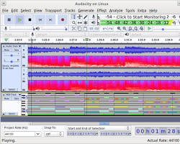 Opens in a new window www.softwareadvice.com
Audacity software
- Adobe Audition: Professional-grade software with advanced editing capabilities.
1. Adobe Audition - Audio recording and editing software

www.adobe.com
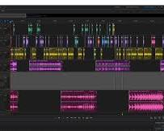 Opens in a new window www.thepodcasthost.com
Adobe Audition software

Mobile Apps:
- MP3 Cutter: User-friendly app with basic editing features.
1. Mp3 Cutter - M4a, Music Cutter on the App Store

apps.apple.com
 Opens in a new window play.google.com
MP3 Cutter app
Choosing the right tool depends on your specific needs:
- Quick and simple trimming: Online tools like AudioTrimmer or Clideo are ideal.
- Advanced editing: Audacity or Adobe Audition offer more control and features.
- On-the-go editing: Mobile apps like MP3 Cutter are convenient.
Additional tips:
- Preview your clip before saving to ensure accuracy.
1. MP3 Trimmer - Chrome Web Store

chromewebstore.google.com
- Consider audio quality when choosing an output format.
- Experiment with different tools to find the one that best suits your workflow.

