Self-Service Analytics

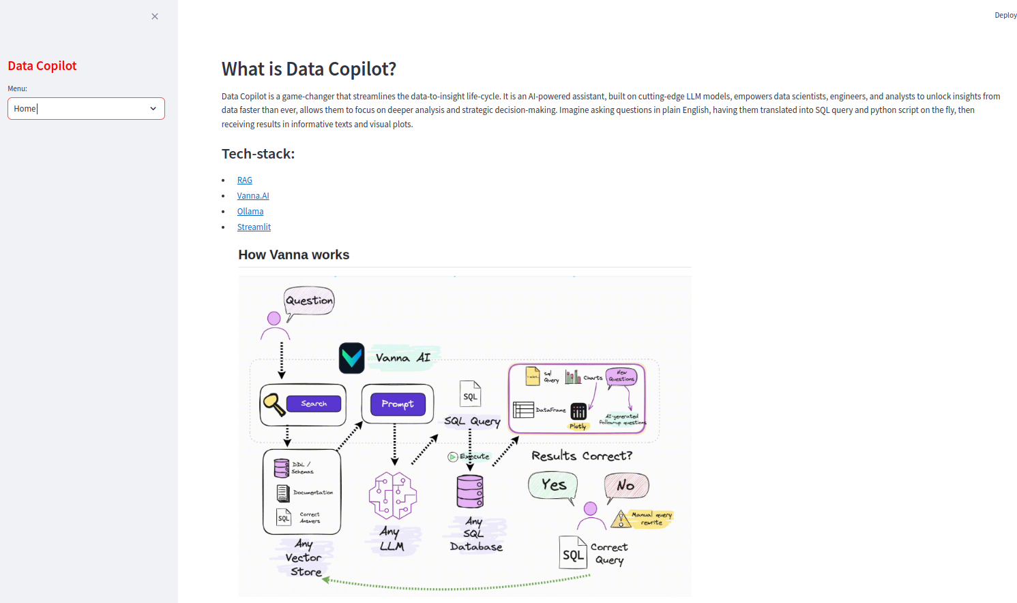

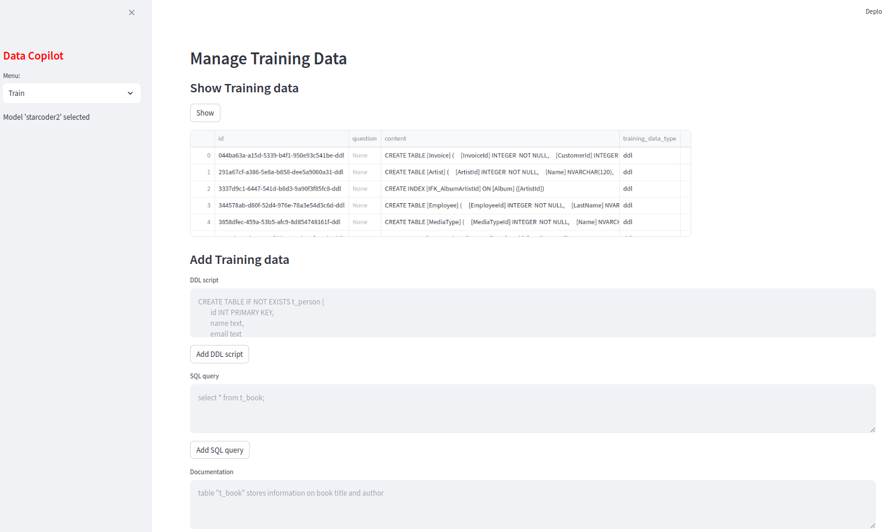

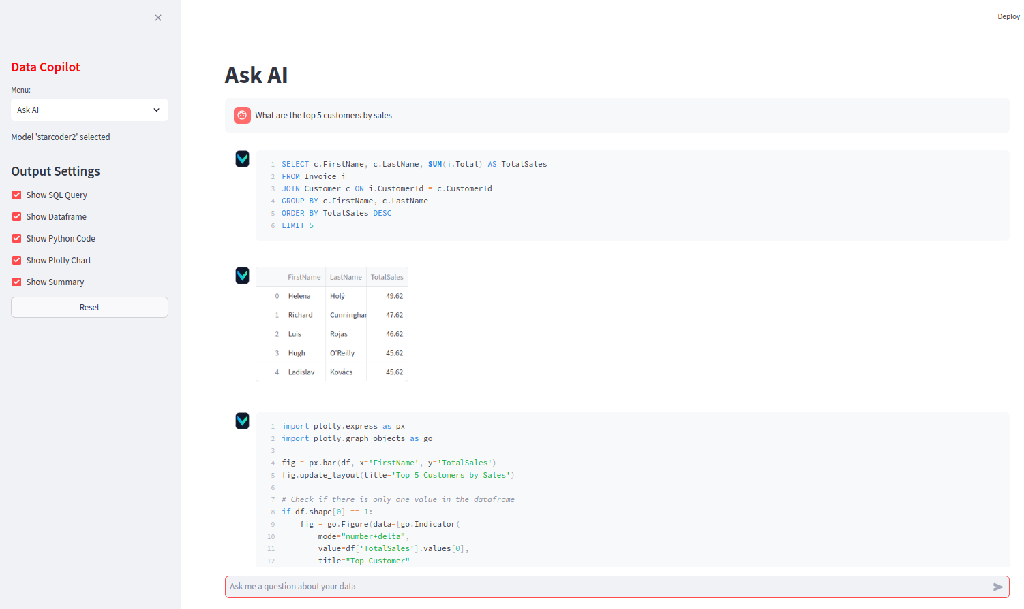

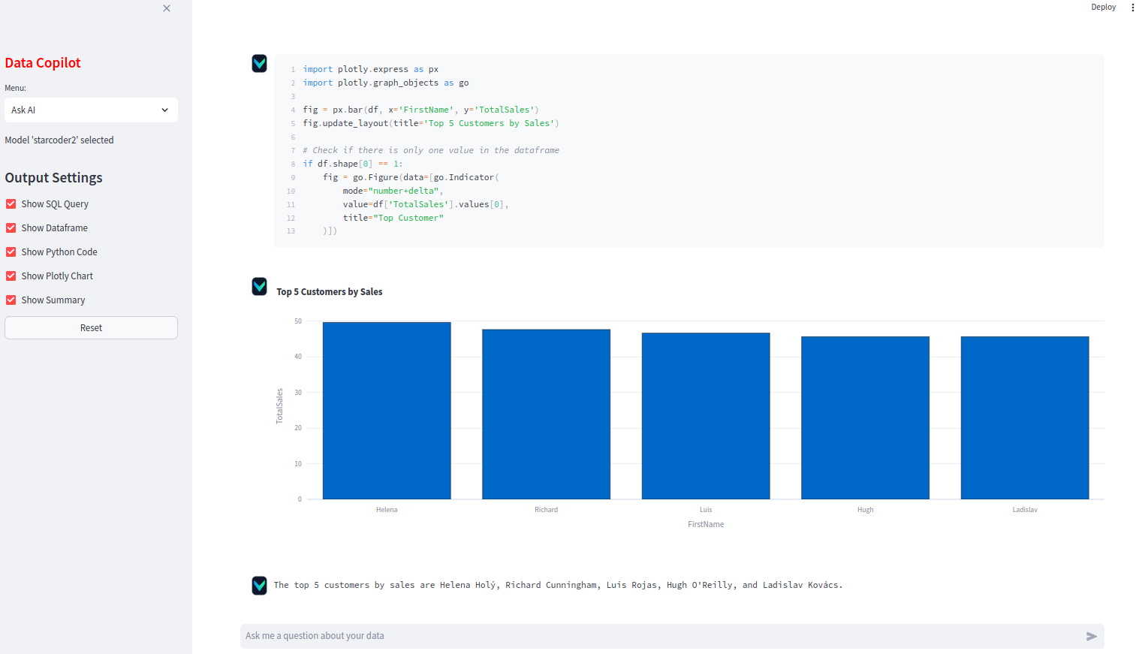

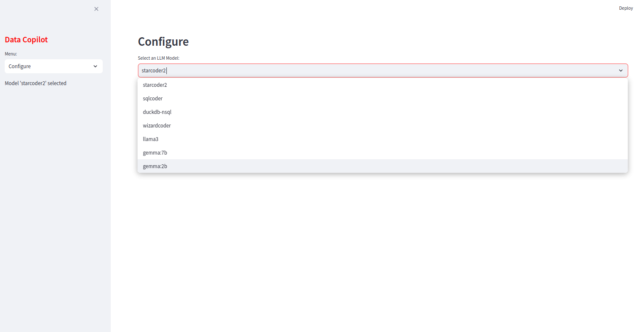

Resources

- Vanna.AI (https://github.com/vanna-ai/vanna) : Chat with Data
- Ollama (https://ollama.com/) : private open-source LLM
- Streamlit (https://streamlit.io/) : build data apps faster
- Number Stations (https://numbersstation.ai/) : AI-native Data Analytics
- DuckDB (https://duckdb.org/) : Fast in-memory OLAP

