Use Ollama, Web-UI and model=mistral-openorca, below are our dialog

CLI:
>>> what is heart sutra
The Heart Sutra (Sanskrit: � sitrā, "Heart of the Perfection of Wisdom") is a Mahayana
Buddhist text that is considered one of the most important and influential scriptures in the
Buddhist tradition. It is a concise, yet profound, text that presents the central teachings of
Buddhism, emphasizing the concept of emptiness (Shunyata) and the interconnectedness of all
things.

The Heart Sutra is known for its concise and terse style, which condenses the essential
teachings of the larger Perfection of Wisdom Sutras into a short, memorable format. Its core
message is the teachings on emptiness (Shunyata), which holds that all phenomena (dharmas) are
empty of inherent existence or independent self-nature and are interdependent and
interconnected.

The Heart Sutra has been widely translated into many languages, including English, Chinese,
Tibetan, Japanese, and Korean. It is chanted and recited in Buddhist practice as a means to
develop insight (Prajna Paramita) and to attain the ultimate truth or reality (Dharmatā). The
Heart Sutra also plays an important role in Mahayana Buddhism's six-fold teaching on
emptiness, which is used as a basis for meditation and study.

Web-UI:

You
do you know heart sutra

Ollama Mistral-Openorca:Latest
The Heart Sutra is a famous Buddhist text that is often chanted or recited for its teachings on the nature of reality and emptiness. It is one of the most important texts in Mahayana Buddhism, and it is known for its concise expression of the ultimate truth. Here's a simplified version of the Heart Sutra:
"Avalokiteshvara, the Bodhisattva of Compassion, while wandering in the world to gather alms, saw at a distance five hundred people who were suffering terribly from the heat and who were about to die. He compassionately created the mind of great compassion and thought: 'May they be free from suffering! May they have happiness and peace!'
"In order to deliver these beings, he practiced profound prajna paramita (wisdom) and found that the five skandhas (aggregates of existence) are empty of self-nature. Sharing this great insight with them, he led the way for countless others to follow.
"So, what is the meaning of all this? Emptiness! He taught the same thing in many other ways: 'Form is emptiness; emptiness is form.' 'Feeling, conception, discrimination, and so on—all these are like this too: they are empty.'
"In truth, there is no attribution of any kind. There is no reaching or attaining of any kind. The Bodhisattva relies on the practice of prajna paramita and, without any obstruction, is saved from all the net of existence.
"There are bodhisattvas whose mind is set upon prajna paramita, and they do not lose even the slightest thing. They rely on the perfection of giving, on the practice of prajna paramita; they depend on the perfection of action, on the practice of prajna paramita; they rely on the perfection of speech, on the practice of prajna paramita; they depend on the perfection of concentration, on the practice of prajna paramita.
"In this way, the bodhisattva, relying on the practice of prajna paramita, clears all obstructions from his mind. He is without any obstruction, and he is filled with the right understanding of all aspects of phenomena. Without any obstruction, he is freed from the net of existence."
This is a simplified translation of the Heart Sutra. The original text is much more profound and can be found in various translations available online or in Buddhist texts.

You
can you translate heart sutra into Chinese
Ollama Mistral-Openorca:Latest
如何弘法品 (心經)
"佛隅有一位大悲問菩薩，行修煙香道，見五百人所餒虫不樂，將死於熱焰。大悲問菩薩心生大悲悲哀而應鼓。
"他想：「我欲令其無痛！歡樂！安乐！」即時創意，以大智慧（般若波羅蜜）力穿透五污炭（五経），見自性無有。
"此者說：「形是空、空是形。感想识分、及等等，皆如此。」
"實在，無賦也。不獲任何種類。大悲問菩薩依生般若波羅蜜而自由于生存網。
"有般若波羅蜜心者，勿失微物。亦依攸福行、般若波羅蜜；依行善行、般若波羅蜜；依言正語、般若波羅蜜；依定法定、般若波羅蜜。
"如是，依生般若波羅蜜，大悲問菩薩逐除心中礙，無礙而自在。自在而清空，不受生存網之幻。"
This is a simplified translation of the Heart Sutra into Chinese. The original text is much more profound and can be found in various translations available online or in Buddhist texts.

PC is very busy during inference:

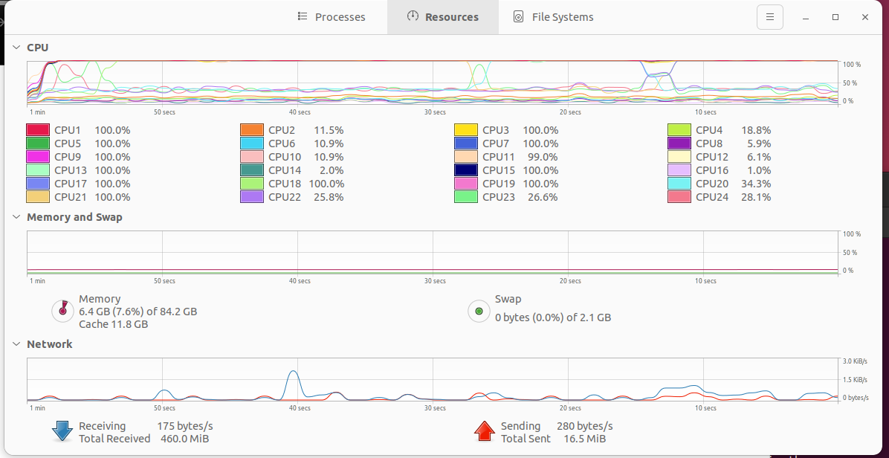
The performance is clearly not so good with local LLM/GPT

You
what is quantum physics
Ollama Mistral-Openorca:Latest
Quantum physics is a branch of physics that deals with the study of matter and energy at the most basic level. It is the fundamental theory in physics that explains the nature of reality at the smallest scale, such as atoms and subatomic particles like electrons, protons, and neutrons.
The term "quantum" refers to discrete packets or quanta of energy, which are the smallest possible units of energy. These quanta are represented by particles in quantum physics, and they behave differently from classical particles in ways that can be counterintuitive and seemingly paradoxical. Some key concepts of quantum physics include superposition (where particles can exist in multiple states simultaneously until they are measured), entanglement (where particles can influence each other instantaneously over large distances), and the uncertainty principle (which states that certain pairs of properties, like position and momentum, cannot be known precisely at the same time).
Quantum physics has been incredibly successful in explaining phenomena from atomic structure to the behavior of light. It forms the foundation for technologies such as transistors, lasers, and quantum computing, which have significantly impacted our modern world. However, there is still much to be understood about quantum physics, as some aspects remain mysterious or contradictory, and ongoing research continues to explore these phenomena further.

