https://theconsciousnessexplosion.ai/
https://singularitynet.io/

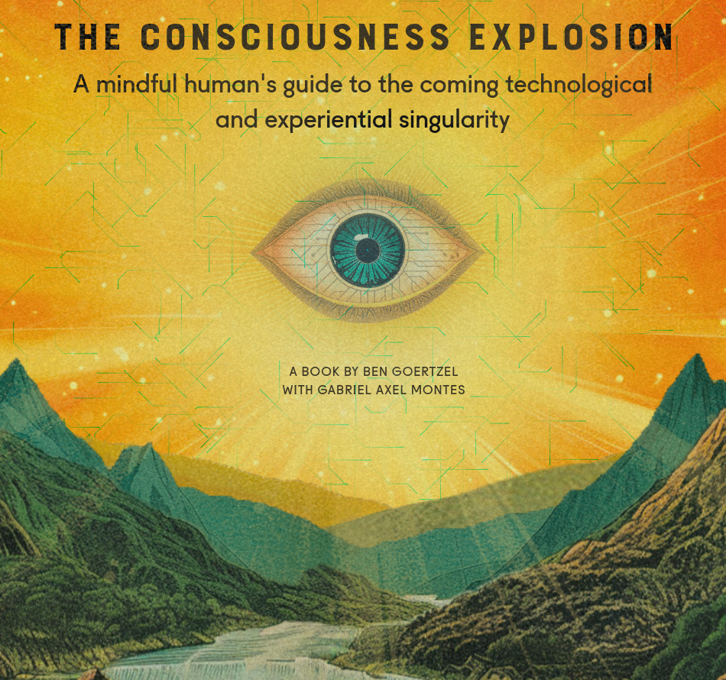

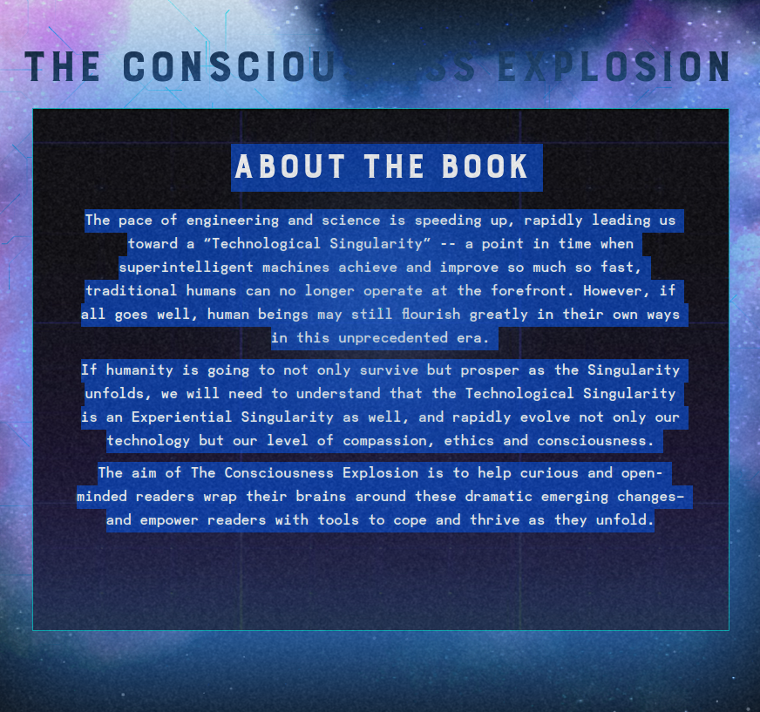

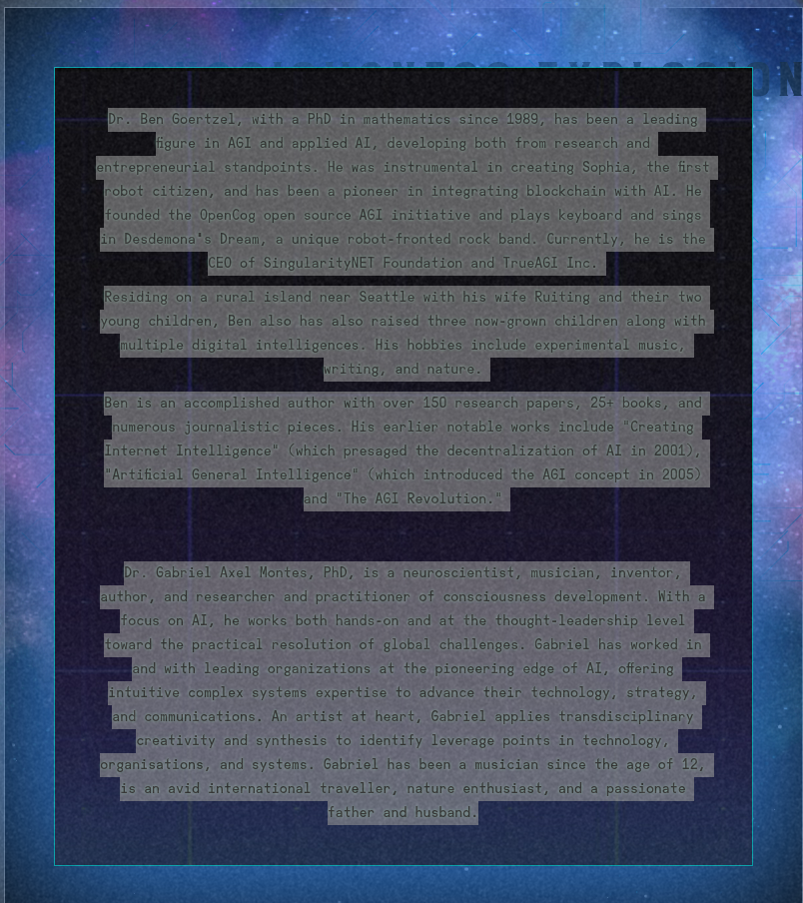

https://deepfunding.ai/

https://github.com/opencog/atomspace-bridge

The bridge connects pre-existing SQL DB's to the AtomSpace, so that data can move between the two, in both directions. It is meant to allow the AtomSpace to access foreign, external data, and manipulate it using the AtomSpace software stack.

https://github.com/opencog/atomspace
The OpenCog (hyper-)graph database and graph rewriting system

https://github.com/opencog/atomspace

The AtomSpace is a platform for building Artificial General Intelligence (AGI) systems. It provides the central knowledge representation component for OpenCog. As such, it is a fairly mature component, on which a lot of other systems are built, and which depend on it for stable, correct operation in a day-to-day production environment.

What is it, then? Most simply, the AtomSpace stores immutable, globally unique, typed s-expressions. The types can be thought of as being like object-oriented classes, and many (not all) Atom types do have a corresponding C++ class. Each s-expression is called "an Atom". Each Atom is globally unique: there is only one copy, ever, of any given s-expression (Atom). It's almost just that simple, with only one little twist: a (mutable) key-value database is attached to each Atom. Now, "ordinary" graph databases do this too: every vertex or edge can have "attributes" on it. The AtomSpace allows these attributes to be dynamic: to change in time or to "flow". The flow itself is described by a graph; thus, graphs can be thought of as "plumbing"; whereas the Values are like the "fluid" in these pipes. This is much like the distinction between "software" and "data": software describes algos, data is what moves through them. In the AtomSpace, the algos are explicit graphs. The Values are the data.

The AtomSpace borrows ideas and concepts from many different systems, including ideas from JSON, SQL and graph stores. The goal of the AtomSpace is to be general: to allow you to work with whatever style of data you want: structured or unstructured. As graphs, as tables, as objects. As lambda expressions, as abstract syntax trees, as prolog-like logical statements. A place to store relational data obeying some relational algebra. As a place to store ontologies or mereologies or taxonomies. A place for syntactic (BNF-style) productions or constraints or RDF/OWL-style schemas. In a mix of declarative, procedural and functional styles. The AtomSpace is meant to allow general knowledge representation, in any format.

The graph is the "code"; the values are the data that the code acts on.

