Discovering Quark-Gluon-Plasma at RHIC

Quark-gluon plasma (QGP) is an exotic state of matter in which quarks and gluons, the fundamental particles that make up protons and neutrons, exist in a deconfined state. Under normal conditions, quarks are always bound together by gluons to form hadrons like protons and neutrons. However, at extremely high temperatures or densities, the strong force binding quarks becomes so weak that they can move freely, creating this plasma-like state.
Yes, quark-gluon plasma has been discovered. It was first created and observed in laboratory conditions in the early 2000s.
The Relativistic Heavy Ion Collider (RHIC) at Brookhaven National Laboratory (BNL) has made significant contributions to our understanding of QGP. Some key achievements include:
- First creation of QGP: In 2005, RHIC announced the creation of a "perfect" liquid QGP, which behaved more like a liquid than the expected gas-like state.
- Discovery of QGP properties: RHIC experiments revealed that QGP behaves as a nearly perfect fluid with extremely low viscosity, close to the theoretical lower limit.
- Observation of jet quenching: RHIC detected the suppression of high-energy particle jets in heavy-ion collisions, providing evidence for the opacity of QGP to color charges.
- Study of QGP temperature: Measurements at RHIC helped determine that the temperature of the created QGP is about 4 trillion degrees Celsius, the hottest material ever created in a laboratory.
- Exploration of the QCD phase diagram: RHIC's Beam Energy Scan program has been investigating the properties of nuclear matter across a range of temperatures and densities, helping to map out the phase diagram of quantum chromodynamics (QCD).
- Observation of antimatter nuclei: RHIC experiments have produced and detected various antimatter nuclei, including anti-helium-4, the heaviest antimatter nucleus observed to date.
These discoveries have significantly advanced our understanding of the strong nuclear force and the behavior of matter under extreme conditions, similar to those that existed in the early universe microseconds after the Big Bang.

The Relativistic Heavy Ion Collider (RHIC) has a rich history that dates back to the 1980s. Here's a brief overview:
- Conception: The idea for RHIC emerged in the early 1980s as physicists sought to study nuclear matter under extreme conditions.
- Approval and Construction: The U.S. Department of Energy approved the project in 1991, and construction began at Brookhaven National Laboratory in 1991.
- Completion: RHIC was completed in 1999 at a cost of about $616 million.
- First Collisions: The first collisions at RHIC occurred in 2000, marking the beginning of its experimental program.

T.D. Lee, a Nobel laureate in Physics (1957), played a crucial role in the conception and development of RHIC. His contributions include:
- Theoretical Foundation: In the 1970s, Lee, along with other physicists, proposed the idea that nuclear matter could undergo a phase transition to a new state (later known as quark-gluon plasma) under extreme conditions.
- Advocacy: Lee was a strong advocate for the construction of a dedicated heavy-ion collider to study this predicted state of matter. His influence and scientific reputation were instrumental in garnering support for the project.
- RHIC Physics Program: Lee was heavily involved in shaping the physics program at RHIC. He emphasized the importance of studying the properties of hot, dense nuclear matter and exploring the QCD phase diagram.
- Continued Involvement: Even after RHIC's construction, Lee remained actively involved in its research program. He frequently visited Brookhaven and participated in discussions about the interpretation of RHIC results.
- Educational Impact: Lee also contributed to the training of a new generation of physicists who would work at RHIC. He mentored many students and postdocs who went on to become leading researchers in the field.
- China-U.S. Scientific Collaboration: Lee played a significant role in fostering collaboration between Chinese and American scientists in the RHIC program, helping to make it a truly international effort.
T.D. Lee's contributions to RHIC extend beyond just the technical aspects. His vision, advocacy, and continued involvement were crucial in establishing RHIC as a premier facility for studying nuclear matter under extreme conditions. His work helped bridge theoretical predictions with experimental capabilities, setting the stage for the groundbreaking discoveries that RHIC would later make.

Celebrating 20 years of Smashing Success at RHIC
https://www.bnl.gov/newsroom/news.php?a=217221

Collaborators from China
https://phys.org/news/2006-04-china-cooperate-high-energy-physics.html#google_vignette
- the Institute of Particle Physics at Wuhan, China,
- the Institute of Modern Physics at LanZhou, China,
- the Shanghai Institute of Applied Physics,
- Tsinghua University in Beijing,
- the University of Science and Technology of China at Hefei
- the Institute of High Energy Physics in Beijing.

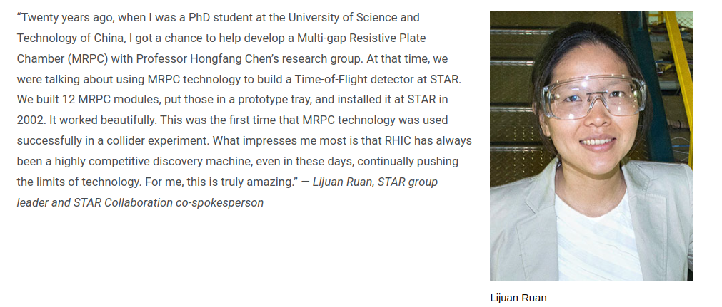

Huan Huang – CUSPEA student, now physics professor at UCAL
https://www.pa.ucla.edu/faculty-websites/huang.html

