Optimal Migratory Speed of Large Capital Breeders

Gough, W.T., Czapanskiy, M.F., Savoca, M.S., Hazen, E.L., Oestreich, W.K., Fahlbusch, J., Palacios, D.M., Bejder, L., Goldbogen, J.A.

7/28/2023

# Outline of Ideas

1. Migration is an extreme behavioral process and might be impacted by climate change into the future.
2. Krogh Principle: Baleen whales are the best species to study migration because they display some of the longest migrations of any animals plus they are capital breeders.
3. We would like to know if there is an optimal migratory speed for large capital breeding animals that minimizes the energetic cost of the migration as a function of their annual energy gain.
4. How does this theoretical optimal speed change with changes to the migratory variables

# Abstract

Long-distance migrations are one of the most energetically challenging behaviors observed within the animal kingdom and are undertaken to find seasonally variable food sources or move between spatially distinct foraging and breeding grounds. Large body sizes, such as those seen in mysticete whales (Mysticeti), allow for migrations across vast distances. Mysticetes must also rely on the energy from a defined feeding season to last them throughout the year, a strategy known as capital breeding. This annual strategy means that maximum migratory distance should be a direct result of the amount of energy gained during the feeding season. Using estimates of foraging and swimming energetic intake and costs for mysticetes of varying body sizes, we estimated the energy gained during a mysticete foraging season as well as the energy subsequently used during migration. For a successful foraging season, the energetic cost of migration relative to intake only amounts to ~20% across body sizes, while a poor foraging year could result in exorbitant migratory costs of ~100% or more. We also found that migratory costs are dependent on total distance, duration, and swimming speed. Combining a theoretical model with satellite tracks of individual whales, we determined that longer migrations are more costly and occur at higher speeds than shorter migrations. In a rapidly changing ocean, even small differences in the distance or duration of a migration could have major impacts on individual fitness. NEEDS TO BE UPDATED

# Introduction

Animal migration serves an important role in the re-distribution of nutrients, genetic dispersal across population boundaries, and to maximize fitness across a dynamic landscape (Dingle and Drake 2007). Long-distance migrations can span continents and ocean basins and are one of the most energetically extreme behaviors observed within the animal kingdom. Many species transit thousands of kilometers in search of seasonally variable food resources (Block et al. 2011; La Sorte et al. 2016; Merkle et al. 2016) or to move between spatially distinct foraging and breeding grounds (Kenney, Mayo, and Winn 2020). The distances traveled during these journeys are often informed by environmental features (Abrahms et al. 2019; Block et al. 2011; Oestreich et al. 2022), but they are also constrained by physiological limitations that must also be overcome through novel adaptation (Weber 2009).

A common adaptation that aids long migration is large body size and increased energy storage (Burns and Bloom 2020; Hein, Hou, and Gillooly 2012), with the exception being powered flight (e.g., insects and songbirds) (Alerstam, Hedenström, and Åkesson 2003). Larger animals have lower mass-specific metabolic rates (Glazier 2005; Kleiber 1975) and costs of transport (Taylor, Heglund, and Maloiy 1982; Williams 1999), resulting in more efficient locomotion over greater distances. Even as mass-specific costs decrease for larger animals, absolute costs increase and must be accounted for with efficient prey capture strategies (Goldbogen et al. 2019; McNab 1999). Many of the largest terrestrial species are ruminants that take advantage of seasonal greening for their plant-based diet and a specialized digestive apparatus to increase their energetic surplus (Aikens et al. 2020; Merkle et al. 2016). Large marine species are unable to utilize such stability and predictability in ocean resources (but see Abrahms et al. (2019)), instead relying on ephemeral prey patches of fish, krill, or copepods (Carroll et al. 2021; Goldbogen et al. 2019).

Many of the largest marine animals, including mysticete (baleen) whales (Mysticeti), whale sharks (Rhincodon typus), and oceanic manta rays (Mobula birostris), efficiently exploit small, abundant prey species (e.g., schooling fish and crustaceans) by filter feeding on large aggregations (Goldbogen et al. 2019; Motta et al. 2010; Paig-Tran, Kleinteich, and Summers 2013). These large body sizes allow many species to undertake months-long migrations over tens of thousands of kilometers (Corkeron and Connor 1999; Guzman et al. 2018; Kenney, Mayo, and Winn 2020). Unlike terrestrial ungulates that forage during the migration, mysticetes are capital breeders, meaning they have a defined feeding season (spring and summer months) and exhibit relatively little feeding behavior outside the feeding season (Lockyer 1981). Thus, mysticetes need to live off these reserves for the rest of the year (Drent and Daan 1980; Jönsson 1997; Stephens et al. 2009). This annual strategy means that maximum migratory distance should be a direct result of the amount of energy gained during the feeding season.

Recent studies on several mysticete species combining biologging tags with UAS morphometrics and hydrodynamic physical modeling have produced high-resolution estimates of energetic intake and costs for both foraging and swimming (Goldbogen et al. 2019; Savoca et al. 2021). Studies using satellite tags have also produced estimates of mysticete bi-directional migration durations ranging from ~60-180 days and distances ranging from ~5000-20000 km (Félix and Guzmán 2014; Kettemer et al. 2022; Mate, Lagerquist, and Calambokidis 1999; Mate et al. 2015; Modest et al. 2021; Riekkola et al. 2019). Using these comprehensive datasets, we estimate the net energy gained during the foraging season as well as the energy subsequently used during migration. We hypothesize that due to the bulk filter feeding strategy employed by mysticetes that has shown to be highly energetically efficient, migration will not be constrained by energy acquisition during the foragins season, but rather by timing and the potential opportunity costs of lost foraging periods. As an extension, we predict that whales that undertake longer migrations will do so at faster swimming speeds despite the increased energetic cost of doing so. As a validation, we will compare our modeled predictions against migration distances and swimming speeds taken from the real-world satellite tag dataset.

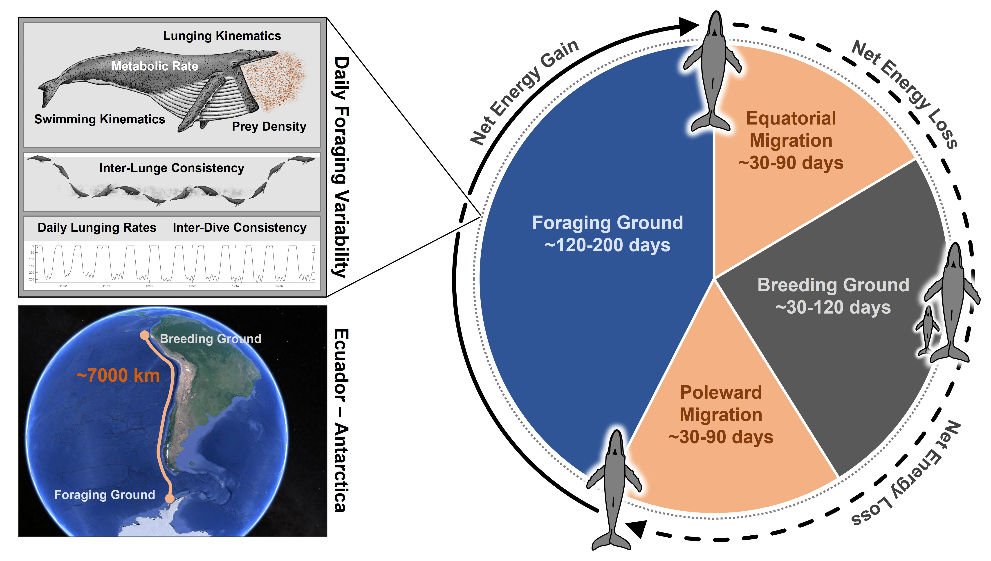

Figure 1. Schematic of a humpback whale annual cycle with a generic migratory route highlighted

# Materials & Methods

## Species

We included four species in our energetic analyses: blue (*Balaenoptera musculus*), fin (*Balaenoptera physalus*), humpback (*Megaptera novaeangliae*), and Antarctic minke (*Balaenoptera bonaerensis*). Informed by morphological (Kahane‐Rapport and Goldbogen 2018) and UAV datasets (William T. Gough et al. 2021; William T. Gough et al. 2022), we chose a five-meter range of body lengths () for each species. In a review of migratory track satellite tag data, we found data for the four previously-mentioned species in addition to sei (*Balaenoptera borealis*) and gray whale (*Eschrichtius robustus*).

## Satellite Tag Data

Satellite tag data was compiled from multiple literature sources and tag types (Table 1). To be included in our dataset, a satellite track had to include: 1) a complete migration moving in either direction (i.e. from foraging ground to breeding ground or vice-versa), 2) not include any portions of swimming on the foraging or breeding grounds, 3) the overall distance covered by the animal during the migration (; km), and 4) the duration of the migratory period (; days). Using this data, we were able to calculate the GPS-based over-ground speed of each animal (; ) using the equation:

Using average values for , , and (Fig 1), we calculated the distance (), duration (), and over-ground speed () for a stereotypical migratory route. We used these values to parameterize a standardized annual cycle as well as our energetic models.

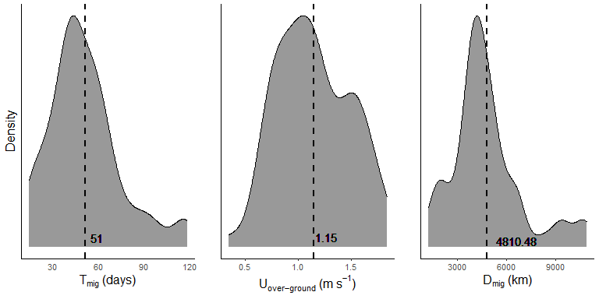

Figure 2. Density graphs for the migratory distance, duration, and over-ground speed. Vertical lines denote the mean value for each graph.

## Standardized Annual Cycle

Our energetic models were predicated on a standardized annual cycle, with costs and benefits calculated as deviations from that cycle. In order to determine the portion of the year devoted to migration, we used our calculated from our literature search and estimated to 60 days for a uni-directional migration (), resulting in 120 days spent migrating during a standardized annual cycle (). For the time spent on the breeding ground (), we estimated 90 days based on sightings data, specifically from Maui-Nui for humpback whales (van Aswegen, pers. comm.). Finally, we estimated the feeding season as the remaining portion of the year, set to 120 days (). Reproduction and weaning of calves requires a set period of time and the sighting data suggest that the breeding season could be a more set duration than the feeding season. As a result, our model presumes that changes to the migratory duration due to swimming speed will result in a longer or shorter foraging season duration while the breeding season duration remains unchanged ().

## Foraging Season Energetics

We determined the net energy obtained from a day of foraging (; kJ) using the equation:

where and are calculated for each species at a given body length using body length regressions calculated by William T. Gough et al. (2022). These regressions subtracted the energetic cost of a lunge feeding event from the energetic intake of that same event, then multiplied the duration of the lunge feeding event by the average number of lunges performed in a day for that species taken from Savoca et al. (2021). For the remaining portion of the day, we calculated the energetic cost per second using metabolic equations outlined by William T. Gough et al. (2022) and body mass (; kg) calculated from body length using methods outlined by Kahane‐Rapport and Goldbogen (2018). To determine the net energy flux for a standard feeding season (; kJ), we multiplied by the using the equation:

## Migratory Route Energetics

We estimated the combined energetic cost of swimming and metabolism (; ) for each species at a given body length using the equation:

where is the thrust power output () estimated for a given swimming speed (; ) with a regression taken from William T. Gough et al. (2021), is a metabolic efficiency factor set at 0.25 (Frank E. Fish 1996; F. E. Fish and Rohr 1999; Potvin et al. 2021), is a propulsive efficiency factor set at 0.90 (William T. Gough et al. 2021), is the basal metabolic rate using a Kleiber function () (Kleiber 1975). To determine the energetic cost of a single migratory day (; kJ), we multiplied the per-second value of by the percentage of time spent actively fluking for each species () and the number of seconds in a day:

We estimated for each species using previously published tag data from the four species included in our analyses (William T. Gough et al. 2022). These estimations resulted in 35% for the blue whale, 40% for for fin whale, 55% for the humpback whale, and 65% for the minke whale. Finally, we could calculate the overall cost of a migration () using the equation:

## Speed-Adjusted Energetics

We used previously published data from 2 migrating blue whales (Oestreich et al. 2020) to compare straight-line migratory speed to both and . These measurements resulted in a multiplicative factor to convert values of from our literature review into values that could be used to more accurately calculate (Figure 3). This factor also allowed us to create a range of speeds for both and to calculate changes in annual energy flux.

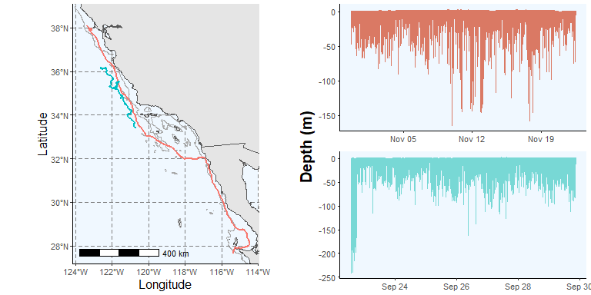

Figure 3. Data from two multi-sensor blue whale tag deployments used to calculate a conversion factor between over-ground speed and swimming speed. The map on the left shows the gps tracks for each whale during the period of migratory swimming. The graphs on the right show the time-depth traces for each whale during the same period of migratory swimming.

For a given value, we could calculate an adjusted value for the duration of a uni-directional migratory period () using the equation:

with the overall days spent migrating during an annual cycle () given given as:

We could then update the uni-directional cost of migration () using the equation:

with the annual cost of migration given as:

We then used our values across our range of to calculate the change in feeding season duration from due to migratory speed () using the equation:

and the subsequent change in net energy intake per year () using the following equations:

Next, we recalculated the net energy from the foraging season () using the equation:

We then calculated the ratio of between and () using the following equation:

Finally, we could calculate the speed values (both and ) at which is minimized () using the following equation:

We repeated these analyses for a range of values from 4000-12000km, informed by our literature review. A schematic of these equations is given in Figure 4.

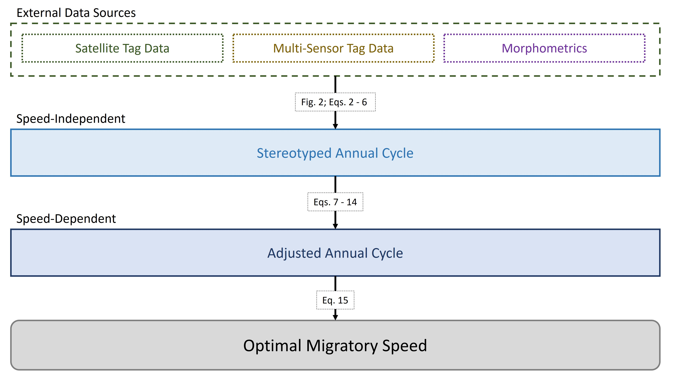

Figure 4. Schematic of equations 2-15 used to calculate the stereotyped annual cycle and speed-dependent annual models used to calculate our values.

# Results

## Energetic

## Optimal Migratory Speed

We found that produced a U-shaped relationship with across a range of values from 4000-12000km (Figure 5). Increasing led to an increase in as a proportion of as well as increasing .

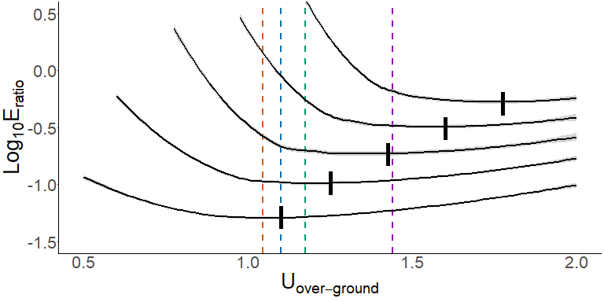

Figure 5. Relationship between and . Dotted lines denote the converted values for average for each species in our analysis taken from William T. Gough et al. (2019)

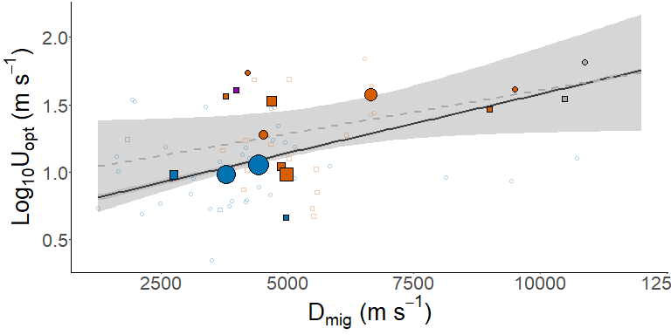

Figure 6. Relationship and for satellite tracks obtained from literature sources. Points denote single uni-directional migratory routes as described in Table 1, with size corresponding to the number of tag deployments averaged together from that migratory route. The dotted gray line denotes the relationship for these points, while the solid black line denotes the relationship between and taken from our modeled optimal over-ground speeds shown in Figure 5.

## EXTRA - Graph of Migration Literature - Speed Over Ground vs. Distance

Plot the speed of movement over ground () against the migratory distance () for each satellite track in the literature data (MigrationDistancesLit.rda):

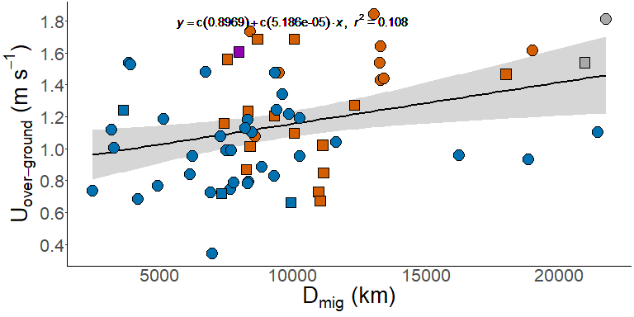

## EXTRA - Graph of Optimal Speeds for each species at different migration distances

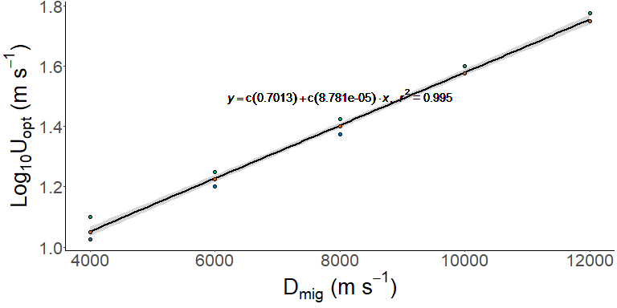

# Tables

| Species | Data Source | Migratory Route | Direction | Distance | Duration | Speed |
| --- | --- | --- | --- | --- | --- | --- |
| Humpback | Riekkola et al. 2020 | Southern Oceania - New Zealand | Polar | 5564 | 63.0 | 1.02 |
| Humpback | Riekkola et al. 2020 | Southern Oceania - New Zealand | Polar | 6161 | 56.0 | 1.27 |
| Humpback | Riekkola et al. 2020 | Southern Oceania - New Zealand | Polar | 5025 | 53.0 | 1.10 |
| Humpback | Riekkola et al. 2020 | Southern Oceania - New Zealand | Polar | 3709 | 37.0 | 1.16 |
| Humpback | Riekkola et al. 2020 | Southern Oceania - New Zealand | Polar | 5487 | 87.0 | 0.73 |
| Humpback | Riekkola et al. 2020 | Southern Oceania - New Zealand | Polar | 5517 | 95.0 | 0.67 |
| Humpback | Riekkola et al. 2020 | Southern Oceania - New Zealand | Polar | 4202 | 48.0 | 1.01 |
| Humpback | Riekkola et al. 2020 | Southern Oceania - New Zealand | Polar | 4127 | 55.0 | 0.87 |
| Humpback | Riekkola et al. 2020 | Southern Oceania - Australia | Polar | 4158 | 39.0 | 1.23 |
| Humpback | Riekkola et al. 2020 | Southern Oceania - Australia | Polar | 5579 | 76.0 | 0.85 |
| Humpback | Modest et al. 2021 | South Pacific Coast | Equatorial | 6654 | 47.0 | 1.64 |
| Humpback | Modest et al. 2021 | South Pacific Coast | Equatorial | 6640 | 50.0 | 1.54 |
| Humpback | Modest et al. 2021 | South Pacific Coast | Equatorial | 6652 | 54.0 | 1.43 |
| Humpback | Modest et al. 2021 | South Pacific Coast | Equatorial | 6714 | 54.0 | 1.44 |
| Humpback | Modest et al. 2021 | South Pacific Coast | Equatorial | 6532 | 41.0 | 1.84 |
| Humpback | Kettemer et al. 2022 | Cross-Atlantic | Equatorial | 9500 | 68.0 | 1.62 |
| Humpback | Kettemer et al. 2022 | Cross-Atlantic | Polar | 9000 | 71.0 | 1.47 |
| Fin | Perez-Jorge et al. 2020 | North Atlantic | Polar | 3986 | 28.7 | 1.61 |
| Gray | Mate et al. 2015 | North Pacific Rim | Equatorial | 10880 | 69.5 | 1.81 |
| Gray | Mate et al. 2015 | North Pacific Rim | Polar | 10484 | 78.8 | 1.54 |
| Humpback | Palacios et al. 2019 | North Pacific - Alaska | Equatorial | 4744 | 37.2 | 1.48 |
| Humpback | Palacios et al. 2019 | North Pacific - Alaska | Equatorial | 4303 | 46.2 | 1.08 |
| Humpback | Palacios et al. 2019 | Pacific Coast - Gulf of California | Equatorial | 4213 | 28.1 | 1.74 |
| Humpback | Palacios et al. 2019 | North Pacific - Alaska | Polar | 4339 | 29.8 | 1.69 |
| Humpback | Palacios et al. 2019 | North Pacific - Aleutians | Polar | 3775 | 28.0 | 1.56 |
| Humpback | Palacios et al. 2019 | North Pacific - Alaska | Polar | 5030 | 34.5 | 1.69 |
| Humpback | Palacios et al. 2019 | North Pacific - Alaska | Polar | 4662 | 44.8 | 1.20 |
| Blue | Palacios et al. 2019 | Pacific Coast - Costa Rica Dome | Equatorial | 4711 | 44.0 | 1.24 |
| Blue | Palacios et al. 2019 | Pacific Coast - Costa Rica Dome | Equatorial | 5136 | 50.0 | 1.19 |
| Blue | Palacios et al. 2019 | Pacific Coast - Gulf of California | Equatorial | 2473 | 37.3 | 0.77 |
| Blue | Palacios et al. 2019 | Pacific Coast - Costa Rica Dome | Equatorial | 4815 | 41.6 | 1.34 |
| Blue | Palacios et al. 2019 | Pacific Coast - Gulf of California | Equatorial | 3840 | 59.5 | 0.75 |
| Blue | Palacios et al. 2019 | Pacific Coast - Gulf of California | Equatorial | 1647 | 19.0 | 1.00 |
| Blue | Palacios et al. 2019 | Pacific Coast - Gulf of California | Equatorial | 1607 | 16.7 | 1.12 |
| Blue | Palacios et al. 2019 | Pacific Coast - Costa Rica Dome | Equatorial | 3764 | 44.1 | 0.99 |
| Blue | Palacios et al. 2019 | Pacific Coast - Costa Rica Dome | Equatorial | 4168 | 40.9 | 1.18 |
| Blue | Palacios et al. 2019 | Pacific Coast - Gulf of California | Polar | 3661 | 59.0 | 0.72 |
| Blue | Palacios et al. 2019 | Pacific Coast - Gulf of California | Equatorial | 1932 | 14.6 | 1.54 |
| Blue | Palacios et al. 2019 | Pacific Coast - Gulf of California | Equatorial | 3076 | 42.5 | 0.84 |
| Blue | Palacios et al. 2019 | Pacific Coast - Gulf of California | Polar | 1824 | 17.0 | 1.24 |
| Blue | Palacios et al. 2019 | Pacific Coast - Costa Rica Dome | Equatorial | 4233 | 44.5 | 1.10 |
| Blue | Palacios et al. 2019 | Pacific Coast - Costa Rica Dome | Equatorial | 8125 | 98.0 | 0.96 |
| Blue | Palacios et al. 2019 | Pacific Coast - Gulf of California | Equatorial | 4184 | 61.2 | 0.79 |
| Blue | Palacios et al. 2019 | Pacific Coast - Costa Rica Dome | Equatorial | 3498 | 118.5 | 0.34 |
| Blue | Palacios et al. 2019 | Pacific Coast - Costa Rica Dome | Equatorial | 4663 | 65.1 | 0.83 |
| Blue | Palacios et al. 2019 | Pacific Coast - Costa Rica Dome | Equatorial | 3900 | 57.4 | 0.79 |
| Blue | Palacios et al. 2019 | Pacific Coast - Gulf of California | Equatorial | 2106 | 35.6 | 0.68 |
| Blue | Palacios et al. 2019 | Pacific Coast - Gulf of California | Equatorial | 4429 | 57.8 | 0.89 |
| Blue | Palacios et al. 2019 | Pacific Coast - Costa Rica Dome | Equatorial | 3851 | 45.0 | 0.99 |
| Blue | Palacios et al. 2019 | Pacific Coast - Costa Rica Dome | Equatorial | 3130 | 38.0 | 0.95 |
| Blue | Palacios et al. 2019 | Pacific Coast - Gulf of California | Equatorial | 1968 | 14.9 | 1.52 |
| Blue | Palacios et al. 2019 | Pacific Coast - Gulf of California | Equatorial | 1246 | 19.7 | 0.73 |
| Blue | Palacios et al. 2019 | Pacific Coast - Costa Rica Dome | Equatorial | 3657 | 39.3 | 1.08 |
| Blue | Palacios et al. 2019 | Pacific Coast - Gulf of California | Equatorial | 9428 | 117.3 | 0.93 |
| Blue | Palacios et al. 2019 | Pacific Coast - Gulf of California | Equatorial | 10724 | 112.5 | 1.10 |
| Blue | Palacios et al. 2019 | Pacific Coast - Costa Rica Dome | Polar | 4966 | 87.0 | 0.66 |
| Blue | Palacios et al. 2019 | Pacific Coast - Costa Rica Dome | Equatorial | 4169 | 61.8 | 0.78 |
| Blue | Palacios et al. 2019 | Pacific Coast - Costa Rica Dome | Equatorial | 4111 | 42.2 | 1.13 |
| Blue | Palacios et al. 2019 | Pacific Coast - Costa Rica Dome | Equatorial | 5142 | 62.5 | 0.95 |
| Blue | Palacios et al. 2019 | Pacific Coast - Costa Rica Dome | Equatorial | 3368 | 26.3 | 1.48 |
| Blue | Palacios et al. 2019 | Pacific Coast - Gulf of California | Equatorial | 2580 | 25.2 | 1.18 |
| Blue | Palacios et al. 2019 | Pacific Coast - Costa Rica Dome | Equatorial | 4942 | 47.0 | 1.22 |
| Blue | Palacios et al. 2019 | Pacific Coast - Gulf of California | Equatorial | 3468 | 55.3 | 0.73 |
| Blue | Palacios et al. 2019 | Pacific Coast - Gulf of California | Equatorial | 5825 | 64.8 | 1.04 |
| Blue | Palacios et al. 2019 | Pacific Coast - Costa Rica Dome | Equatorial | 4677 | 36.8 | 1.47 |

# References

Abrahms, Briana, Elliott L. Hazen, Ellen O. Aikens, Matthew S. Savoca, Jeremy A. Goldbogen, Steven J. Bograd, Michael G. Jacox, Ladd M. Irvine, Daniel M. Palacios, and Bruce R. Mate. 2019. “Memory and Resource Tracking Drive Blue Whale Migrations.” *Proceedings of the National Academy of Sciences* 116 (12): 5582–87. <https://doi.org/10.1073/pnas.1819031116>.

Aikens, Ellen O., Atle Mysterud, Jerod A. Merkle, Francesca Cagnacci, Inger Maren Rivrud, Mark Hebblewhite, Mark A. Hurley, et al. 2020. “Wave-Like Patterns of Plant Phenology Determine Ungulate Movement Tactics.” *Current Biology* 30 (17): 3444–3449.e4. <https://doi.org/10.1016/j.cub.2020.06.032>.

Alerstam, Thomas, Anders Hedenström, and Susanne Åkesson. 2003. “Long-Distance Migration: Evolution and Determinants.” *Oikos* 103 (2): 247–60. <https://doi.org/10.1034/j.1600-0706.2003.12559.x>.

Block, B. A., I. D. Jonsen, S. J. Jorgensen, A. J. Winship, S. A. Shaffer, S. J. Bograd, E. L. Hazen, et al. 2011. “Tracking Apex Marine Predator Movements in a Dynamic Ocean.” *Nature* 475 (7354): 86–90. <https://doi.org/10.1038/nature10082>.

Burns, Michael D., and Devin D. Bloom. 2020. “Migratory Lineages Rapidly Evolve Larger Body Sizes Than Non-Migratory Relatives in Ray-Finned Fishes.” *Proceedings of the Royal Society B: Biological Sciences* 287 (1918): 20192615. <https://doi.org/10.1098/rspb.2019.2615>.

Carroll, Gemma, Stephanie Brodie, Rebecca Whitlock, James Ganong, Steven J. Bograd, Elliott Hazen, and Barbara A. Block. 2021. “Flexible Use of a Dynamic Energy Landscape Buffers a Marine Predator Against Extreme Climate Variability.” *Proceedings of the Royal Society B: Biological Sciences* 288 (1956): 20210671. <https://doi.org/10.1098/rspb.2021.0671>.

Corkeron, Peter J., and Richard C. Connor. 1999. “Why Do Baleen Whales Migrate?” *Marine Mammal Science* 15 (4): 1228–45. <https://doi.org/10.1111/j.1748-7692.1999.tb00887.x>.

Dingle, Hugh, and V. Alistair Drake. 2007. “What Is Migration?” *BioScience* 57 (2): 113–21. <https://doi.org/10.1641/B570206>.

Drent, R. H., and S. Daan. 1980. “The Prudent Parent: Energetic Adjustments in Avian Breeding 1).” *Ardea* 55 (1–2): 225–52. <https://doi.org/10.5253/arde.v68.p225>.

Félix, Fernando, and Héctor M. Guzmán. 2014. “Satellite Tracking and Sighting Data Analyses of Southeast Pacific Humpback Whales (Megaptera Novaeangliae): Is the Migratory Route Coastal or Oceanic?” *Aquatic Mammals* 40 (4): 329–40. <https://doi.org/10.1578/AM.40.4.2014.329>.

Fish, F. E., and J. J. Rohr. 1999. “Review of Dolphin Hydrodynamics and Swimming Performance:” Fort Belvoir, VA: Defense Technical Information Center. <https://doi.org/10.21236/ADA369158>.

Fish, Frank E. 1996. “Transitions from Drag-Based to Lift-Based Propulsion in Mammalian Swimming.” *American Zoologist* 36 (6): 628–41. <https://doi.org/10.1093/icb/36.6.628>.

Glazier, Douglas S. 2005. “Beyond the ‘3/4-Power Law’: Variation in the Intra- and Interspecific Scaling of Metabolic Rate in Animals.” *Biological Reviews* 80 (04): 611. <https://doi.org/10.1017/S1464793105006834>.

Goldbogen, J. A., D. E. Cade, D. M. Wisniewska, J. Potvin, P. S. Segre, M. S. Savoca, E. L. Hazen, et al. 2019. “Why Whales Are Big but Not Bigger: Physiological Drivers and Ecological Limits in the Age of Ocean Giants.” *Science* 366 (6471): 1367–72. <https://doi.org/10.1126/science.aax9044>.

Gough, William T, David E Cade, Max F Czapanskiy, Jean Potvin, Frank E Fish, Shirel R Kahane-Rapport, Matthew S Savoca, et al. 2022. “Fast and Furious: Energetic Tradeoffs and Scaling of High-Speed Foraging in Rorqual Whales.” *Integrative Organismal Biology* 4 (1): obac038. <https://doi.org/10.1093/iob/obac038>.

Gough, William T., Paolo S. Segre, K. C. Bierlich, David E. Cade, Jean Potvin, Frank E. Fish, Julian Dale, et al. 2019. “Scaling of Swimming Performance in Baleen Whales.” *The Journal of Experimental Biology* 222 (20): jeb204172. <https://doi.org/10.1242/jeb.204172>.

Gough, William T., Hayden J. Smith, Matthew S. Savoca, Max F. Czapanskiy, Frank E. Fish, Jean Potvin, K. C. Bierlich, et al. 2021. “Scaling of Oscillatory Kinematics and Froude Efficiency in Baleen Whales.” *Journal of Experimental Biology* 224 (13): jeb237586. <https://doi.org/10.1242/jeb.237586>.

Guzman, Hector M., Catalina G. Gomez, Alex Hearn, and Scott A. Eckert. 2018. “Longest Recorded Trans-Pacific Migration of a Whale Shark (Rhincodon Typus).” *Marine Biodiversity Records* 11 (1): 8. <https://doi.org/10.1186/s41200-018-0143-4>.

Hein, Andrew M., Chen Hou, and James F. Gillooly. 2012. “Energetic and Biomechanical Constraints on Animal Migration Distance.” *Ecology Letters* 15 (2): 104–10. <https://doi.org/10.1111/j.1461-0248.2011.01714.x>.

Jönsson, K. Ingemar. 1997. “Capital and Income Breeding as Alternative Tactics of Resource Use in Reproduction.” *Oikos* 78 (1): 57–66. <https://doi.org/10.2307/3545800>.

Kahane‐Rapport, Shirel R., and Jeremy A. Goldbogen. 2018. “Allometric Scaling of Morphology and Engulfment Capacity in Rorqual Whales.” *Journal of Morphology* 279 (9): 1256–68. <https://doi.org/10.1002/jmor.20846>.

Kenney, Robert D., Charles A. Mayo, and Howard E. Winn. 2020. “Migration and Foraging Strategies at Varying Spatial Scales in Western North Atlantic Right Whales: A Review of Hypotheses.” *J. Cetacean Res. Manage.*, 251–60. <https://doi.org/10.47536/jcrm.vi.283>.

Kettemer, Lisa Elena, Audun H. Rikardsen, Martin Biuw, Fredrik Broms, Evert Mul, and Marie-Anne Blanchet. 2022. “Round-Trip Migration and Energy Budget of a Breeding Female Humpback Whale in the Northeast Atlantic.” *PLOS ONE* 17 (5): e0268355. <https://doi.org/10.1371/journal.pone.0268355>.

Kleiber, Max. 1975. “Metabolic Turnover Rate: A Physiological Meaning of the Metabolic Rate Per Unit Body Weight.” *Journal of Theoretical Biology* 53 (1): 199–204. <https://doi.org/10.1016/0022-5193(75)90110-1>.

La Sorte, Frank A., Wesley M. Hochachka, Andrew Farnsworth, André A. Dhondt, and Daniel Sheldon. 2016. “The Implications of Mid-Latitude Climate Extremes for North American Migratory Bird Populations.” *Ecosphere* 7 (3): e01261. <https://doi.org/10.1002/ecs2.1261>.

Lockyer, C. 1981. “Growth and Energy Budgets of Large Baleen Whales from the Southern Hemisphere.” Mammals in the Seas.

Mate, Bruce R., Valentin Yu. Ilyashenko, Amanda L. Bradford, Vladimir V. Vertyankin, Grigory A. Tsidulko, Vyacheslav V. Rozhnov, and Ladd M. Irvine. 2015. “Critically Endangered Western Gray Whales Migrate to the Eastern North Pacific.” *Biology Letters* 11 (4): 20150071. <https://doi.org/10.1098/rsbl.2015.0071>.

Mate, Bruce R., Barbara A. Lagerquist, and John Calambokidis. 1999. “Movements of North Pacific Blue Whales During the Feeding Season Off Southern California and Their Southern Fall Migration1.” *Marine Mammal Science* 15 (4): 1246–57. <https://doi.org/10.1111/j.1748-7692.1999.tb00888.x>.

McNab, Brian K. 1999. “On the Comparative Ecological and Evolutionary Significance of Total and Mass‐Specific Rates of Metabolism.” *Physiological and Biochemical Zoology* 72 (5): 642–44. <https://doi.org/10.1086/316701>.

Merkle, Jerod A., Kevin L. Monteith, Ellen O. Aikens, Matthew M. Hayes, Kent R. Hersey, Arthur D. Middleton, Brendan A. Oates, Hall Sawyer, Brandon M. Scurlock, and Matthew J. Kauffman. 2016. “Large Herbivores Surf Waves of Green-up During Spring.” *Proceedings of the Royal Society B: Biological Sciences* 283 (1833): 20160456. <https://doi.org/10.1098/rspb.2016.0456>.

Modest, Michelle, Ladd Irvine, Virginia Andrews-Goff, William Gough, David Johnston, Douglas Nowacek, Logan Pallin, Andrew Read, Reny Tyson Moore, and Ari Friedlaender. 2021. “First Description of Migratory Behavior of Humpback Whales from an Antarctic Feeding Ground to a Tropical Calving Ground.” *Animal Biotelemetry* 9 (1): 42. <https://doi.org/10.1186/s40317-021-00266-8>.

Motta, Philip J., Michael Maslanka, Robert E. Hueter, Ray L. Davis, Rafael de la Parra, Samantha L. Mulvany, Maria Laura Habegger, et al. 2010. “Feeding Anatomy, Filter-Feeding Rate, and Diet of Whale Sharks Rhincodon Typus During Surface Ram Filter Feeding Off the Yucatan Peninsula, Mexico.” *Zoology* 113 (4): 199–212. <https://doi.org/10.1016/j.zool.2009.12.001>.

Oestreich, William K., Briana Abrahms, Megan F. McKenna, Jeremy A. Goldbogen, Larry B. Crowder, and John P. Ryan. 2022. “Acoustic Signature Reveals Blue Whales Tune Life-History Transitions to Oceanographic Conditions.” *Functional Ecology* 36 (4): 882–95. <https://doi.org/10.1111/1365-2435.14013>.

Oestreich, William K., James A. Fahlbusch, David E. Cade, John Calambokidis, Tetyana Margolina, John Joseph, Ari S. Friedlaender, et al. 2020. “Animal-Borne Metrics Enable Acoustic Detection of Blue Whale Migration.” *Current Biology* 30 (23): 4773–4779.e3. <https://doi.org/10.1016/j.cub.2020.08.105>.

Paig-Tran, E.W. Misty, Thomas Kleinteich, and Adam P. Summers. 2013. “The Filter Pads and Filtration Mechanisms of the Devil Rays: Variation at Macro and Microscopic Scales: Filter Pads and Filtration Mechanisms of Devil Rays.” *Journal of Morphology* 274 (9): 1026–43. <https://doi.org/10.1002/jmor.20160>.

Potvin, J, D E Cade, A J Werth, R E Shadwick, and J A Goldbogen. 2021. “Rorqual Lunge-Feeding Energetics Near and Away from the Kinematic Threshold of Optimal Efficiency.” *Integrative Organismal Biology* 3 (1). <https://doi.org/10.1093/iob/obab005>.

Riekkola, Leena, Virginia Andrews-Goff, Ari Friedlaender, Rochelle Constantine, and Alexandre N. Zerbini. 2019. “Environmental Drivers of Humpback Whale Foraging Behavior in the Remote Southern Ocean.” *Journal of Experimental Marine Biology and Ecology* 517: 1–12. <https://doi.org/10.1016/j.jembe.2019.05.008>.

Savoca, Matthew S., Max F. Czapanskiy, Shirel R. Kahane-Rapport, William T. Gough, James A. Fahlbusch, K. C. Bierlich, Paolo S. Segre, et al. 2021. “Baleen Whale Prey Consumption Based on High-Resolution Foraging Measurements.” *Nature* 599 (7883): 85–90. <https://doi.org/10.1038/s41586-021-03991-5>.

Stephens, Philip A., Ian L. Boyd, John M. McNamara, and Alasdair I. Houston. 2009. “Capital Breeding and Income Breeding: Their Meaning, Measurement, and Worth.” *Ecology* 90 (8): 2057–67. <https://doi.org/10.1890/08-1369.1>.

Taylor, C. R., N. C. Heglund, and G. M. Maloiy. 1982. “Energetics and mechanics of terrestrial locomotion. I. Metabolic energy consumption as a function of speed and body size in birds and mammals.” *The Journal of Experimental Biology* 97: 1–21. <https://doi.org/10.1242/jeb.97.1.1>.

Weber, Jean-Michel. 2009. “The Physiology of Long-Distance Migration: Extending the Limits of Endurance Metabolism.” *Journal of Experimental Biology* 212 (5): 593–97. <https://doi.org/10.1242/jeb.015024>.

Williams, Terrie M. 1999. “The Evolution of Cost Efficient Swimming in Marine Mammals: Limits to Energetic Optimization.” *Philosophical Transactions of the Royal Society of London. Series B: Biological Sciences* 354 (1380): 193–201. <https://doi.org/10.1098/rstb.1999.0371>.