Supplementary Information For:

Hydrogel Interfaced Glass Nanopore for High-Resolution Sizing of Short DNA Fragments
Muhammad Asad Ullah Khalid¹, Md. Ahasan Ahamed¹, Ming Dong¹, Aneesh Kshirsagar¹ and Weihua Guan^{1, 2*}

¹Department of Electrical Engineering, Pennsylvania State University, University Park, Pennsylvania 16802, United States
²Department of Biomedical Engineering, Pennsylvania State University, University Park, Pennsylvania 16802, United States

* Corresponding Author’s Email: wzg111@psu.edu

Contents
S2. Supplementary Figures ------------------------------------------------------------------------------- 02
S3. Supplementary Tables -------------------------------------------------------------------------------- 07
Supplementary References ------------------------------------------------------------------------------- 13

S2. Supplementary Figures

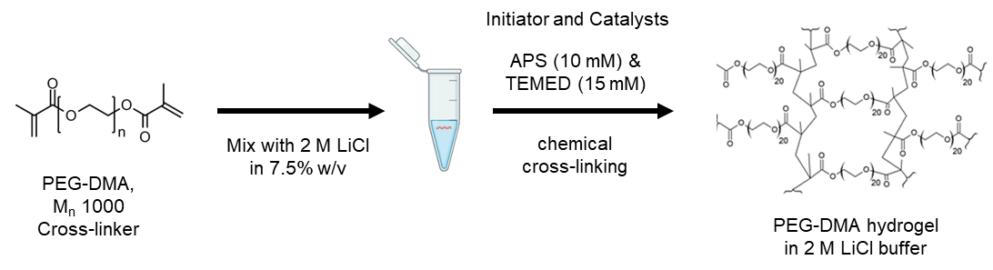
Figure S1. Synthesis of 7.5% PEG-DMA hydrogel in 2 M LiCl (TrisEDTA, pH 8.0) using chemical cross-linking initiated and catalyzed by ammonium persulfate (APS) and N,N,N’,N’-Tetramethylethylenediamine (TEMED).

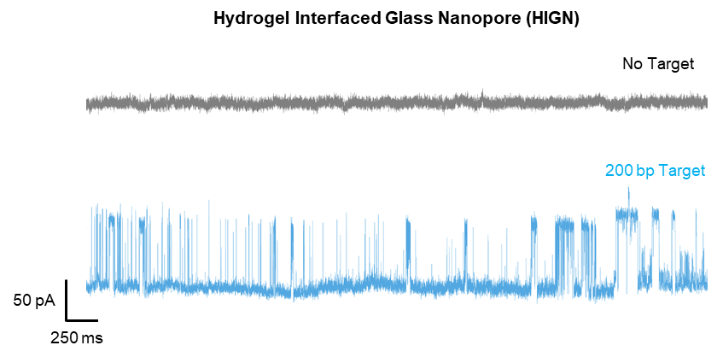
Figure S2. 5 second current-time (I-t) traces for HIGN in the absence and presence of 200 bp dsDNA target, when the glass nanopore is inserted in PEG-DMA hydrogel at fixed insertion location and depth.

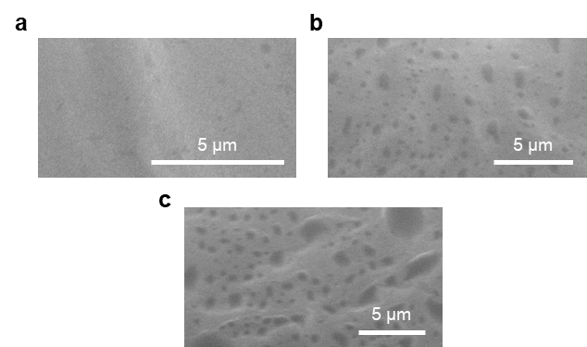
Figure S3. FE-SEM images of the PEG-DMA hydrogels for (a) 5%, (b) 7.5%, and (c) 10% w/v at lower magnifications. Dark spots in the images above show popped bubbles after a lyophilization process.

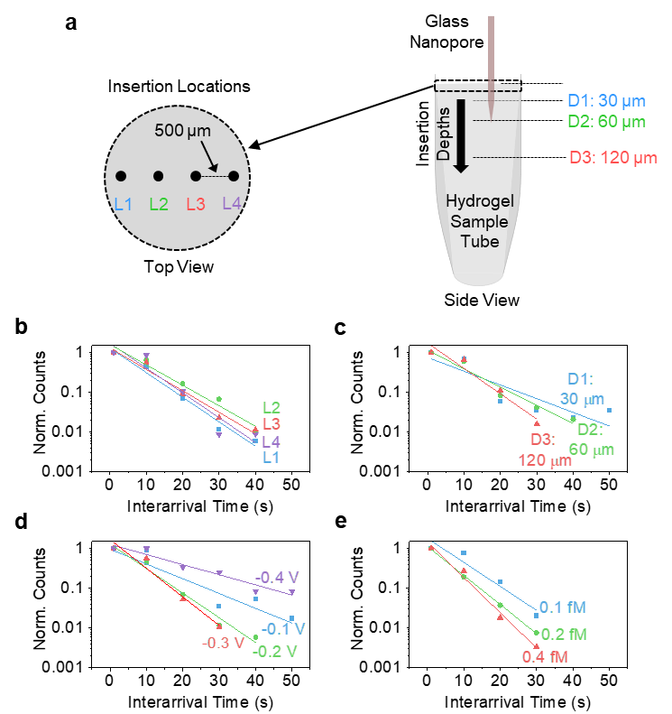
Figure S4. (a) Spatial configurations of glass nanopore in PEG-DMA hydrogel. Interarrival times analysis of (b) insertion locations, (c) insertion depths, (d) applied bias, and (e) and target concentrations. Interval times follow Poisson’s distributions, and their slopes indirectly estimate the expected event rates.

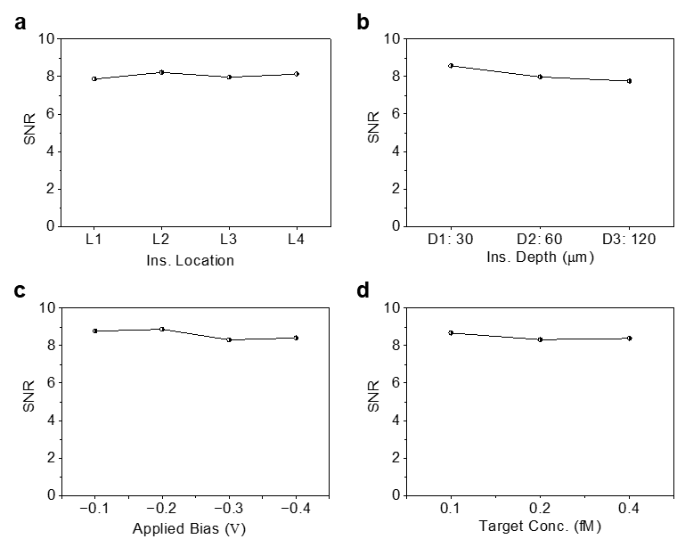
Figure S5. Signal-to-noise ratio (SNR) comparison for spatial configurations of HIGN, applied bias, and target dsDNA concentrations. All tested experimental conditions do not significantly impact the SNR.

S3. Supplementary tables

Table S1. Sequences of primers and oligos for IAV.
Components | Sequence
Forward | CAAGACCAATCYTGTCACCTCTGAC
Reverse | TGCTTTGTCCATGTTATTTGGATC
Segment 7*  gene  fragment | 168 to 313 (146 bp)  CAAGACCAATCCTGTCACCTCTGACTAAGGGGATTTTAGGATTTGTGTTCACGCTCACCGTGCCCAGTGAGCGAGGACTGCAGCGTAGACGCTTTGTCCAAAATGCCCTTAATGGGAACGGGGATCCAAATAACATGGACAAAGCA
* For IAV, the vRNA (viral RNA) segment 7 codes for the M1 matrix protein and M2 ion channel.

Table S2. Sequences of primers and oligos for SARS-CoV-2.
Components | Sequence
Forward | GACCCCAAAATCAGCGAAAT
Reverse | TCTGGTTACTGCCAGTTGAATCTG
N1 region of gene  fragment | 28287 to 28358 (72 bp)  GACCCCAAAATCAGCGAAATGCACCCCGCATTACGTTTGGTGGACCCTCAGATTCAACTGGCAGTAACCAGA

Table S3. PCR reaction setup for single plex assays of IAV and SARS-CoV-2.
PCR Components for singleplex IAV | Volume  (µL)/rxn | Stock Conc.
qScript XTL ToughMix | 10 | 2×
IAV Forward Primer | 0.15 | 20 µM
IAV Reverse Primer | 0.15 | 20 µM
RNA sample | 2 | 10⁴ cp/µL
UltraPure™ DNase/RNase-Free Distilled Water | 7.7
Total Volume: | 20 µL
PCR Components for singleplex SARS-CoV-2
qScript XTL ToughMix | 10 | 2×
SARS-CoV-2 Primers Mix | 1.5 | undil.
DNA sample | 2 | 2×10⁴ cp/µL
UltraPure™ DNase/RNase-Free Distilled Water | 6.5
Total Volume: | 20 µL

Table S4. PCR reaction setup for multiplexed (IAV + SARS-CoV-2) assay.
PCR Components for multiplexed assay | Volume  (µL)/rxn | Stock Conc.
qScript XTL ToughMix | 10 | 2×
IAV Forward Primer | 0.15 | 20 µM
IAV Reverse Primer | 0.15 | 20 µM
SARS-CoV-2 Primers Mix | 1.5 | undil.
IAV RNA sample | 2 | 10⁴ cp/µL
SARS-CoV-2 DNA sample | 2 | 2×10⁴ cp/µL
UltraPure™ DNase/RNase-Free Distilled Water | 4.2
Total Volume: | 20 µL

