Remotely Controlled Continuous Surveillance of Viral RNA in Wastewater Using a LoRa Network

Aneesh Kshirsagar, Member, IEEE, Anthony J. Politza, Ming Dong, and Weihua Guan, Senior Member, IEEE

Aneesh Kshirsagar and Weihua Guan are with the Department of Intelligent Systems Engineering, Luddy School of Informatics, Computing, and Engineering, Indiana University Bloomington, Bloomington, IN 47405, USA (e-mail: anekshir@iu.edu, guanw@iu.edu).
Anthony J. Politza is with the Department of Biomedical Engineering, The Pennsylvania State University, University Park, PA 16802, USA (e-mail: ajp6126@psu.edu).
Ming Dong is with the Department of Electrical Engineering, The Pennsylvania State University, University Park, PA 16802, USA (e-mail: mkd5669@psu.edu).
(Corresponding author: Weihua Guan).

Contents
Supplementary Figures 2
Supplementary Tables 4
Supplementary Videos 5

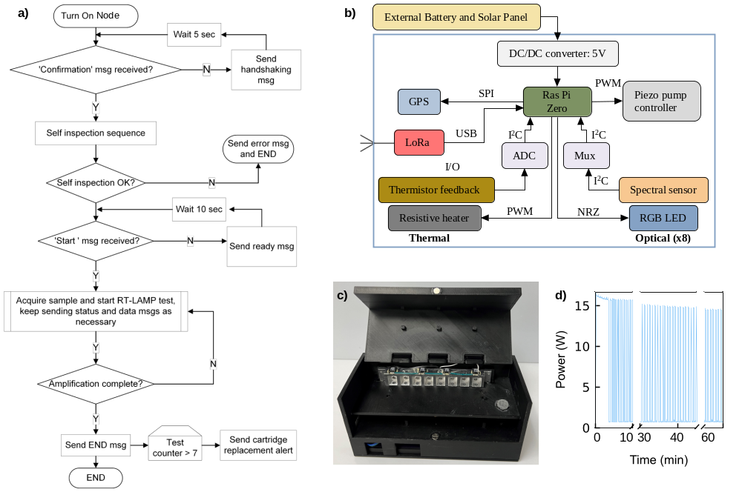
Supplementary Figures
Fig. S1. Additional information regarding the design and operation of the node. (a) Operational flowchart of the node. (b) A brief overview of the electronic hardware design of the node: it consists of a Raspberry Pi Zero, a thermal module that contains a resistive heater and thermistor feedback, an optical module consisting of a blue LED and a multi-channel spectral sensor, a Global Positioning System (GPS) module, a long-range radio (LoRa) module, and piezo-pump controller. The Raspberry Pi Zero microprocessor runs a Linux-based operating system and coordinates between the specific modules. (c) An additional close-up image of the node with the hinged lid open. (d) The node’s real-time power consumption, as recorded using a GW-Instek GPM8310 power meter during the RT-LAMP reaction. After the initial heating period, a ‘square-wave’ pattern was observed, resulting from the heater cycling on and off to maintain the necessary temperature. The total energy consumed per 1-hour test is approximately 5.2 Wh, while standby energy consumption is estimated at ~16 Wh per day.

Fig. S2. Design and operation of Gateway. (a) An Overview of the simple electronic block diagram of the Gateway. A LoRa module interfaced with a Raspberry Pi 4B connected to the internet and running the Firebase Admin SDK to interact with the cloud database (Firebase) hosted on Firestore. (b) Operational flowchart of the Gateway shows the processing of each incoming message from any Node on the network. (c) An image of the simple Gateway in headless mode.

Supplementary Tables
Table S1. RT-LAMP assay primer sequences for SARS-CoV-2 N gene
Primer | Sequence (5’ 3’)
F3 | AACACAAGCTTTCGGCAG
B3 | GAAATTTGGATCTTTGTCATCC
BIP | TGCGGCCAATGTTTGTAATCAGCCAAGGAAATTTTGGGGAC
FIP | CGCATTGGCATGGAAGTCACTTTGATGGCACCTGTGTAG
LF | TTCCTTGTCTGATTAGTTC
LB | ACCTTCGGGAACGTGGTT

Table S2. RT-LAMP assay master mix
Component | Concentration | Volume/reaction (μL)
FIP/BIP primers | 1.6 μM | 0.8
F3/B3 primers | 0.2 μM | 0.25
LF/LB primers | 0.8 μM | 0.40
Isothermal amplification buffer | 1x | 2.50
MgSO₄ | 5 mM | 1.25
Betaine | 0.5 M | 2.50
dNTP | 1.4 mM | 3.50
SYTO-9 green fluorescent | 3 μM | 0.15
Bst 2.0 DNA polymerase | 10 U | 1.25
WarmStart reverse transcriptase | 7.5 U | 0.50
Sample | variable | 10
Ultrapure water |  | 0.45
 |  | Total = 25 μL

Supplementary Videos
Supplementary Video S1. Demonstrates the database design hosted on Google Firestore and the format in which experimental data is stored.
Supplementary Video S2. Demonstrates using the dashboard to view the spatiotemporal data, including historical and live amplification data from multiple nodes transmitted simultaneously.

