Supplementary information

Title: Fully integrated point-of-care testing of blood cell count using multi-frame morphology analysis
Authors: Wenchang Zhang^{a,1*}, Ya Li^{b,1}, Bing Chen^{b,1}, Yuan Zhang^{c}, Ziqiang Du^{d}, Feibin Xiangª, Yu Hu^{d}, Xiaochen Meng^{e}, Chunliang Shang^{f}, Shengfa Liangª, Xiaonan Yang^{d*} and Weihua Guan^{g, h}
ª Key Lab of Microelectronic Devices & Integrated Technology, Institute of Microelectronics, Chinese Academy of Sciences, Beijing 100029, China
^{b} Department of Gastroenterology, The First Affiliated Hospital of Zhengzhou University, Zhengzhou 450052, China
^{c} Key Clinical Laboratory of Henan Province, Department of Clinical Laboratory, The First Affiliated Hospital of Zhengzhou University, Zhengzhou 450052, China
^{d} School of Information Engineering, Zhengzhou University, Zhengzhou 450001, China
^{e} Key Laboratory of the Ministry of Education for Optoelectronic Measurement Technology and Instrument, Beijing Information Science & Technology University, Beijing 100192, China
^{f} Department of Obstetrics and Gynecology, Peking University Third Hospital, Beijing 100191, China
^{g} Department of Electrical Engineering, Pennsylvania State University, University Park 16802, USA
^{h} Department of Biomedical Engineering, Pennsylvania State University, University Park 16802, USA

*Corresponding Authors: zhangwenchang@ime.ac.cn (W. Zhang), iexnyang@zzu.edu. cn (X. Yang), w.guan@psu.edu (W. Guan)

Contents
- Key parameters of the simulation
- Optimization of the cell rotation structure
- Data sets
- YOLO-V4 model and single-frame analysis
- Multi-frame analysis

1. Key parameters of the simulation
Two physics interfaces and one study are used in the simulation model:
- Laminar Flow to model the fluid flow;
- Particle Tracking for Fluid flow to computer the trajectories of RBCs;
- Study 1 (Time dependent) estimates the particle trajectories in the flow.
The key steps of the simulation (cell arrangement and single-cell rotation) are listed in Fig. S2. The material parameters of the liquid include density 1 × 10³ kg/m³ and dynamic viscosity 1 × 10⁻³ Pa·s. The material parameters of RBCs are Young’s modulus 2 × 10⁻³ Pa, Poisson’s ratio 0.33 (dimensionless), and density 7850 kg/m³.

2. Optimization of the cell rotation structure
The shrinkage-expansion structure was designed based on the fact: the laminar flow distribution remains constant in the channel with a fixed size, even if the channel was a 90° swerve (Fig. S3 (A)). When the channel width increases suddenly, the laminar flow distribution width will also increase suddenly. Combined with 90° steering, the cells will be subjected to more asymmetric shear forces in the wide channel area, thus promoting cell rotation (Fig. S3 (B)). We could define the width of the shrinkage and expansion area as w₁ and w₂ respectively, and k = w₂/w₁ as the ratio of the widths. As shown in Fig. S3 (A-C), with k increase from 1 to 2.4, the laminar flow distribution variation is intensified. However, limited by the area of FOV, w₂ could not be increased indefinitely to exacerbate the variation of laminar flow distribution. Meanwhile, with the decrease of w₁, the probability of clot increases correspondingly. Considering that the cell rotation was designed to occur in the FOV, the rectangular channel was adopted to get as enough FOV as possible. Therefore, the shrinkage-expansion structure with widths of w₁ = 30 μm, w₂ = 60 μm (k =2) is used in this work. Moreover, the performance and stability of the cell-rotation structure are verified with a large number of experiments (Sections 3.4, 3.5, and 3.6). The shrinkage-expansion structure in this work is useful and stable for single-cell rotation with improved accuracy of recognition and counting. It seems that our channel with corners was quite simple, and was capable to perform stably in a POCT device.
On the other hand, in order to investigate the influence of the corners, we simulated the structure in Fig. S3 (B) with different chamfers (r = 5, 10, and 15 μm). As shown in Fig. S3 (D-F), compared with the width ratio k the corners introduce little influence on the laminar flow distribution.

3. Data sets
Pure RBCs, WBCs, and PLTs were used for training sets. The pure RBCs and WBCs were obtained from human whole blood by using a lymphocyte separation medium (Solarbio, Beijing, China). Briefly, equal volume lymphocyte lysis separation solutions were added into whole blood, followed by centrifugation at 400 g for 20 min to get four layers. Pure PLTs, WBCs, and RBCs were collected carefully from the top layer, second layer, and bottom layer, respectively, and washed using phosphate-buffered saline three times.
Before training, about 2,900 RBC images, 2,350 WBC images, and 2,350 PLT images were collected and divided into the training set, the validation set, and the test set. The total set contained 4,000 training images (2,000 RBCs, 1,000 WBCs, and 1,000 PLTs), 1,100 validation images (400 RBC, 350 WBC, and 350 PLT), and 2,500 test images (500 RBCs, 1,000 WBCs, and 1,000 PLTs, more specifically, the ground truth of these three types of cells in the test set images were 1,000, 1,000, and 1,000, respectively.). During the production of the dataset, cells in each image were manually marked as "RBC", "WBC" or "PLT" according to their ground truth with the aid of a labeling tool called "Colabeler". To obtain a better recognition effect, the image size in the data set was unified to be 540 × 800 pixels and all the raw images were pre-processed by image processing programs, including gray mapping and image sharpening, etc.
4. YOLO-V4 model and single-frame analysis
In this study, YOLO-V4 was used to detect cells in image sequences. YOLO-V4 is an open-source object detection model that can classify and localize objects with high accuracy, meanwhile, it also has excellent detection capability for small-sized or obscured objects, which is expected to perform the detection of blood cells excellently. For the training process, the model’s parameters were set as follows: the momentum was set to 0.949, the initial learning rate was 0.001, the weight decay was 0.0005, and the batch size and the subdivisions were set to 64 and 16 respectively. To better analyze the training process, 10,000 iterations were performed. As the training progressed, the learning rate was set to 0.0001 at 8,000 steps and 0.00001 at 9,000 steps. In the calculation of the validation set and the test set, the confidence thresh was 0.25 and the intersection over union (IOU) thresh was 0.5.
Four key parameters, precision, recall, average precision (AP), and mean average precision (mAP) were introduced to evaluate the performance of the model. Precision refers to the proportion of positive samples among the predicted positive samples, and recall refers to the proportion of predicted positive samples among the actual total positive samples. AP refers to the area under the precision-recall (PR) curve and mAP represents the mean value of AP of the three types of cells. They were defined as follows:
$Precision=\frac{TP}{TP+FP}$ (1)
$Recall=\frac{TP}{TP+FN}$ (2)
$AP=\int_{0}^{1}{Precision ⋅Recall} dr$ (3)
Where TP, FN, and FP represented the number of true positives, false negatives, and false positives. r represents the integral variable, which is used to determine the integral of Precision-Recall and is between 0 and 1.
The learning history from the model training experiments during iterations could be seen in Figure.5(a). In the initial stage of the training process, the learning efficiency of the model was higher, and the convergence speed of the curve was faster. As the training proceeded, the slope of the training curve gradually decreased. Finally, when the training iterations reached about 10,000 iterations, the learning of the model gradually saturated, and the final loss value was stable at approximately 0.55. The mAP curve of the validation set also showed a similar trend. It is shown that the model converged at 10,000 iterations and the final mAP value of the validation set reaches 98.48%. This was consistent with the trend of convergence of the loss curve, indicating that the training converged as expected and worked well.
After training, the test set was used to evaluate the performance of the trained model. The statistical confusion matrix based on the detection results of the test set is shown in Figure.5(b), and to intuitively verify the performance of the trained model, PR(Precision-Recall) curves of the test set were drawn through the well-trained model. The area enclosed by the PR curve and the two coordinate axes is AP (Average Precision), which represents the average detection accuracy of this type of cell. As shown in Figure.5(c), the AP of the three types of cells all reached 0.9843 or higher, which indicates a very high detection accuracy.
5. Multi-frame analysis
Cells detection had achieved high accuracy in this model, but from the detection results, we found that some discontinuous misidentifications or missed identifications may occur due to differences in imaging angles when cells were turned over in the microfluidic channels with reduced-expanded structures. The accuracy of cell detection still had some room for improvement, and this improvement was expected to be realized in the data correlation of multiple frames.
To quantitatively compare the single-frame-based detection (Traditional static cell detection) and the multi-frame-based correlation detection in terms of recognition effect, here we took WBCs as an example and analyzed the detection results of 500 WBCs in the background of complete blood cells in their respective consecutive 5 frames.
To simulate the traditional single-frame analysis method based on static single-angle imaging, a random algorithm was used in this study to randomly select one of the 5 consecutive frames of each cell (WBCs and RBCs with misidentified occurred in the background) as the detection result. AP values based on the detection results obtained in 1000 random experiments were calculated, respectively, and the distribution of these values is shown on the left side of Figure.5(d). Statistical results showed that the minimum AP value obtained in the randomized experiment was 0.7837 and the maximum value was 0.9807, and the interval of numerical dispersion based on the mean and standard deviation (Mean ± σ) was between 0.8174 and 0.9071.
In the multi-frame correlation detection method, the number of times a cell was identified as WBC in consecutive frames was recorded as n (1 ≤ n ≤ 5). Then, different n-values were used as the threshold to make a secondary classification decision on the target cell as the multi-frame detection result. Similarly, based on the detection results obtained from different thresholds, we calculated these corresponding AP values, as shown on the right side of Figure.5(d). Different AP values indicate that when the threshold n was taken at the value of non-endpoints, the AP of multi-frame detection was significantly improved compared to the average AP of 0.8622 for single-frame detection. In particular, the AP of the method reaches as high as 0.9934 when n was taken as 3. Here, we also discussed the cases of n = 1 and n = 5, while n = 1, the method presented an over-relaxed state, that was, no false positive suppression on the classification results, a large number of non-contiguous frames of cell misidentification caused by RBCs flip greatly reduced the accuracy of WBCs identification, resulting in a lower AP; While n = 5, the method presented an overly strict state, that was, the cells were not allowed to miss at each frame, which was reflected in the decline of the recall of WBCs, resulting in a lower AP. In summary, with a reasonable threshold setting, this multi-frame correlation detection method had a significant improvement in the average accuracy of WBCs detection.

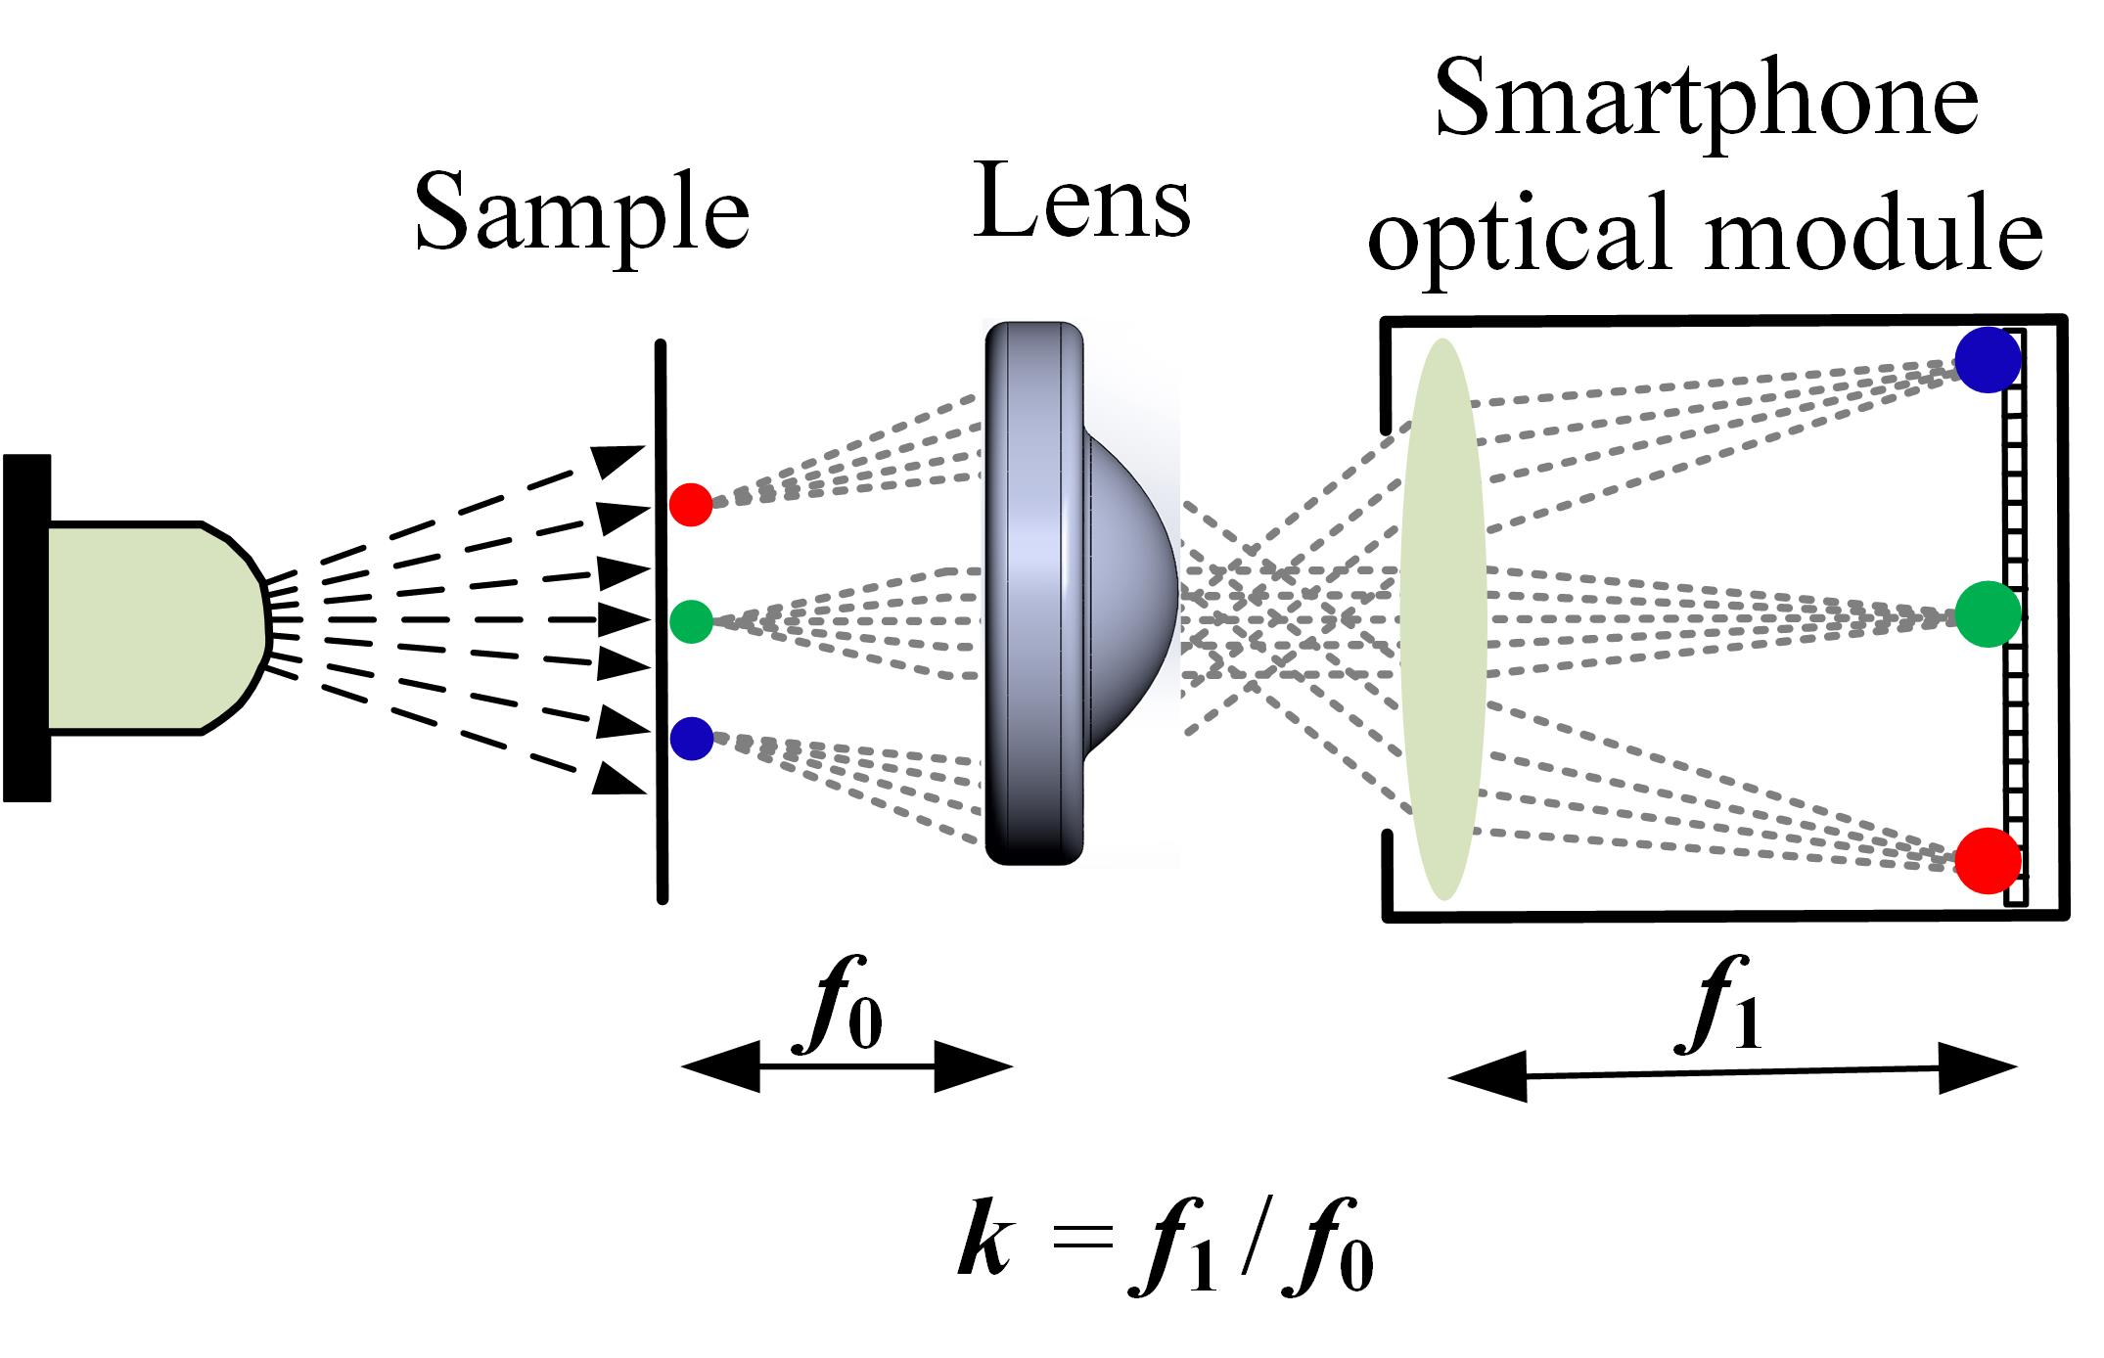
Figure. S1 The schematic of the smartphone-based single-lens microscope. The optical magnification depends on the focal length ratio of the smartphone optical module (f₁) and the external single-lens (f₀).

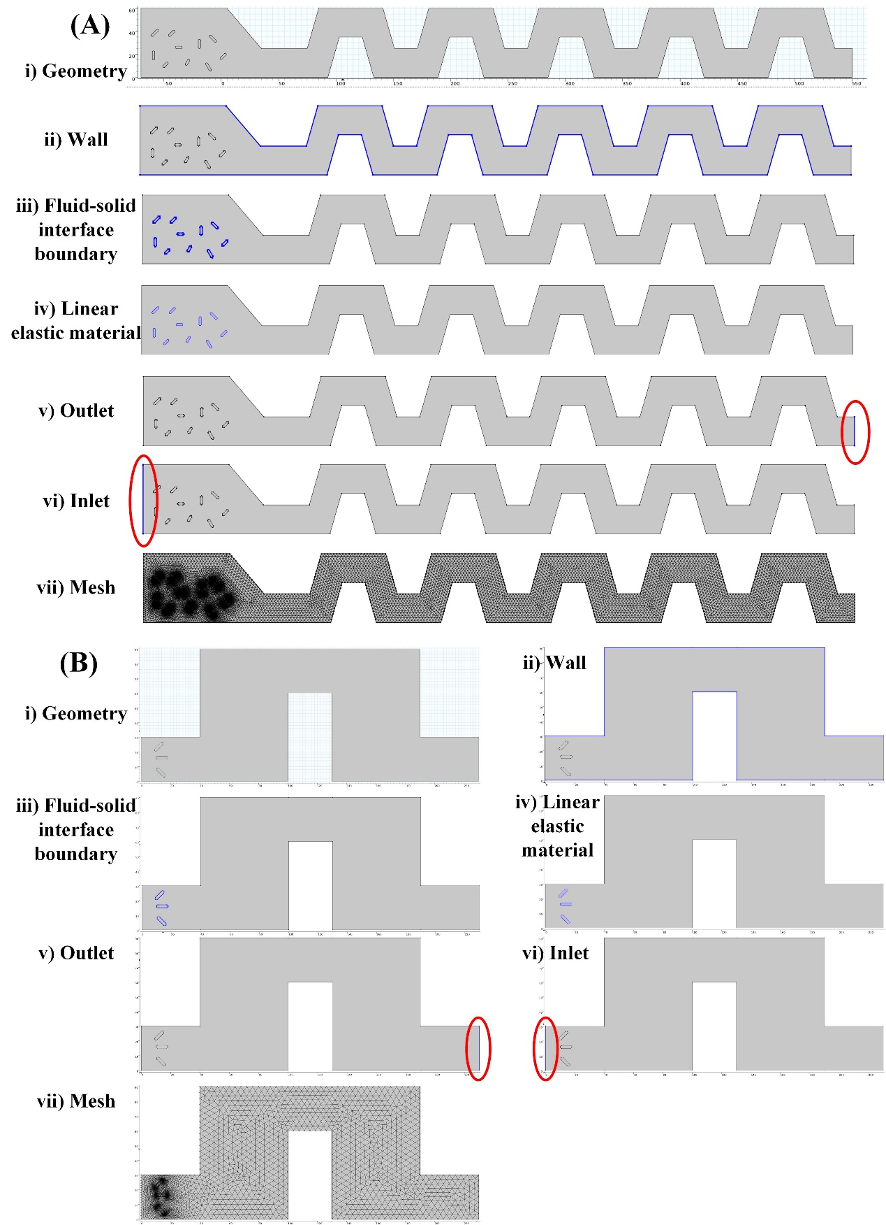
Fig. S2 Key steps of the simulation with Comsol Multiphysics 5.6. (A) The steps of simulation single-cell arrangement structure. (B) The steps of simulation cell rotation structure. ⅰ) Geometry; ⅱ) Wall; ⅲ) Fluid-solid interface boundary; ⅳ) Linear elastic material; ⅴ) Outlet; ⅵ) Inlet; ⅶ) Mesh.

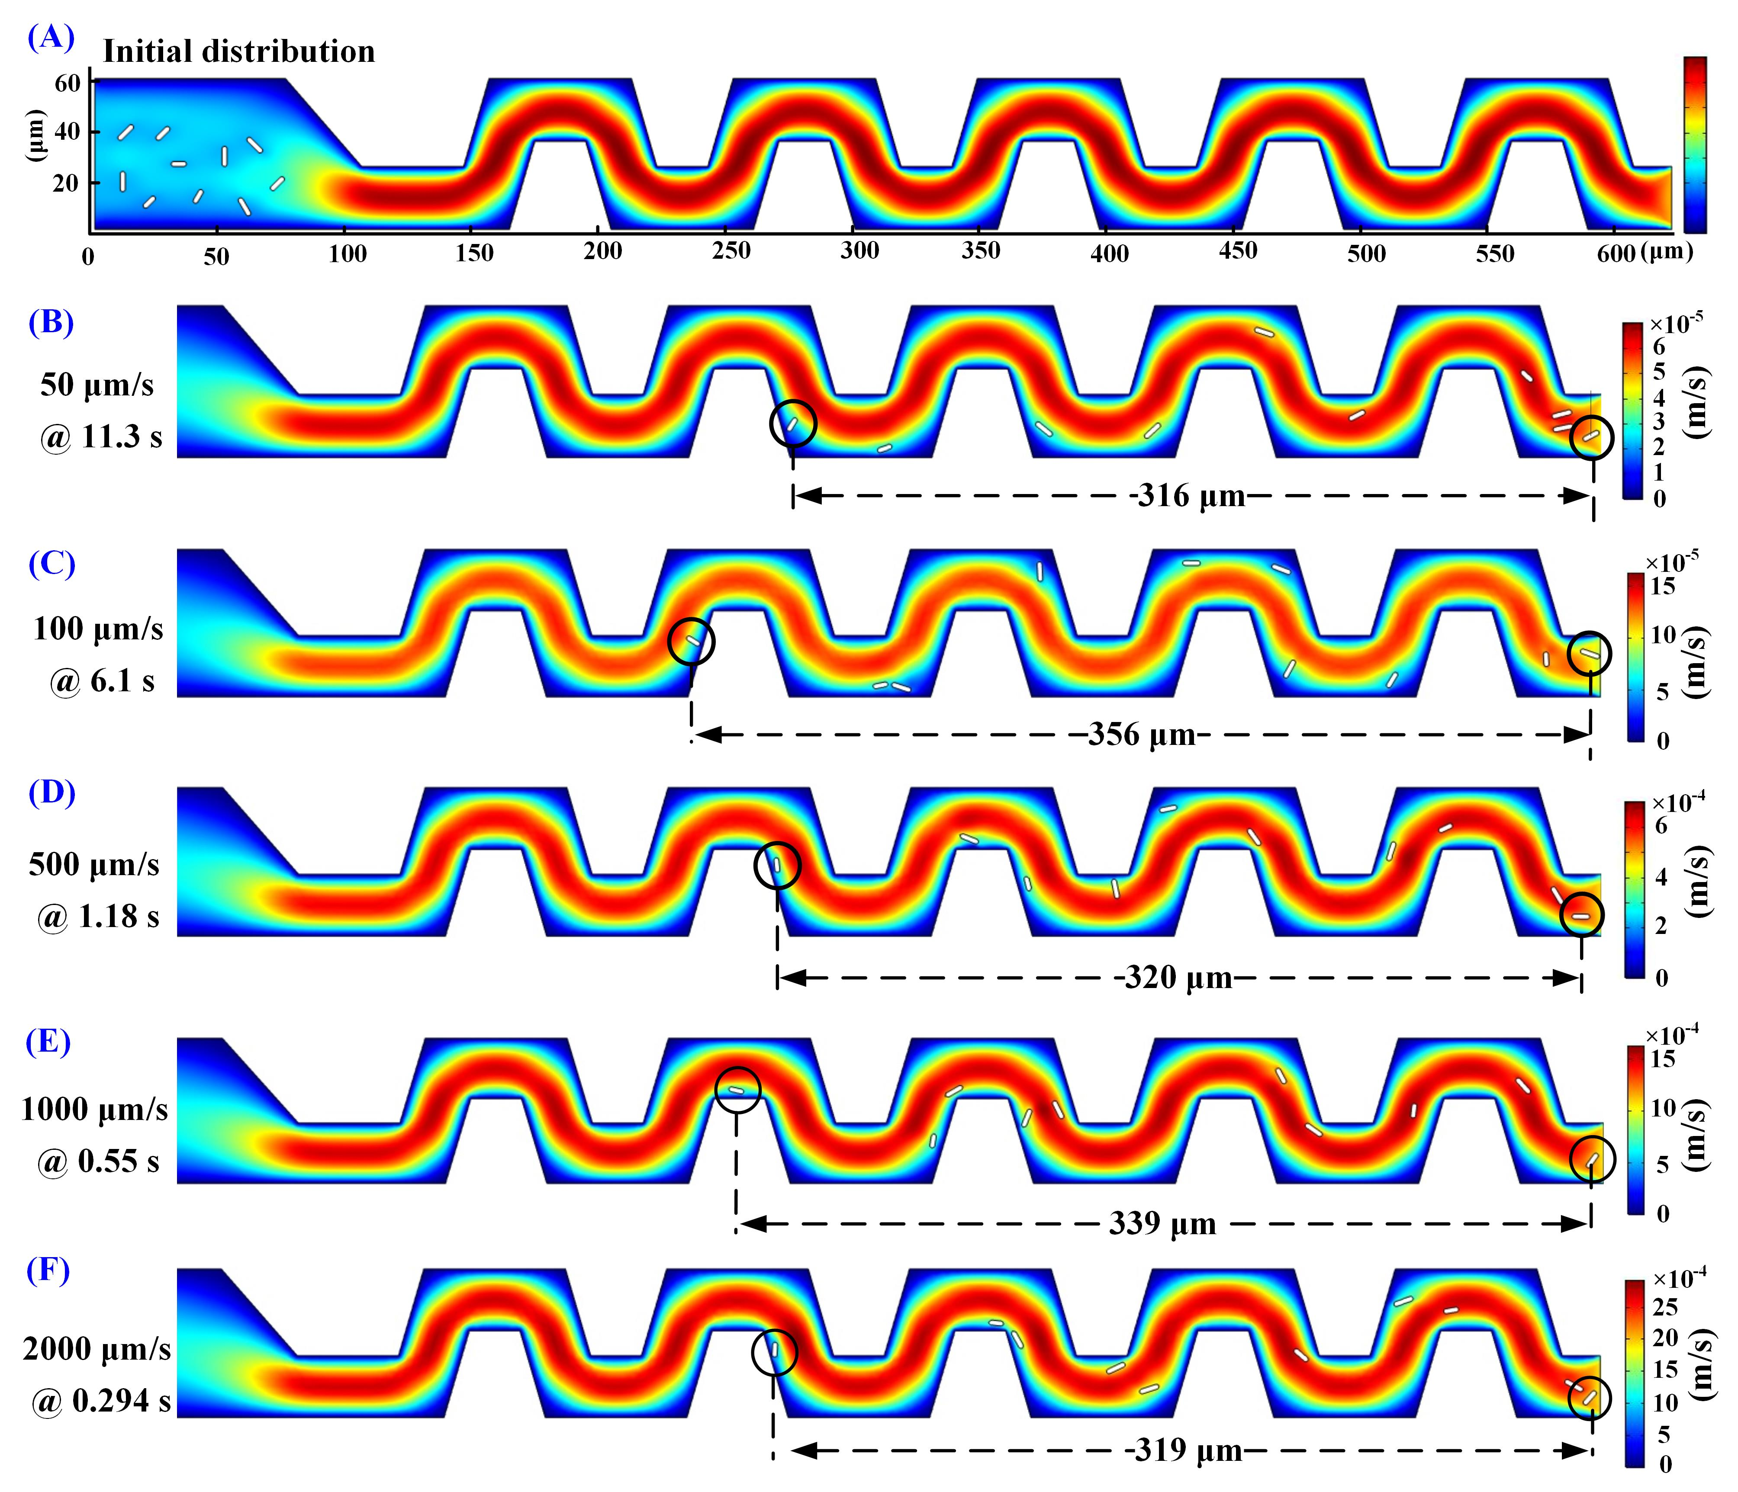
Fig. S3 Simulation results of straight-line pattern arrangement of various outlet velocities ($\overline{V_{o}}$). (A) Steady-state velocity field distribution. (B) $\overline{V_{o}}$= 50 μm/s. The first RBC reaches the outlet at 11.3 s, and the distance between the first and last RBCs is 316 μm. (C) $\overline{V_{o}}$= 100 μm/s. The first RBC reaches the outlet at 6.1 s, and the distance between the first and last RBCs is 356 μm. (D) $\overline{V_{o}}$= 500 μm/s. The first RBC reaches the outlet at 1.18 s, and the distance between the first and last RBCs is 320 μm. (E) $\overline{V_{o}}$= 1,000 μm/s. The first RBC reaches the outlet at 0.55 s, and the distance between the first and last RBCs is 339 μm. (F) $\overline{V_{o}}$= 2,000 μm/s. The first RBC reaches the outlet at 0.294 s, and the distance between the first and last RBCs is 319 μm.
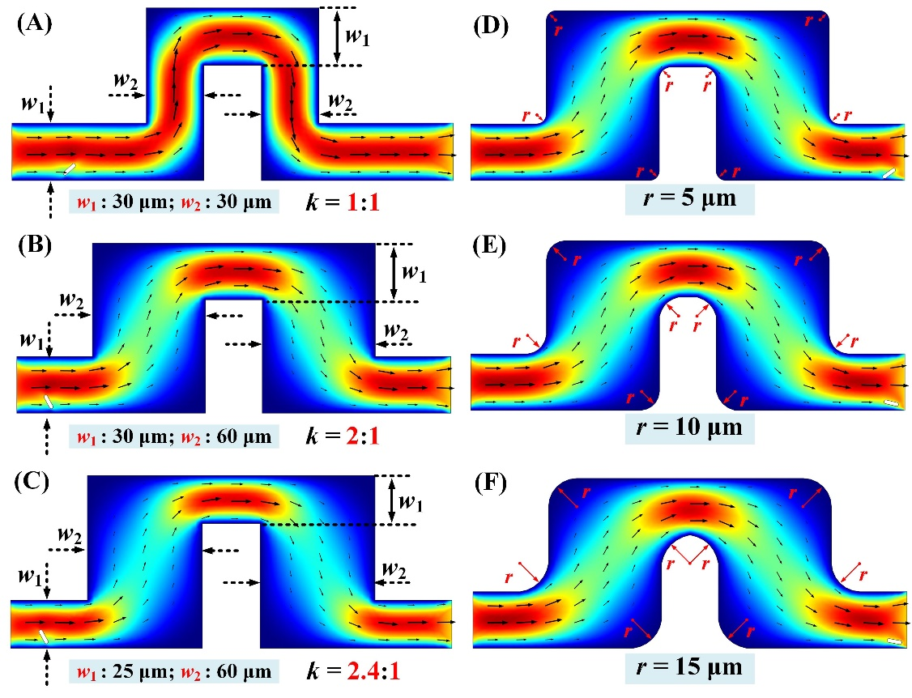
Fig. S4 Simulation results of single-cell rotation in different channel structures. (A) Laminar flow distribution of a channel with a fixed size and a 90° swerve (w₁ = 30 μm, w₂ = 30μm, k = 1). (B) Laminar flow distribution of a shrinkage-expansion structure (w₁ = 30 μm, w₂ = 60 μm, k = 2). (C) Laminar flow distribution of a shrinkage-expansion structure (w₁ = 25 μm, w₂ = 60 μm, k = 2.4). (D) Laminar flow distribution of a shrinkage-expansion structure with chamfers (r = 5 μm). (E) Laminar flow distribution of a shrinkage-expansion structure with chamfers (r = 10 μm)). (F) Laminar flow distribution of a shrinkage-expansion structure with chamfers (r = 15 μm)).

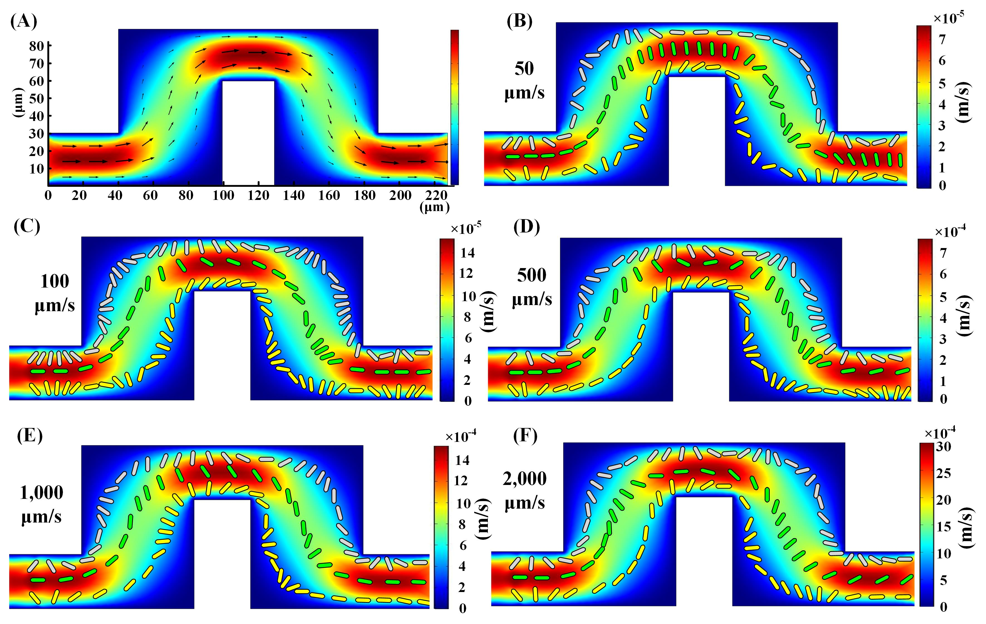
Fig. S5 Simulation results of single-cell rotation of various outlet velocities ($\overline{V_{o}}$) and different RBC initial positions. (A) Steady-state velocity field distribution. (B)The trajectories and posture angles of RBCs when $\overline{V_{o}}$= 50 μm/s. (C)The trajectories and posture angles of RBCs when $\overline{V_{o}}$= 100 μm/s. (D)The trajectories and posture angles of RBCs when $\overline{V_{o}}$= 500 μm/s. (E) The trajectories and posture angles of RBCs when $\overline{V_{o}}$= 1,000 μm/s. (F) The trajectories and posture angles of RBCs when $\overline{V_{o}}$= 2,000 μm/s.

Supplementary Table S1. Bill of materials (excluding the smartphone)
System | Description | Function | Unit cost ($) | Unit Qty. | Ext. Cost ($)
Electronics | Trimmer Potentiometer, 3296W, 100 Ω | DC motor Voltage regulating | 0.34 | 1 | 0.34
Electronics | Trimmer Potentiometer, 3296W, 100 Ω | LED Voltage regulating | 0.34 | 1 | 0.34
Electronics | Trimmer Potentiometer, 3296W, 100 Ω | Pump Voltage regulating | 0.34 | 1 | 0.34
Electronics | Resistor, 100 Ω, 1%, 0603 | Resistor for DC motor, LED, Pump | 0.01 | 3 | 0.03
Electronics | Capacitor 4.7 µF | Power stabilizing | 0.01 | 3 | 0.03
Electronics | Tantalum Capacitor, 10µF, 16V | Power stabilizing | 0.01 | 3 | 0.03
Electronics | Aluminum Capacitors, 100µF, 50V | Power stabilizing | 0.01 | 3 | 0.03
Electronics | AMS1117-ADJ | Power chip | 0.018 | 3 | 0.054
Electronics | Lithium-ion battery, 3.7V, 8000 mAh | Battery | 3.3 | 1 | 3.3
LED | 510~530 nm (Green), 1W | LED | 0.13 | 1 | 0.13
Pump | Mini vacuum pump, 0.28L/min | Liquid and sample driving | 0.97 | 1 | 0.97
Servo | Micro-size DC motor | Actuation of the magnetic stirrer | 0.82 | 1 | 0.82
Guideway | Msism, stainless steel mini guideway | IOM slide | 10.25 | 1 | 10.25
Optics | Mounted Aspheric Lens, C392TME-A | Extra single lens | 95.25 | 1 | 95.25
Enclosure | Lens sleeve | Extra single-lens mounting | 2.10 | 1 | 2.10
Enclosure | Pogopin, spring contact pins (4-PIN) | The electrical connection of IOM | 1.12 | 2 | 2.24
Enclosure | Spring contact pins holder (4-PIN) | The electrical connection of IOM | 0.84 | 2 | 1.68
Enclosure | Spring clasp, PR4PK | IOM locking and releasing | 1.91 | 1 | 1.91
Enclosure | 3D-printed based case | Device base case | 17.57 | 1 | 17.57
Enclosure | 3D printed chip clamp | Chip and single-lens assembling | 7.03 | 1 | 7.03
Total Cost |  |  | ~144.44

Supplementary Table S2. Microfluidic chip & reagent cost
Reagents | Vendors | Function | Stock specifications | Unit Cost ($) | Consume/test | Ext.Cost ($)/test
PDMS | SYLGARDTM | Chip fabrication | 1100 g | 126.19 | 5 g | 0.574
PBS (1X) | GibcoTM | Blood dilution | 1000 mL | 94.29 | 147 μL | 0.014
BSA (10X) | Thermo Scientific™ | Chip blocker | 200 mL | 342.18 | 40 μL | 0.068
Coverslip | Citotest® | Chip fabrication | 100 pcs | 2.10 | 1 pcs | 0.021
Micro stirrer | BYly | Magnetic stirring | 1 pcs | 0.18 | 1 pcs | 0.18
Total Cost |  |  |  |  |  | 0.857
Supplementary Table S3．Results of double-blind trial and error analysis
Sample No | LH750 |  | In-flow imaging |  | Errors (%)
Sample No | R_{R/W} | R_{P/W} | R_{R/W} | R_{P/W} | E_{R/W} | E_{P/W}
S₁ | 412.68 | 22.68 | 441.63 | 21.57 | 7.02 | -4.86
S₂ | 340.68 | 9.24 | 362.87 | 9.96 | 6.51 | 7.80
S₃ | 250.72 | 15.87 | 245.12 | 14.31 | -2.23 | -9.83
S₄ | 1,273.63 | 56.72 | 1,271.56 | 58.16 | -0.16 | 2.54
S₅ | 1,187.50 | 11.25 | 1,265.36 | 11.72 | 6.56 | 4.20
S₆ | 207.55 | 10.19 | 217.19 | 10.81 | 4.64 | 6.07
S₇ | 527.89 | 1.99 | 519.23 | 2.12 | -1.64 | 6.40
S₈ | 911.21 | 3.97 | 947.19 | 4.04 | 3.95 | 1.71
S₉ | 213.55 | 2.26 | 226.14 | 2.43 | 5.90 | 7.76
S₁₀ | 578.00 | 9.00 | 538.64 | 8.75 | -6.81 | -2.78

