Contents
Supplementary Figures 2
Supplementary Tables 4
Supplementary Videos 6

Supplementary Figures

Figure S2. Portable device materials, reagent volumes, and vacuum procedure. a) Photograph of the portable device with the top lid removed. The inset graphic shows the circuit schematic for the device. b) Internal components of the sealable package included a preloaded cartridge (reagents in c.), silica column, and a disposable pipette. c) Volume measurements of each buffer pre-allocated into the cartridge prior to vacuum sealing. d) Procedure for storage. Vacuum sealing is conducted with a FoodSaver©.

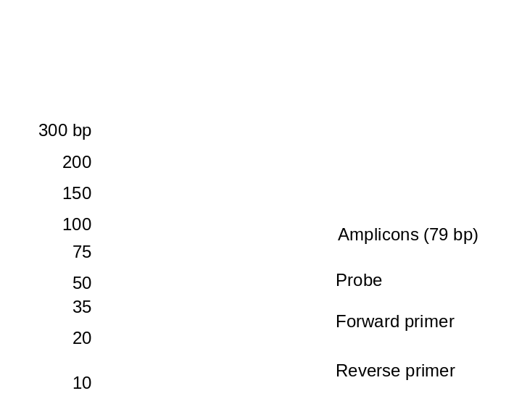

Figure S1. Gel electrophoresis confirmation of qRT-PCR assay. No Target Control (NTC) shows no realization of the amplicon band at 79 bp. Positive Control (PC @ 10⁵ copies/rxn) demonstrates the amplification of the target region. The faint bands smaller than the amplicons are assay components (ex. Probe, Forward and Reverse primers).
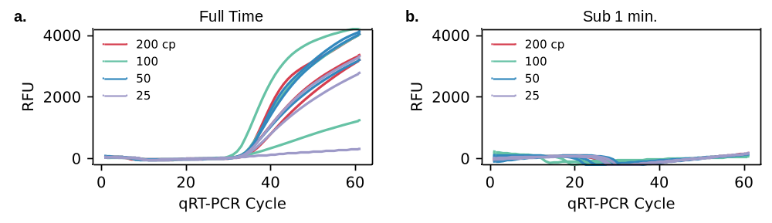
Figure S3. Performance of sub 1 minute protocol a) Amplification curves for samples extracted using the portable device at the full-time protocol. All samples from 200 down to 25 copies per 100 µL sample were detected. b) Amplification curves for samples extracted using the portable device using the reduced time protocol below 1 minute. No samples from 200 down to 25 copies per 100 µL sample were detected.
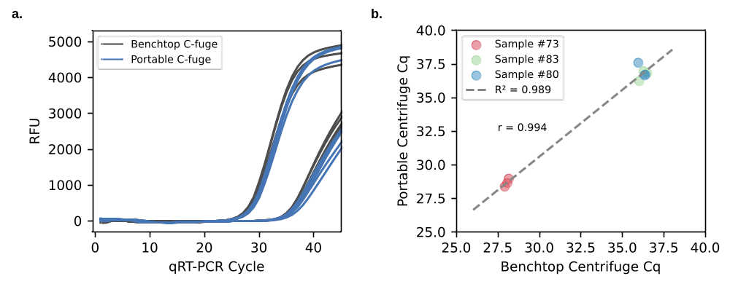
Figure S4. Extraction performance with archived clinical samples. a) Amplification curves for samples extracted using the benchtop device (gray) and portable device (blue). 50 µl of archived plasma were used for each method. b) Quantification cycle (C_{q}) comparison between benchtop and portable methods. Three samples were tested in triplicate, showing very strong agreement (r = 0.994) and very strong linearity (R² = 0.989).

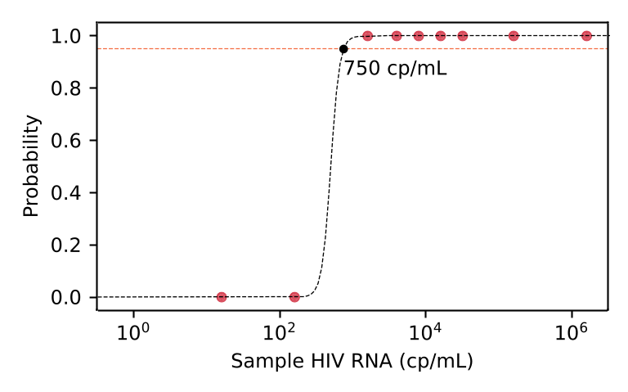
Figure S5. Probability analysis of samples using our device. Hit curve analysis of our samples from main Figure 4 (red data points) shows great range and strong probability of detection. Samples were converted to the more clinically relevant concentration label of ‘cp/mL’. The data shows a modest limit of detection at 93 copies/mL when using a confidence level of 95% (orange horizontal line).

Supplementary Tables

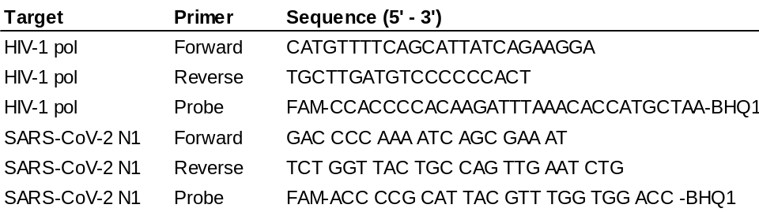
Table S1. qRT-PCR Primers & Probes

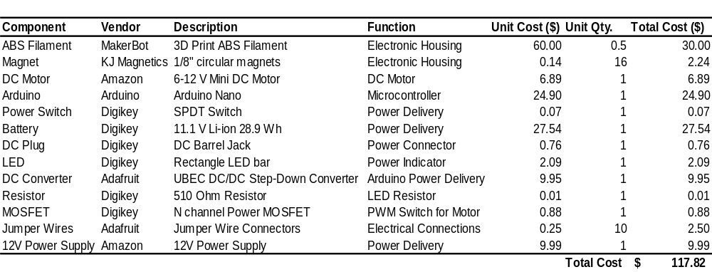
Table S2. Portable centrifuge BOM

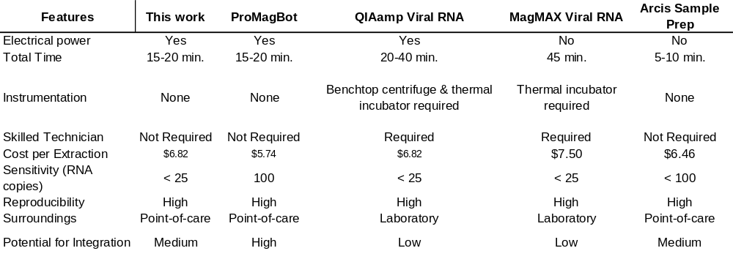
Table S3. Nucleic Acid Extraction Protocols

Supplementary Videos

Supplementary Video S1. (Duration 1 m 25 s) Demonstration of steps using the extraction kit and portable centrifuge for processing a sample.

