Supplementary Figures and captions
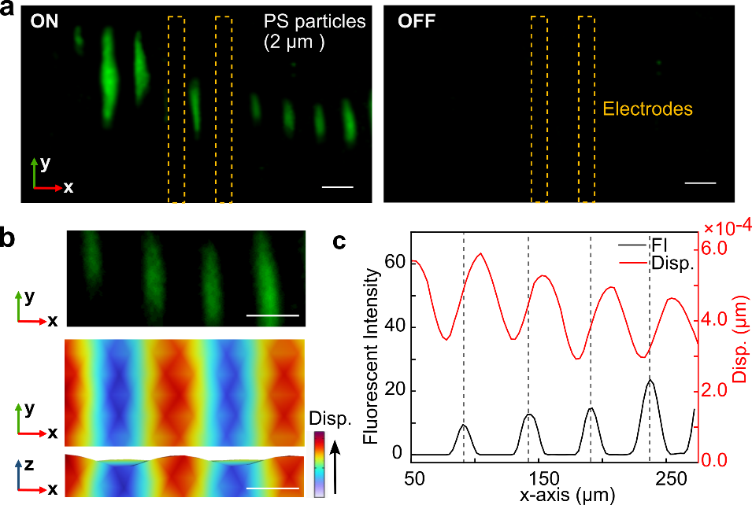
Supplementary Fig. 1. Characterization of acoustic enrichment. (a) Distribution of the microbeads with (ON) and without (OFF) acoustic enrichment. (b) Comparison of the distribution of enriched microbeads and acoustic wave simulation results with the actual particle enrichment at the same positions. (c) Quantification of acoustic displacements on the piezoelectric substrate and the microbeads distribution measured by fluorescence intensity. The zero point of the x-axis is the axes of symmetry. Scale bar: 50 µm.

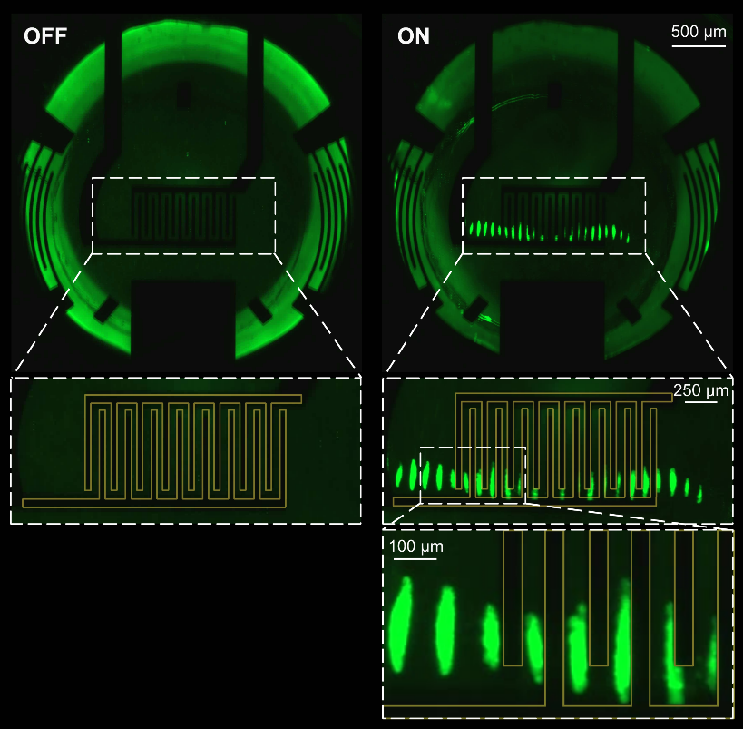
Supplementary Fig. 2. Distribution of green fluorescence microbeads without (OFF) and with (ON) acoustic enrichment. Zoom in image of enriched microbeads over the multiple pair of electrodes (indicated by yellow lines) of the organic electrochemical transistor (OECT) sensor.

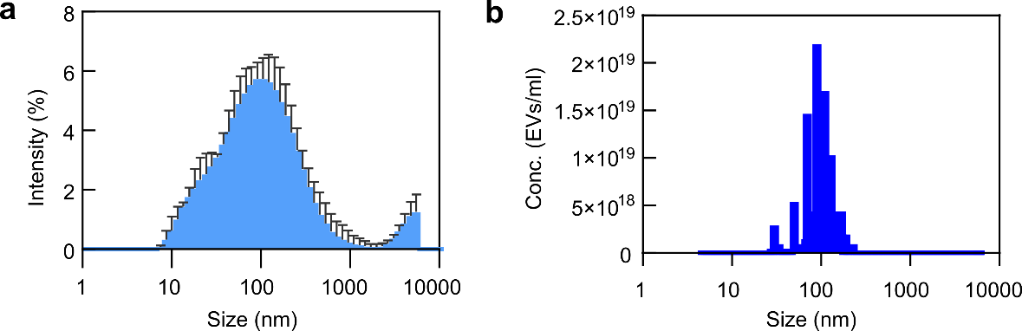
Supplementary Fig. 3. Characterization of EVs purified from AD patient samples. Dynamic light scattering(DLS) (a) and nanoparticle tracking analysis (NTA) (b) showed the size distribution and total concentration of EVs.

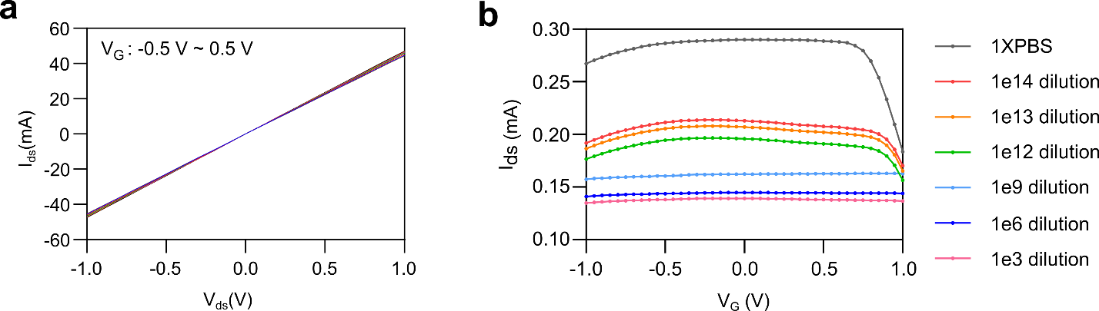
Supplementary Fig. 4. Characterization of OECT sensing. (a) The transfer curve of the baseline showed excellent linearity. (b) The representative transition curve for EV detection in AD patient samples. Each curve indicated a different dilution factor or baseline (1XPBS). The curve shifted further down based on the EV concentration.

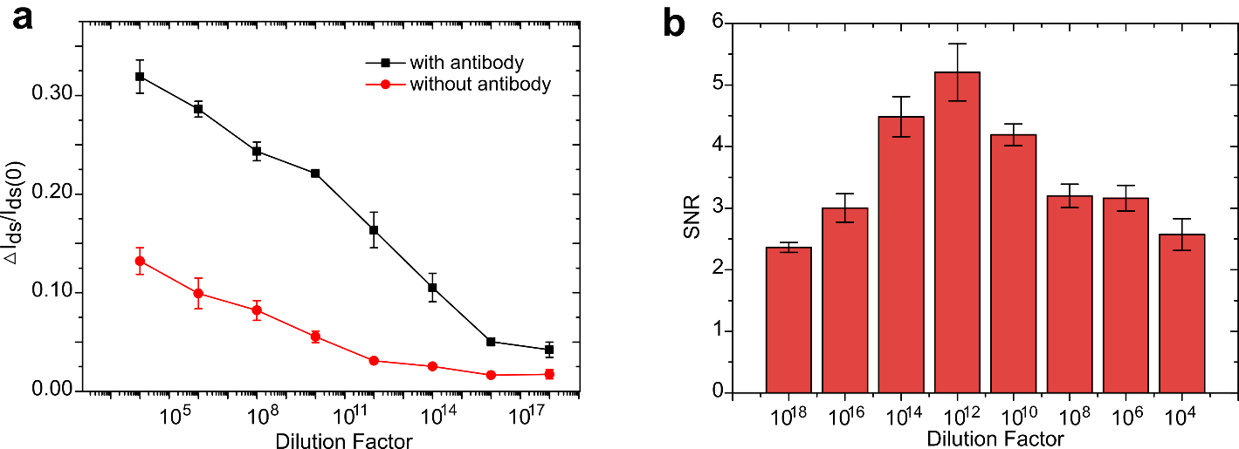

Supplementary Fig. 5. Optimization of OECT sensing. (a) The response of the integrated POCT sensor modified/unmodified antibodies for detecting AD serum in different dilutions. The signal/noise is defined by the response of the device with/without modification. (b) The calculated signal-to-noise ratio (SNR) in various dilutions.

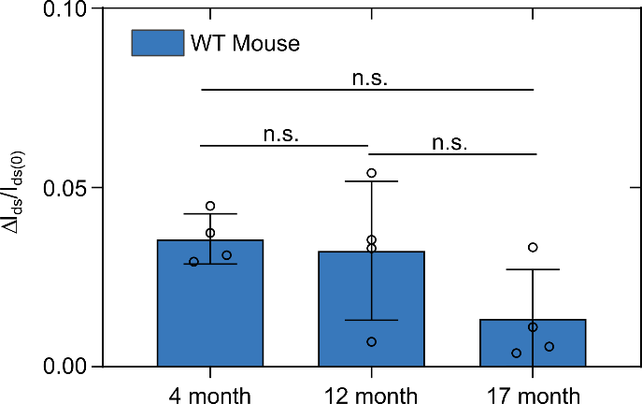
Supplementary Fig. 6. Longitudinal EV sensing of wide-type (WT) mice. There was no significant difference among the different time points, and the variations over different time points were within the baseline range (0.027 ± 0.016).

