Capstone Project

Introduction

Business problem
It is aimed to build a model to predict the severity of an accident based on a database which contains a set of accident severity data. This model is prepared for the local transportation department and this model may be used to set up diverted routes, and temporary speed limits etc.

Data

General description of the dataset
The dataset contains 194673 attributes and 38 columns. The general information of the dataset is shown below.
# Column Non-Null Count Dtype
--- ------ -------------- -----
0 SEVERITYCODE 194673 non-null int64
1 X 189339 non-null float64
2 Y 189339 non-null float64
3 OBJECTID 194673 non-null int64
4 INCKEY 194673 non-null int64
5 COLDETKEY 194673 non-null int64
6 REPORTNO 194673 non-null object
7 STATUS 194673 non-null object
8 ADDRTYPE 192747 non-null object
9 INTKEY 65070 non-null float64
10 LOCATION 191996 non-null object
11 EXCEPTRSNCODE 84811 non-null object
12 EXCEPTRSNDESC 5638 non-null object
13 SEVERITYCODE.1 194673 non-null int64
14 SEVERITYDESC 194673 non-null object
15 COLLISIONTYPE 189769 non-null object
16 PERSONCOUNT 194673 non-null int64
17 PEDCOUNT 194673 non-null int64
18 PEDCYLCOUNT 194673 non-null int64
19 VEHCOUNT 194673 non-null int64
20 INCDATE 194673 non-null object
21 INCDTTM 194673 non-null object
22 JUNCTIONTYPE 188344 non-null object
23 SDOT_COLCODE 194673 non-null int64
24 SDOT_COLDESC 194673 non-null object
25 INATTENTIONIND 29805 non-null object
26 UNDERINFL 189789 non-null object
27 WEATHER 189592 non-null object
28 ROADCOND 189661 non-null object
29 LIGHTCOND 189503 non-null object
30 PEDROWNOTGRNT 4667 non-null object
31 SDOTCOLNUM 114936 non-null float64
32 SPEEDING 9333 non-null object
33 ST_COLCODE 194655 non-null object
34 ST_COLDESC 189769 non-null object
35 SEGLANEKEY 194673 non-null int64
36 CROSSWALKKEY 194673 non-null int64
37 HITPARKEDCAR 194673 non-null object

The aim of this project is to predict the severity which is described by the severity code. The description of the codes are:
- Code 1: Property Damage Only Collision, and
- Code 2: Injury Collision.

The number of different severity is shown in Figure 1.
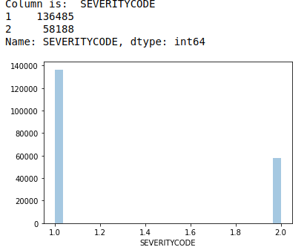Figure 1: Number of different severity in the data set
19 number columns contains NaN value, and the percentage of NaN in 7 columns exceeds 30%, as shown in Figure 2.
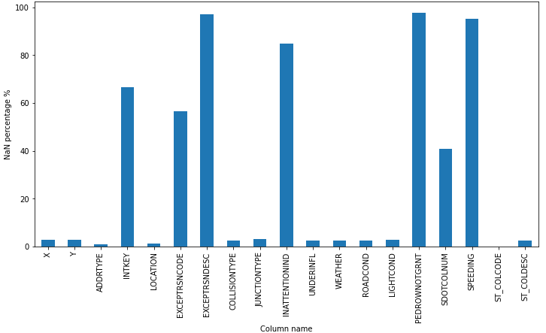Figure 2: Columns having NaN values and the percentage of NaN

Data cleaning

Columns containing coordinates, id and unexplainable information
Columns which are clearly not related to the severity of an accident are X, Y, OBJECTID, INCKEY, INTKEY, STATUS, LOCATION, EXCEPTRSNCODE, EXCEPTRSNDESC, UNDERINFL, ST_COLDESC, SEGLANEKEY, UNDERINFLL.

Column PERSONCOUNT, PEDCOUNT, and PEDCYLCOUNT
The involved persons column “PERSONCOUNT” includes the persons within the vehicle. This is not strongly related to an accident severity. This column will be removed from any further analysis.
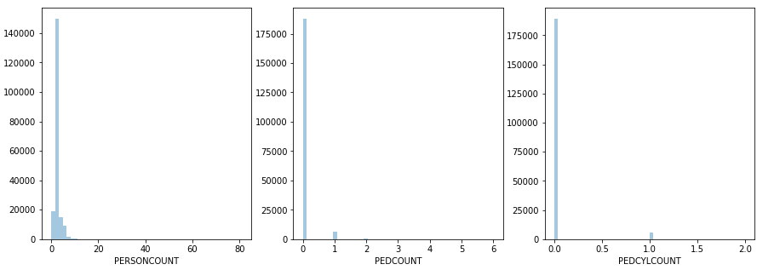Figure 3: Attributes and distributions of PERSONCOUNT, PEDCOUNT AND PEDCLYCOUNT
The involved pedestrians and cyclists “PEDCYLCOUNT” includes the pedestrian count “PEDCOUNT”. Therefore the “PEDCOUNT” column is redundant data, and it will be removed from any further analysis.

Column WEATHER and ROADCOND
The attributes in the column WEATHER are “Raining”, “Clear” , “Unknown” etc . The attributes in column ROADCOND are “Wet”, “Dry”, “Unknown” etc. These two columns have redundant information. Therefore, only the ROADCOND column is considered for further analysis.

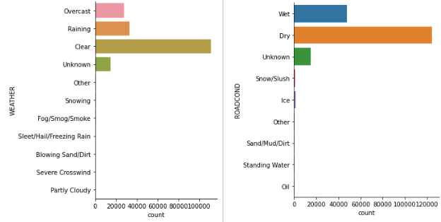Figure 4: Attributes and distribution of column WEATHER and ROADCOND

Column SDOT_COLDESC, and SDOT_COLCODE
Columen SDOT_COLDESC is the description of the column SDOT_COLCODE, which is the indication of the collision type. This is likely related to the accident severity.
Therefore, column SDOT_COLCODE will be used for further analysis. Column SDOT_COLDESC will be removed as redundant information.

Summary of the columns to be removed
As discussed above, some columns will not be considered in further analysis and modelling. They are summarised in Table 1.
Table 1: Columns not considered in further analysis and modelling to predict accident severity
Column name | Reasons not included in further analysis
X | They are the coordinates which are not related to the accident severity
Y
SEVERITYDESC and SEVERITYCODE.1 | SEVERITYCODE.1 is the same as SEVERITYCODE. SEVERITYDESC is the description of SEVERITYCODE. Therefore, these two columns are redundant information.
OBJECTID | An identification number which is not related to the accident severity
INCKEY, INTKEY
INATTENTIONIND, INATTENTIONIND | Meaningless column, removed
STATUS | This contains binary information “Match” and “Unmatch” however what status are they are not clear. Therefore, this column is not used for further analysis
LOCATION | Accurate address of an accident, which is not related to the severity
EXCEPTRSNCODE | More than 50% data is NaN
EXCEPTRSNDESC | More than 90% data is NaN
UNDERINFL | This contains binary data “N”, “Y”, 0 and 1. However the meaning of these data is unknown. Therefore this column is not considered in further analysis
ST_COLDESC | This is the description of ST_COLCODE.
SEGLANEKEY | An identification number and not related to the accident sereviry
CROSSWALKKEY
PERSONCOUNT | Redundant information of PEDCOUNT
PEDCYLCOUNT | Redundant information of PEDCOUNT
WEATHER | Redundant information of ROADCOND
SDOT_COLDESC | Redundant information of SDOT_COLCODE
JUNCTIONTYPE | Redundant information of ADDTYPE

Data organisation for modelling

Collision type
The collision type does not have a clear patten related to the accident severity as shown in Figure 5.
For example, “Angles” is recorded more than 35000, however, this can be severe and not severe. Therefore, this column is removed for any further analysis.
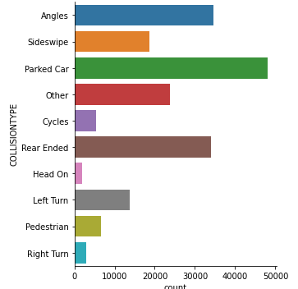Figure 5: Collision type

Speeding
In the original data only 9333 over 194673 cases are recorded as speeding. The majority is remaining NaN. It is assumed that the remaining data is not on the condition of over speed.
[“Y”, “N”] are replaced by [1, 0]. The distribution plot is shown in Figure 6.
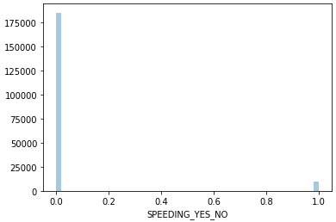Figure 6: Speeding distribution plot
Address type
xxx
Road condition
xxx
light condition
xxx

