Github 简明教程

创建ssh key

先生成一个key

<https://help.github.com/en/github/authenticating-to-github/connecting-to-github-with-ssh>

在C盘创建的文件夹code中右击Open Git Bash here

$ ssh-keygen -t rsa -C "your_email@youremail.com"

改为你在github上注册的邮箱，之后会要求确认路径和输入密码，我们这使用默认的一路回车就行。

$ ssh-add ~/.ssh/id_rsa

成功的话会在~/下生成.ssh文件夹，进去，打开id_rsa.pub，复制里面的key。

clip < ~/.ssh/id_rsa.pub 复制ssh key

<https://help.github.com/en/github/authenticating-to-github/adding-a-new-ssh-key-to-your-github-account>

回到github上，进入 Account Settings（账户配置），左边选择SSH Keys，Add SSH Key,

title随便填，粘贴在你电脑上生成的key。

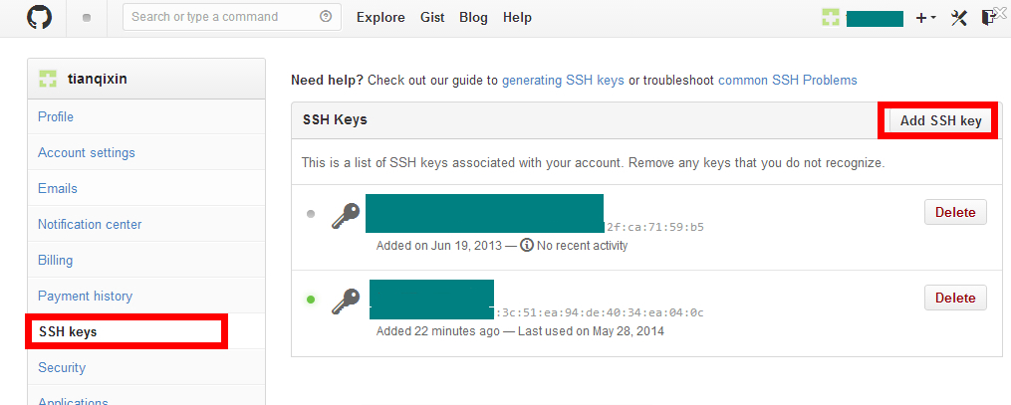

为了验证是否成功，Cmd 直接添加git

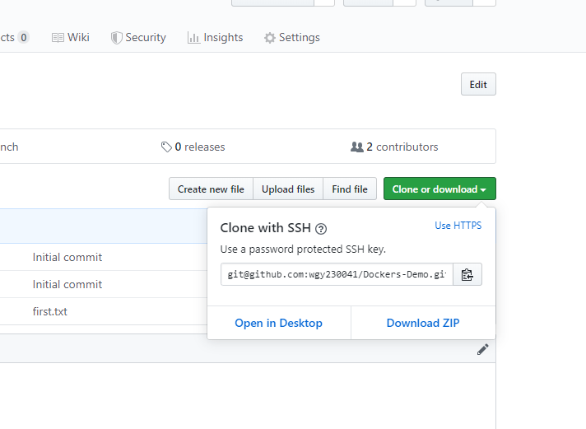

1. 直接复制clone ssh key

git clone git@github.com:wgy230041/Dockers-Demo.git

就可以复制到本地设置的默认文件夹code 下

Code 文件夹就是git 接管的工作区

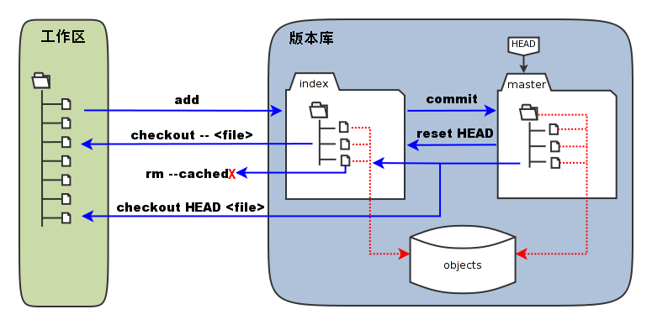

2. 上传文件

先进入在工作区内的相应文件夹Dockers-Demo

cd Dockers-Demo

或者直接打卡code工作区下的相应文件夹下空白处shift + 右击选择powershell open here

$ git status 查看状态

On branch master

Your branch is up to date with 'origin/master'.

Changes to be committed:

(use "git restore --staged <file>..." to unstage)

new file: first.txt

wgy@Guoyang▒sPC MINGW64 /c/Code/Dockers-Demo (master)

$ git add first.txt 推送到缓存区， 需要commit推送到index

首次使用的时候需要用户认证：

$ git config --global user.name "wgy230041"

$ git config --global user.email “[wgy198910014@gmail.com](mailto:wgy198910014@gmail.com)”

wgy@Guoyang▒sPC MINGW64 /c/Code/Dockers-Demo (master)

$ git commit -m "first.txt" 推送到远端 -m 是messages日志方便以后查看 git show 查看

[master ce1e894] first.txt

1 file changed, 0 insertions(+), 0 deletions(-)

create mode 100644 first.txt

git log

显示 commit id （倒叙排列）

git reset （+ commit id）

将不需要的文件逆向回去过程

wgy@Guoyang▒sPC MINGW64 /c/Code/Dockers-Demo (master)

$ git log

commit ce1e894be9104c3f4c0cc02e2d69db0ce24229dc (HEAD -> master)

Author: wgy230041 <32069426+wgy891004@users.noreply.github.com>

Date: Wed Oct 30 22:34:27 2019 -0400

first.txt

commit 3ff66df6f8879af8955d7f4f59cd345f8f9d1f69 (origin/master, origin/HEAD)

Author: Yang <44243561+wgy230041@users.noreply.github.com>

Date: Wed Oct 30 21:56:05 2019 -0400

Initial commit

wgy@Guoyang▒sPC MINGW64 /c/Code/Dockers-Demo (master)

$ git show

commit ce1e894be9104c3f4c0cc02e2d69db0ce24229dc (HEAD -> master)

Author: wgy230041 <32069426+wgy891004@users.noreply.github.com>

Date: Wed Oct 30 22:34:27 2019 -0400

first.txt

**diff --git a/first.txt b/first.txt**

**new file mode 100644**

**index 0000000..e69de29**

wgy@Guoyang▒sPC MINGW64 /c/Code/Dockers-Demo (master)

$ git reset ce1e894be9104c3f4c0cc02e2d69db0ce24229dc

此处则返reverse到缓存处

wgy@Guoyang▒sPC MINGW64 /c/Code/Dockers-Demo (master)

$ git push

Warning: Permanently added the RSA host key for IP address '140.82.113.4' to the list of known hosts.

Enumerating objects: 4, done.

Counting objects: 100% (4/4), done.

Delta compression using up to 8 threads

Compressing objects: 100% (2/2), done.

Writing objects: 100% (3/3), 325 bytes | 162.00 KiB/s, done.

Total 3 (delta 0), reused 0 (delta 0)

To github.com:wgy230041/Dockers-Demo.git

3ff66df..ce1e894 master -> master

将文件传输到index中

注意文件名字不能用空格

wgy@Guoyang▒sPC MINGW64 /c/Code/Dockers-Demo (master)

$ git commit -m setting-notes.docx

[master e28a20a] setting-notes.docx

1 file changed, 0 insertions(+), 0 deletions(-)

create mode 100644 setting-notes.docx

wgy@Guoyang▒sPC MINGW64 /c/Code/Dockers-Demo (master)

$ git log

commit e28a20a2e763fc16195e6cdc040934808393ed86 (HEAD -> master)

Author: wgy230041 <32069426+wgy891004@users.noreply.github.com>

Date: Thu Oct 31 17:03:13 2019 -0400

setting-notes.docx

commit ce1e894be9104c3f4c0cc02e2d69db0ce24229dc (origin/master, origin/HEAD)

Author: wgy230041 <32069426+wgy891004@users.noreply.github.com>

Date: Wed Oct 30 22:34:27 2019 -0400

first.txt

commit 3ff66df6f8879af8955d7f4f59cd345f8f9d1f69

Author: Yang <44243561+wgy230041@users.noreply.github.com>

Date: Wed Oct 30 21:56:05 2019 -0400

Initial commit

wgy@Guoyang▒sPC MINGW64 /c/Code/Dockers-Demo (master)

$ git push

传输到远端去

需要看别人的修改，在克隆的时候可以加仓库名

git clone [git@github.com:wgy230041/Dockers-Demo.git](mailto:git@github.com:wgy230041/Dockers-Demo.git) **other**

这里加入Other表示仓库名下，方便区分

清空操作 clear

cmd中清空操作 cls

解决提交版本冲突

git status

git add . (这里的. 是当前目录提交)

git commit -m “I commit”

git push

不是最新的则更新 git pull

解决冲突以后

git commit -m “fix conflict”