下载源码
git clone --branch v5.2.8.RELEASE https://gitee.com/Z201/spring-framework.git

修改settings.gradle文件
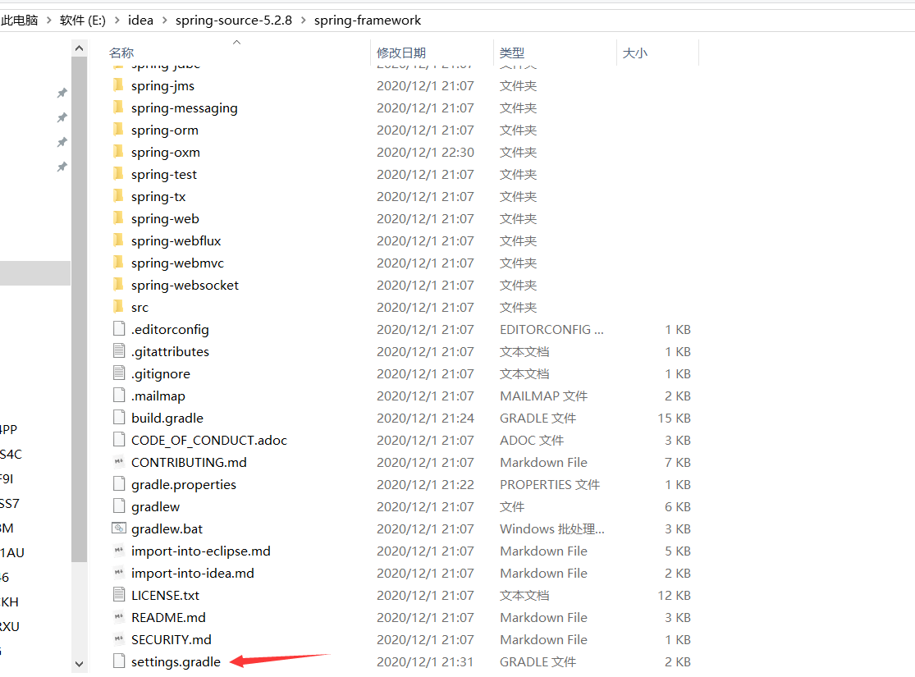
repositories {
gradlePluginPortal()
maven { url 'https://maven.aliyun.com/repository/public' }
maven { url 'https://repo.spring.io/plugins-release' }
}

修改gradle.properties文件
version=5.2.8.RELEASE
org.gradle.jvmargs=-Xmx2048M
org.gradle.caching=true
org.gradle.parallel=true
org.gradle.configureondemand=true
org.gradle.daemon=true

修改build.gradle文件
maven { url 'https://maven.aliyun.com/nexus/content/groups/public/' }
maven { url 'https://maven.aliyun.com/nexus/content/repositories/jcenter'}

gradlew :spring-oxm:compileTestJava
编译spring-oxm模块
编译成功后的截图
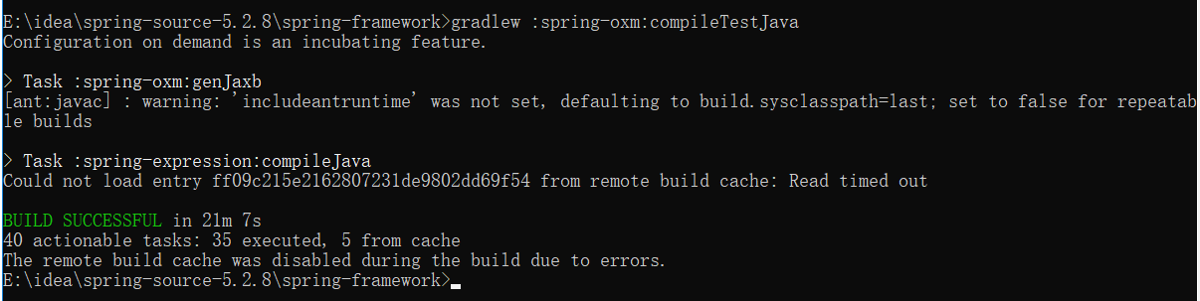

6、IDEA导入Spring源码
File -> New -> Project from Existing Souces...
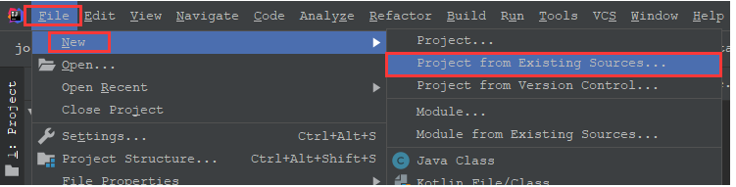
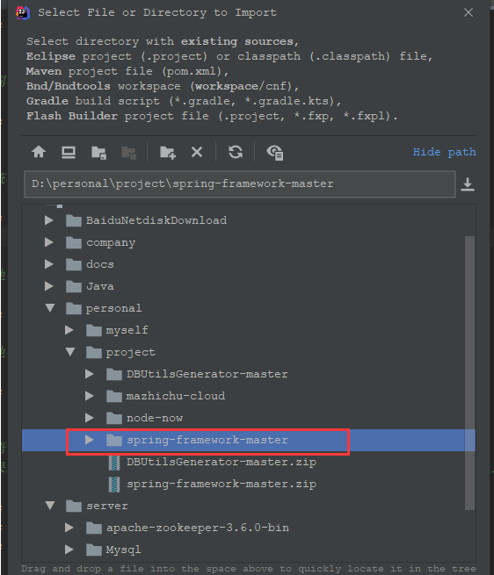
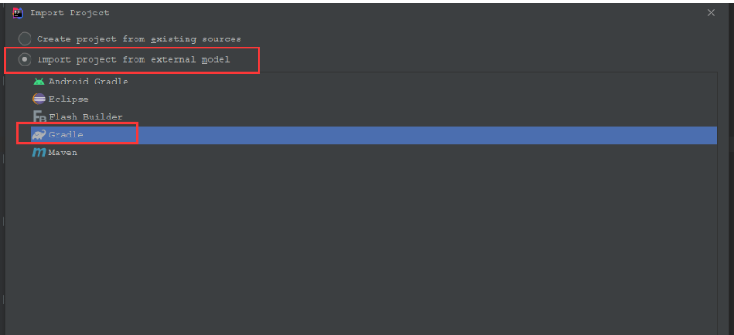

成功后的截图
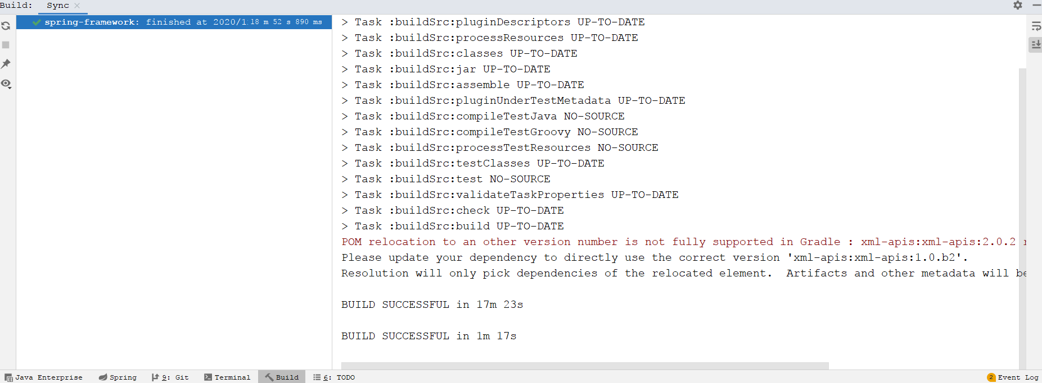

7、Idea kotlin插件安装
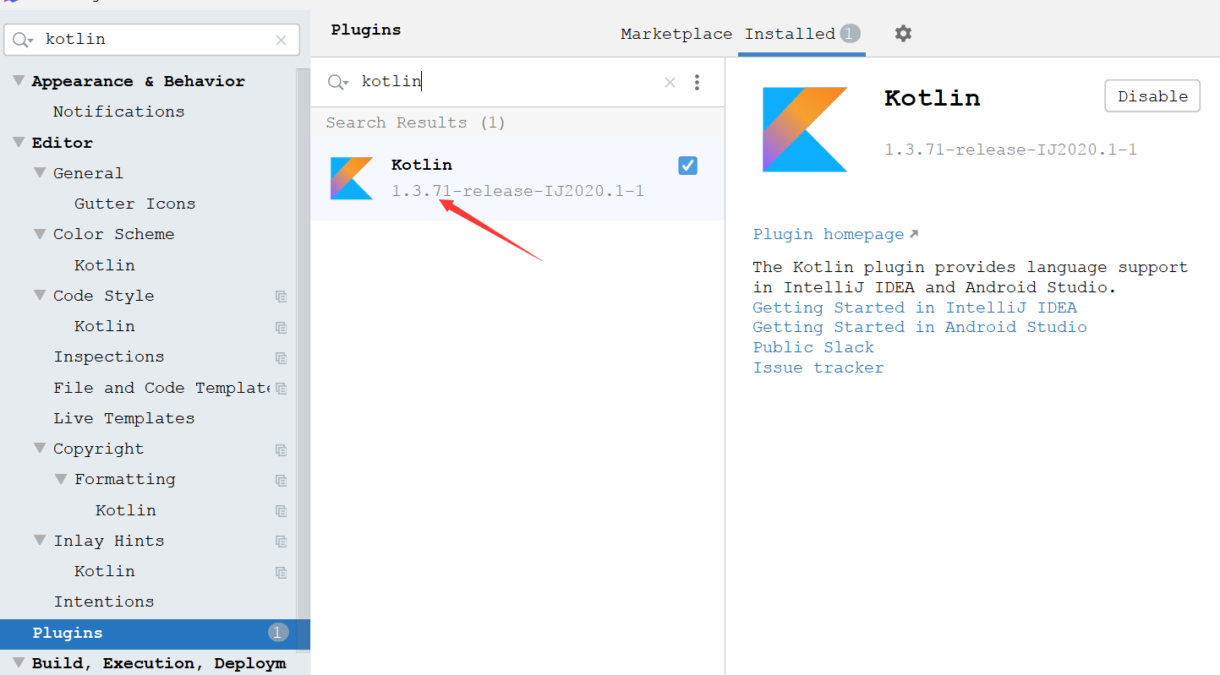

gradle安装
配置gradle环境变量
新增GRADLE_HOME
