## HW #1 – Ansible

Aarsh Sheth || Pooja Sindham || Shivani Jariwala || Aishwarya Indi

Video Demo Link: <https://drive.google.com/file/d/1fgGfNt-3Ul56iy984sOEWaSoRqel8FTS/view?usp=sharing>   
  
GitHub Repo: <https://github.com/wh0th3h3llam1/cmpe-272/>

**Ansible-Based Webserver Deployment on AWS VMs**This project will configure and deploy Apache web server on multiple AWS EC2 instances using Ansible. The setup includes a control node (VM3) managing two target nodes (VM1 and VM2). The Ansible playbook performs tasks such as installing Apache, modifying its configuration to run on port 8080, and deploying custom web pages to each VM. Security groups are configured to allow inbound traffic on port 8080, ensuring accessibility. The project demonstrates infrastructure automation, remote configuration management, and cloud-based deployment using Ansible.

1. Created Two Virtual Machines (VM1 and VM2)

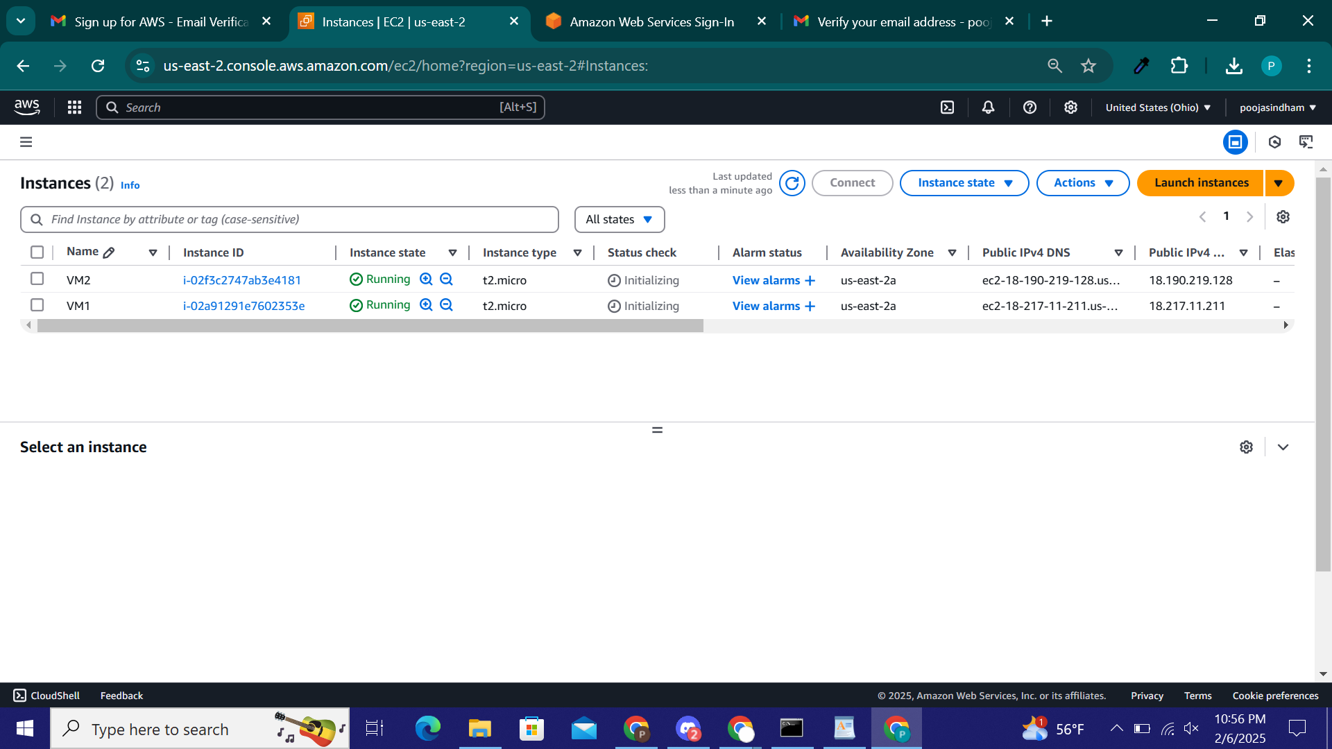

2. Created VM3 as Control Node.

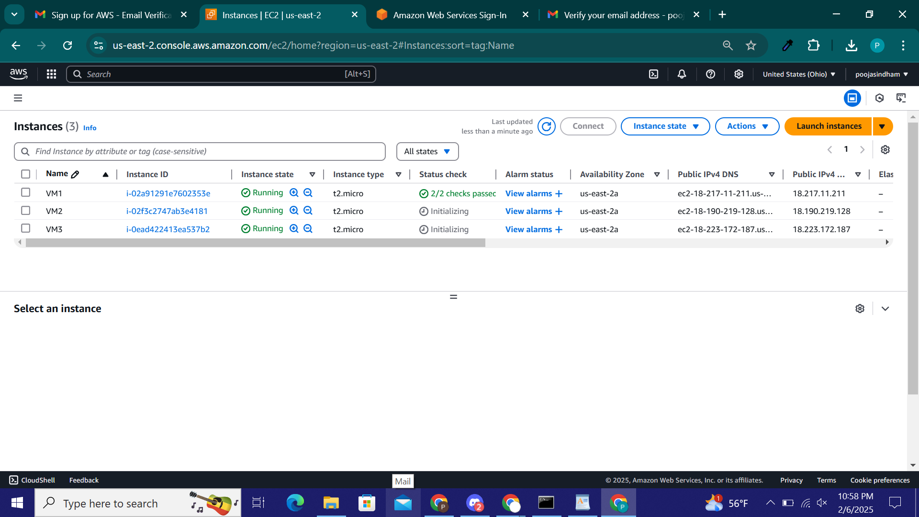

3. Connect to control Node from local through SSH.

ssh -i sjsu-ansible-key.pem ubuntu@18.223.172.187

sudo apt update

sudo apt install -y ansible

4. Copy key file to control node.

scp -i sjsu-ansible-key.pem sjsu-ansible-key.pem ubuntu@18.223.172.187:~

ssh -i sjsu-ansible-key.pem ubuntu@18.223.172.187

5. Testing ssh connectivity to VM1 and VM2 from VM3 (Control Node)

ssh -i ~/.ssh/sjsu-ansible-key.pem ubuntu@18.190.219.128

ssh -i ~/.ssh/sjsu-ansible-key.pem ubuntu@18.217.11.211

6. Create Inventory File

sudo mkdir -p /etc/ansible

sudo touch /etc/ansible/hosts

sudo nano /etc/ansible/hosts

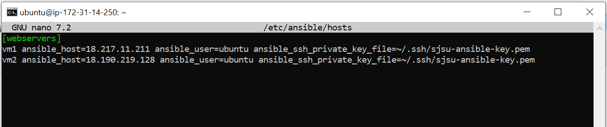

7. Test Ansible Ping  
 ansible all -m ping

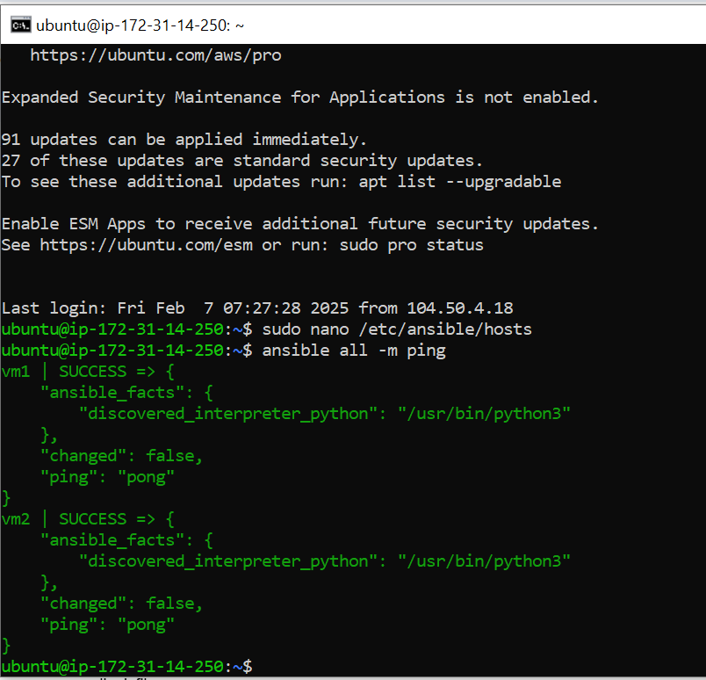

8. Create the Ansible Playbook  
 nano deploy_webserver.yml

|  |
| --- |
| ---  - name: Deploy Webserver on VM1 and VM2  hosts: webservers  become: true  tasks:  - name: Install Apache Web Server  apt:  name: apache2  state: present  update_cache: yes  - name: Change Apache port to 8080  lineinfile:  path: /etc/apache2/ports.conf  regexp: "^Listen 80"  line: "Listen 8080"  - name: Change Virtual Host to 8080  replace:  path: /etc/apache2/sites-available/000-default.conf  regexp: "VirtualHost \\*:80"  replace: "VirtualHost *:8080"  - name: Restart Apache service  service:  name: apache2  state: restarted  - name: Deploy custom index.html for VM1  copy:  content: "Hello World from SJSU-1"  dest: /var/www/html/index.html  when: "'vm1' in inventory_hostname"  - name: Deploy custom index.html for VM2  copy:  content: "Hello World from SJSU-2"  dest: /var/www/html/index.html  when: "'vm2' in inventory_hostname" |

9. Run the Ansible Playbook  
 ansible-playbook deploy_webserver.yml  
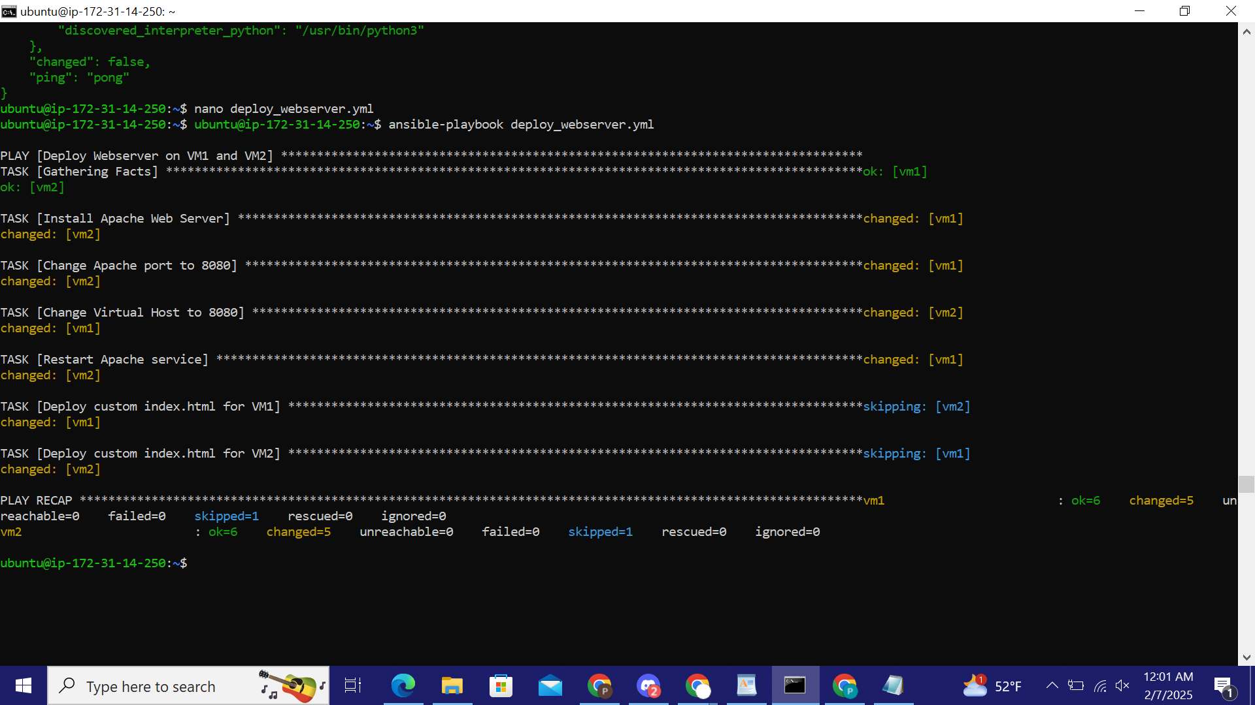

10.Verify in the Browser

http://18.217.11.211:8080/

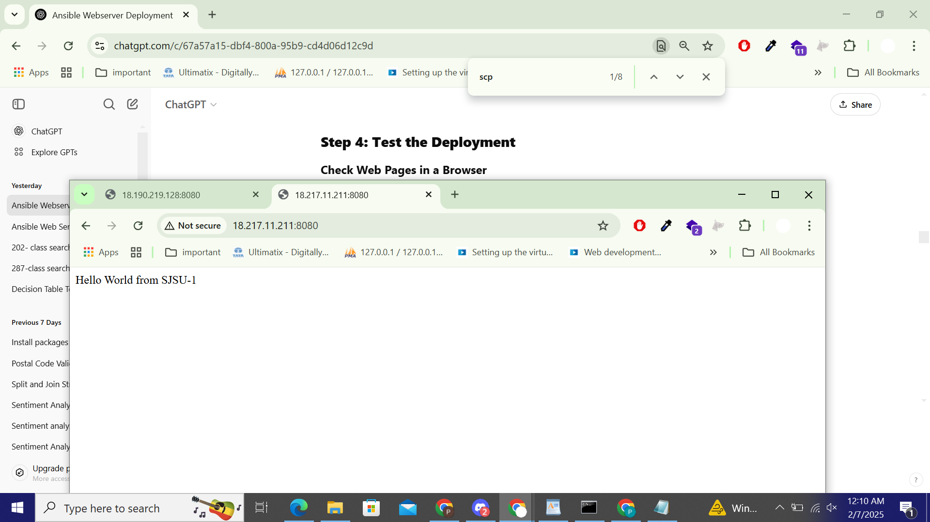

http://18.190.219.128:8080/

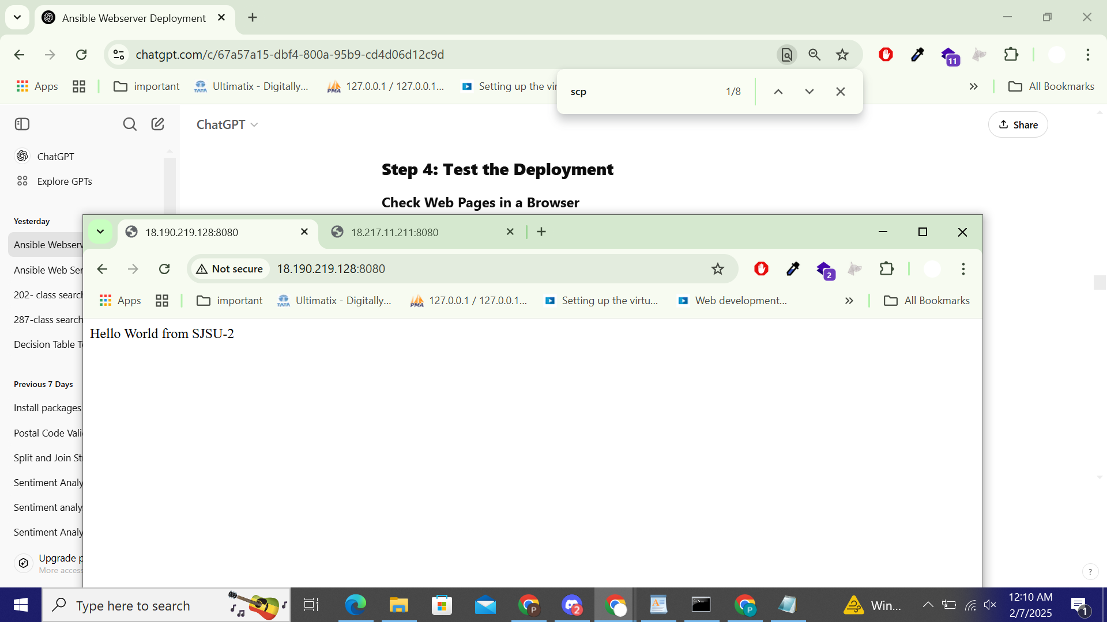

11. Undeploy Webserver Ansible Playbook   
 nano undeploy_webserver.yml

|  |
| --- |
| ---  - name: Uninstall Webserver from VM1 and VM2  hosts: webservers  become: true  tasks:  - name: Stop Apache Service  service:  name: apache2  state: stopped  - name: Remove Apache Package  apt:  name: apache2  state: absent  - name: Remove Web Files  file:  path: /var/www/html/index.html  state: absent |

12. Run the playbook.  
 ansible-playbook undeploy_webserver.yml

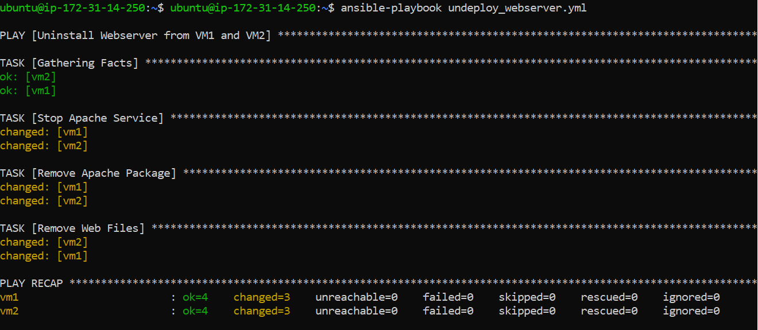

13. Verify in the Browser

http://18.217.11.211:8080/

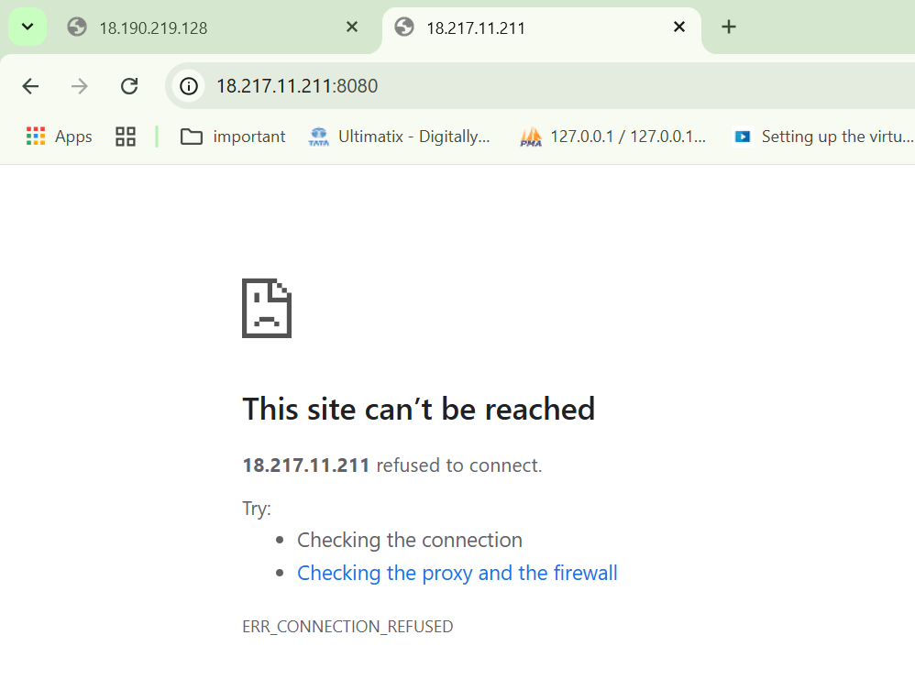

<http://18.190.219.128:8080/>

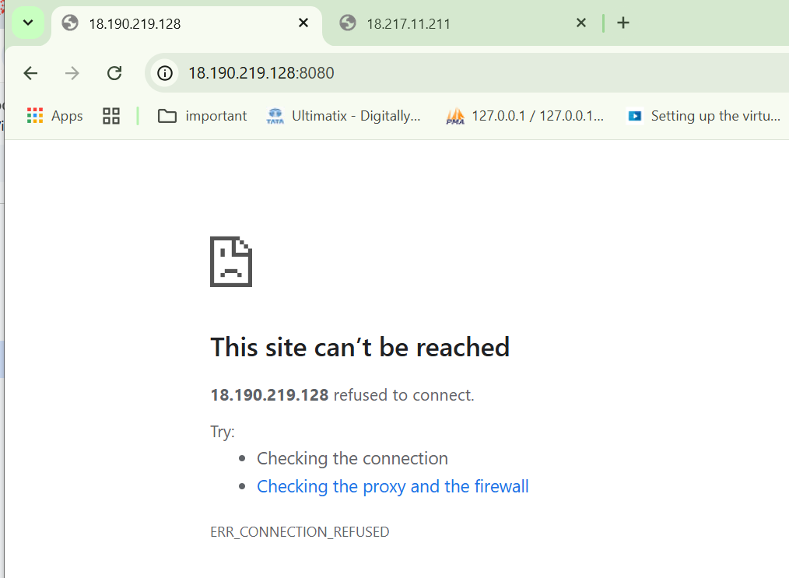

**Issues Faced -**

**Issue 1 – When trying to rerun deploy_webserver.yml it is appending 8080 to the config file of apache**  
Below are steps to rectify it.

1. **Open the Apache port configuration file:**

sudo nano /etc/apache2/ports.conf

Make sure it contains:

Listen 8080

If there's a Listen 80 line, replace it with Listen 8080.

1. **Open the default virtual host configuration:**

sudo nano /etc/apache2/sites-available/000-default.conf

Change:  
<VirtualHost *:80>

To:  
<VirtualHost *:8080>

Save and exit (Ctrl + X → Y → Enter).  
  
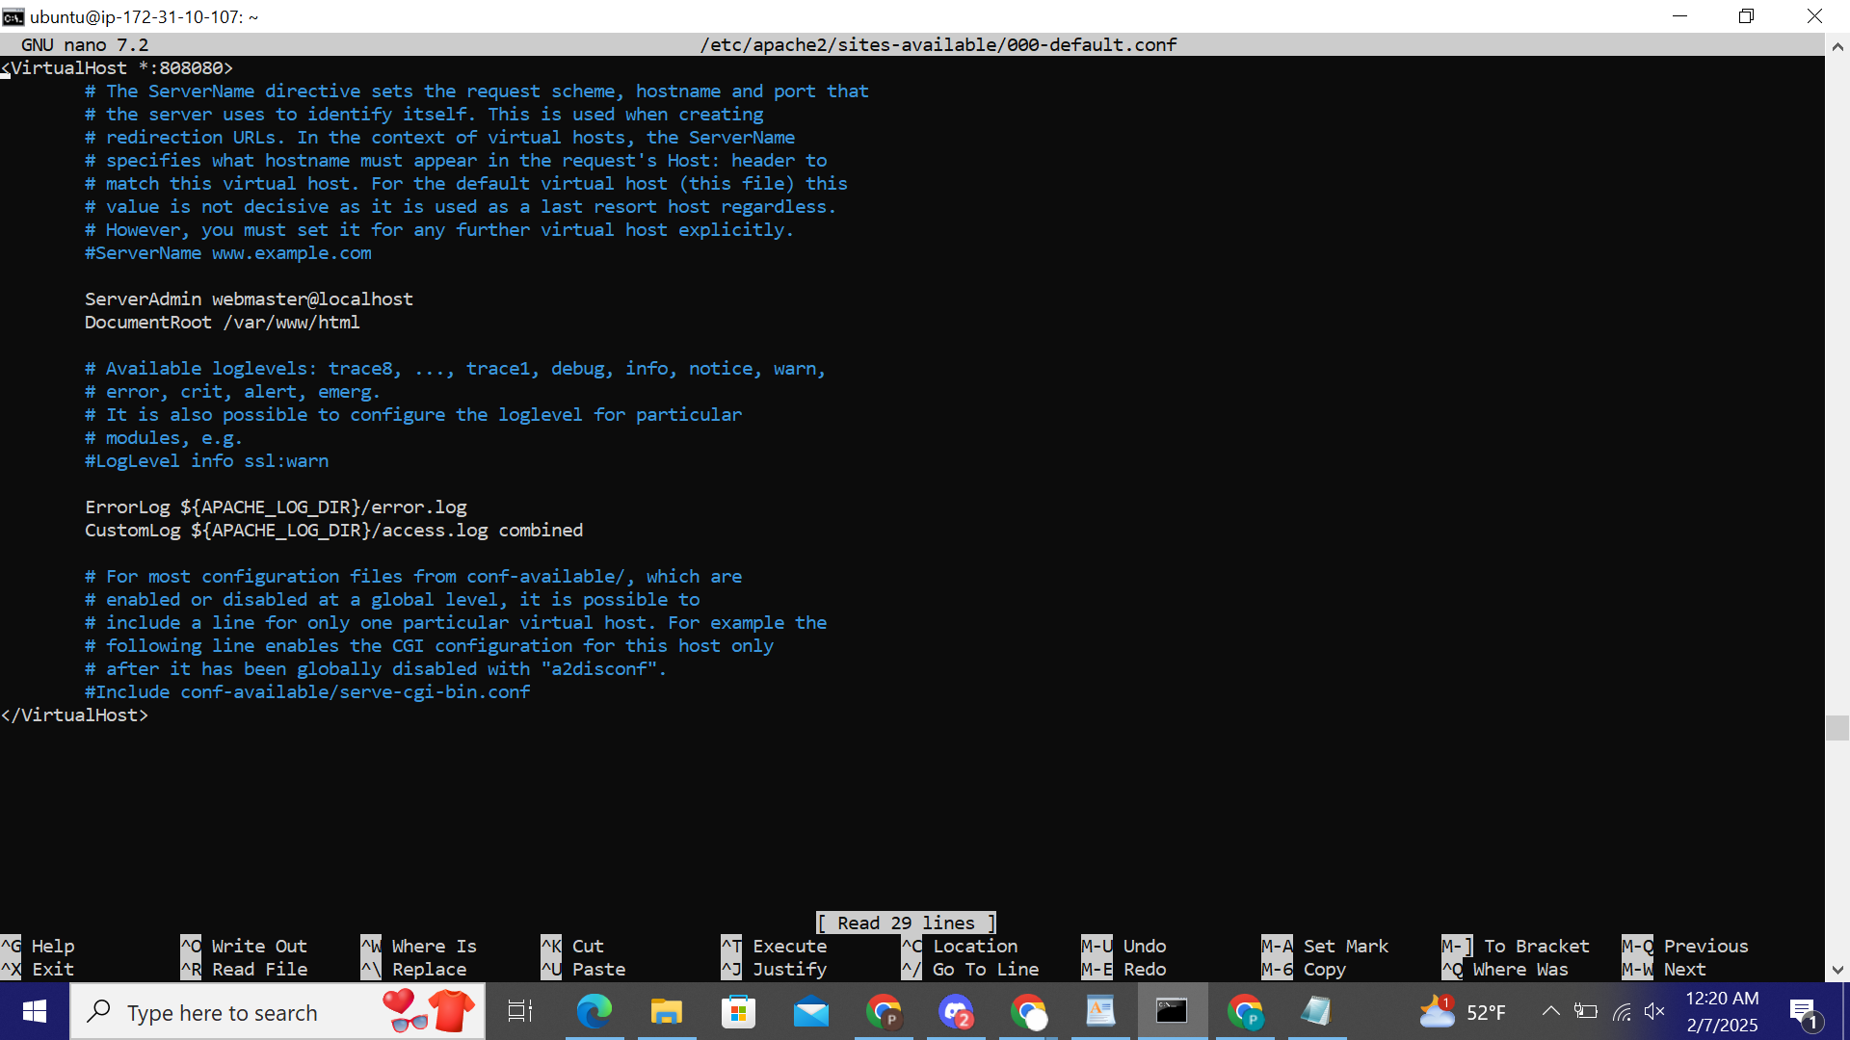  
 Issue with Apache Config File

1. **Restart Apache**

After making the above changes, restart Apache manually:

sudo systemctl restart apache2

If the restart fails again, check which process is using port 8080:

sudo netstat -tulnp | grep 8080

If another process is running on port 8080, stop it and restart Apache.

**Issue 2 - `apache not found`**

**Check if Apache is Installed**

Run this command to verify:

apache2 -v

If Apache is **not found**, install it using:

sudo apt update && sudo apt install -y apache2

After installation, start Apache:]

sudo systemctl start apache2

sudo systemctl enable apache2

Now check its status:

sudo systemctl status apache2

**Issue 3 –** sudo apachectl configtest AH00526: Syntax error on line 1 of /etc/apache2/sites-enabled/000-default.conf: The address or port is invalid

there's an issue with the Virtual Host configuration in /etc/apache2/sites-enabled/000-default.conf. Let's fix it step by step.

1. **Open the Virtual Host Configuration File**

Run:

sudo nano /etc/apache2/sites-enabled/000-default.conf

Make sure it has the **correct syntax** like this:

<VirtualHost *:8080>

DocumentRoot /var/www/html

ErrorLog ${APACHE_LOG_DIR}/error.log

CustomLog ${APACHE_LOG_DIR}/access.log combined

</VirtualHost>

* Ensure **<VirtualHost *:8080>** is correctly written.
* Remove any extra characters, invalid IP addresses, or typos.

Save the file (CTRL + X, then Y, then ENTER).

1. **Check Apache Ports Configuration**

Run: sudo nano /etc/apache2/ports.conf

Make sure it contains:

Listen 8080

Save the file and exit.

### **Disable and Re-enable the Site**

Run these commands to apply the changes:

sudo a2dissite 000-default

sudo a2ensite 000-default

1. **Restart Apache**

Now, restart Apache:

sudo systemctl restart apache2

Check the status:

sudo systemctl status apache2