**In-Class: Camunda**

*Aarsh Sheth || Pooja Sindham || Shivani Jariwala || Aishwariya Indi*

**Step 1:**

**Create an account:**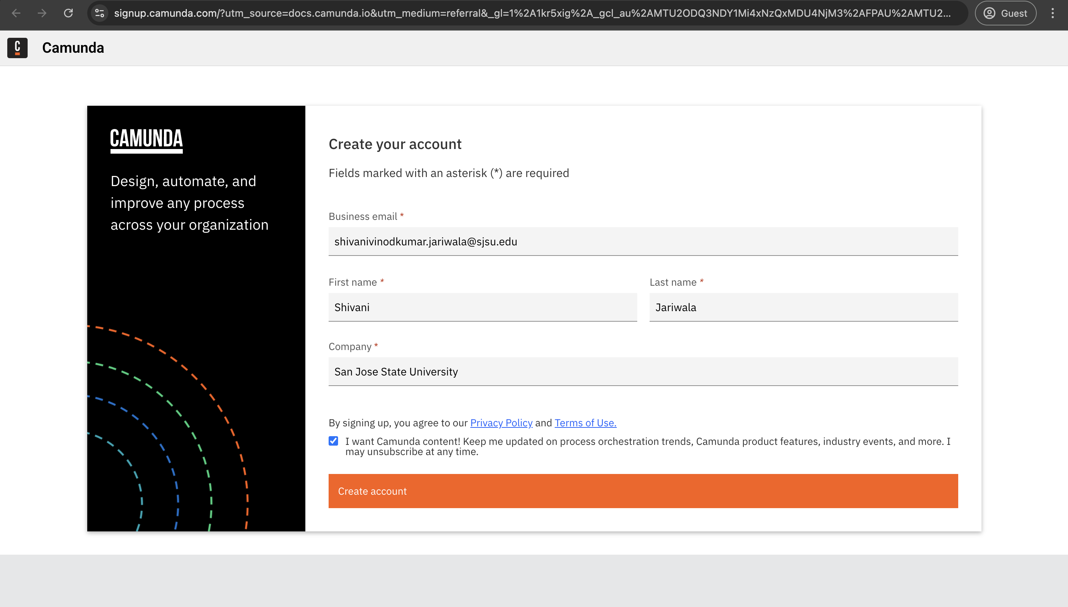  
  
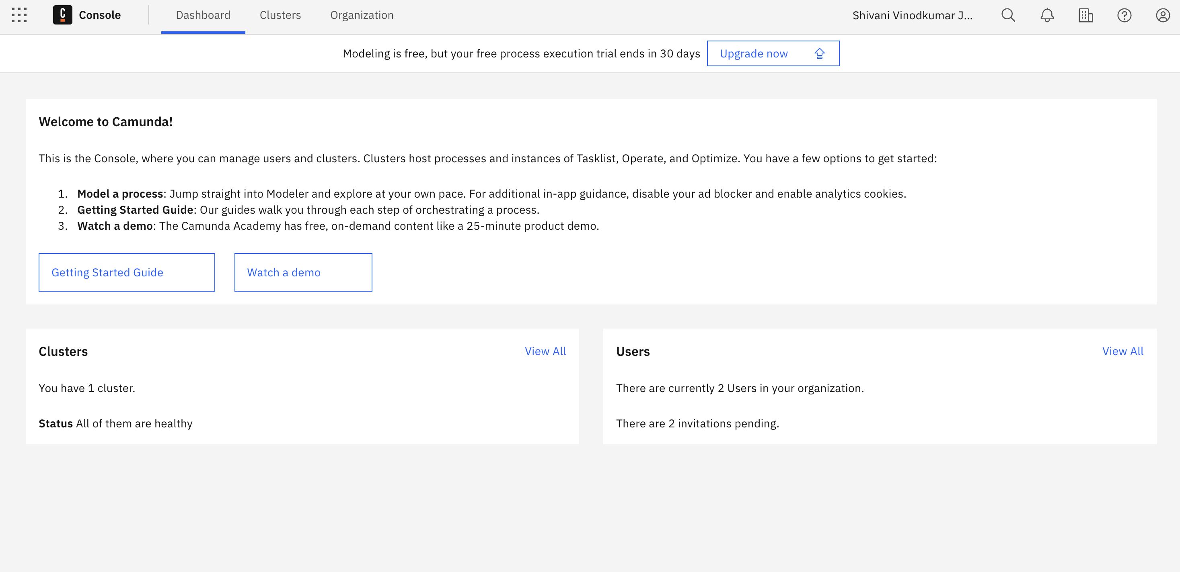  
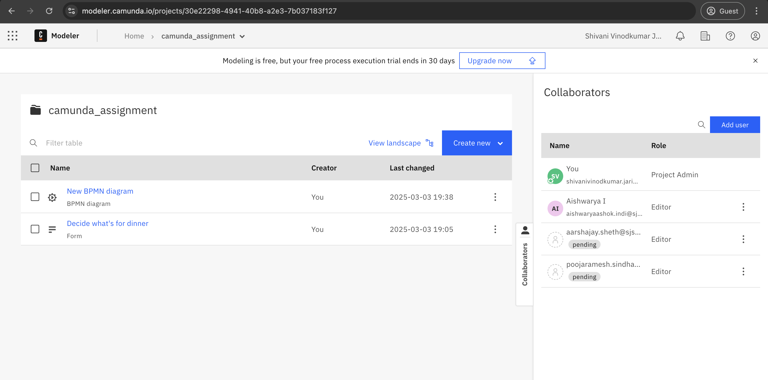

# **Step 2:**

# **Model your first process:**

**Step 3:**

**Create a cluster:**  
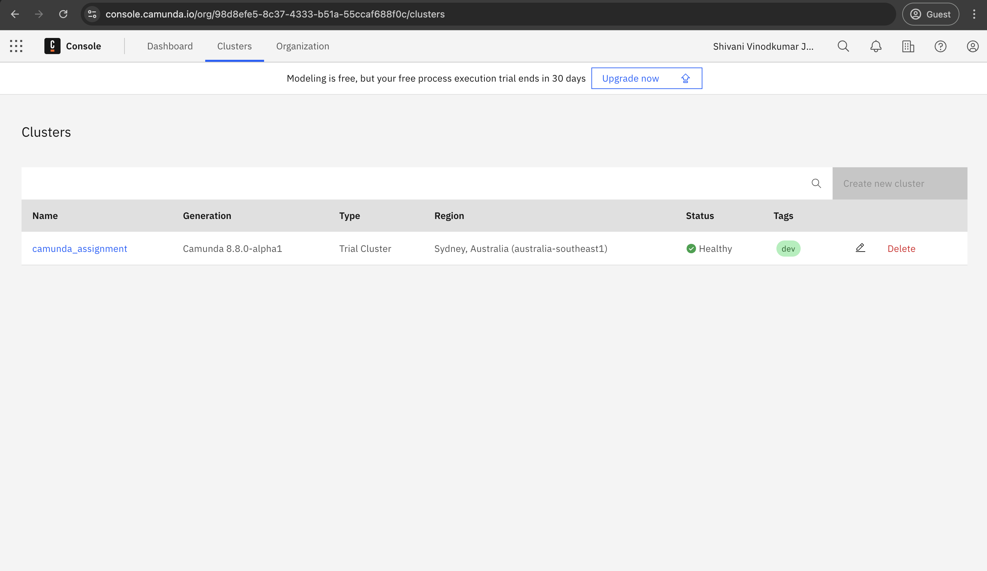

**Step 4:**

**Orchestrate human tasks:**

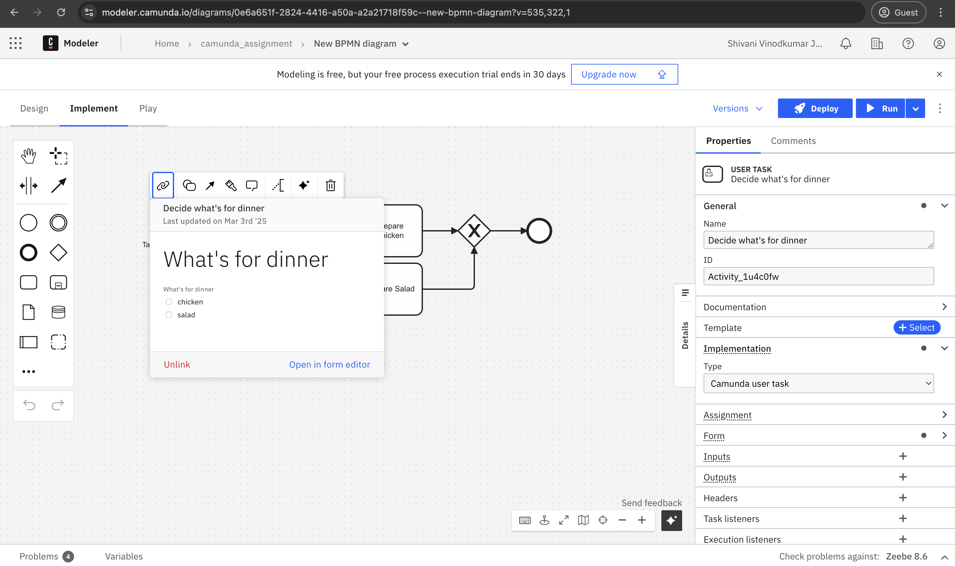

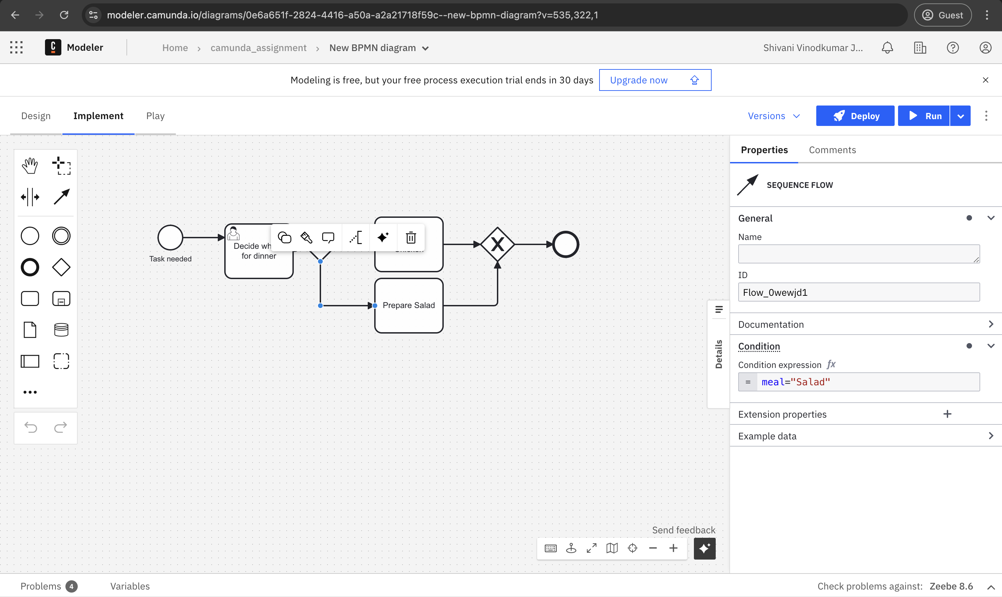

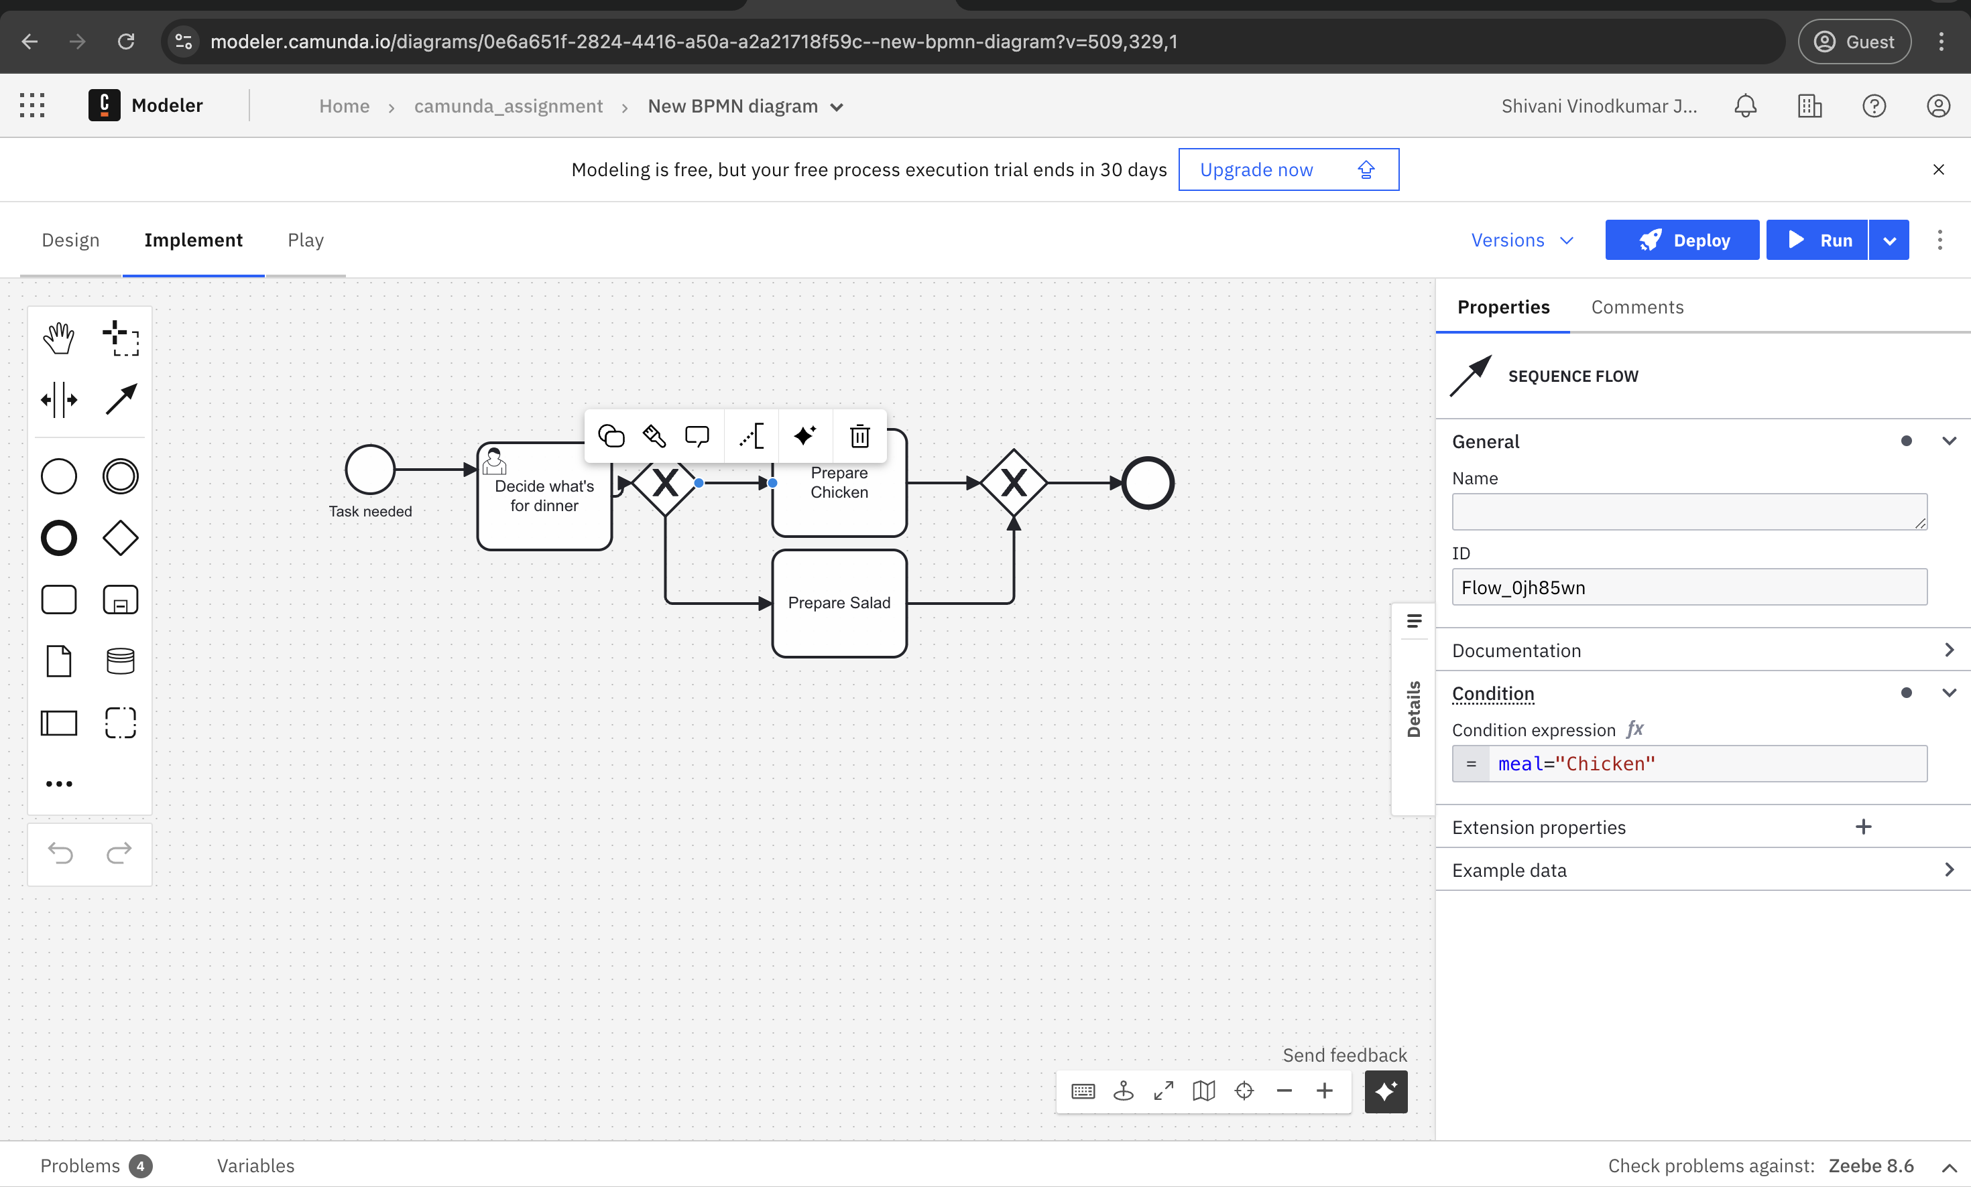

**Step 5:**

**Get started with API orchestration:**  
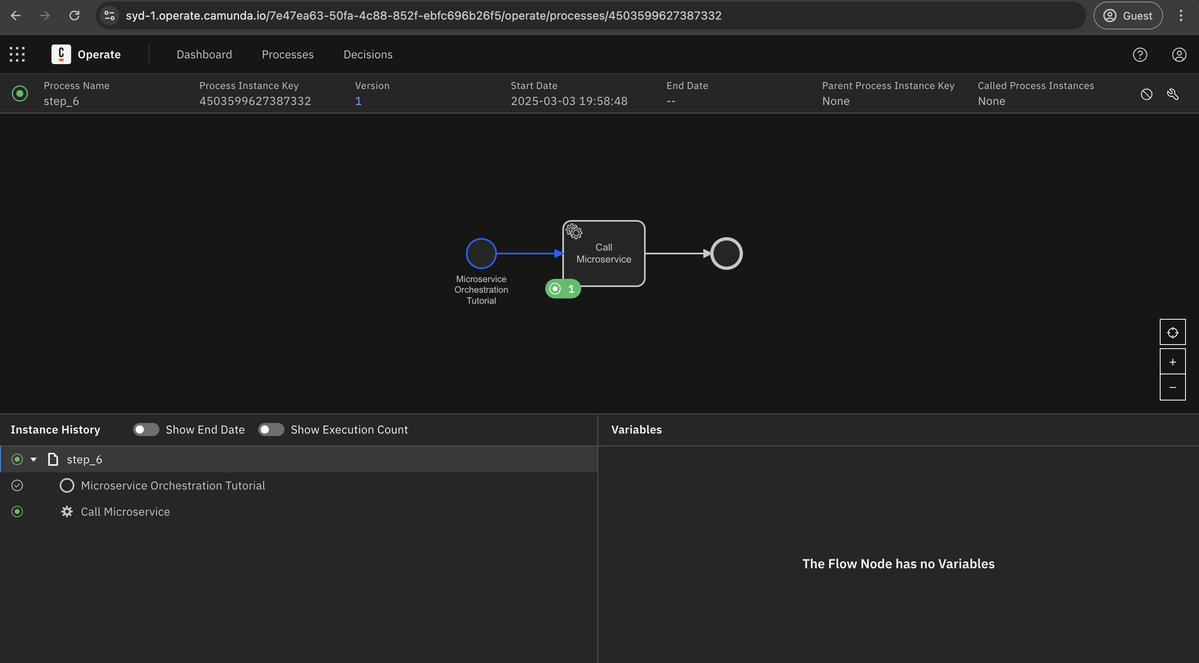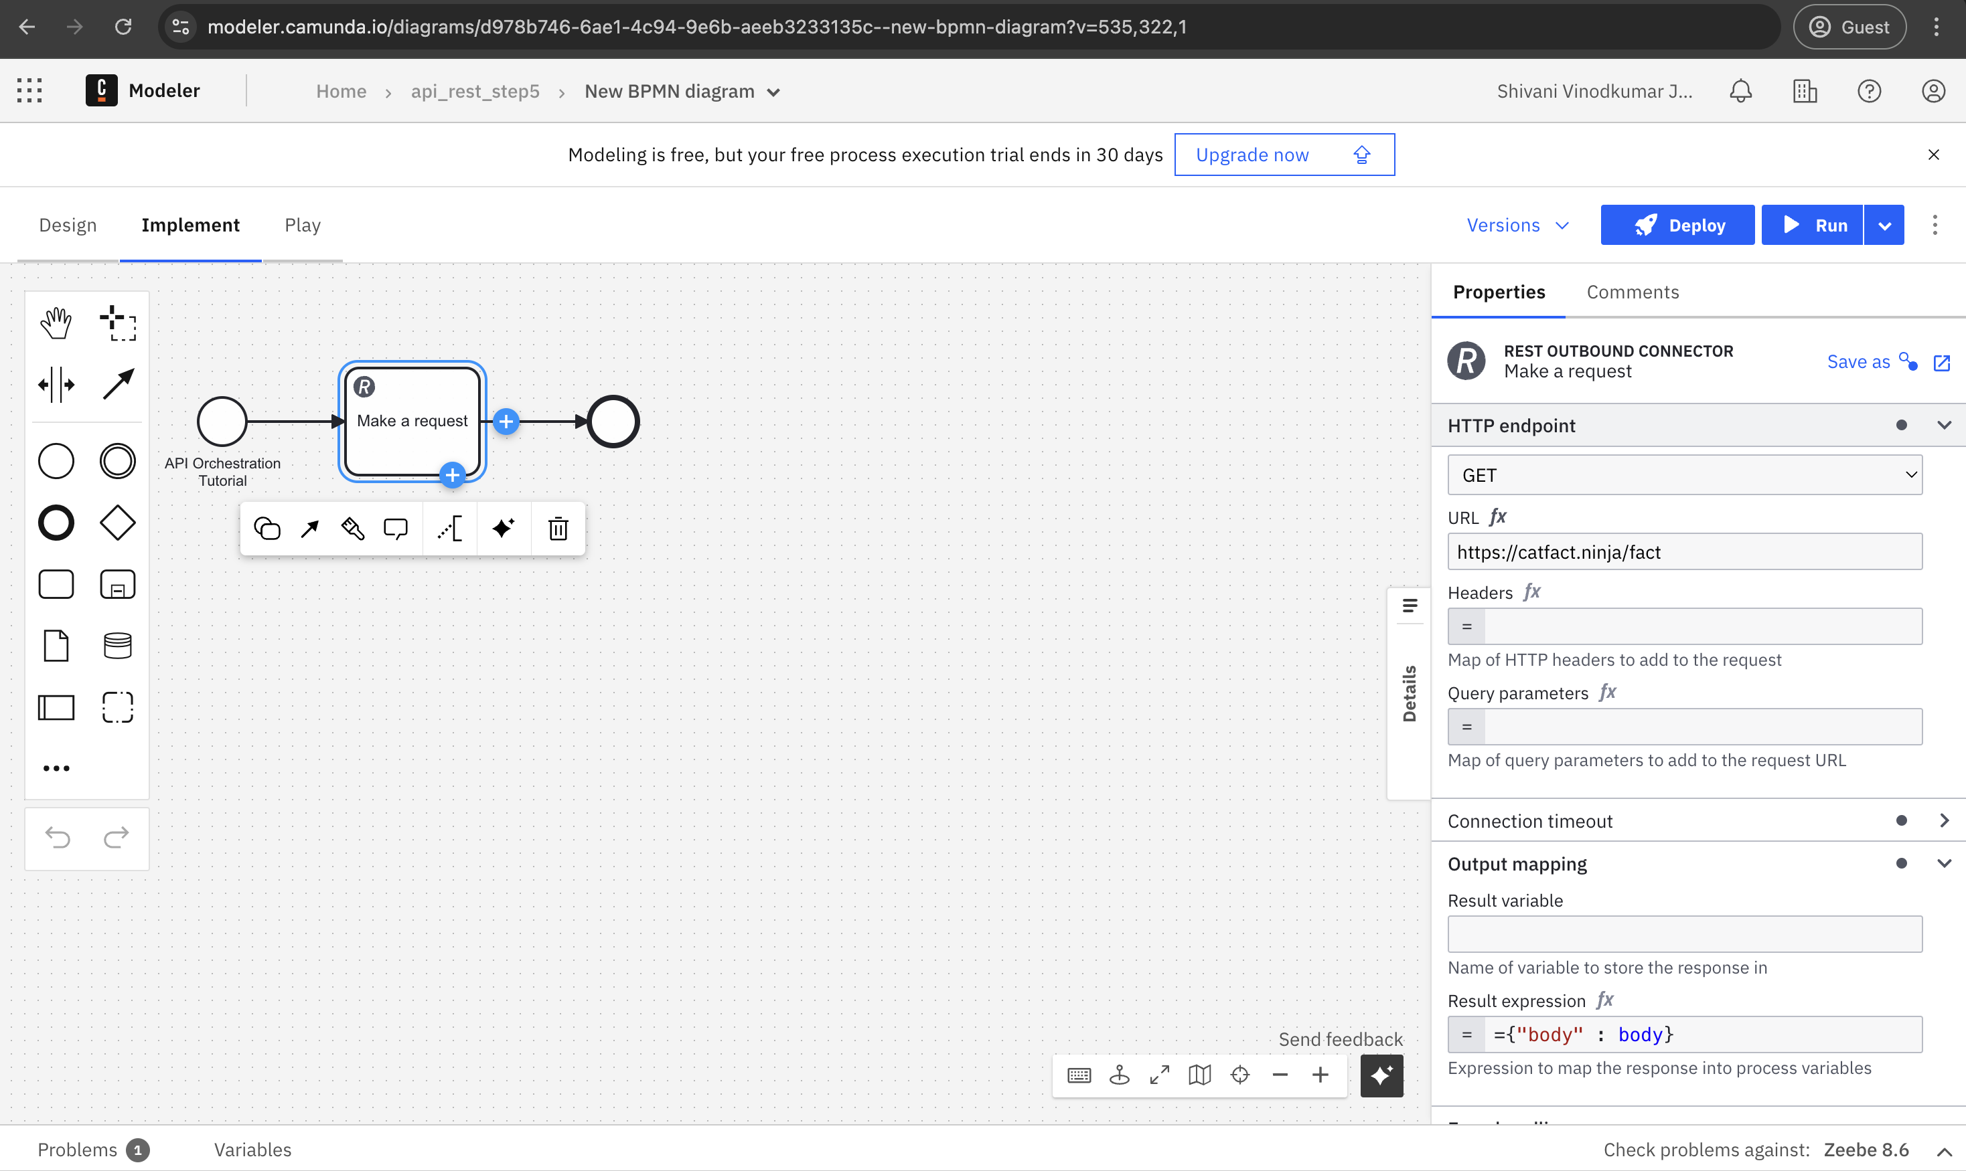  
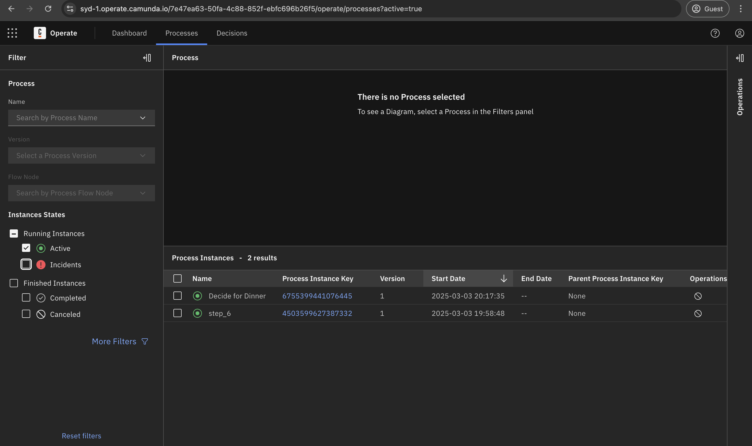

**Step 6:**

**Orchestrate Microservices –** Skipped as it requires paid version of Camunda