IN-Class: Programming with LLMs

Team Puma: Aarsh Sheth (TL) || Pooja Sindham || Shivani Jariwala || Aishwarya Indi

Github Link: https://github.com/wh0th3h3llam1/cmpe-272
ChatGPT Link: https://chatgpt.com/share/67a19a57-1a7c-800a-a0ba-9c19eef5c07f

ChatGPT Prompt:
```
4,3,Mon May 11 03:17:40 UTC 2009,kindle2,tpryan,"@stellargirl I loooooooovvvvvveee my Kindle2. Not that the DX is cool, but the 2 is fantastic in its own right." 4,4,Mon May 11 03:18:03 UTC 2009,kindle2,vcu451,Reading my kindle2... Love it... Lee childs is good read. 4,5,Mon May 11 03:18:54 UTC 2009,kindle2,chadfu,"Ok, first assesment of the #kindle2 ...it fucking rocks!!!" 4,6,Mon May 11 03:19:04 UTC 2009,kindle2,SIX15,@kenburbary You'll love your Kindle2. I've had mine for a few months and never looked back. The new big one is huge! No need for remorse! :) 4,7,Mon May 11 03:21:41 UTC 2009,kindle2,yamarama,@mikefish Fair enough. But i have the Kindle2 and I think it's perfect :) 4,8,Mon May 11 03:22:00 UTC 2009,kindle2,GeorgeVHulme,@richardebaker no. it is too big. I'm quite happy with the Kindle2. 0,9,Mon May 11 03:22:30 UTC 2009,aig,Seth937,Fuck this economy. I hate aig and their non loan given asses. 4,10,Mon May 11 03:26:10 UTC 2009,jquery,dcostalis,Jquery is my new best friend.
This is my input csv file with thousands of data. I want to do sentiment analysis on thi susing textblob and Outputs a message about the sentiment of the text string, whether it’s “Positive”, “Negative” or “Neutral”.
```

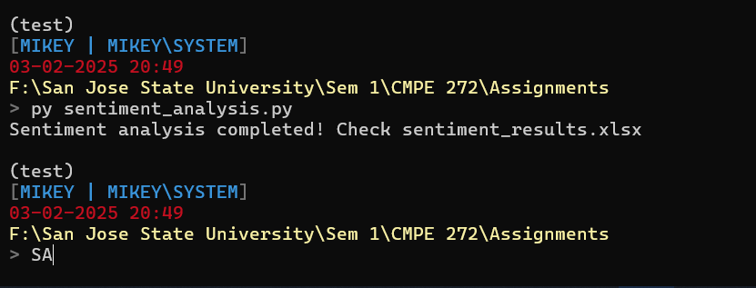
Command Prompt

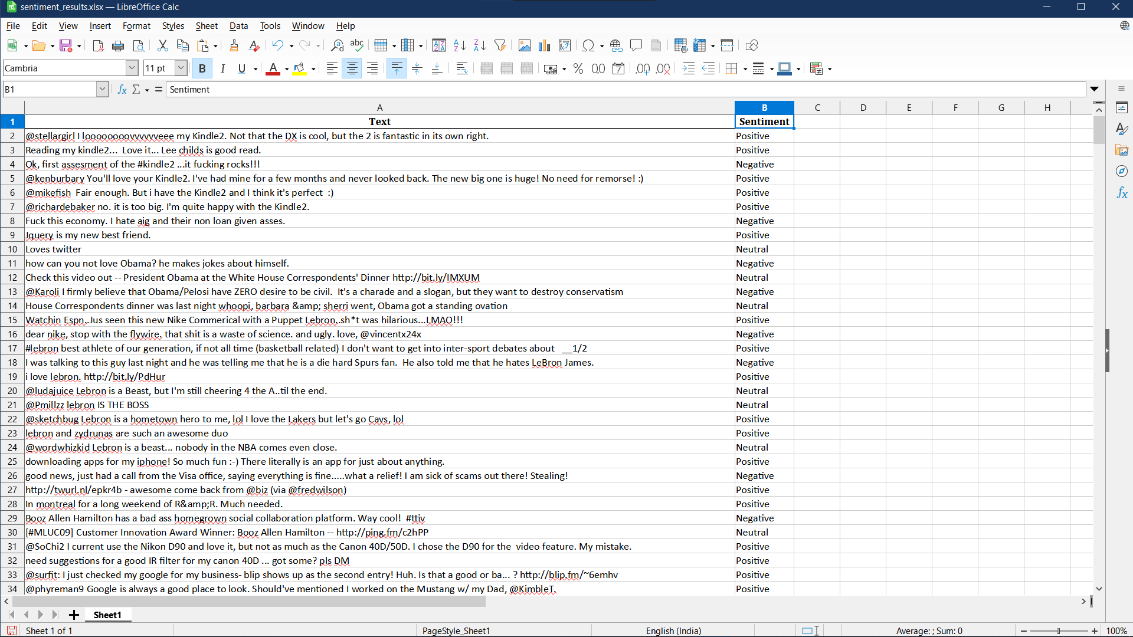
Sentiment Analysis Output

HackerRank Coding Problems usign LLM
Language: Python

1. HackerRank Easy Question:
ChatGPT Prompt: https://chatgpt.com/c/67a1b04d-15b4-800a-af10-88edd91c83a0
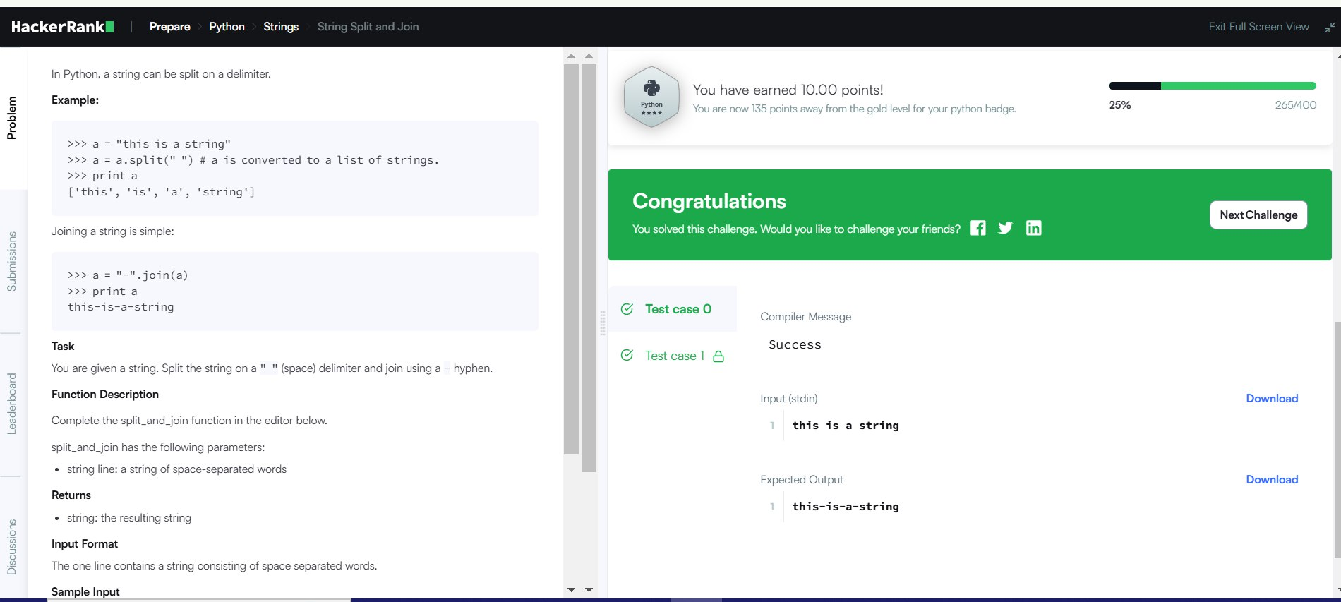
HackerRank Easy

def split_and_join(line):
return "-".join(line.split())

# Taking user input
user_input = input()
print(split_and_join(user_input))

