文档修订说明

|  |  |  |  |
| --- | --- | --- | --- |
| **版本号** | **修订日期** | **修订说明** | **修订人** |
| V1.0.0 | 2019/03/12 | 创建文档 | 王海 |
|  |  |  |  |
|  |  |  |  |

目录

1. 确保Android设备和PC端处于同一网络 2

1.1. 查看PC端的IP地址 2

1.2. 获取Android端IP地址 2

2. 获取Android设备的adb tcp端口号 4

3. PC端通过网络连接Android设备 4

4. 确认当前PC和Android端是否连接成功 5

5. 网络连接成功之后，就可以使用所有的adb命令 5

在开发的过程中，由于各种原因，有些Android设备的USB接口无法使用，这时我们就可以使用adb的网络调试功能，也就是通过Wifi或者Ethernet进行Android调试。

In the process of development, for various reasons, the USB interface of some Android devices can not be used, then we can use the network debugging function of adb, that is, Android debugging through Wifi or Ethernet.

一般通过WIFI的具体调试步骤如下：

Generally, the specific debugging steps through WIFI are as follows:

# 确保Android设备和PC端处于同一网络

Ensure that Android devices and PC terminals are on the same network

## 查看PC端的IP地址

View the IP address on the PC side

在 win10里，打开cmd，输入**Ipconfig**

In Win10, open CMD and enter Ipconfig

**例如**：我的电脑IP如下：

For example, my computer IP is as follows:

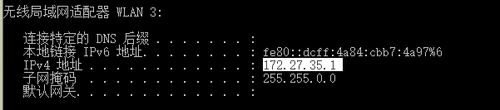

## 获取Android端IP地址

Get the Android IP address

首先确保Android设备**已经连接**到网络：

First, make sure that Android devices are connected to the network:

打开 **设置APK**，点击：关于设备 -> 状态 -> IP地址：

Open the settings APK and click: About device - > status - > IP address:

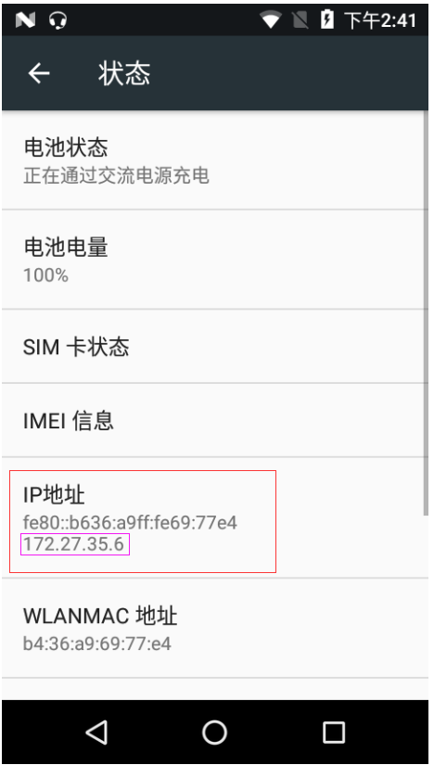

# 获取Android设备的adb tcp端口号

Get the ADB TCP port number of the Android device

下载一个终端模拟器apk，在Android终端模拟器窗口输入如下命令：

Download a terminal emulator APK and enter the following commands in the Android terminal emulator window:

**getprop service.adb.tcp.port**



通过以上命令可知，当前Android设备的端口号为 5555

According to the above command, the port number of the current Android device is 5555.

# PC端通过网络连接Android设备

PC connects Android devices over the network

命令：adb connect [Android的IP地址]**:[**端口号]

Command: ADB connect [IP address of Android]: [port number]

在win 10的cmd里，执行以下命令：

In win 10 cmd, execute the following commands:

**adb connect** 172.27.35.6:5555



# 确认当前PC和Android端是否连接成功

Verify that the current PC and Android terminals are successfully connected

命令：adb devices

Command: **adb devices**

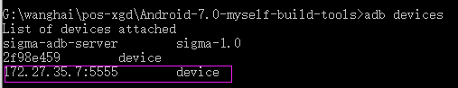

# 网络连接成功之后，就可以使用所有的adb命令

Once the network connection is successful, you can use all the ADB commands

例如：**adb shell**

For example: **adb shell**

