CMSC 491N/691N Introduction to Neural Networks Spring 2001
Review 1 (Chapters. 1, 2, 6, 3)
- Basics
- Comparison between human brain and von Neumann architecture
- Processing units
- Activation/output functions (threshold, linear-threshold, sigmoid)
- Network architecture (hidden nodes, feed-forward/recurrent nets, layered)
- Connection and weights
- Types of learning (supervised/unsupervised), Hebbian rule
      - Single Layer networks (Perceptron, Adaline, and the delta rule)
        - Architecture
        - Decision boundary and the problem of linear separability (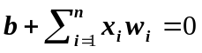)
        - Hebbian nets (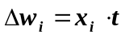)
        - Perceptron learning rule (only when 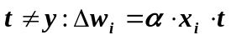)
        - Perceptron convergence theorem
        - Delta learning rule in Adaline (driven by error: 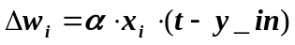)
        - Gradient descent approach in deriving delta learning rule
squared error: 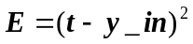or 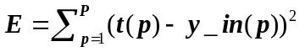
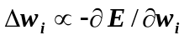
      - Backpropagation (BP) Networks
- Multi-layer feed-forward architecture with hidden nodes of non-linear and differentiable activation functions
- Motivation to have hidden nodes (representational power). Why non-linear?
- Feed forward computing
- BP learning
- Training samples
- Obtain errors at output layer (feed-forward phase): 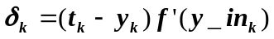
- Obtain errors at hidden layer (error backpropagation phase): 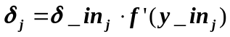 and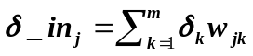
- Learning procedure (batch and sequential modes)
- In what sense BP learning generalizes delta rule of Adaline
- Why BP learning works (gradient descent to minimize error): 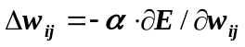
- Issues of practical concerns
- Bias, error bound, training data, initial weights, number and size of hidden layers;
- Learning rate (momentum, adaptive rate)
- Advantages and problems with BP learning
- Powerful (general function approximator); easy to use; wide applicability; good generalization
- Local minima; overfitting; parameters may be hard to determine; network paralysis; long learning time, hard to accommodate new samples (non-incremental learning)

- Pattern Association and Associative memory (AM)
  - Simple AM
Associative memory (AM) (content-addressable/associative recall; pattern correction/completion) Network architecture: single layer or two layers of non-linear units
- Hebbian rule: 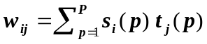
  - Correlation matrix: 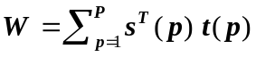(assuming both s and t are row vectors).
  - Principal and cross-talk term: 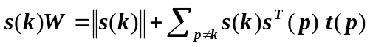
- Delta rule: 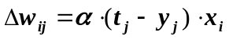 or ,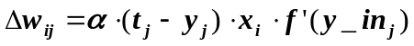derived following gradient descent (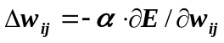)
- Auto-associative memory: 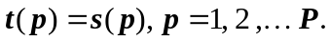
Storage capacity: up to n-1 mutually orthogonal patterns of dimension n
- Iterative autoassociative memory
  - Motives (comparing with non-iterative recall)
  - Using the output of the current iteration as input of the next iteration (stop when a state repeats)
  - Dynamic system (stable states, attractors, genuine and spurious memories)
- Hopfield model for autoassociative memory
  - Network architecture (single-layer, fully connected, recurrent)
  - Weight matrix for Hopfield model (symmetric with zero diagonal elements)
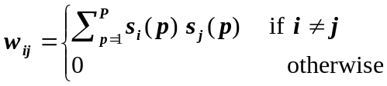
- Recall procedure (iterative until stabilized)
- Stability of dynamic systems
    - Ideas of Lyapunov function/energy function (monotonically non-increasing and bounded from below)
    - Convergence of Hopfield AM: its an energy function
    - 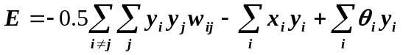
  - Storage capacity of Hopfield AM (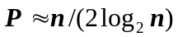).
- Bidirectional AM (BAM)
  - Architecture: two layers of non-linear units
  - Weight matrix: 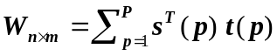
  - Recall: bi-directional (from x to y and y to x); recurrent
  - Analysis
    - Energy function: 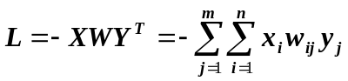
    - Storage capacity: 