CMSC 475/675 Introduction to Neural Networks Fall 2004
Section 0101 Tuesday/Thursday 2:30-3:45 PM ITE239
Review for Exam 2 (Chapters 5, 6, 7)
- Competitive Learning Networks (CLN)
  - Purpose: self-organizing to form pattern clusters/classes based on similarities.
  - Architecture: competitive output nodes (WTA, Mexican hat, Maxnet)
- external judge
- lateral inhibition (explicit and implicit)
- Learning (unsupervised and incremental)
  - both training examples (samples) and weight vectors are normalized.
  - two phase process (competition phase and reward phase)
  - learning rules (moving winner's weight vector toward input training vector)
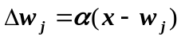 or 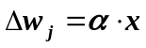 where x is the current input vector
  - learning algorithm
  - 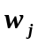 is trained to represent class of patterns (close to the centroid of that class).
- Advantages and problems
  - unsupervised
  - simple (less time consuming)
  - number of output nodes and the initial values of weights affects the learning results (and thus the classification quality)
  - stuck vectors and unsticking

    - Kohonen Self-Organizing Map (SOM)
- Motivation: from random map to topographic map
  - what is topographic map
  - biological motivations
- SOM data processing
  - network architecture: two layers
  - output nodes have neighborhood relations
  - lateral interaction among neighbors
- SOM learning
  - weight update rule (differs from competitive learning when R > 0)
  - learning algorithm (winner and its neighbors move their weight vectors toward training input)
  - illustrating SOM on a two dimensional plane
- plot output nodes (weights as the coordinates)
- links connecting neighboring nodes
- Applications
  - TSP (how and why)

- Counter Propagation Networks (CPN)
- Purpose: fast and coarse approximation of vector mapping 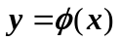
- Architecture (forward only CPN):
  - three layers (input, hidden, and output)
  - hidden layer is competitive (WTA) for classification/clustering
- CPN learning (two phases). For the winning hidden node 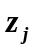
  - phase 1: 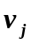 (weights from input to hidden) is trained by competitive learning to become the representative vector of a cluster of input vectors.
  - phase 2: 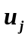 (weights from hidden to output) is trained by delta rule to become an average output of for all input x in cluster j
  - learning algorithm
- Works like table lookup (but for multi-dimensional input space)
- Full CPN (bi-directional) (only if an inverse mapping 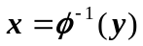 exists)

- Adaptive Resonance Theory (ART)
- Motivation: stability-elasticity dilemma in neural network models
  - how to determine when a new class needs to be created
  - how to add a new class without damaging/destroying existing classes
- ART1 model (for binary vectors)
  - architecture: F1(a), F1(b), F2, G1, G2, R,
bottom up weights 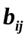 and topdown weights 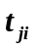between F1(b) and F2
- operation: cycle of two phases
- recognition (recall) phase:
competitively determine the winner J (at F2) with 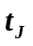as its class representative.
- comparison (verification) phase:
determine if the input resonates with (sufficiently similar to) class J
- vigilance 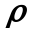
  - classification as search
- ART1 learning/adaptation
  - weight update rules:
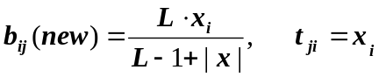
- learning when search is successful: only winning node J updates its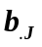and 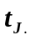.
- when search fails: treat x as an outlier (discard it) or create a new class (add a node on F2) for x
- learning algorithm
- Properties of ART1 and comparison to competitive learning networks

- Continuous Hopfield model
- Architecture:
- fully connected (thus recurrent) with 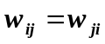 and 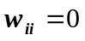
- input to node i: 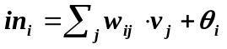
internal activation 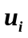: 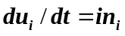 (approximated as 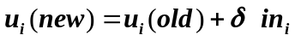)
output: 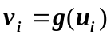 where g(.) is a sigmoid function
- Convergence
- energy function 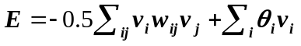
- 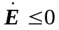(why) so E is a Lyapunov function
- during computation, all 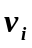's change along the gradient descent of E.
- Hopfield model for optimization (TSP)
- energy function (penalty for constraint violation)
- weights (derived from the energy function)
- local optima
- general approach for constraint satisfaction optimization problems

- Simulated Annealing (SA)
- Why need SA (overcome local minima for gradient descent methods)
- Basic ideas of SA
- gradual cooling from a high T to a very low T
- adding noise
- system reaches thermal equilibrium at each T
- Boltzmann-Gibbs distribution in statistical mechanics
- States and its associated energy
- Change state in SA (stochastically)
- 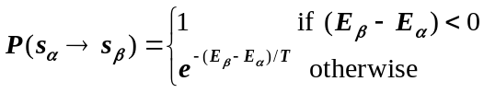probability of changing from 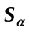 to 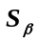 (Metropolis method):
- 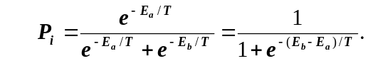probability of setting 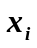 to 1 (another criterion commonly used in NN):
- Cooling schedule
- 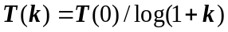 (Cauchy machine, with longer tail)
- 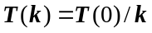, or 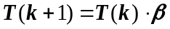
- annealing schedule (cooling schedule plus number of iteration at each temperature)
- SA algorithm
- Advantages and problems
  - escape from local minimum
  - very general
  - slow

- Boltzmann Machine (BM) = discrete HM + Hidden nodes + SA
- BM architecture
- visible and hidden units
- energy function (similar to HM)
- BM computing algorithm (SA)
- BM learning
- what is to be learned (probability distribution of visible vectors in the training set)
- free run and clamped run
- learning to maximize the similarity between two distributions 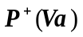 and 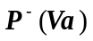
- learning take gradient descent approach to minimize
- 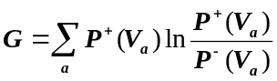the learning rule 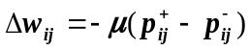 (meaning of 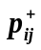 and 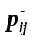)
- learning algorithm
- Advantages and problems
- higher representational power
- learning probability distribution
- extremely slow

- Basic Ideas of Some Other Neural Network Models
- Reinforcement learning (RL)
- general ideas of RL (reward and penalty)
- ARP (associative reward-and-penalty) algorithm for NN
- stochastic units (for random search)
- desired output induced by reward signal
- Recurrent BP (RBP)
- generalization of BP to recurrent networks
- Hopfield units
- gradient descent to minimize error E (how to obtain E: 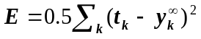, where 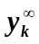 is computed by relaxing the original network to equilibrium)
  - transposed network, driven by error, computes weight updates by relaxing it to equilibrium.
  - weight update process for RBP
- Networks of Radial Basis Functions (RBF)
  - A better function approximator
  - unit of RBF (e.g., normalized Gaussian unit), receptive field of a unit
  - architecture and computation (compare to CPN: hidden nodes are not WTA)
  - learning (competitive for hidden units; LMS for output units)
  - compare with BP and CPN
- Probabilistic Neural Networks (PNN)
  - purpose: NN realization of Bayesian decision rule for classification
  - network structure: layers of pattern units and summation/class units
  - learning is not to minimize the error but to obtain probability density function

