CMSC 475/675: Introduction to Neural Networks
Review for Exam 1 (Chapters 1, 2, 3, 4)
- Basics
- Comparison between human brain and von Neumann architecture
- Processing units/nodes (input/output/hidden)
- Activation/node functions (threshold/step, linear-threshold, sigmoid, RBF)
- Network architecture (feed-forward/recurrent nets, layered)
- Connection and weights (excitatory, inhibitory)
- Types of learning (supervised/unsupervised), Hebbian rule,
  - Training samples
  - Overtraining/overfitting problem, cross-validation test
- Single Layer networks (Perceptron, Adaline, and the delta rule)
        - Architecture
        - Decision boundary and the problem of linear separability (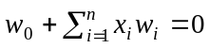)
        - Perceptron
  - learning rule (only when 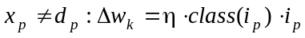)
  - Perceptron convergence theorem
        - Delta learning rule and Adaline
  - Error driven: 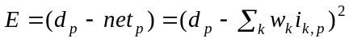 or 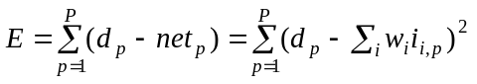
  - Learning rule (delta rule): 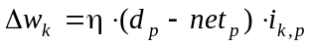) for each training sample 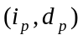
  - Gradient descent approach in deriving delta learning rule
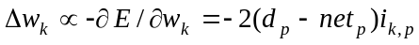
- Local minimum error for gradient descent approach
Backpropagation (BP) Networks
- Multi-layer feed-forward architecture with at least one layer of hidden nodes of non-linear and differentiable activation functions
- Motivation to have non-linear hidden nodes (representational power). Why non-linear?
- Feed forward computing
- BP learning
- Training samples:
- Obtain errors at output layer (feed-forward phase): 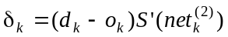
- Obtain errors at hidden layer (error backpropagation phase): 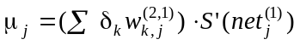
- Weight update: 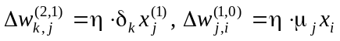
- Why BP learning works (gradient descent to minimize error): 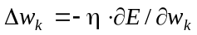
- Learning procedure (batch and sequential modes)
- In what sense BP learning generalizes the delta rule
- Issues of practical concerns
- Bias, error bound, training data, initial weights, number and size of hidden layers;
- Learning rate (momentum, adaptive rate)
- Advantages and problems with BP learning
- Powerful (general function approximator); easy to use; wide applicability; good generalization
- Local minima; overfitting; parameters may be hard to determine; network paralysis; long learning time, black-box; hard to accommodate new samples (non-incremental learning)
- Variations of BP nets
- Momentum term
- Adaptive learning rate
- Quickprop
- Other Multilayer Nets with Supervised Learning
  - Adaptive multilayer nets
- Why smaller net (with smaller # of hidden nodes) are often preferred
- Finding “optimal” network size: pruning and growing hidden nodes
- Cascade net (basic ideas):
  - When and how to add a new hidden node
  - What weights are to be trained when a new node is added, and how they are trained
- Prediction networks:
  - BP nets for prediction
  - Recurrent nets: unfolding vs gradient descent
- NN of radial basis function (RBF)
  - Definition of RBF, examples of RBF (especially Gaussian function)
  - Advantages of RBF wrt sigmoid functions
  - RBF for function approximation
- Polynomial networks

Types of questions that may appear on Exam 1:

- True/False
  - Backpropagation learning is guaranteed to converge.
- Definitions
  - Recurrent networks.
- Short questions (conceptual)
  - What are the major differences between human brain and Von Neumann machine?
- Longer questions
  - What is the overfitting problem in BP learning? What can you suggest to ease this problem?
- Apply some NN model to a small concrete problem
  - Construct a neural network with one hidden node and one output node to solve the XOR problem. The network should be feedforward but not necessarily layered.

