CMSC 475/675: Introduction to Neural Networks
Review for Exam 2 (Chapters 5, 6, 7)
- Competitive Learning Networks (CLN)
  - Purpose: self-organizing to form pattern clusters/classes based on similarities.
  - Architecture: competitive output nodes (WTA, Mexican hat, Maxnet, Hamming nets)
- external judge
- lateral inhibition (explicit and implicit)
- Simple competitive learning (unsupervised)
  - both training examples (samples) and weight vectors are normalized.
  - two phase process (competition phase and reward phase)
  - learning rules (moving winner's weight vector toward input training vector)
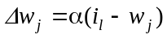 or 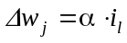 where i_{l} is the current input vector and w_{j} is the winner’s weight vector
  - learning algorithm
  - 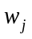 is trained to represent a class of patterns (close to the centroid of that class).
- Advantages and problems
  - unsupervised
  - simple (less time consuming)
  - number of output nodes and the initial values of weights affects the learning results (and thus the classification quality), over- and under-classification
  - stuck vectors and unstuck

    - Self-Organizing Map (SOM)
- Motivation: from random map to topographic map
  - what is topographic map
  - biological motivations
- SOM data processing
  - network architecture: two layers
  - output nodes have neighborhood relations
  - lateral interaction among neighbors (depending on radius/distance function D)
- SOM learning
  - weight update rule (differs from competitive learning when D > 0)
  - learning algorithm (winner and its neighbors move their weight vectors toward training input)
  - illustrating SOM on a two dimensional plane
- plot output nodes (weights as the coordinates)
- links connecting neighboring nodes
- Applications
  - TSP (how and why)

- Counter Propagation Networks (CPN)
- Purpose: fast and coarse approximation of vector mapping 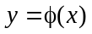
- Architecture (forward only CPN):
  - three layers (input, hidden, and output)
  - hidden layer is competitive (WTA) for classification/clustering
- CPN learning (two phases). For the winning hidden node 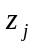
  - phase 1: weights from input to hidden (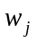) are trained by competitive learning to become the representative vector of a cluster of input vectors.
  - phase 2: weights from hidden to output (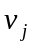)are trained by delta rule to become an average output of for all input x in cluster j.
  - learning algorithm
- Works like table lookup (but for multi-dimensional input space)
- Full CPN (bi-directional) (only if an inverse mapping 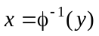 exists)

Adaptive Resonance Theory (ART)
- Motivation: varying number of classes, incremental learning
  - how to determine when a new class needs to be created
  - how to add a new class without damaging/destroying existing classes
- ART1 model (for binary vectors)
- architecture:
- bottom up weights 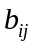 and topdown weights 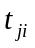
- vigilance for similarity comparison
- operation: cycle of three phases
- recognition (recall) phase: competitively determine the winner j* (at output layer) using as its class representative.
- comparison (verification) phase: determine if the input resonates with (sufficiently similar to) class j* using .
- weight update (adaptation) phase: based on similarity comparison, either add a new class node or update weights (both and ) of the winning node
- vigilance
  - classification as search
- ART1 learning/adaptation
  - weight update rules:
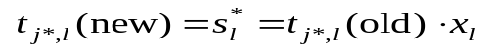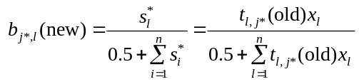
- learning when search is successful: only winning node j* updates its 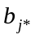 and 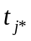.
- when search fails: treat x as an outlier (discard it) or create a new class (add a new output node) for x
- Properties of ART1 and comparison to competitive learning networks

Principle Component Analysis (PCA) Networks
- What is PCA: a statistical procedure that transform a given set of input vectors to reduce their dimensionality while minimizing the information loss
- Information loss: ||x – x’|| = ||x – W^{T}Wx||, where y = Wx, x’ = W^{T}y
- Pseudo-inverse matrix as the transformation matrix for minimizing information loss
- PCA net to approximate PCA:
  - two layer architecture (x and y)
  - learning to find W to minimize 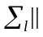xl – xl’|| = xl – WTWxl|| = xl – WTyl||
  - error-driven: for a given x, 1) compute y using W; 2) compute x’ using W^{T}
3)
- Associative Models
  - Simple AM
Associative memory (AM) (content-addressable/associative recall; pattern correction/completion) Network architecture: single layer or two layers
Auto- and hetero-association
- 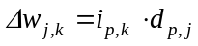Hebbian rule:
  - 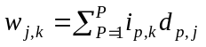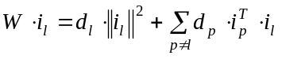Correlation matrix:
  - 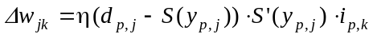Principal and cross-talk term:
- Delta rule: , derived following gradient descent to minimize total error
- Storage capacity: up to n - 1 mutually orthogonal patterns of dimension n
- Iterative autoassociative memory
  - Motives (comparing with non-iterative recall)
  - Using the output of the current iteration as input of the next iteration (stop when a state repeats)
  - Dynamic system (stable states, attractors, genuine and spurious memories)
- Discrete Hopfield model for auto-associative memory
  - Network architecture (single-layer, fully connected, recurrent)
  - Weight matrix for Hopfield model (symmetric with zero diagonal elements)
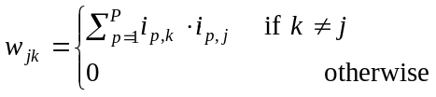
- Net input and node function: 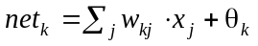, 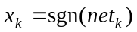
- Recall procedure (iterative until stabilized)
- Stability of dynamic systems
    - Ideas of Lyapunov function/energy function (monotonically non-increasing and bounded from below)
    - Convergence of Hopfield AM: its an energy function
    - 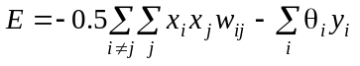
  - Storage capacity of Hopfield AM (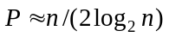).
- Bidirectional AM (BAM)
  - Architecture: two layers of non-linear units
  - Weight matrix: 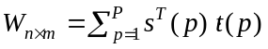
  - Recall: bi-directional (from x to y and y to x); recurrent
  - Analysis
    - Energy function: 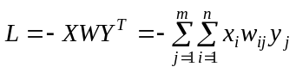
    - Storage capacity: 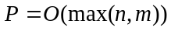

Continuous Hopfield Models
- Architecture:
- fully connected (thus recurrent) with 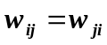 and 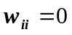
- net input to: same as in DHM
internal activation : 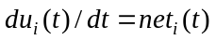 (approximated as 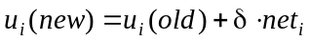)
output: 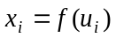 where f(.) is a sigmoid function
- Convergence
- energy function 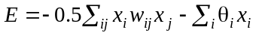
- 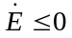(why) so E is a Lyapunov function
- during computation, all 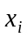's change along the gradient descent of E.
- Hopfield model for optimization (TSP)
- energy function (penalty for constraint violation)
- weights (derived from the energy function)
- local optima
- General approach for formulating combinatorial optimization problems in NN
- Represent problem space as NN state space
- Define an energy function for the state space: feasible solutions as local minimum energy space, optimal solutions as global minimum energy space
- Find weights that let the system moves along the energy reduction trajectory

- Simulated Annealing (SA)
- Why need SA (overcome local minima for gradient descent methods)
- Basic ideas of SA
- Gradual cooling from a high T to a very low T
- Adding noise
- System reaches thermal equilibrium at each T
- Boltzmann-Gibbs distribution in statistical mechanics
- 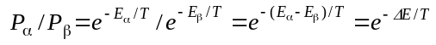States and its associated energy
- Change state in SA (stochastically)
- 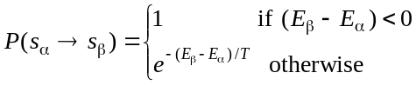probability of changing from 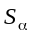 to 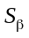 (Metropolis method):
- probability of setting to 1 (another criterion commonly used in NN):
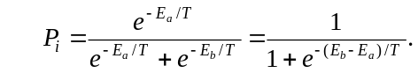
- Cooling schedule
- 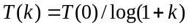
- 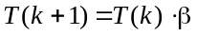
- annealing schedule (cooling schedule plus number of iteration at each temperature)
- SA algorithm
- Advantages and problems
  - escape from local minimum
  - very general
  - slow

- Boltzmann Machine (BM) = discrete HM + Hidden nodes + SA
- BM architecture
- visible and hidden units
- energy function (similar to HM)
- BM computing algorithm (SA)
- BM learning
- what is to be learned (probability distribution of visible vectors in the training set)
- free run and clamped run
- learning to maximize the similarity between two distributions 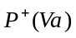 and 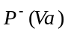
- learning takes gradient descent approach to minimize
- 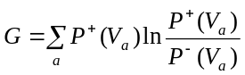the learning rule 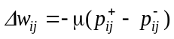 (meaning of 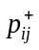 and 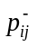, and how to compute them)
- learning algorithm
- Advantages and problems
- higher representational power
- learning probability distribution
- extremely slow

Evolutionary Computing
- Biological evolution:
- Reproduction (cross-over, mutation)
- Selection (survival of the fittest)
- Computational model (genetic algorithm)
  - Fitness function
  - Randomness (stochastic process)
  - termination
- Advantages and problems
- General optimization method (can find global optimal solution in theory)
- Very expensive (large population size, running for many iterations)

Note: neural network models and variations covered in the class but not listed in this document will not be tested in Exam 2.

