

**MEEM 4707: Autonomous system**

**Spring, 2024**

**Lab - 5**

**By**

**Colton Kreischer**

# **Problem 1.** Consider an area of square shape and size 2m x 2m. The robot is located at its center. Discretize the given square space into a 100 x 100 2d matrix.

1. What is the resolution of discretization?

Resolution = 2 m / 100 = 0.02 m = 2 cm

1. Write the row and column values from the matrix above of a point which is at:
2. 0.43 m and 30 degrees with respect to the robot’s x-axis.
3. 0.57 m and 330 degrees with respect to the robot’s x-axis.
4. 1.1 m and 45 degrees with respect to the robot’s x-axis.
5. 0.6 m and 120 degrees with respect to the robot’s x-axis.

Report the error if the row or column value(s) does not exist.

Assuming 2m x 2m, 101x101 discretization, where the origin is at (1,1) and (0,0) represents the lower left corner.

|  |  |  |  |  |
| --- | --- | --- | --- | --- |
|  | X (m) | X (index) | Y (m) | Y (index) |
| A | 0.3724 | 68 | 0.2150 | 60 |
| B | 0.4936 | 74 | -0.2850 | 35 |
| C | 0.7778 | 88 | 0.7778 | 88 |
| D | -0.3000 | 35 | 0.5196 | 75 |

1. Write the x and y coordinate values (with respect to the robot’s axis) of a point that has row and column values as:
2. 11 and 34, respectively.
3. 11 and 85, respectively.
4. 52 and 34, respectively.
5. 52 and 85, respectively.

|  |  |  |  |  |
| --- | --- | --- | --- | --- |
|  | X (m) | X (index) | Y (m) | Y (index) |
| A | -0.78 | 11 | -0.32 | 34 |
| B | -0.78 | 11 | 0.70 | 85 |
| C | 0.04 | 52 | -0.32 | 34 |
| D | 0.04 | 52 | 0.70 | 85 |

1. Assume that one of the lidar scan point readings corresponds to a cylinder surface and is 0.5 m at 30 degrees w.r.t robot’s x-axis. The radius of the cylinder is 0.3 m.  **What would be the values of rows and columns for the possible cylinder centers?** You may use the hand-drawn sketch of a matrix grid and highlight the possible centers to explain your approach.

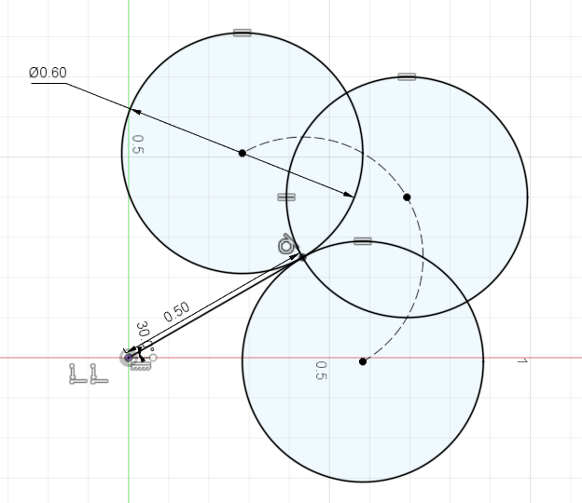

Possible centers would fall along the dotted semicircle, where any point less than half the discretization resolution from the arc segment is a possible center point. The possible center points are plotted and listed below.

0.2800 0.5000  
 0.2800 0.5200  
 0.3000 0.5200  
 0.3200 0.5200  
 0.3200 0.5400  
 0.3400 0.5400  
 0.3600 0.5400  
 0.3800 0.5400  
 0.4000 0.5400  
 0.4200 0.5400  
 0.4400 0.5400  
 0.4600 0.5400  
 0.4800 0.5400  
 0.5000 0.5400  
 0.5200 0.5400  
 0.5400 0.5200  
 0.5400 0.5400  
 0.5600 0.5200  
 0.5800 0  
 0.5800 0.5000  
 0.5800 0.5200  
 0.6000 0  
 0.6000 0.5000  
 0.6200 0  
 0.6200 0.0200  
 0.6200 0.4800  
 0.6200 0.5000  
 0.6400 0.0200  
 0.6400 0.0400  
 0.6400 0.4600  
 0.6400 0.4800  
 0.6600 0.0400  
 0.6600 0.0600  
 0.6600 0.4400  
 0.6600 0.4600  
 0.6800 0.0600  
 0.6800 0.0800  
 0.6800 0.1000  
 0.6800 0.4000  
 0.6800 0.4200  
 0.6800 0.4400  
 0.7000 0.1000  
 0.7000 0.1200  
 0.7000 0.1400  
 0.7000 0.3600  
 0.7000 0.3800  
 0.7000 0.4000  
 0.7200 0.1400  
 0.7200 0.1600  
 0.7200 0.1800  
 0.7200 0.2000  
 0.7200 0.3000  
 0.7200 0.3200  
 0.7200 0.3400  
 0.7200 0.3600  
 0.7400 0.2000  
 0.7400 0.2200  
 0.7400 0.2400  
 0.7400 0.2600  
 0.7400 0.2800  
 0.7400 0.3000

**Problem 2.** Read the “perception_lidar.py” code and summarize your understanding.

* 1. Point out the variable names and command lines in the code that define the Hough Transform vote matrix.

The variable ‘mat’, defined on line 47, stores the vote matrix. ‘a’ and ‘b’, defined on lines 45-46, define the matrix parameters.

* 1. Describe the meaning of the variable “C” in the code.

‘C’ represents the index of the highest vote, indicating the most likely center point of the arc/circle as voted on by the 360 points calculated for each point seen.

* 1. Explain how we can utilize “C” to detect and navigate the cylinder.

The value of C allows us to estimate the centerpoint (and through calculation, surface) of the cylindrical objects. This allows us to estimate the points of the cylinder which cannot be seen by the lidar, and potentially reveal unknown routes.