**INTERAKSI MOUSE**

#ifdef __APPLE__

#include <GLUT/glut.h>

#else

#include <GL/glut.h>

#endif

#include <stdlib.h>

#include<windows.h>

#ifdef __APPLE__

#include <GLUT/glut.h>

#else

#include <GL/glut.h>

#endif

#include <stdlib.h>

int w=480,h=480;

float x=0,y=0,z=0;

int l=5, t=5;

int s1=0, s2=0;

void drawQuad(){

glBegin(GL_QUADS);

glColor3f(5,0,0.5);

glVertex2i(x+l-3*t-s1,y+t-3*l-s1);

glVertex2i(x+l-3*t-s1,y+2*t+s1);

glVertex2f(x+2*l+s1,y+2*t+s1);

glVertex2f(x+2*l+s1,y+t-3*l-s1);

glEnd();

}

void myDisplay(){

glClear(GL_COLOR_BUFFER_BIT);

glPushMatrix();

drawQuad();

glPopMatrix();

glFlush();

}

void mouse(int button, int state, int xmouse, int ymouse){

if(button==GLUT_RIGHT_BUTTON && state==GLUT_DOWN){

x = xmouse-(w/2);

y=(h/2) - ymouse;

}

}

void motion(int xmouse, int ymouse){

s1 =x- (xmouse-(w/2));

s2=y-((h/2) - ymouse);

}

void timer (int value){

glutPostRedisplay();

glutTimerFunc(1,timer,0);

}

main(int argc, char **argv){

glutInit(&argc, argv);

glutInitWindowPosition(200,200);

glutInitWindowSize(w,h);

glutCreateWindow("Agung");

gluOrtho2D(-w/2,w/2,-h/2,h/2);

glClearColor(1, 1, 1, 0);

glutDisplayFunc(myDisplay);

glutTimerFunc(0,timer,0);

glutMouseFunc(mouse);

glutMotionFunc(motion);

glutMainLoop();

}

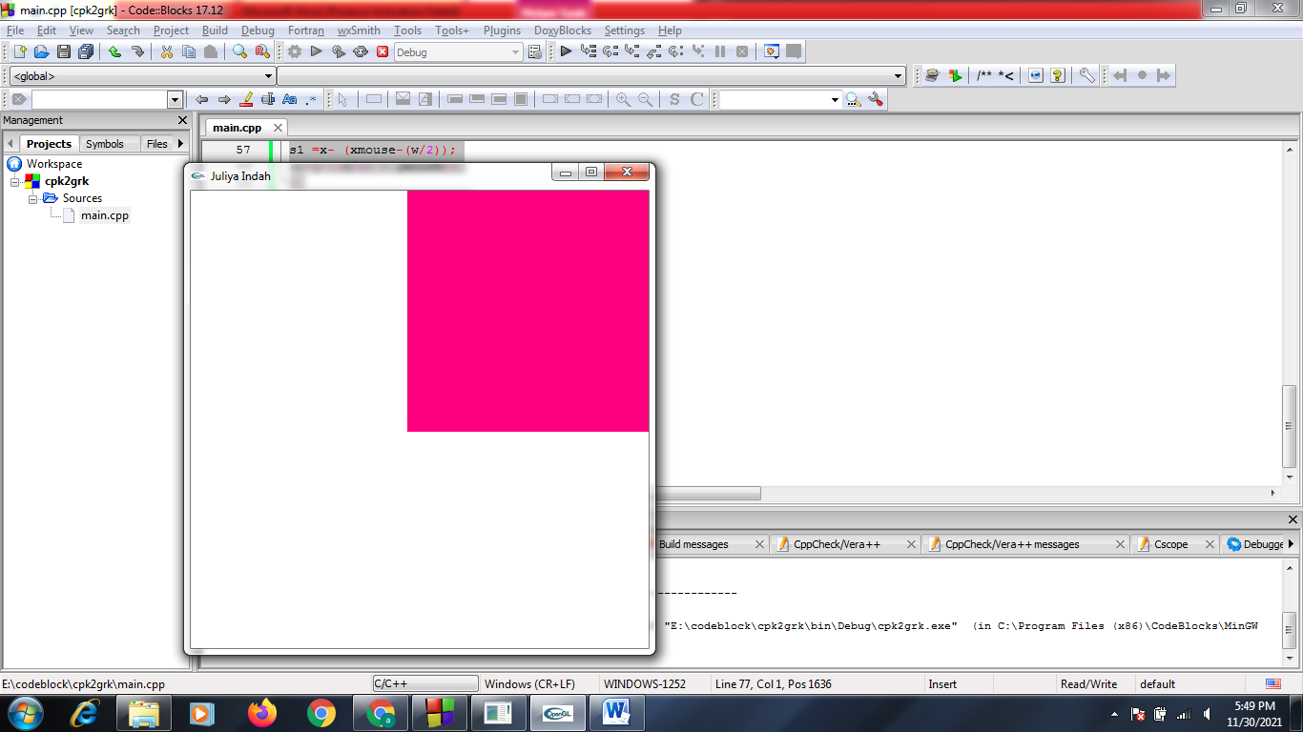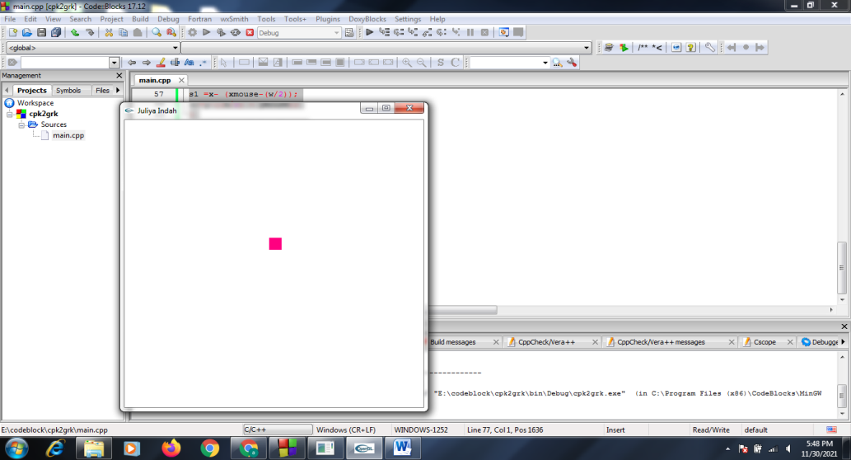**OUTPUT**

Tampilan Normal Tampilan Drag Menjauh

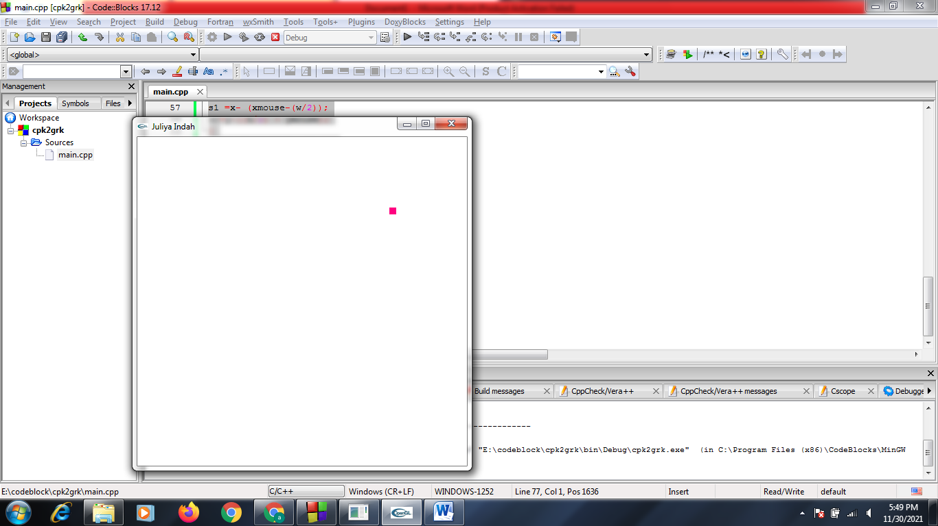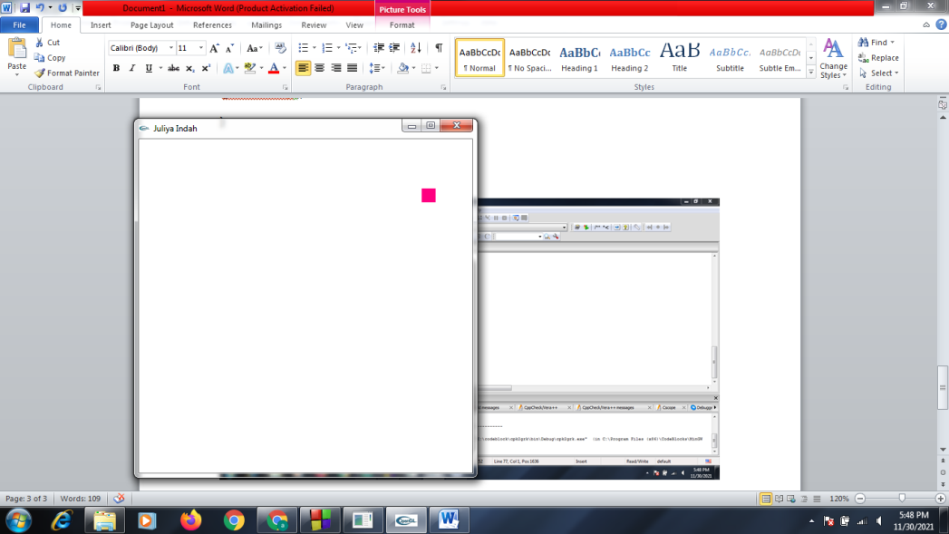 Tampilan Klik Kanan Tampilan Drag Mendekat

**INTERAKSI KEYBOARD BIASA**

#ifdef __APPLE__

#include <GLUT/glut.h>

#else

#include <GL/glut.h>

#endif

#include <stdlib.h>

#include<windows.h>

#ifdef __APPLE__

#include <GLUT/glut.h>

#else

#include <GL/glut.h>

#endif

#include <stdlib.h>

void drawQuad(int x, int y){

glBegin(GL_QUADS);

glVertex2i(0,0);

glVertex2i(x,0);

glVertex2i(x,y);

glVertex2i(0,y);

glEnd();

}

void display(){

glClear(GL_COLOR_BUFFER_BIT);

glColor3d(1,0.5,0);

drawQuad(60,40);

glFlush();

}

void myKeyboard(unsigned char key, int x, int y){

if(key=='g' ) glTranslatef(-4,0,0);

else if(key=='h') glTranslatef(4,0,0);

else if(key=='y') glTranslatef(0,4,0);

else if(key=='b') glTranslatef(0,-4,0);

}

void update(int value){

glutPostRedisplay();

glutTimerFunc(50,update,0);

}

int main(int argc, char **argv){

glutInit(&argc, argv);

glutInitDisplayMode(GLUT_DEPTH | GLUT_SINGLE | GLUT_RGBA);

glutInitWindowPosition(100,100);

glutInitWindowSize(640,480);

glutCreateWindow("Agung");

glClearColor(1,1,1,0);

gluOrtho2D(-320,320,-320,320);

glutDisplayFunc(display);

glutTimerFunc(50,update,0);

glutKeyboardFunc(myKeyboard);

glutMainLoop();

}

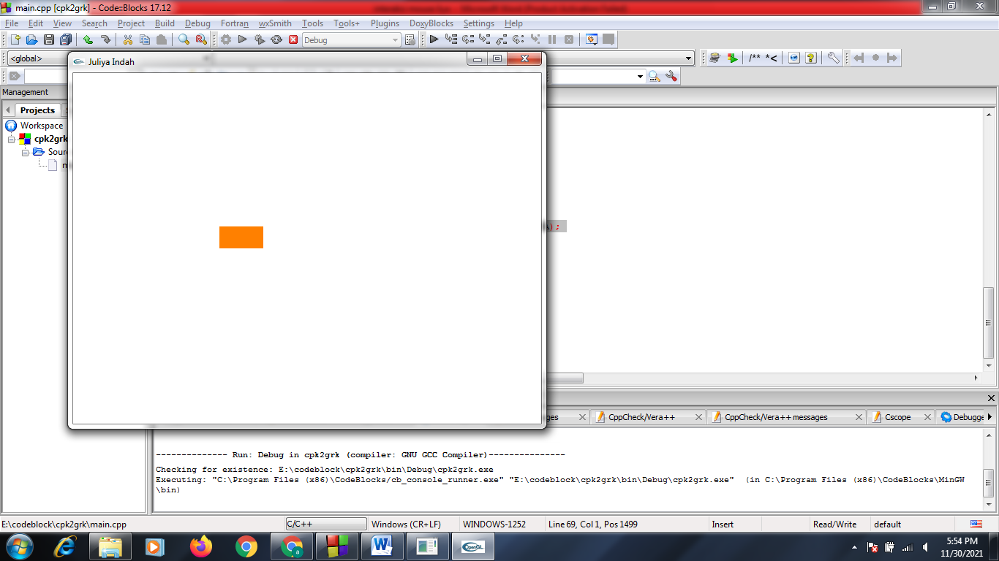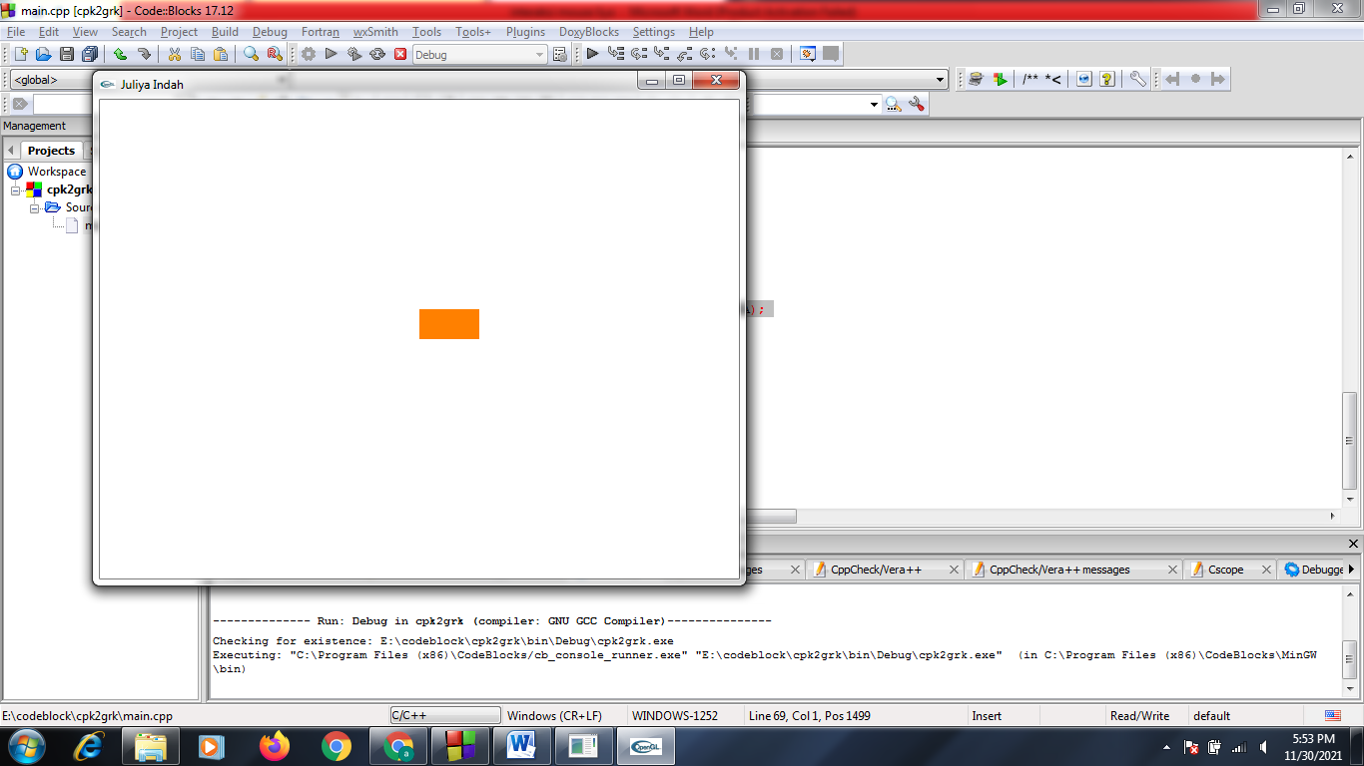**OUTPUT**

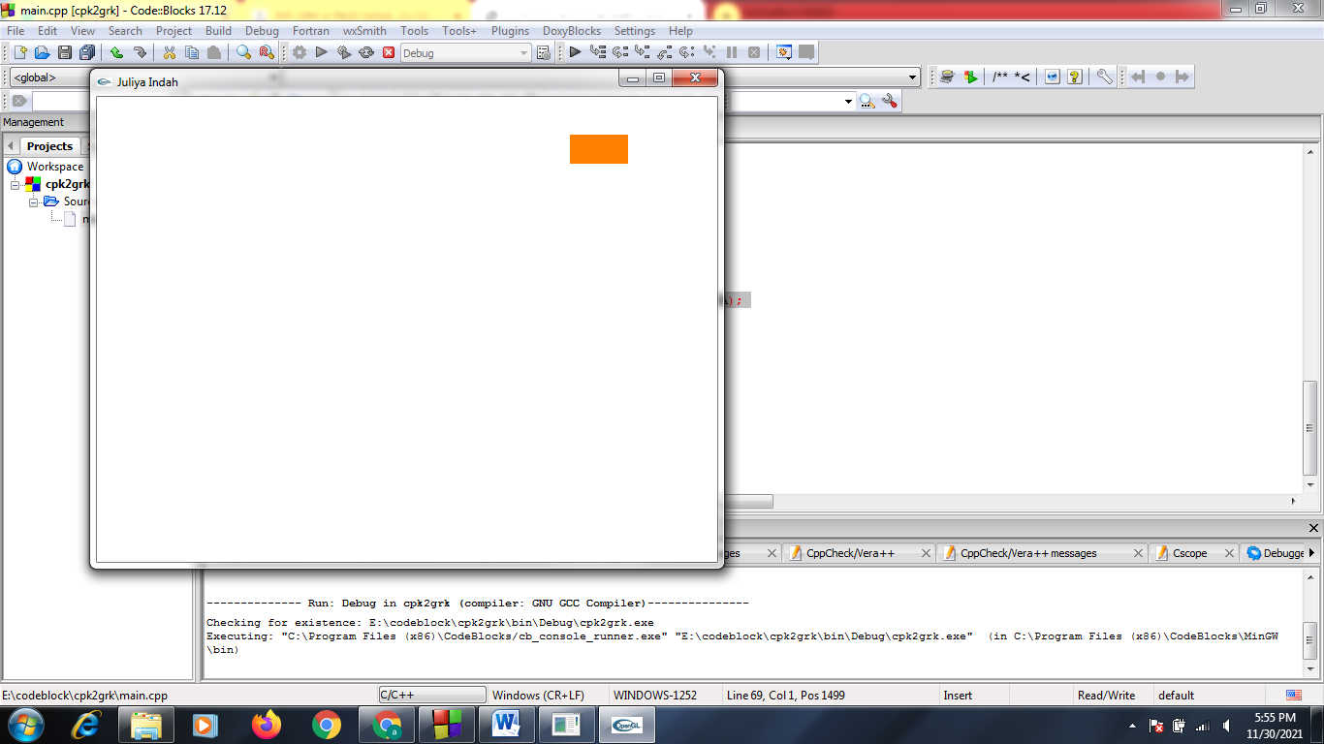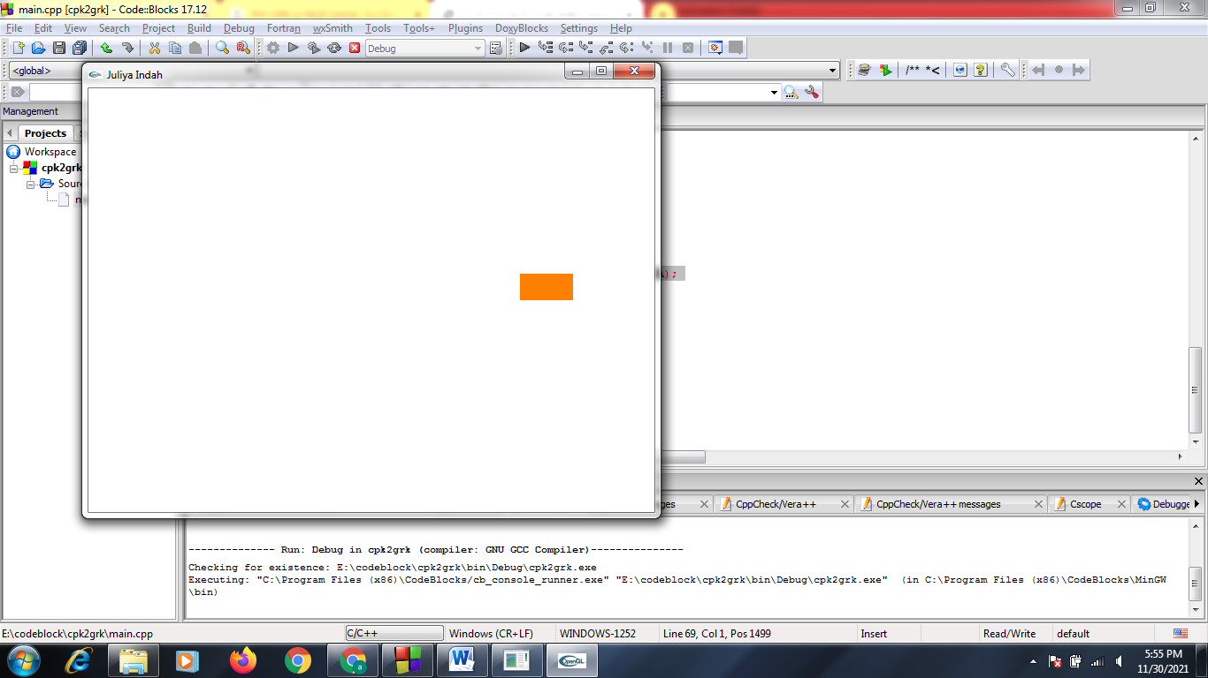Tampilan Normal Tampilan Interaksi Keyboard “g”

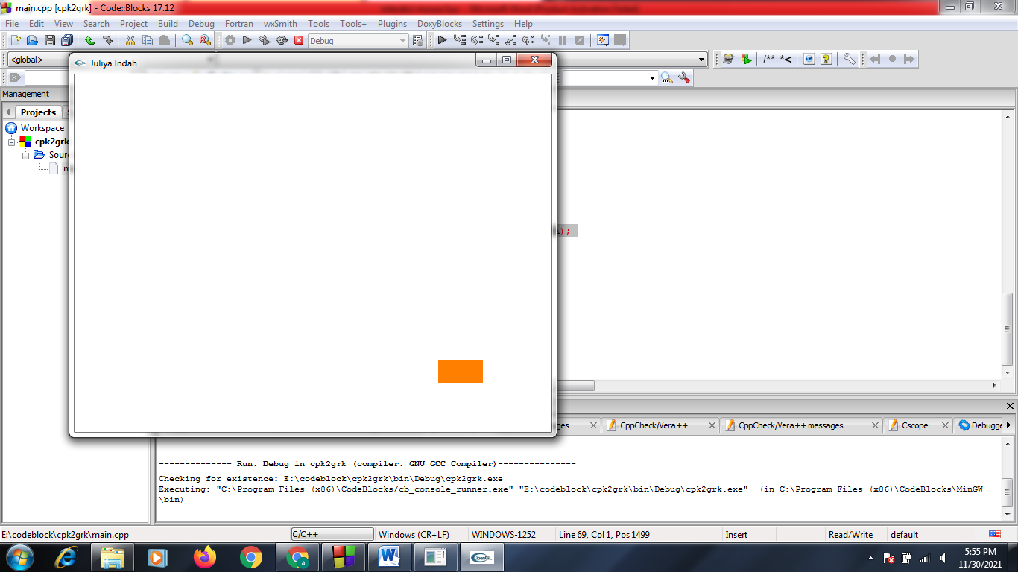Tampilan Interaksi Keyboard “h” Tampilan Interaksi Keyboard “y”

Tampilan Interaksi Keyboard “b”

**INTERAKSI KEYBOARD SPESIAL**

#ifdef __APPLE__

#include <GLUT/glut.h>

#else

#include <GL/glut.h>

#endif

#include <stdlib.h>

#include<windows.h>

#ifdef __APPLE__

#include <GLUT/glut.h>

#else

#include <GL/glut.h>

#endif

#include <stdlib.h>

void drawQuad(int x, int y){

glBegin(GL_QUADS);

glVertex2i(0,0);

glVertex2i(x,0);

glVertex2i(x,y);

glVertex2i(0,y);

glEnd();

}

void display(){

glClear(GL_COLOR_BUFFER_BIT);

glColor3d(0.5,2,5);

drawQuad(50,50);

glFlush();

}

void mySpecialKeyboard(int key, int x, int y){

switch(key){

case GLUT_KEY_DOWN :

glRotatef(4,0,0,1);

break;

}

}

void update(int value){

glutPostRedisplay();

glutTimerFunc(50,update,0);

}

int main(int argc, char **argv){

glutInit(&argc, argv);

glutInitDisplayMode(GLUT_DEPTH | GLUT_SINGLE | GLUT_RGBA);

glutInitWindowPosition(100,100);

glutInitWindowSize(640,480);

glutCreateWindow("Agung");

glClearColor(1,1,1,0);

gluOrtho2D(-320,320,-320,320);

glutDisplayFunc(display);

glutTimerFunc(50,update,0);

glutSpecialFunc(mySpecialKeyboard);

glutMainLoop();

}

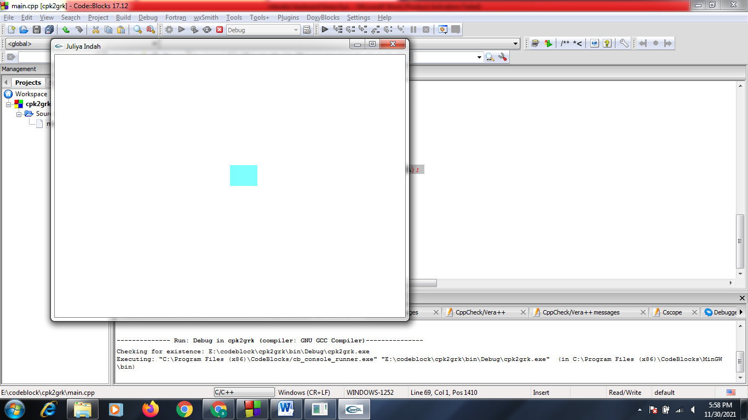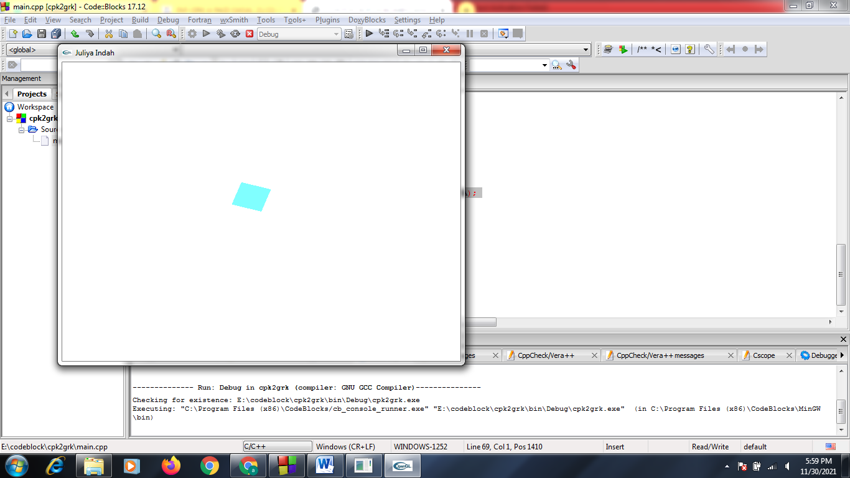**OUTPUT**

Tampilan Normal Tampilan Dengan r bawah

**Nama : Agung Gumilang**

**NIM : 200602034**