CS6326 Human-Computer Interactions

Spring 2017

Assignment 4: Multithreaded Text Search

Write a program that searches a text file for a string. It must find all occurrences of the string and show them in a list. Since the text file could be very long, and lists in C# do not display until the button-press code that fills them exits, your program must be multithreaded. The program should do the following:

1. Have a textbox for the name of a text file. You can also have a Browse button that will let you find a file to put in the textbox.
2. Another textbox will accept text to be found in the document.
3. A search button will cause the document to be searched.
4. A listview control displays the entire line on which the text was found and the line number within the document.
5. Search each line of text as you read it for the search string. You should probably do a case-insensitive comparison. Every time the string is found, put the entire line in which it occurs in the list along with its line number. To make it interesting, put in a pause of 100 milliseconds every time you read a line. This will simulate a long document.
6. The Search button text should be change to “Cancel” once the search starts, and should cancel the operation when pressed.
7. Add any other features to this program that you think may make it more usable or understandable to the average computer user. (Do not e-mail me to ask if this or that feature is allowable. Use your knowledge of design, and material provided, to make the determination. In-class discussion is welcome, however.)

I have provided a long text file that is from a software engineering text. Search for words like “software” and “object” to test your program.

A possible screen design is shown on the next page.

|  |  |
| --- | --- |
| **Grading: 100 points possible** | |
| Program is truly multithreaded and works according to the above specification | 50 |
| Program follows other UI design rules and guidelines | 30 |
| Additional features for usability/learnability | 10 |
| Program comments and good variable names | 10 |

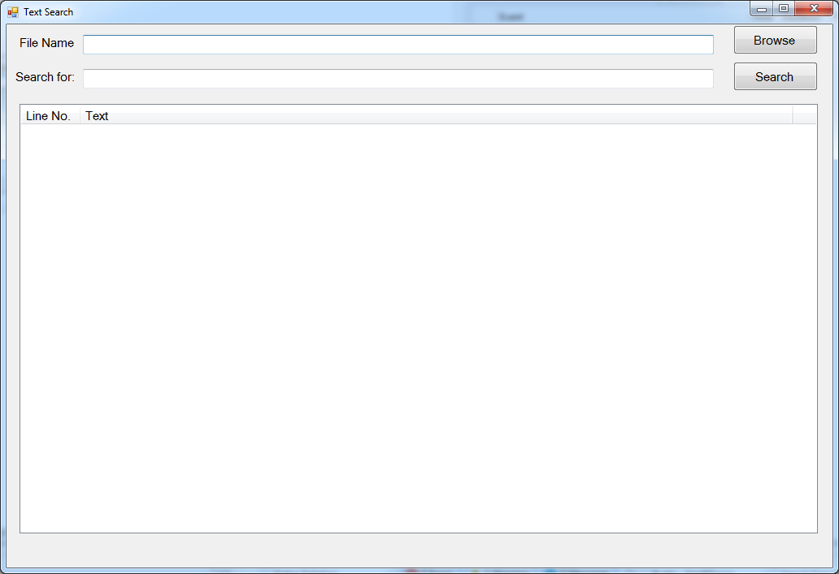

notes of prof’s comments on this assignment:

* background worker
* button should not be always enabled
* if a word appears more than one time in a line, don’t show it multiple times, just move on to the next line
* progress indicator
* status bar
* two threads running: UI thread and background
* string function search
* comments needed/name/author