1. Air Delay by Airport Graph

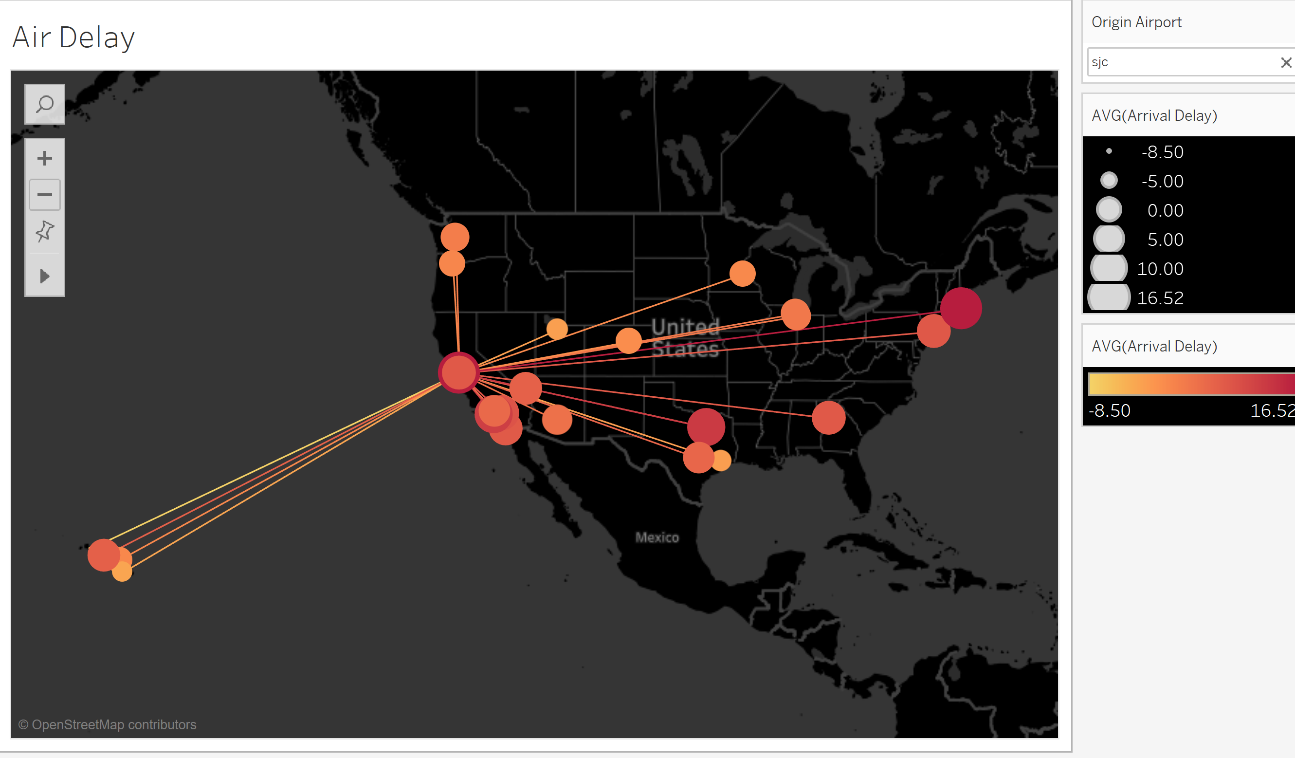

I did not narrow the data down to California and use all USA data. This dataset is from Kaggle that Karen provided. (<https://www.kaggle.com/usdot/flight-delays#flights.csv>). But I have a problem with the origin airport filter. I am not sure why when I plot this graph, it generates some numbers for origin airport filter so I hide it.

Data source: airports.csv & flights.csv in flight-delays folder

1. All stations graph

Air: airports in California

Train: Amtrak

Bus: Greyhound

Data source: travel_all.csv

1. Air passenger Traffic graph

Data Source: travel_airport1.csv

1. Train Ridership Graph

Data Source: travel_amtrak1.csv