The baseline is setting survive to the value that has the higher count between 1 and 0, in this case 0. As a simple baseline if guessing the most common result every time, the accuracy is .62 for both the training data and the test set.
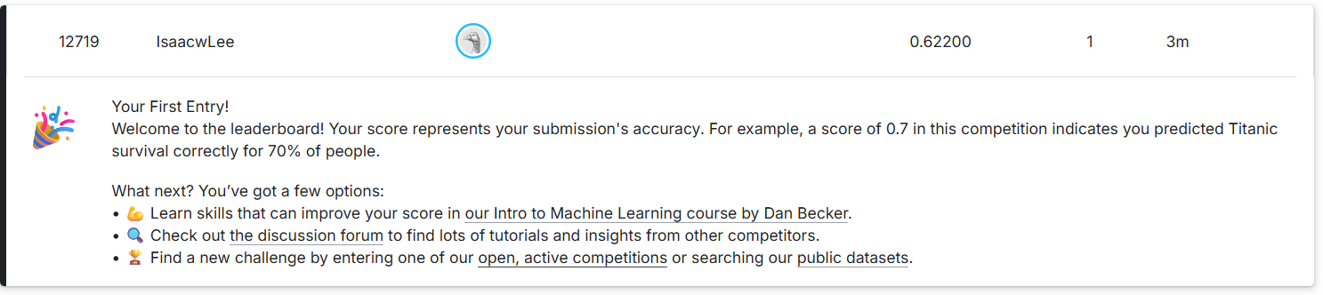

Accuracy: 0.6161616161616161
F1: 0.0
Confusion matrix:
[[549 0]
[342 0]]

Final machine learning questions
- I used a random forest model based off of the Kaggle titanic tutorial, so I did not need to do any feature scaling. It does need numeric values, so the categorical data was one hot encoded. The Cabin information was unique to each passenger, so to get general data from it, I pulled the first character from the cabin code, and removed the entry containing T because it was not in the test set, but this did not seem to improve the model.
- I used a random forest model

Accuracy: 0.8314606741573034
F1: 0.7611464968152867
[[501 47]
[103 239]]
- Rank 2758, acc .78468
