Hw3
1. 503
2.
Max: 5.0
Min: 0.1
Mean: 0.7976540755467197
3.
0.6938369781312127
4.
0.26288731176280106
5.
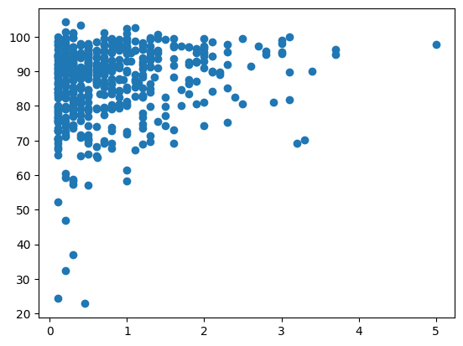
6.
[2.78665993]x +[84.54015334]
7.
10.711492451359439
8.
