1.1
Actual: [0 1 0 0 0 1 0 0 0 1]
Predicted: [0 0 0 0 1 0 1 1 1 0]
1.2
0.2
1.3
[[3 4]
[3 0]]
[[np.int64(3), np.int64(4)], [np.int64(3), np.int64(0)]]
1.4
precision: 0.0
recall: 0.0
# F1 is 0
1.5
TNR: 0.42857142857142855
FNR: 1.0
TPR: 0.0
FPR: 0.5714285714285714
1.6
# precision and recall are always 0 for this seed?
1.7
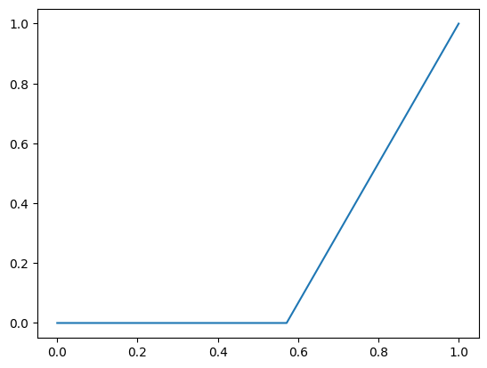
1.8
auc: 0.2142857142857143

2.1
Actual: [3 4 2 4 4 1 2 2 2 4]
Predicted: [3 2 4 1 3 1 3 4 0 3]
2.2
[[0 0 0 0 0]
[0 1 0 0 0]
[1 0 0 1 2]
[0 0 0 1 0]
[0 1 1 2 0]]
2.3
[[0. 0. 0. 0. 0.]
[0. 0. 0. 0. 0.]
[1. 0. 0. 1. 2.]
[0. 0. 0. 0. 0.]
[0. 1. 1. 2. 0.]]
[[0. 0. 0. 0. 0. ]
[0. 0. 0. 0. 0. ]
[0.25 0. 0. 0.25 0.5 ]
[0. 0. 0. 0. 0. ]
[0. 0.25 0.25 0.5 0. ]]

