Coding Test

12011124 冯柏钧

1.

Result

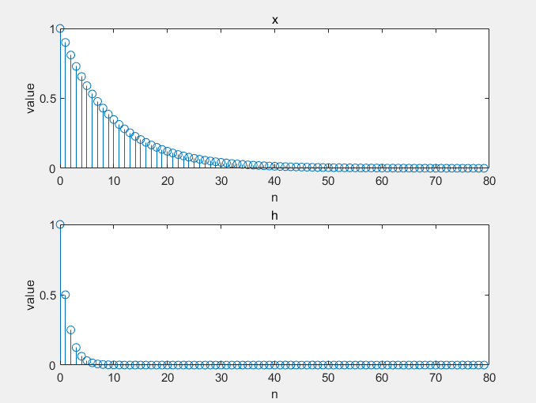

2.

Result

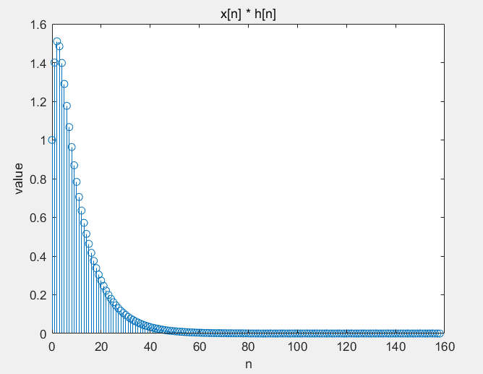

3.

Result

Real part

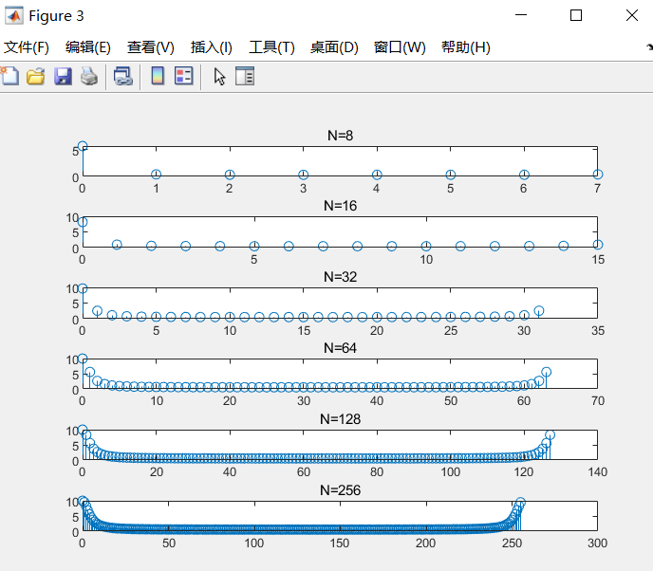

Imagine part

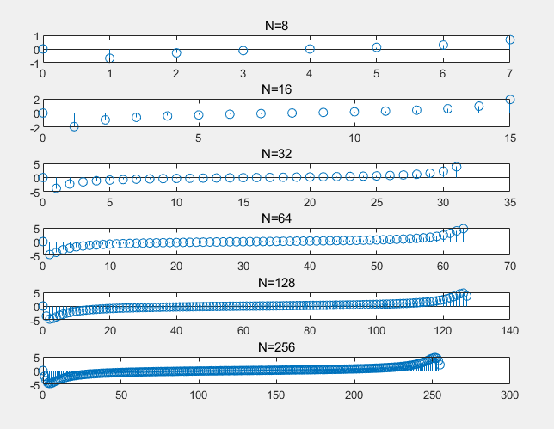

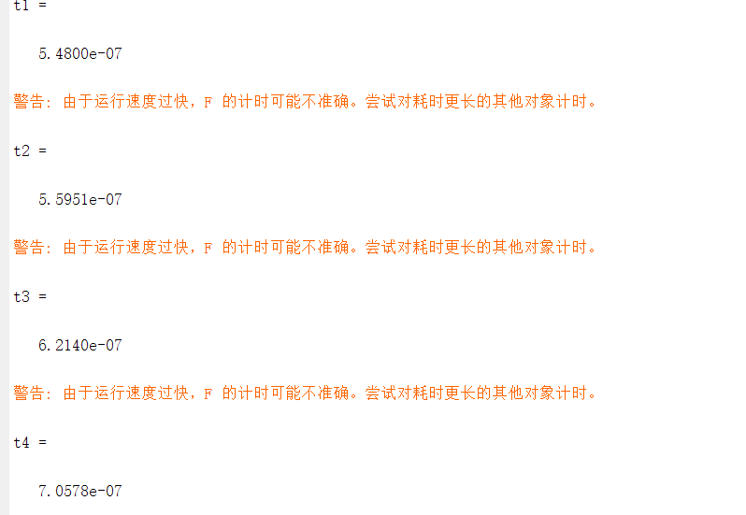

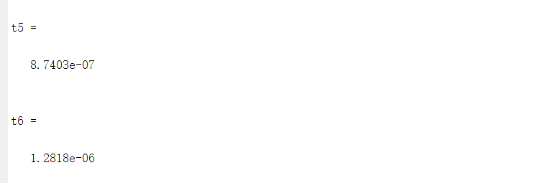

4.

con =

列 1 至 12

0.0125 0.0113 0.0101 0.0091 0.0082 0.0074 0.0066 0.0060 0.0054 0.0048 0.0044 0.0039

列 13 至 24

0.0035 0.0032 0.0029 0.0026 0.0023 0.0021 0.0019 0.0017 0.0015 0.0014 0.0012 0.0011

列 25 至 36

0.0010 0.0009 0.0008 0.0007 0.0007 0.0006 0.0005 0.0005 0.0004 0.0004 0.0003 0.0003

列 37 至 48

0.0003 0.0003 0.0002 0.0002 0.0002 0.0002 0.0001 0.0001 0.0001 0.0001 0.0001 0.0001

列 49 至 60

0.0001 0.0001 0.0001 0.0001 0.0001 0.0000 0.0000 0.0000 0.0000 0.0000 0.0000 0.0000

列 61 至 72

0.0000 0.0000 0.0000 0.0000 0.0000 0.0000 0.0000 0.0000 0.0000 0.0000 0.0000 0.0000

列 73 至 80

0.0000 0.0000 0.0000 0.0000 0.0000 0.0000 0.0000 0.0000

5.

Result

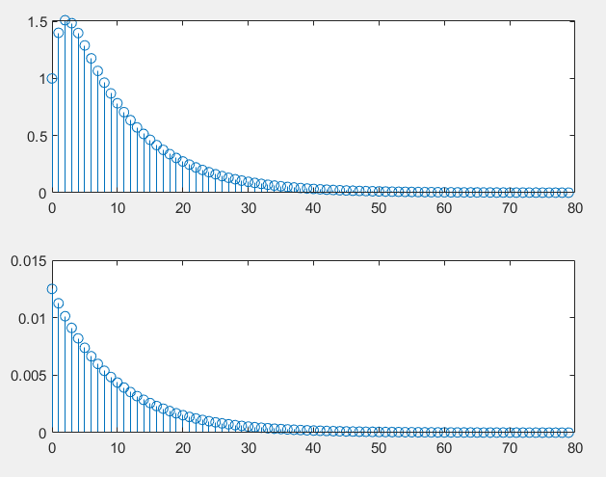

上面为线性，下面为循环

不相等，要截取一部分

Code

clc

clear

%1

x(1) = 1;

h(1) = 1;

for i = 2:81

x(i) = 0.9\*x(i-1);

h(i) = 0.5\*h(i-1);

end

figure(1)

subplot(211)

stem(0:80,x),title('x'),xlabel('n'),ylabel('value')

subplot(212)

stem(0:80,h),title('h'),xlabel('n'),ylabel('value')

%2

clc

clear

x(1) = 1;

h(1) = 1;

for i = 2:80

x(i) = 0.9\*x(i-1);

h(i) = 0.5\*h(i-1);

end

figure(1)

subplot(211)

stem(0:79,x),title('x'),xlabel('n'),ylabel('value')

subplot(212)

stem(0:79,h),title('h'),xlabel('n'),ylabel('value')

y1 = conv(x, h);

figure(2)

stem(0:158,y1),title('x[n] \* h[n]'),xlabel('n'),ylabel('value')

%3

clc

clear

x(1) = 1;

h(1) = 1;

for i = 2:8

x(i) = 0.9\*x(i-1);

h(i) = 0.5\*h(i-1);

end

fftx1 = fft(x);

f = @()fft(x);

t1 = timeit(f)

for i = 6:16

x(i) = 0.9\*x(i-1);

h(i) = 0.5\*h(i-1);

end

fftx2 = fft(x);

f = @()fft(x);

t2 = timeit(f)

for i = 17:32

x(i) = 0.9\*x(i-1);

h(i) = 0.5\*h(i-1);

end

fftx3 = fft(x);

f = @()fft(x);

t3 = timeit(f)

for i = 33:64

x(i) = 0.9\*x(i-1);

h(i) = 0.5\*h(i-1);

end

fftx4 = fft(x);

f = @()fft(x);

t4 = timeit(f)

for i = 65:128

x(i) = 0.9\*x(i-1);

h(i) = 0.5\*h(i-1);

end

fftx5 = fft(x);

f = @()fft(x);

t5 = timeit(f)

for i = 129:256

x(i) = 0.9\*x(i-1);

h(i) = 0.5\*h(i-1);

end

fftx6 = fft(x);

f = @()fft(x);

t6 = timeit(f)

figure(3)

subplot(611)

stem(0:7,fftx1),title('N=8')

subplot(612)

stem(0:15,fftx2),title('N=16')

subplot(613)

stem(0:31,fftx3),title('N=32')

subplot(614)

stem(0:63,fftx4),title('N=64')

subplot(615)

stem(0:127,fftx5),title('N=128')

subplot(616)

stem(0:255,fftx6),title('N=256')

figure(4)

subplot(611)

stem(0:7,imag(fftx1)),title('N=8')

subplot(612)

stem(0:15,imag(fftx2)),title('N=16')

subplot(613)

stem(0:31,imag(fftx3)),title('N=32')

subplot(614)

stem(0:63,imag(fftx4)),title('N=64')

subplot(615)

stem(0:127,imag(fftx5)),title('N=128')

subplot(616)

stem(0:255,imag(fftx6)),title('N=256')

%4

clc

clear

x(1) = 1;

h(1) = 1;

for i = 2:80

x(i) = 0.9\*x(i-1);

h(i) = 0.5\*h(i-1);

end

fftx = fft(x);

conx = conv(x,h);

con = 1/80\*ifft(fftx)

%5

figure(5)

subplot(211)

stem(0:79,conx(1:80))

subplot(212)

stem(0:79,con(1:80))