William Harley , Jackson Long, Oscar Cisneros, David Degman

ENGR114 Fall 2019

11/6/2019

Revised: 12/4/2019

***Humidity vs. Temperature***

***Hardware Setup:***

**Bill of Materials:**

|  |  |  |  |  |
| --- | --- | --- | --- | --- |
| Part Name | Purpose | Item Name | URL | Price (USD) |
| Adafruit Feather Huzzah  #2821 | Transmit arduino code | Microcontroller | <https://www.adafruit.com/product/2821?hidden=yes&main_page=product_info&products_id=2821&gclid=EAIaIQobChMIucK6gMmd5gIVfCCtBh2Q8ATgEAAYASAAEgIH9fD_BwE> | 16.95 |
| Digital Temperature and Humidity Sensor #[DHT22](https://www.amazon.com/gp/slredirect/picassoRedirect.html/ref=pa_sp_atf_industrial_sr_pg1_1?ie=UTF8&adId=A00612692CPY5JXXR7K4D&url=%2FHiLetgo-Digital-Temperature-Humidity-Replace%2Fdp%2FB01DA3C452%2Fref%3Dsr_1_1_sspa%3Fkeywords%3DAM2302%26qid%3D1574036080%26s%3Dindustrial%26sr%3D1-1-spons%26psc%3D1&qualifier=1574036080&id=6985604544883403&widgetName=sp_atf) | Measure change in humidity and temperature | Temperature and humidity sensor | <https://www.amazon.com/AZDelivery-Digital-Temperature-Humidity-Raspberry/dp/B07F86WXR7/ref=sr_1_8?crid=10YJBPVZBH0SW&keywords=am2302+temperature+%26+humidity+sensor&qid=1574037182&sprefix=AM2302+sensor%2Caps%2C272&sr=8-8> | 5.99 |
| USB micro-B Cable  #10215 | Connect computer to microcontroller | USB cable | <https://www.sparkfun.com/products/10215> | 4.95 |
| Jumper wires standard 7” M/M-30AWG (30pk)#11026 | Connect circuit board to sensor | Jumper wires | <https://www.sparkfun.com/products/11026> | 2.25 |
| Breadboard – Mini Modular (White)  #12043 | Connect microcontroller and sensor | Breadboard | <https://www.sparkfun.com/products/12043> | 3.95 |
| 1000 mL beaker #1000-1L | Hold water (increase humidity) | Glass beaker | <https://www.amazon.com/Pyrex-Glass-Griffin-Beaker-Measuring/dp/B005MIQ7QG/ref=sr_1_1?keywords=CORNING+1000ml+beaker&qid=1574041291&sr=8-1> | 17.99 |
| Aqua Culture 10 Gallon Empty Aquarium | House sensor and beaker | Aquarium | <https://www.amazon.com/Aqua-Culture-Aquarium-10-gallon/dp/B06XQQKDL8/ref=sr_1_7?crid=1DC48KGR93H98&keywords=10+gal+aquarium&qid=1574791013&sprefix=10+gal+aqu%2Caps%2C488&sr=8-7> | 22.97 |
| Thermolyne Cimarec 2 Lab Hot PlateHP46825 | Boil water | Hot Plate | <https://www.amazon.com/Barnstead-Thermolyne-HP46825-Cimarec-T128920/dp/B07Q6BW96V/ref=sr_1_1?keywords=thermalyne+cymarec+2+hot+plate&qid=1574791107&sr=8-1-spell> | 95.00 |
|  |  |  | Total | 170.05 |

Hardware Schematic:

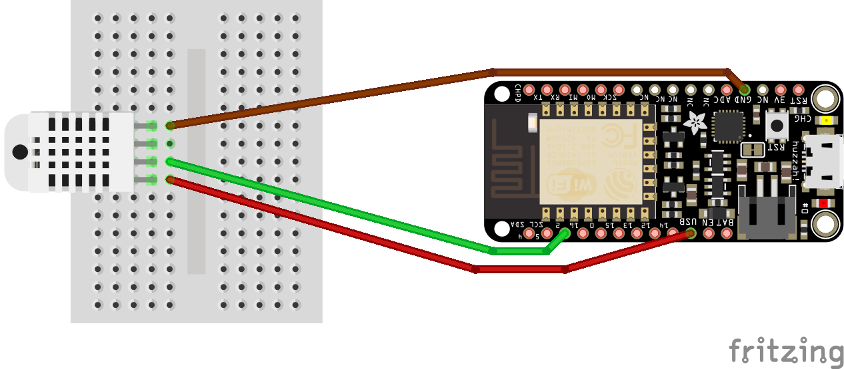

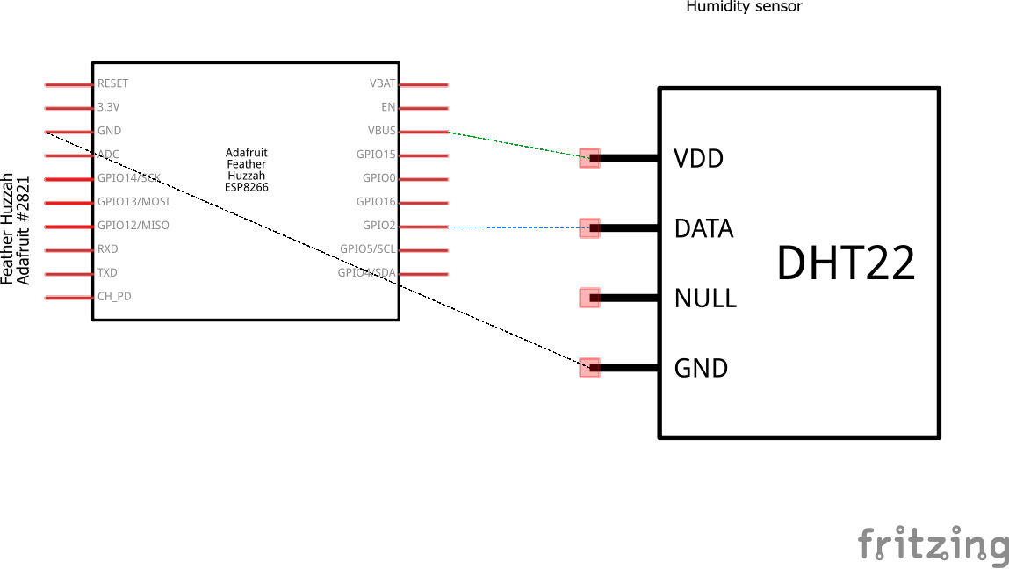

Hookup Guide:

|  |  |  |  |  |
| --- | --- | --- | --- | --- |
| Part | Pin | Connector | Pin | Part |
| Circuit board | USB | Orange wire | VDD | Sensor |
| Circuit board | GND | Brown wire | GND | Sensor |
| Circuit board | 2 | Green wire | DTA | Sensor |
| Sensor |  | Direct | Align with wires | Breadboard |

Images:

