Project 3: Time dependent Heat Equation

Wataru Hashimoto

4/25/2019

MEE 615

1. **Strong form and Inputs**
$$PDE: \frac{∂p}{∂t}-∇ ∙\left(K∇p\right)=q, for \left(x,t\right)∈Ω×\left(0,T\right] (1)$$

$$Drichlet Boundary Conditions:p= g_{D} \left(x,t\right), for x∈Γ_{D}, t∈\left(0,T\right] (2)$$

$$Neuman Boundary Conditions:u∙n= g_{N} \left(x,t\right), for x∈Γ_{N}, t∈\left(0,T\right] (3)$$

$$u= -K∇p (4)$$

$$Initial Condition:p\left(x,t=0\right)=p_{o}\left(x\right), for x∈Ω$$

$$Tensor: K=\left[\begin{matrix}y & 0 \\ 0 & x\end{matrix}\right]$$

$$Exact Solution: p=\cos\left(x-y+t\right)$$

$$Bottom face: g_{D}=\cos\left(x+t\right)for x∈\left(:,0\right)$$

$$Right face: g_{D}=\cos\left(1-y+t\right)for x∈(1,:)$$

$$Top face: g_{N}=-xsin\left(x-1+t\right) for x∈\left(:,1\right)$$

$$Left face: g_{N}=-ysin\left(-y+t\right)for x∈(0,:)$$

2. **Weak form derivation**
3. Convert to Einstein Notation
$$p_{,t}+u_{i,i}=q$$

4. Multiply by weight function
$$wp_{,t}+wu_{i,i}=wq$$

5. Take Integration over domain
$$\int_{Ω}{wp_{,t}}dΩ+\int_{Ω}{wu_{i,i}dΩ}=\int_{Ω}{wqdΩ}$$

6. Integration by parts formula
$${\left(wu_{i}\right)}_{,i}= w_{,i}u_{i}+wu_{i,i}$$

$$w_{,i}u_{i}+wu_{i,i}={\left(wu_{i}\right)}_{,i}$$

$$wu_{i,i}={\left(wu_{i}\right)}_{,i}-w_{,i}u_{i}$$

$$\int_{Ω}{wu_{i,i}dΩ}=\int_{Ω}{ {\left(wu_{i}\right)}_{,i}dΩ}-\int_{Ω}{ w_{,i}u_{i}dΩ}$$

7. Substitute to equation
$$\int_{Ω}{wp_{,t}}dΩ+\int_{Ω}{wu_{i,i}dΩ}=\int_{Ω}{wqdΩ}$$

$$\int_{Ω}{wp_{,t}}dΩ+\int_{Ω}{ {\left(wu_{i}\right)}_{,i}dΩ}-\int_{Ω}{ w_{,i}u_{i}dΩ}=\int_{Ω}{wqdΩ}$$

8. Divergence theorem formula
$$\int_{Ω}{ F_{,i}dΩ}=\int_{Γ}{ F∙ndΓ}$$

9. Apply Divergence theorem and split the boundary to essential and natural
$$\int_{Ω}{wp_{,t}}dΩ+\int_{Ω}{ {\left(wu_{i}\right)}_{,i}dΩ}-\int_{Ω}{ w_{,i}u_{i}dΩ}=\int_{Ω}{wqdΩ}$$

$$\int_{Ω}{wp_{,t}}dΩ+\int_{Γ}{ \left(wu_{i}\right)∙ndΓ} -\int_{Ω}{ w_{,i}u_{i}dΩ}=\int_{Ω}{wqdΩ}$$

$$\int_{Ω}{wp_{,t}}dΩ+\int_{Γ_{D}}{ \left(wu_{i}\right)∙ndΓ_{D}}+\int_{Γ_{N}}{ \left(wu_{i}\right)∙ndΓ_{N}} -\int_{Ω}{ w_{,i}u_{i}dΩ}=\int_{Ω}{wqdΩ}$$

10. Weight function at essential boundary condition $(Γ_{D})$ goes to 0

$$\int_{Ω}{wp_{,t}}dΩ+\int_{Γ_{N}}{ \left(wu_{i}\right)∙ndΓ_{N}} -\int_{Ω}{ w_{,i}u_{i}dΩ}=\int_{Ω}{wqdΩ}$$

1. Using dot product property, using w as a scalar we can rewrite as
$$\int_{Ω}{wp_{,t}}dΩ+\int_{Γ_{N}}{ w(u_{i}∙n)dΓ_{N}} -\int_{Ω}{ w_{,i}u_{i}dΩ}=\int_{Ω}{wqdΩ}$$

2. Substitute Neumann Boundary Condition eq. (3) and algebra
$$\int_{Ω}{wp_{,t}}dΩ+\int_{Γ_{N}}{ wg_{N}dΓ_{N}} -\int_{Ω}{ w_{,i}u_{i}dΩ}=\int_{Ω}{wqdΩ}$$

$$\int_{Ω}{wp_{,t}}dΩ -\int_{Ω}{ w_{,i}u_{i}dΩ}=\int_{Ω}{wqdΩ}- \int_{Γ_{N}}{ wg_{N}dΓ_{N}}$$

3. Substitute eq. (4) to $u_{i}$
$$\int_{Ω}{wp_{,t}}dΩ+\int_{Ω}{ w_{,i}k_{ij}p_{,j}dΩ}=\int_{Ω}{wqdΩ}- \int_{Γ_{N}}{ wg_{N}dΓ_{N}}$$

4. Use simplified notation
$$a\left(w,p\right)= \int_{Ω}{ w_{,i}k_{ij}p_{,j}dΩ}$$

$$\left(w,q\right)= \int_{Ω}{wqdΩ}$$

$$\left(w,p_{,t}\right)= \int_{Ω}{wp_{,t}dΩ}$$

$${\left(w,g_{N}\right)}_{Γ_{N}}= \int_{Γ_{N}}{ wg_{N}dΓ_{N}}$$

5. Weak form
$$\left(w,p_{,t}\right)+ a\left(w,p\right)= \left(w,q\right)- {\left(w,g_{N}\right)}_{Γ_{N}}$$

6. **Discretization**
7. Discretized form
$$\left(w^{h},p_{,t}^{h}\right)+ a\left(w^{h},p^{h}\right)= \left(w^{h},q\right)- {\left(w^{h},g_{N}\right)}_{Γ_{N}}$$

$$p^{h}=v^{h}+g^{h}$$

$$p_{,t}^{h}=v_{,t}^{h}+g_{,t}^{h}$$

8. Substitute
$$\left(w^{h},v_{,t}^{h}\right)+\left(w^{h},g_{,t}^{h}\right)+ a\left(w^{h},v^{h}\right)+a\left(w^{h},g^{h}\right)= \left(w^{h},q\right)- {\left(w^{h},g_{N}\right)}_{Γ_{N}}$$

9. Semi-discrete form (time is still continuous)

$$\left(w^{h},v_{,t}^{h}\right)+ a\left(w^{h},v^{h}\right)= \left(w^{h},q\right)- {\left(w^{h},g_{N}\right)}_{Γ_{N}}-a\left(w^{h},g^{h}\right)-\left(w^{h},g_{,t}^{h}\right)$$

$$I.C.\left(w^{h},v^{h}\left(0\right)\right)=\left(w^{h},p_{o}\right)-(w^{h},g^{h})$$

1. **Galerkin’s Approximation**
2. Shape functions
$$w^{h}\left(x,t\right)=\sum_{A∈η-η_{g}}{N_{A}\left(x\right)C_{A}\left(t\right)}$$

$$v^{h}\left(x,t\right)=\sum_{B∈η-η_{g}}{N_{B}\left(x\right)d_{B}\left(t\right)}$$

$$g^{h}\left(x,t\right)=\sum_{B∈η_{g}}{N_{B}\left(x\right)g_{B}\left(t\right)}$$

$$\dot{v^{h}}\left(x,t\right)=\sum_{B∈η-η_{g}}{N_{B}\left(x\right)\dot{d_{B}}\left(t\right)}$$

$$\dot{g^{h}}\left(x,t\right)=\sum_{B∈η-η_{g}}{N_{B}\left(x\right)\dot{g_{B}}\left(t\right)}$$

3. Substitute
$$\left(\sum_{A∈η-η_{g}}{N_{A}\left(x\right)C_{A}\left(t\right)},\sum_{B∈η-η_{g}}{N_{B}\left(x\right)\dot{d_{B}}\left(t\right)}\right) + a\left(\sum_{A∈η-η_{g}}{N_{A}\left(x\right)C_{A}\left(t\right)},\sum_{B∈η-η_{g}}{N_{B}\left(x\right)d_{B}\left(t\right)}\right)= \left(\sum_{A∈η-η_{g}}{N_{A}\left(x\right)C_{A}\left(t\right)},q\right)- {\left(\sum_{A∈η-η_{g}}{N_{A}\left(x\right)C_{A}\left(t\right)},g_{N}\right)}_{Γ_{N}}-a\left(\sum_{A∈η-η_{g}}{N_{A}\left(x\right)C_{A}\left(t\right)},\sum_{B∈η_{g}}{N_{B}\left(x\right)g_{B}\left(t\right)}\right)-\left(\sum_{A∈η-η_{g}}{N_{A}\left(x\right)C_{A}\left(t\right)},\sum_{B∈η-η_{g}}{N_{B}\left(x\right)\dot{g_{B}}\left(t\right)}\right)$$

4. Simplify
$$\left(N_{A},N_{B}\right)\dot{{d }_{B}} +a\left(N_{A},N_{B}\right)d_{B}=\left(N_{A},q\right)-{\left(N_{A},g_{N}\right)}_{Γ_{N}}-a\left(N_{A},N_{B}\right)g_{B}-a\left(N_{A},N_{B}\right)\dot{g_{B}}$$

5. Matrix Formula
$$Mv+Kd=F$$

$$M=global mass matrix$$

$$v=time derivative of d$$

$$K=global stiffness matrix$$

$$d=unknown temperature$$

$$F=global force matrix$$

6. **Solving for spatially and temporary varying heat source q(x,t)**
7. Finding the q(x,t) for general case, start from governing equation
$$\frac{∂p}{∂t}-∇ ∙\left(K∇p\right)=q$$

8. Exact solution is
$$p=\cos\left(x-y+t\right)$$

9. Take partial differential with respect to time
$$\frac{∂p}{∂t}= -\sin\left(x-y+t\right)$$

10. Gradient formula
$$∇p=\frac{∂p}{∂x}\hat{i}+\frac{∂p}{∂y}\hat{j}$$

11. Plug in to gradient formula
$$\frac{∂p}{∂x}=-\sin\left(x-y+t\right)$$

$$\frac{∂p}{∂y}=sin⁡(x-y+t)$$

12. Found gradient of exact solution
$$∇p= -\sin\left(x-y+t\right)\hat{i}+\sin\left(x-y+t\right)\hat{j}$$

13. Perform matrix multiplication with tensor, (2x2) (2x1) = (2x)
$$K∇p= \left[\begin{matrix}y & 0 \\ 0 & x\end{matrix}\right]\left[\begin{matrix}-sin⁡(x-y+t) \\ sin⁡(x-y+t)\end{matrix}\right]=\left[\begin{matrix}-ysin(x-y+t) \\ xsin(x-y+t)\end{matrix}\right]$$

14. Divergent formula
$$∇ ∙\left(K∇p\right)=\frac{∂P}{∂x}+\frac{∂Q}{∂y}$$

15. Plug in to the divergent
$$P= -ysin\left(x-y+t\right)$$

$$Q= xsin(x-y+t)$$

$$∇ ∙\left(K∇p\right)=-ycos\left(x-y+t\right)-xcos\left(x-y+t\right)$$

16. Found the heat source for general case
$$q(x,t)=\left(x+y\right)\cos\left(x-y+t\right)-\sin\left(x-y+t\right)$$

17. Finding the q(x,t=0) for initial condition, for this case, we won’t use p, but rather, we use $p_{o}$ which is
$$p_{o}=cos⁡(x-y)$$

18. Notice that the $\frac{∂p}{∂t}$ term become zero because $p_{o}$ is independent of the time, hence
$$q(x,t=0)=\left(x+y\right)\cos\left(x-y\right)$$

19. **Boundary Condition Derivation**
20. Drichlet Boundary Condition
$$g_{D}=p=cos⁡(x-y+t)$$

$$g_{D}@x∈\left(:,0\right)=cos⁡(x+t)$$

$$g_{D}@x∈\left(1,:\right)=cos⁡(1-y+t)$$

21. Neumann Boundary Condition

$$g_{N}=u∙n$$

$$u= -K∇p= \left[\begin{matrix}ysin\left(x-y+t\right) \\ -xsin\left(x-y+t\right)\end{matrix}\right]= ysin\left(x-y+t\right)\hat{i}-xsin\left(x-y+t\right)\hat{j}$$

$$u∙n @\left(:,1\right)=\left(ysin\left(x-1+t\right)\hat{i}-xsin\left(x-1+t\right)\hat{j}\right) ∙ \hat{j}= -xsin(x-1+t)$$

$$u∙n @\left(0,:\right)=\left(ysin\left(0-y+t\right)\hat{i}-0sin\left(0-y+t\right)\hat{j}\right) ∙ -\hat{i}= -ysin(-y+t)$$

$$g_{N}@x∈\left(:,1\right)= -xsin(x-1+t)$$

$$g_{N}@x∈\left(0,:\right)= -ysin(-y+t)$$

Normal Vector visualization

$$n\left(0,:\right)= -\hat{i}$$

$$n\left(:,1\right)= \hat{j}$$

1. **Global Coordinate Matrix**
2. This matrix stores the information of the (x,y) coordinates for the each nodes, left to right and bottom to top
3. For example, let’s say we have 2 by 2 elements for total of 4 elements for domain from [0,1], then the coordinates will be

(1,1)

(0,1)

(0.5,1)

(0.5,1)

(0.5,0.5)

(1,0.5)

(1,0)

(0,0)

(0.5,0)

1. **Elemental Node matrix**
2. This matrix stores the information about the location of the nodes for each element, the node for each element is counted starting from bottom left corner and proceed counter clock wise.
3. For example, quadrilateral element with 4 local nodes will be.

4

3

2

1

1. Notice if you would make an elemental node matrix then it will be something like this for 2 by 2 element

|  |  |  |  |  |
| --- | --- | --- | --- | --- |
|  | Number of element | | | |
| Local Nodes | 1 | 2 | 4 | 5 |
| 2 | 3 | 5 | 6 |
| 5 | 6 | 8 | 9 |
| 4 | 5 | 7 | 8 |

1. Which can be treated as this table

|  |  |  |  |  |  |
| --- | --- | --- | --- | --- | --- |
|  | Number of element | | | | |
| Local Nodes | 1 | 2 | 3 | 4 | 5 |
| 2 | 3 | 4 | 5 | 6 |
| 5 | 6 | 7 | 8 | 9 |
| 4 | 5 | 6 | 7 | 8 |

1. And remove each number of element+1 column, and you will get elemental node matrix

|  |  |  |  |  |  |
| --- | --- | --- | --- | --- | --- |
|  | Number of element | | | | |
| Local Nodes | 1 | 2 | 3 | 4 | 5 |
| 2 | 3 | 4 | 5 | 6 |
| 5 | 6 | 7 | 8 | 9 |
| 4 | 5 | 6 | 7 | 8 |

1. **Boundary Matrix**
2. This matrix is to store the information about which nodes we should apply boundary conditions
3. **Assembly Theory**
4. Regular Integration form for local matrix
$$m_{ab}^{e}=local mass matrix= \left(N_{a},N_{b}\right)=\int_{Ω^{e}}{N_{a}N_{b}dΩ} \\ k_{ab}^{e}=local stiffness matrix =a\left(N_{a},N_{b}\right)=\int_{Ω^{e}}{N_{a,i}k_{ij}N_{b,j}dΩ}$$

$$f_{a}^{e}=local force matrix =\left(N_{A},q\right)-{\left(N_{A},g_{N}\right)}_{Γ_{N}}-a\left(N_{A},N_{B}\right)g_{B}-a\left(N_{A},N_{B}\right)\dot{g_{B}}$$

$$=\int_{Ω^{e}}{N_{a}qdΩ}-\int_{Γ_{N}^{e}}{N_{a}g_{N}dΓ_{N} } -Σ(k_{ab}^{e}g_{b}^{e}+m_{ab}^{e}\dot{g_{B}^{e}})$$

5. Forcing term components

$$Assembly= \int_{Ω^{e}}{N_{a}qdΩ}$$

Neumann Boundary Condition = $-\int_{Γ_{N}^{e}}{N_{a}g_{N}dΓ_{N} }$

Dirichlet Boundary Condition = $-Σ(k_{ab}^{e}g_{b}^{e}+m_{ab}^{e}\dot{g_{B}^{e}})$

1. Finding the initial d (or T) and v
$$d\left(0\right)=d_{o}= T\left(0\right)=T_{0}, use Initial Condition and find the T by T=K\backslash F$$

$$V_{o}=M^{-1}(F_{o}-KT_{o})$$

2. Finding the final temperature after time loop
$${\hat{T}}_{n+1}=T_{n}+\left(1-α\right){ΔtV}_{n}$$

$$T_{n+1}={\left(M+αΔK\right)}^{-1}(αΔtF_{n+1}+M{\hat{T}}_{n+1})$$

3. **Results - Convergence Table**
4. Backward Euler (alpha = 1)
   1. Spatial convergence

|  |  |  |  |  |  |  |
| --- | --- | --- | --- | --- | --- | --- |
| Cycle | Time step | Mesh size | # cells | # dofs | L2 error | convergence |
| 1 | 5e-05 | 8 | 64 | 81 | 0.0049801 | 1.996 |
| 2 | 5e-05 | 16 | 256 | 289 | 0.001287 | 1.996 |
| 3 | 5e-05 | 32 | 1024 | 1089 | 0.00032342 | 1.996 |
| 4 | 5e-05 | 64 | 4096 | 4225 | 7.8427e-05 | 1.996 |

* 1. Temporal convergence

|  |  |  |  |  |  |  |
| --- | --- | --- | --- | --- | --- | --- |
| Cycle | Time step | Mesh size | # cells | # dofs | L2 error | convergence |
| 1 | 0.1 | 64 | 4096 | 4225 | 0.012666 | 1.0008 |
| 2 | 0.05 | 64 | 4096 | 4225 | 0.006401 | 1.0008 |
| 3 | 0.025 | 64 | 4096 | 4225 | 0.0031989 | 1.0008 |
| 4 | 0.0125 | 64 | 4096 | 4225 | 0.0015805 | 1.0008 |

1. Crank-Nicolson (alpha = 0.5)
   1. Spatial convergence

|  |  |  |  |  |  |  |
| --- | --- | --- | --- | --- | --- | --- |
| Cycle | Time step | Mesh size | # cells | # dofs | L2 error | convergence |
| 1 | 5e-05 | 8 | 64 | 81 | 0.0049839 | 1.9750 |
| 2 | 5e-05 | 16 | 256 | 289 | 0.0012908 | 1.9750 |
| 3 | 5e-05 | 32 | 1024 | 1089 | 0.00032722 | 1.9750 |
| 4 | 5e-05 | 64 | 4096 | 4225 | 8.2118e-05 | 1.9750 |

* 1. Temporal convergence

|  |  |  |  |  |  |  |
| --- | --- | --- | --- | --- | --- | --- |
| Cycle | Time step | Mesh size | # cells | # dofs | L2 error | convergence |
| 1 | 0.1 | 64 | 4096 | 4225 | 0.00089513 | 1.09 |
| 2 | 0.05 | 64 | 4096 | 4225 | 0.00041947 | 1.09 |
| 3 | 0.025 | 64 | 4096 | 4225 | 0.00019213 | 1.09 |
| 4 | 0.0125 | 64 | 4096 | 4225 | 9.1477e-05 | 1.09 |

1. Forward Euler (alpha = 0)
   1. Spatial convergence

|  |  |  |  |  |  |  |
| --- | --- | --- | --- | --- | --- | --- |
| Cycle | Time step | Mesh size | # cells | # dofs | L2 error | convergence |
| 1 | 5e-05 | 8 | 64 | 81 | 0.0049876 | NaN |
| 2 | 5e-05 | 16 | 256 | 289 | 0.0012946 | NaN |
| 3 | 5e-05 | 32 | 1024 | 1089 | 0.00033109 | NaN |
| 4 | 5e-05 | 64 | 4096 | 4225 | NaN | NaN |

* 1. Temporal convergence

|  |  |  |  |  |  |  |
| --- | --- | --- | --- | --- | --- | --- |
| Cycle | Time step | Mesh size | # cells | # dofs | L2 error | convergence |
| 1 | 0.1 | 64 | 4096 | 4225 | 1.8683e30 | -Inf |
| 2 | 0.05 | 64 | 4096 | 4225 | 2.4648e63 | -Inf |
| 3 | 0.025 | 64 | 4096 | 4225 | 2.3655e124 | -Inf |
| 4 | 0.0125 | 64 | 4096 | 4225 | Inf | -Inf |

1. **Results – Solution plots for benchmark**
2. 2D Plot for 64 by 64 by 500

With mesh

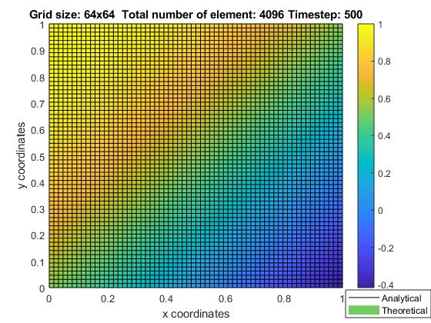

Without mesh

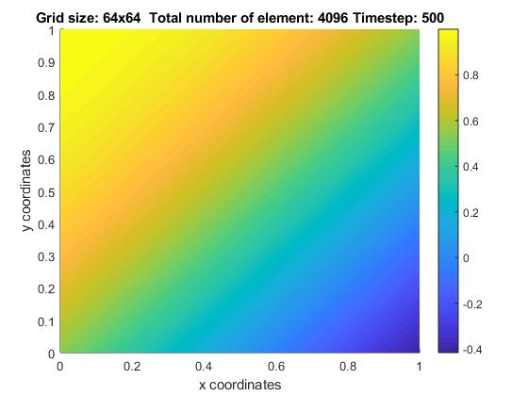

1. 3D Plot for 64 by 64 by 40

With mesh

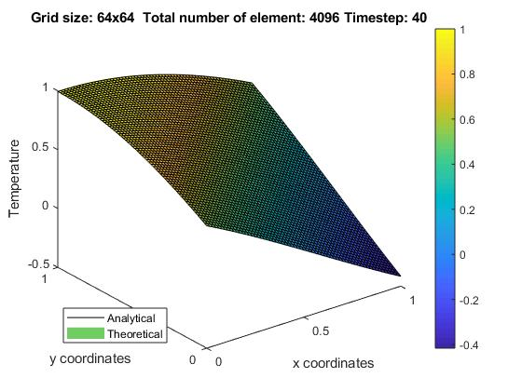

Without mesh

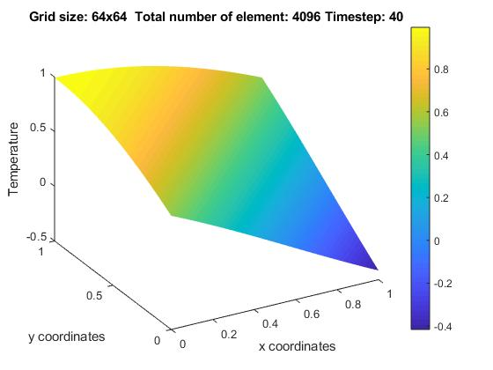

1. **Results – Solution plots for application**
2. Initial (t = 0)
   1. 2D plots

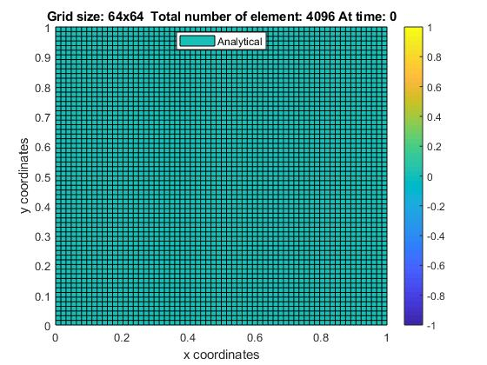

* 1. 3D plots

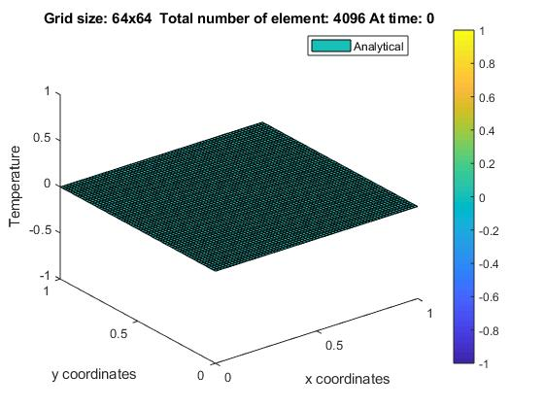

* 1. Profile graph along y = 0.5

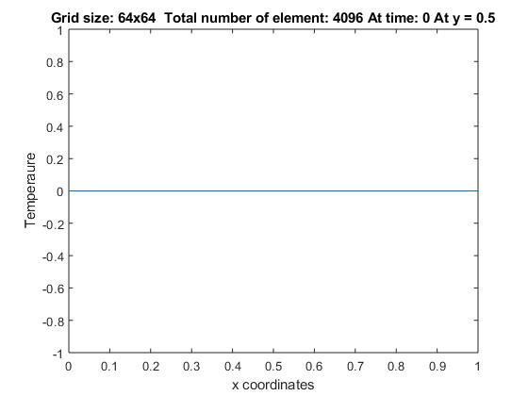

1. Early time (t = 0.005)
   1. 2D plots

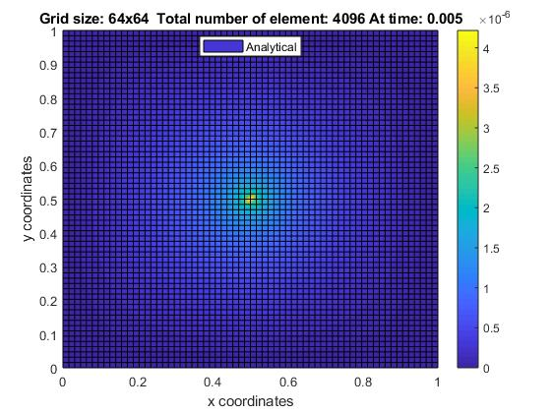

* 1. 3D plots

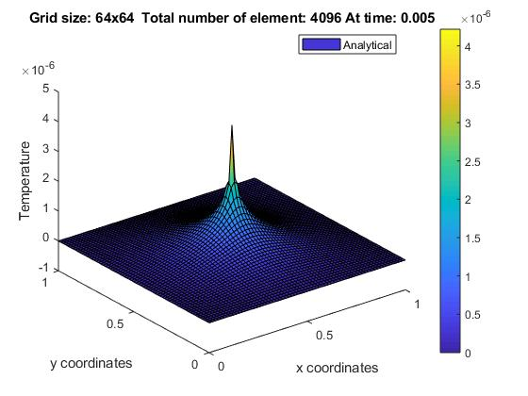

* 1. Profile graph along y = 0.5

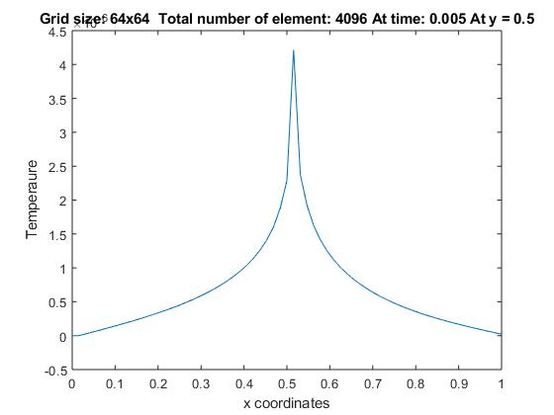

1. Intermediate time (t= 0.01)
   1. 2D plots

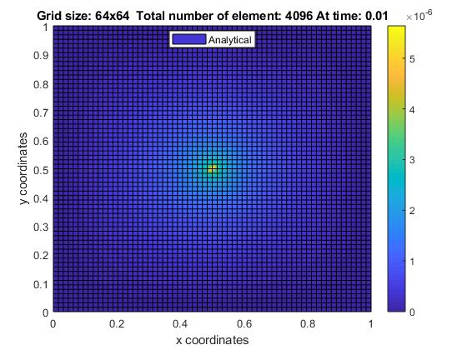

* 1. 3D plots

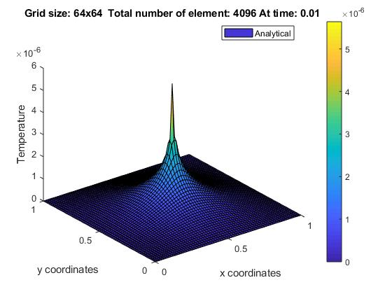

* 1. Profile graph along y = 0.5

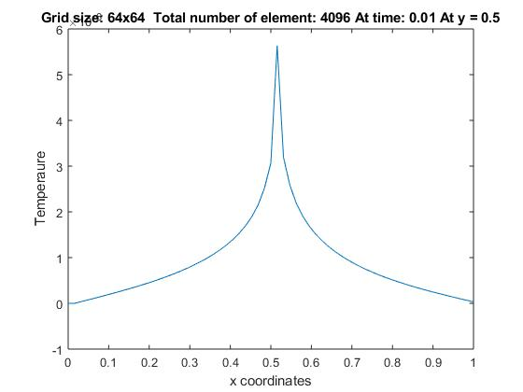

1. Late time (t = 0.02)
   1. 2D plots

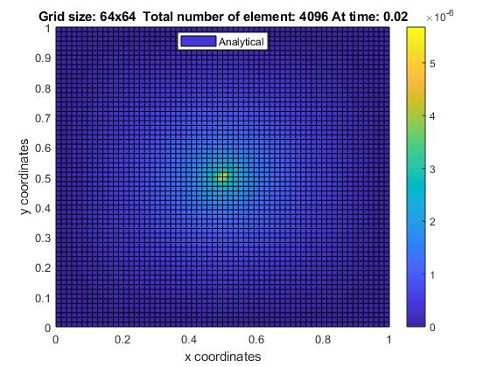

* 1. 3D plots

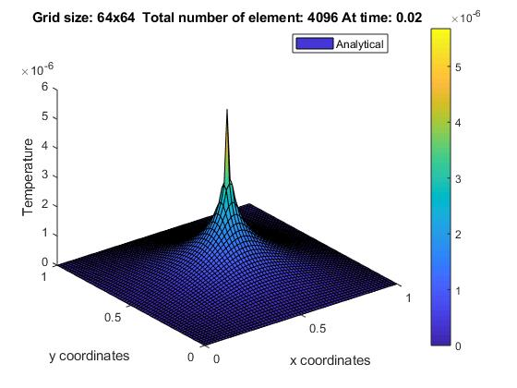

* 1. Profile graph along y = 0.5

