**Data takeout: Instagram (web)**

1. **Log in to Instagram and open the Download your information page**

Open Instagram and log into your account: <https://www.instagram.com/>

Once you sign in, you will need to find the Download your information page on your Accounts Center. You can do this directly by clicking on: <https://accountscenter.instagram.com/info_and_permissions/dyi/?entry_point=deeplink_screen>

1. Click on **Download or transfer information**.

Once you click on Download your information, the following page will appear:

Click on **Download or transfer information**.

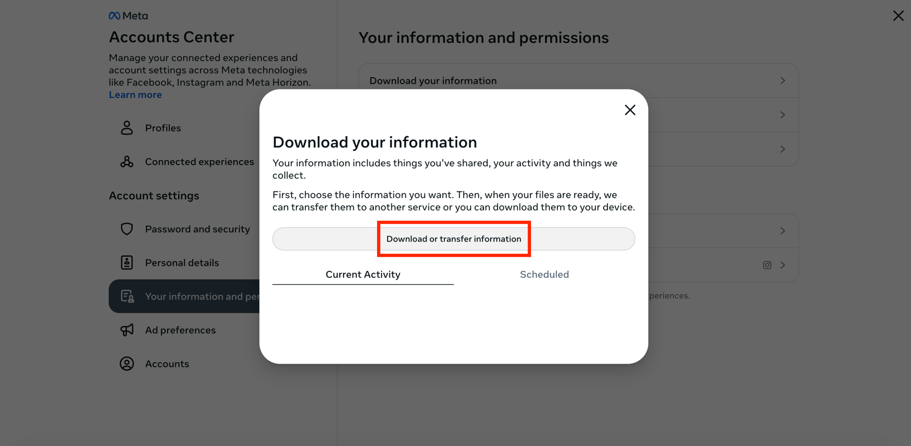

1. **Select the amount of information you would like to download**

Click on **Available information**.

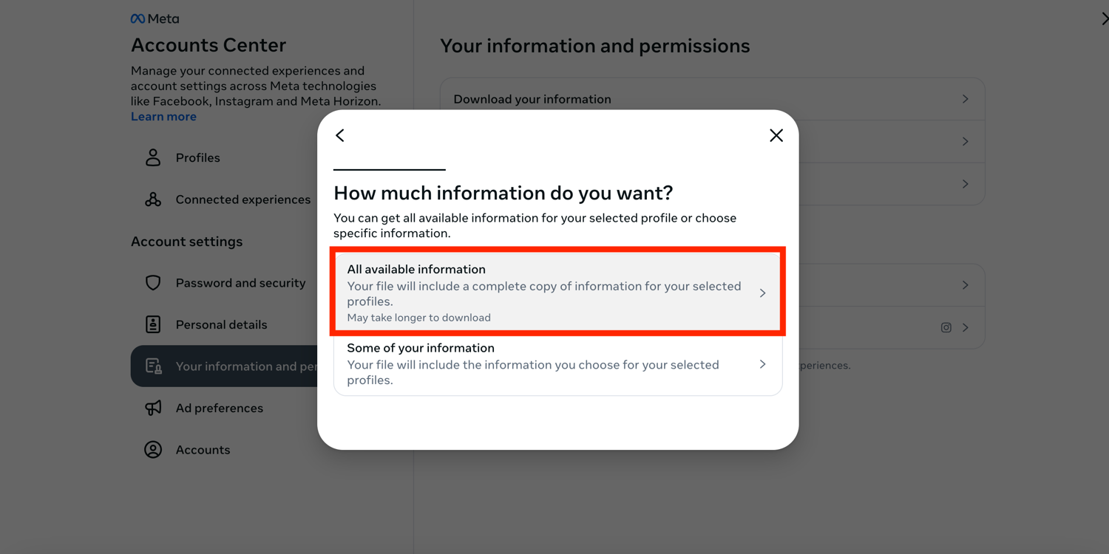

Once you click on Available information, select **Download to device**.

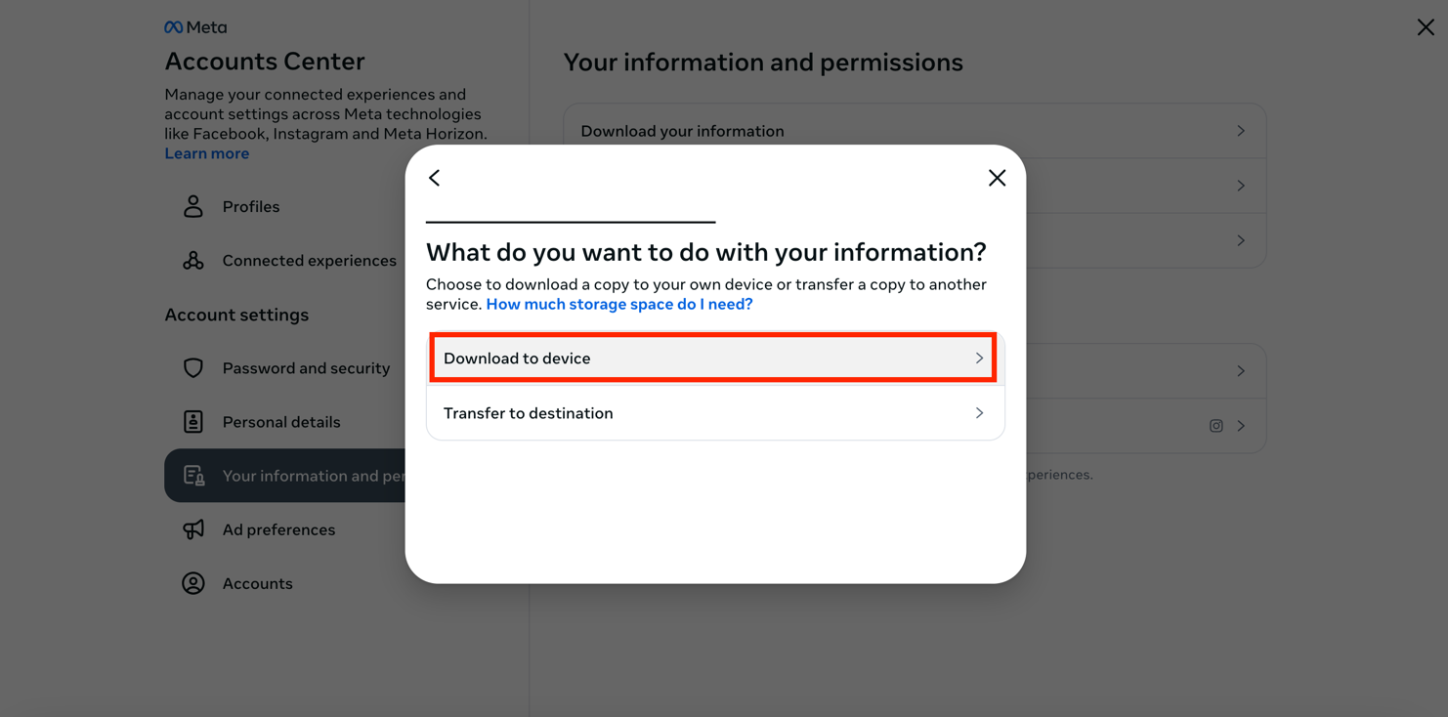

1. **Choose your file options**

The following will appear to select your file options:

Select the **Date range**: All time [*note: Date range can be customised*]

Select who to **notify**: [email address]

Select the **format**:JSON

Select the **media quality**: Medium [*other options: Low/High*]

Then click on **Create files**.

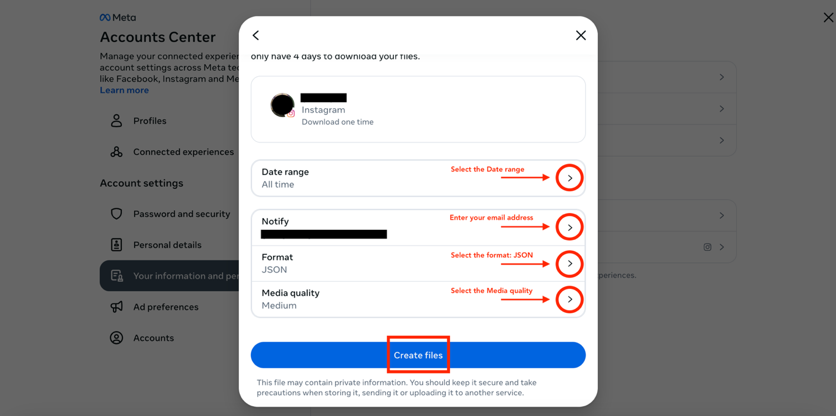

Once you click on **Create files**, this will appear:

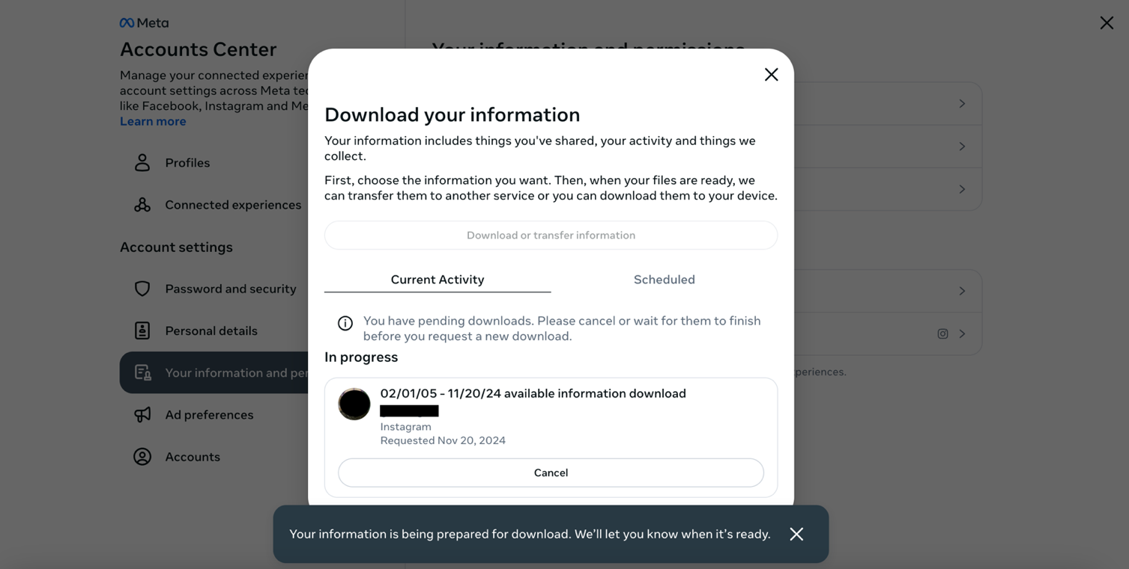

1. **Check your email for the download link**

Instagram [security@mail.instagram.com] will send you an email with a download link within 30 minutes [*note: it took 15 with me with the file options I selected*]. Make sure that you are signed in to the email you entered in the previous step. If you have not received the email within a few hours, make sure to check your junk mail folder.

In the email, click **download your information**. You will have to do this within four days of requesting the information, otherwise you will have to request a new download.

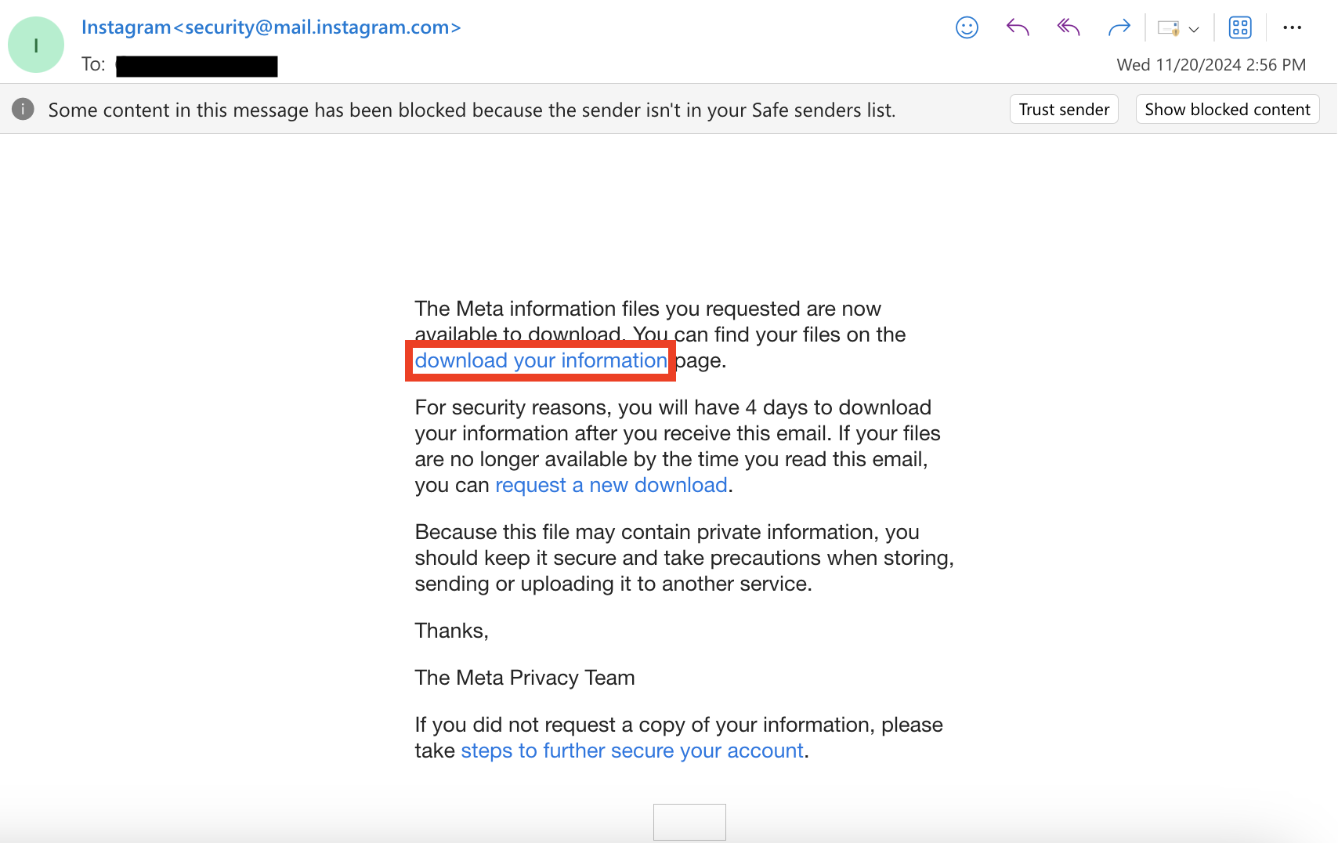

1. **Start downloading the information to your device**

Once you click on the link above, the following page will appear:

Click on **Download** on the bottom left.

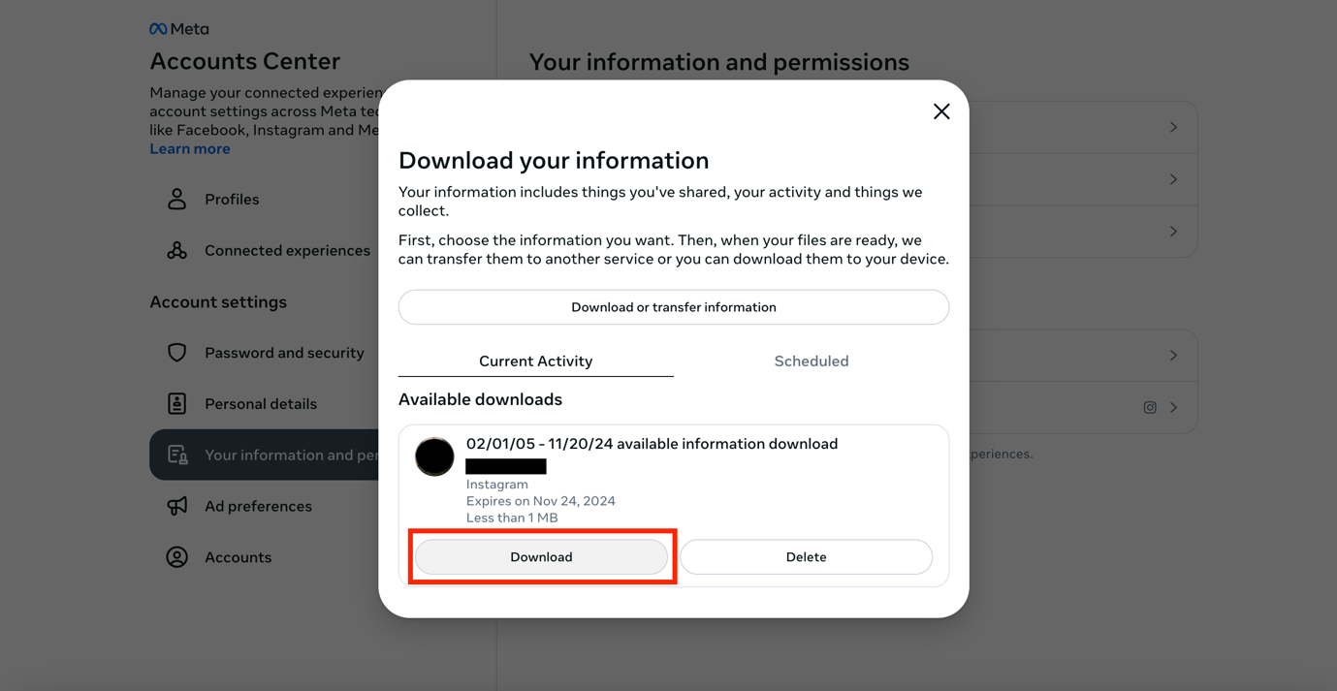

Note that you might be asked to re-enter your Instagram password for security reasons. If so, enter your password and click on Submit.

The file will start downloading on your device.

1. **Locate the downloaded file on your device**

The information will be downloaded to your device as a ZIP file and will be saved on your device in the Downloads folder.

**Data takeout: Instagram (app)**

1. **Sign in on the Instagram app**

Open the Instagram app and sign in to your account.

1. **Open the Accounts Center**

First click on your profile on the bottom right of the screen. Then click on the Settings and activity button on the top right.

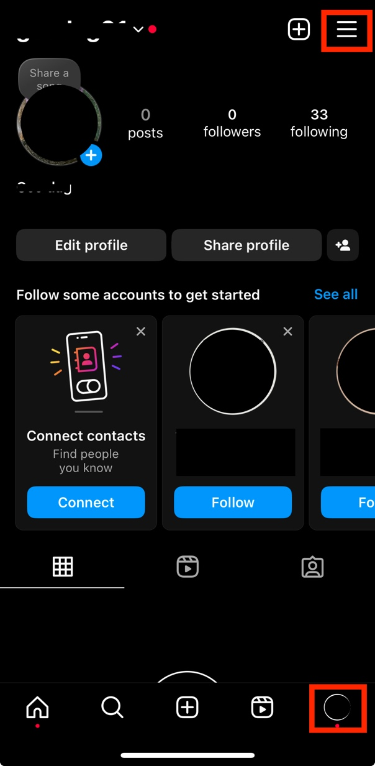

Then click on Accounts Center and Your information and permissions.

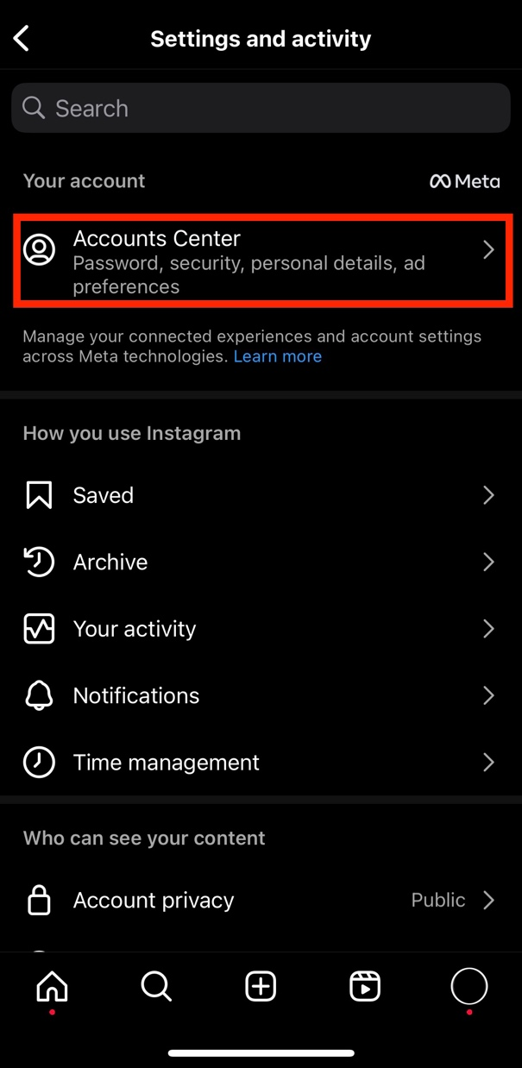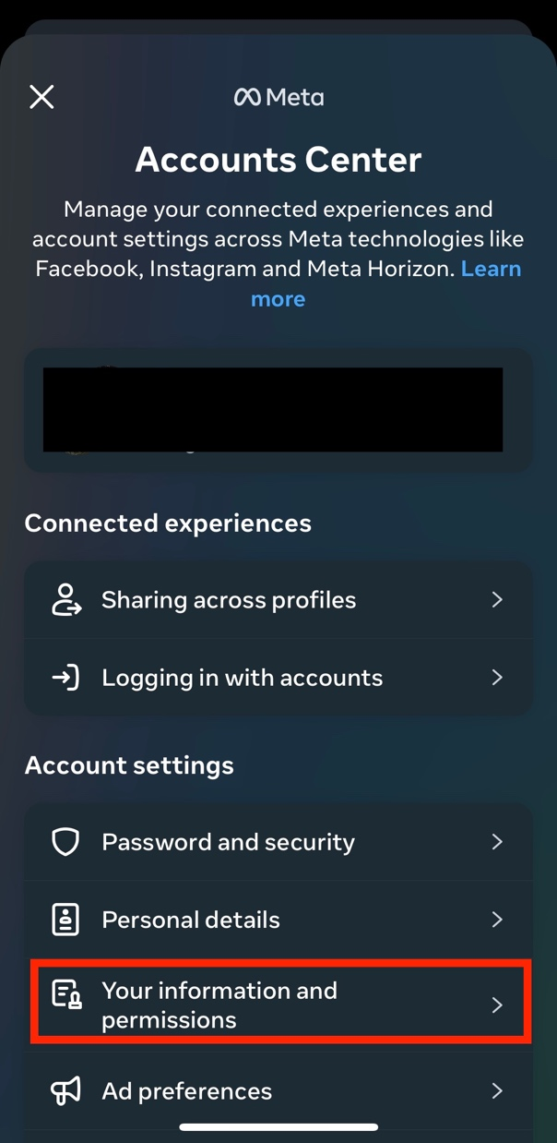

1. **Request your information**

Click on Download your information, then on Download or transfer your information.

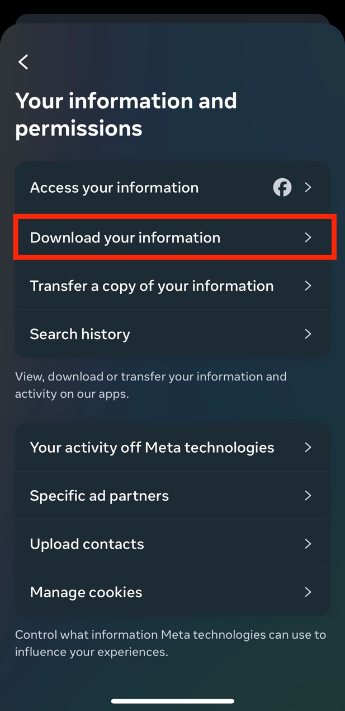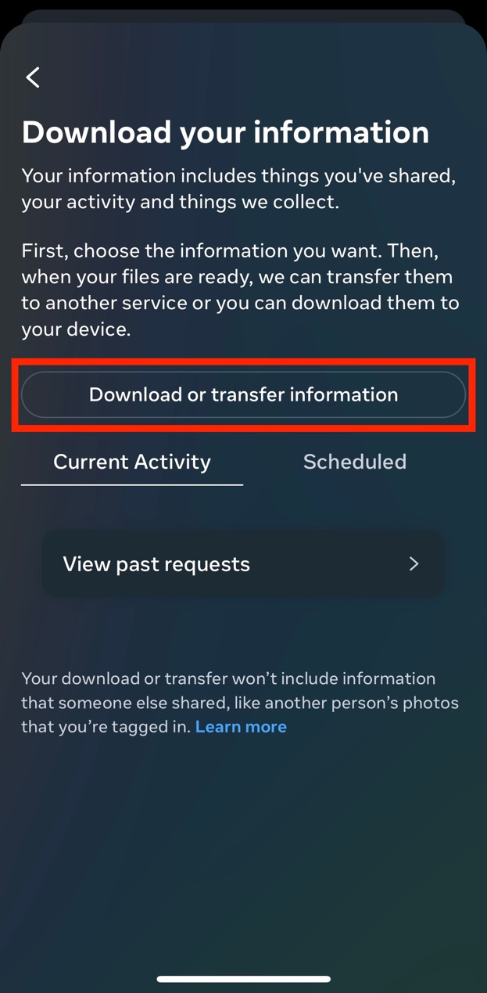

You will be asked how much information you would like to download. Click on Available information.

Then click on Download to device.

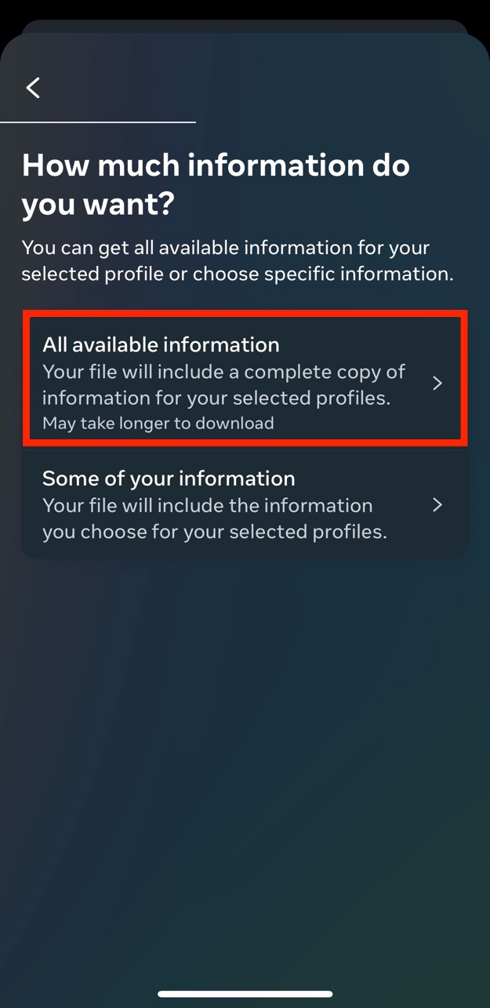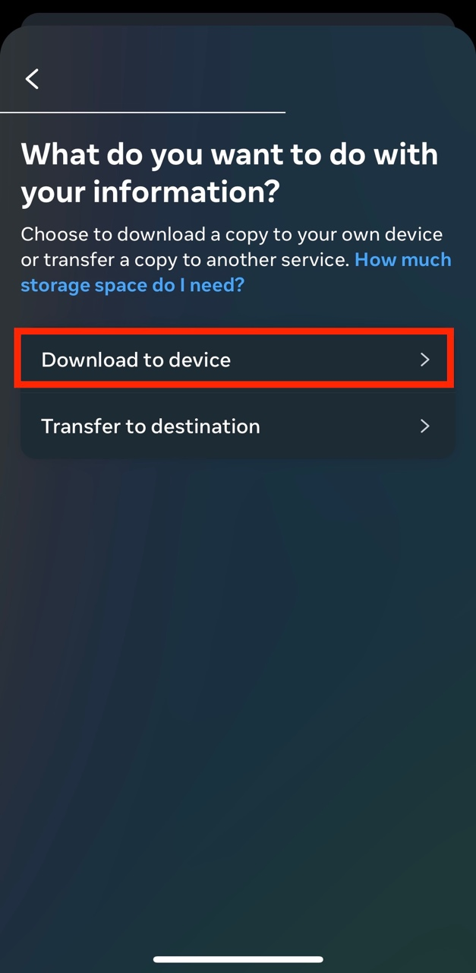

You will then have to specify the date range, who to notify, the format, and the media quality. Select the following:

Date range: All time

Notify: [enter your email]

Format: JSON

Media quality: Medium

Then click on **Create files**.

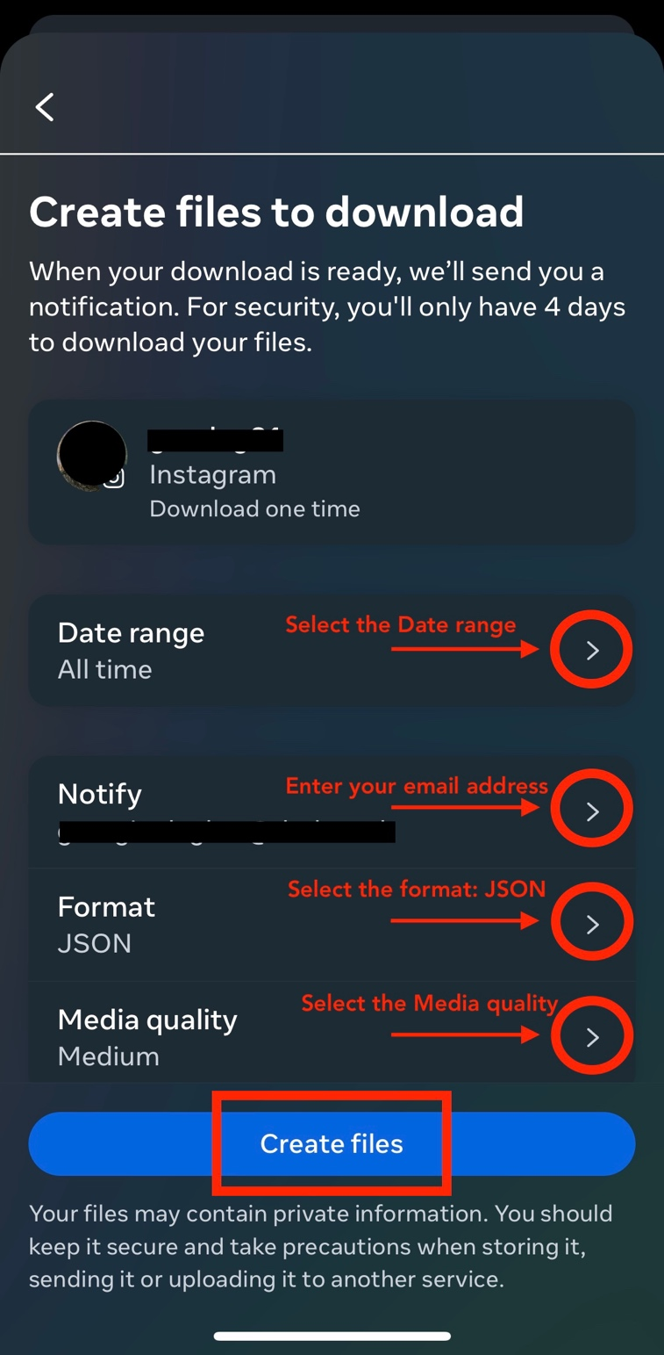

Once you click on Create files, the following page will appear:

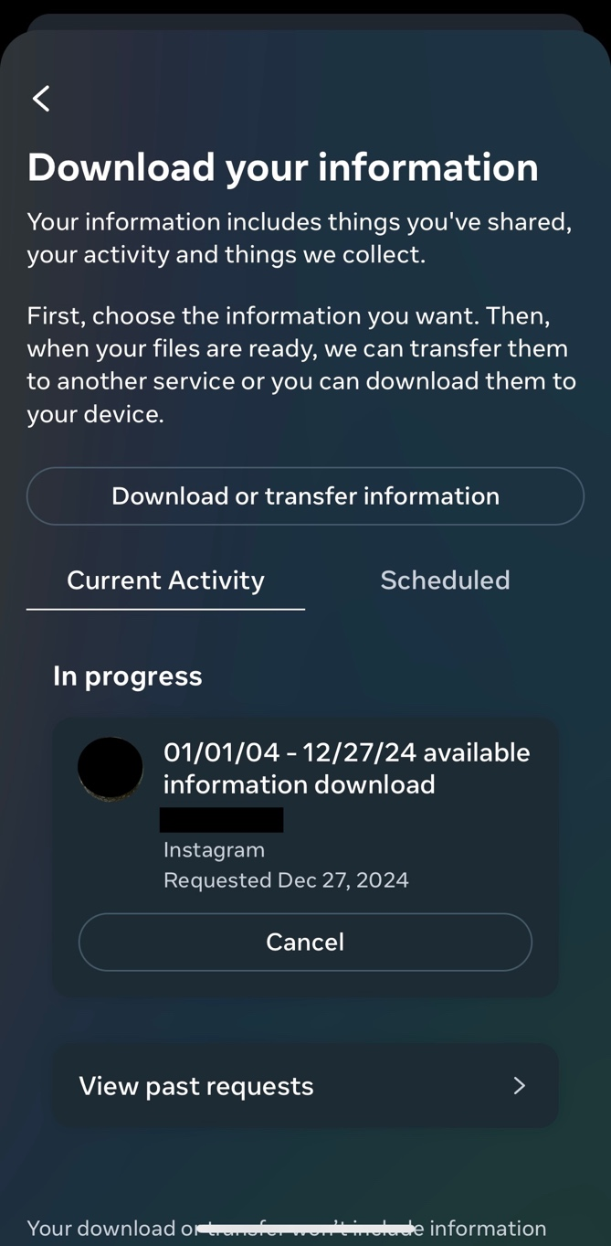

1. **Download your information**

You will then receive an email from Instagram [seccurity@mail.instagram.com] with the download link. Make sure that you are signed in to the email you entered in the previous step. If you have not received the email within a few hours, make sure to check your junk mail folder.

In the email, click download your information. You will have to do this within four days of requesting the information, otherwise you will have to request a new download.

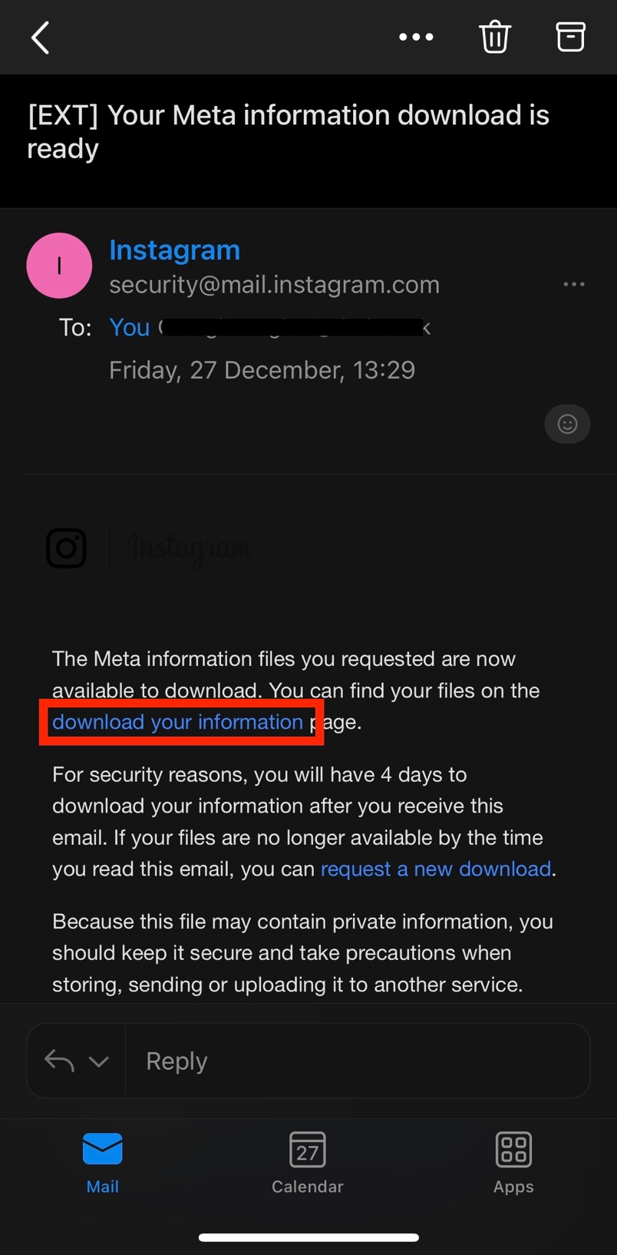

Then open the Instagram app again, and click on Download.

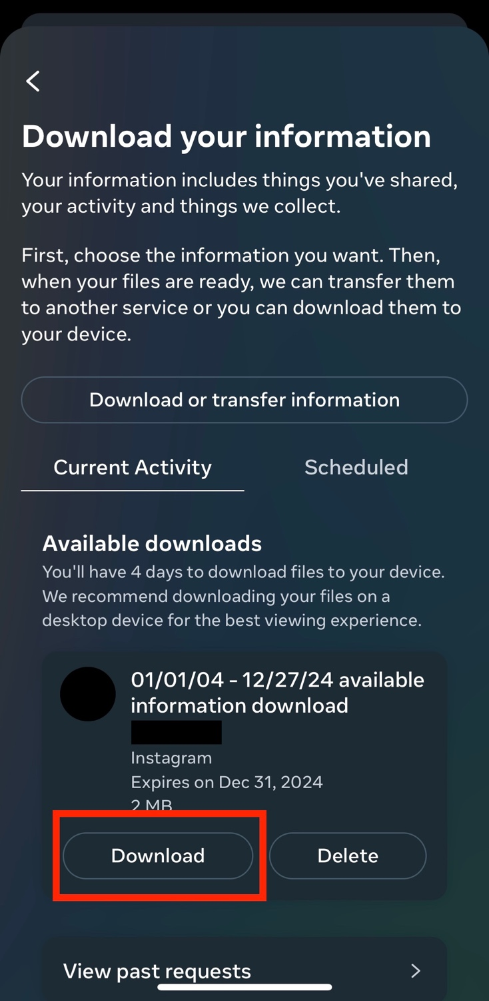

You will be asked to re-enter your Instagram password. Enter your password and click on Continue.

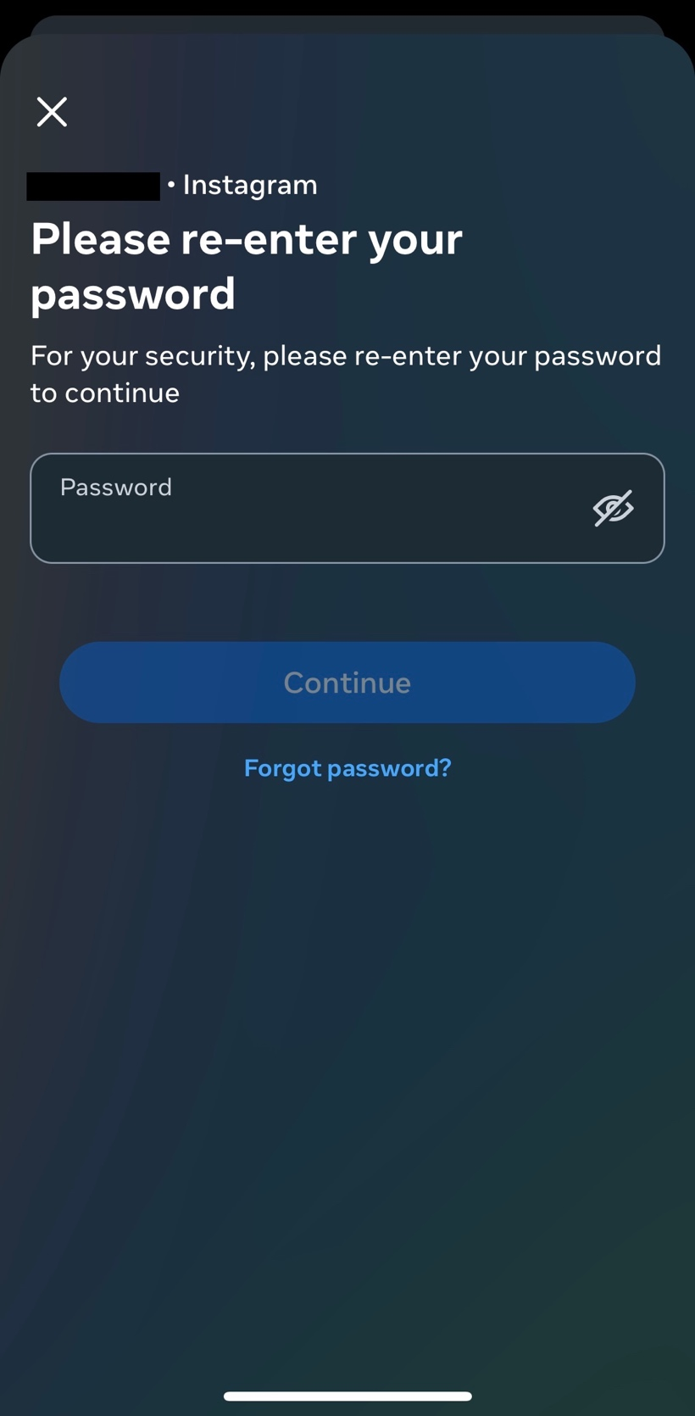

Once you click on Continue, your device browser will automatically open. Click on Download.

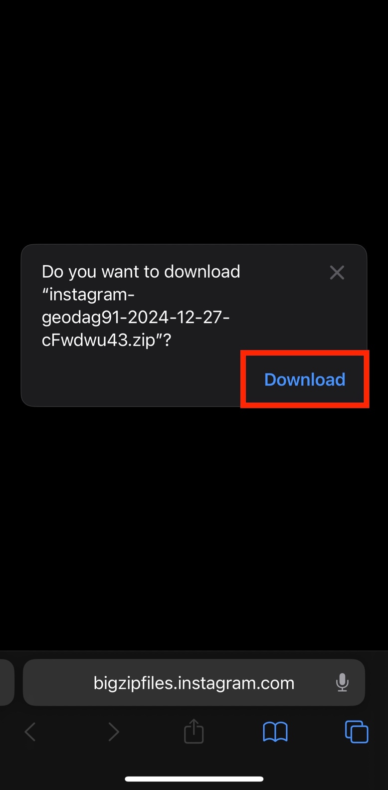

The downloaded information will be a ZIP file. In order to locate it on your device, open your Downloads folder on your device. You can find this through your device’s search bar, or by clicking directly on the ZIP file from your browser.

The Downloads folder should look like this:

