**Data takeout: TikTok (web)**

Open <https://www.tiktok.com/> and sign in to your account.

Then click on <https://www.tiktok.com/setting/download-your-data>.

You will need to specify the amount and format of the data. Select All data under data to download, and select JSON under file format.

Then click on Request data.

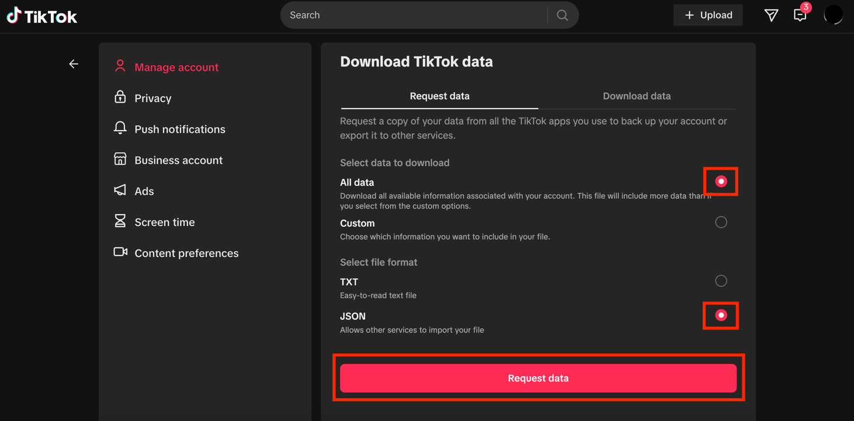

Then click on Download.

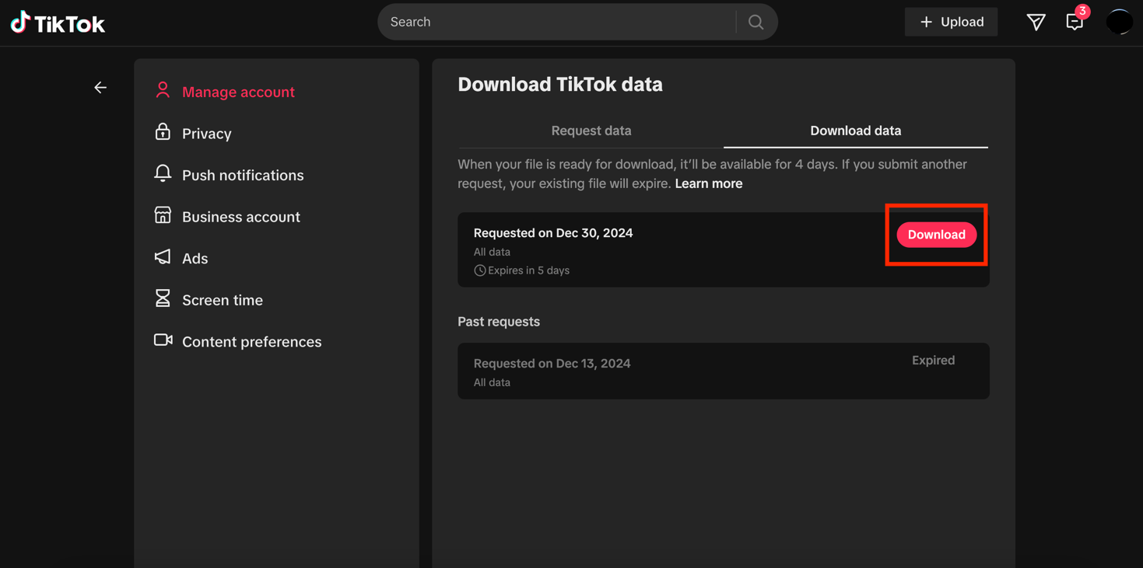

You will need to verify your account before the downloading process can start. To do so, TikTok will send you a verification code by email.

Click on Send code.

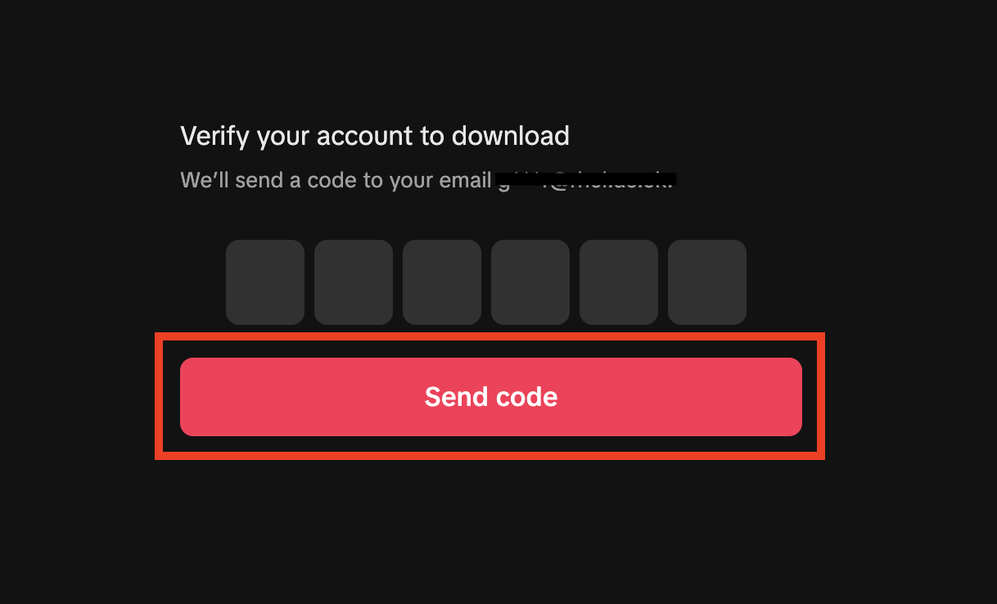

Open your inbox and copy the verification code. The email will be sent by noreply@account.tiktok.com.

If you have not received the email within a few hours, make sure to check your junk mail folder.

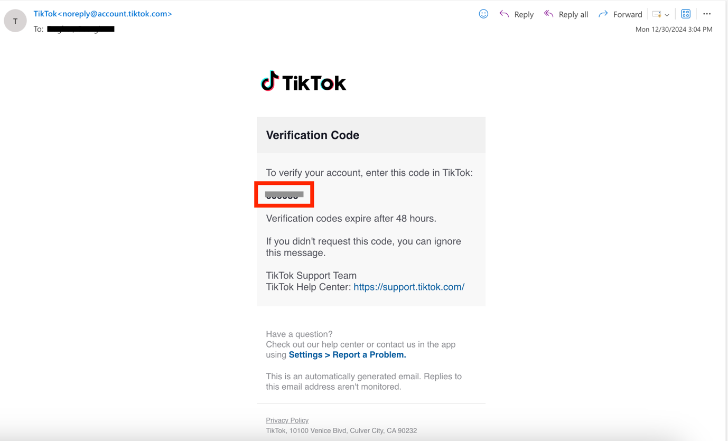

Go back to your browser and enter the verification code. Your download will then start.

The file will be downloaded to your device as a ZIP file and will be saved on your device in the Downloads folder.

**Data takeout: TikTok (app)**

1. **Open the TikTok app and click on the Menu**

Open the TikTok app, click on Profile on the bottom right of the page, then click on Menu ☰ on the top right.

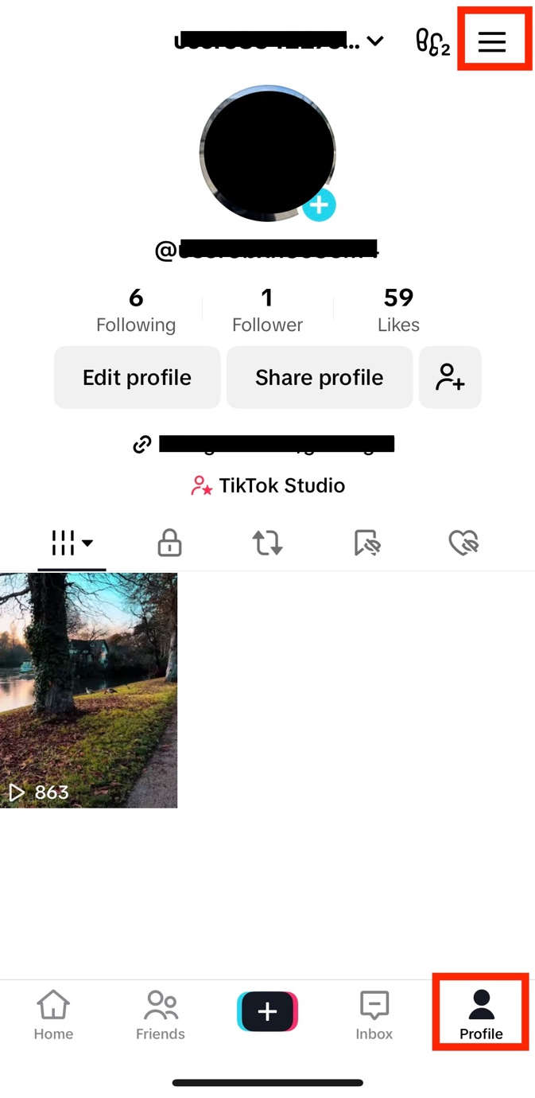

1. **Click on Settings and privacy**

Once you click on Menu, click on Settings and privacy.

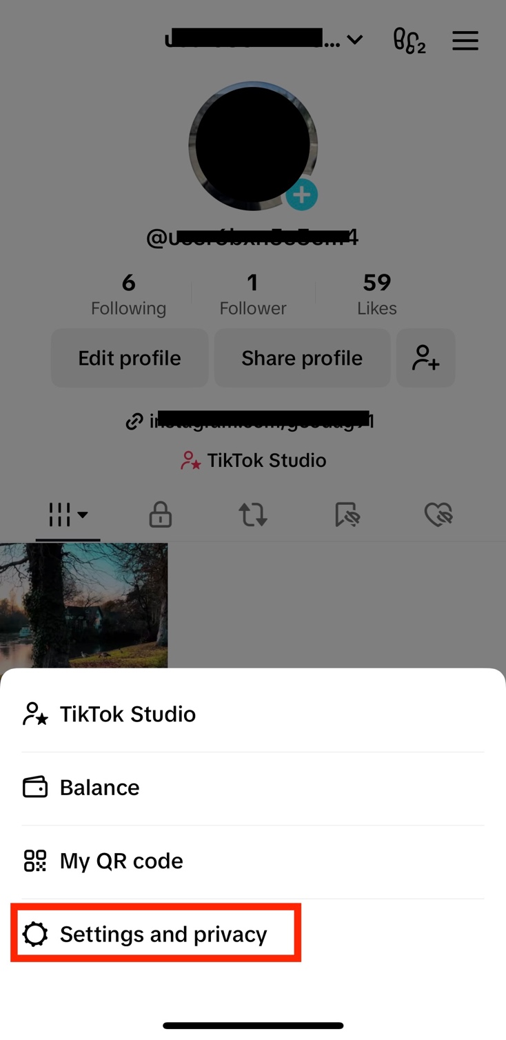

1. **Click on Account**

Then click on Account.

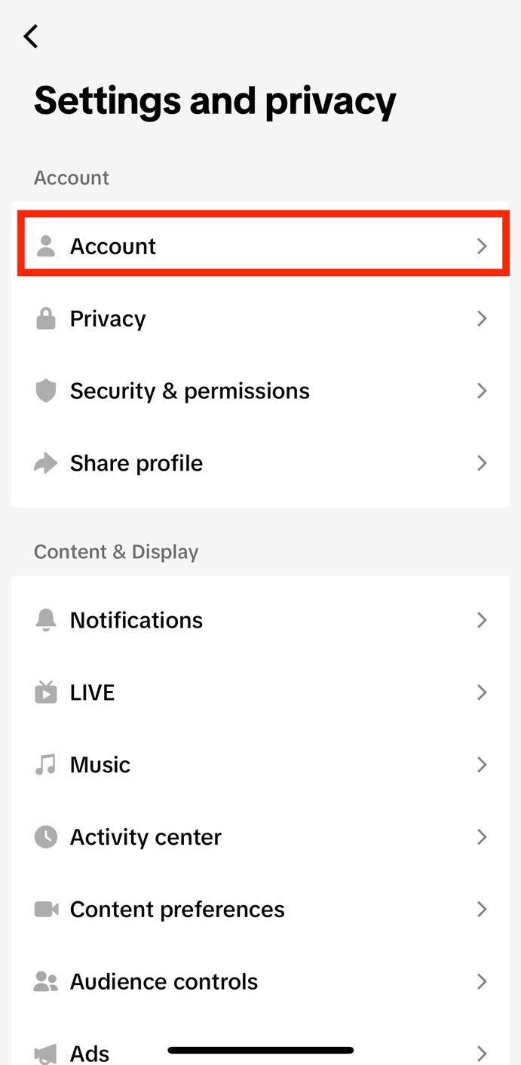

1. **Click on Download your data**

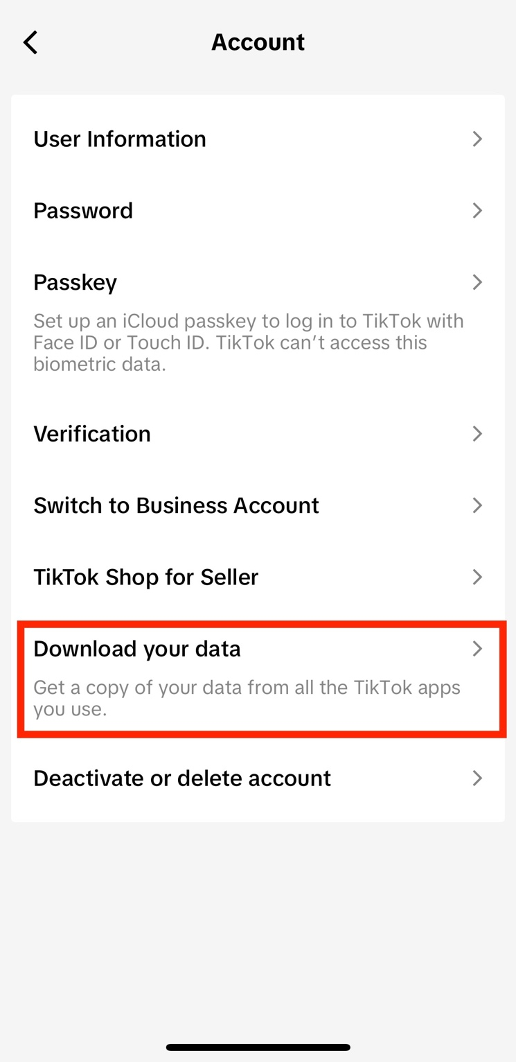

1. **Select the file format**

Once you click on Download your data, the following page will open.

Click on Select file format, then change the format to JSON.

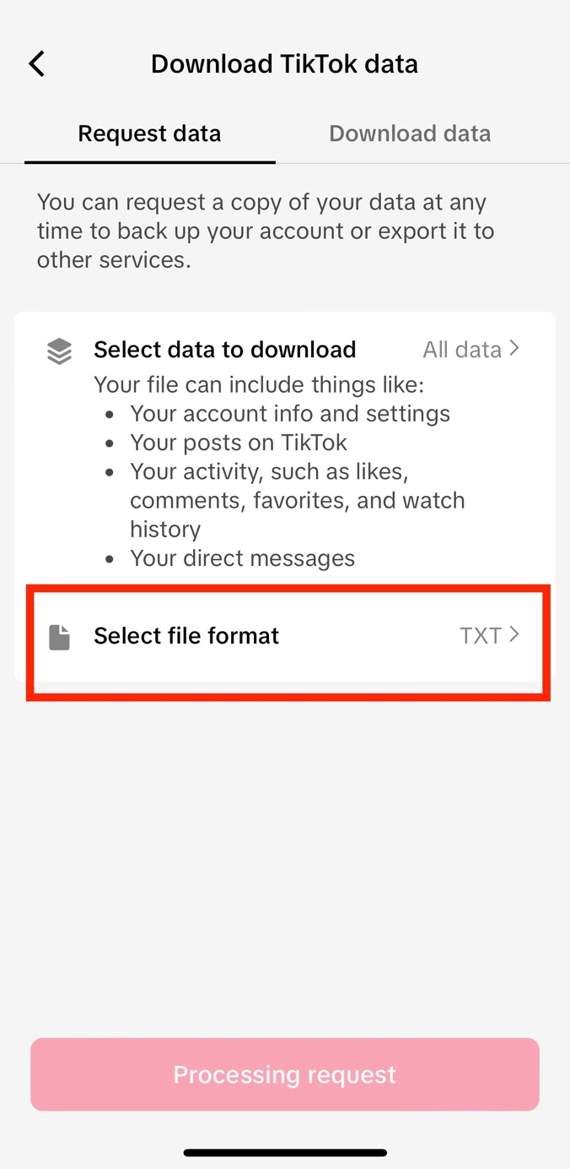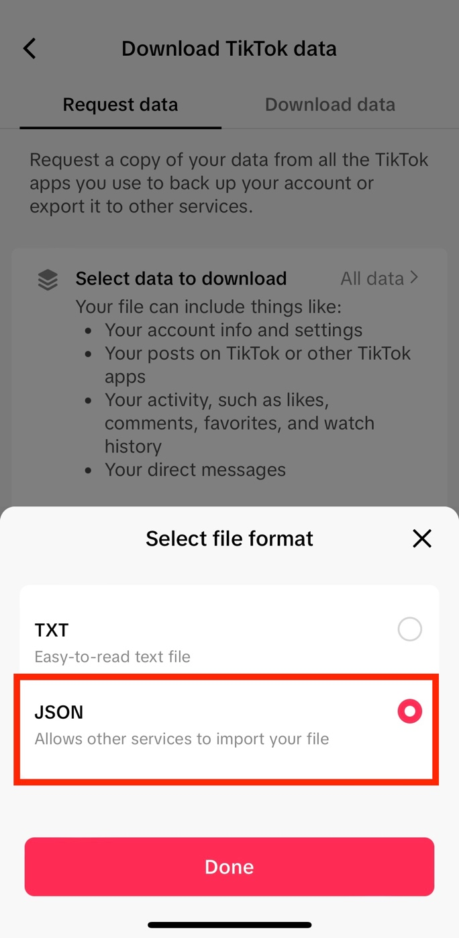

1. **Request data**

Click on Request data.

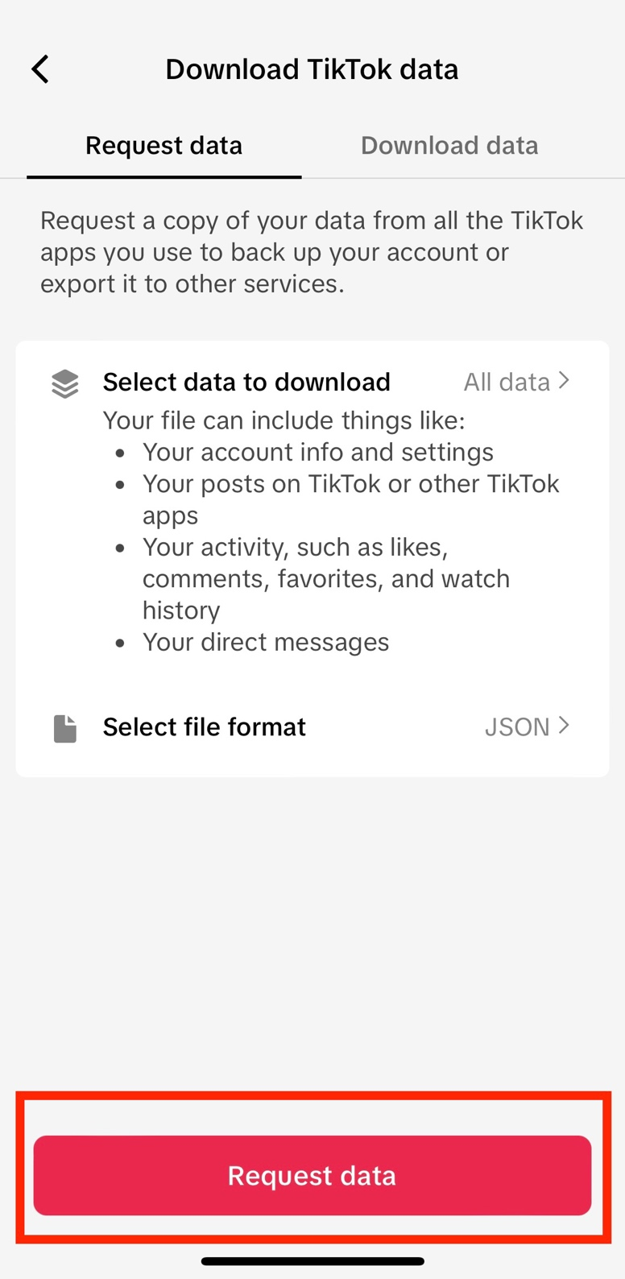

1. **Verify your account**

First click on Download.

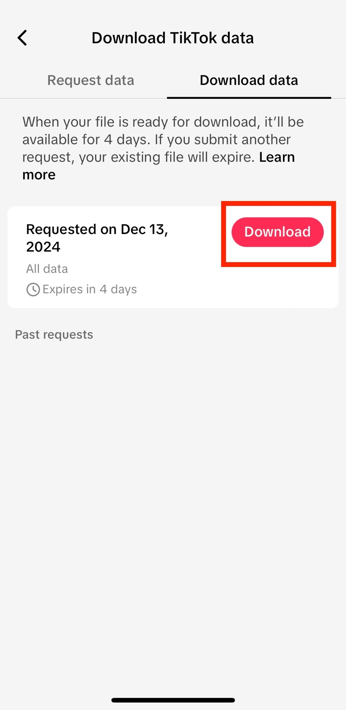

You will need to verify your TikTok account through a verification code sent to your email.

Click on Send code.

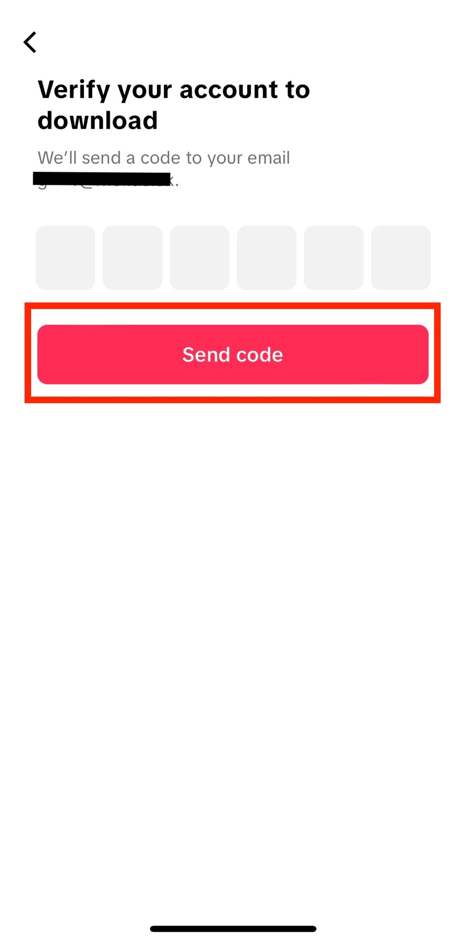

Open your inbox and copy the verification code. The email will be sent by register@account.tiktok.com.

If you have not received the email within a few hours, make sure to check your junk mail folder.

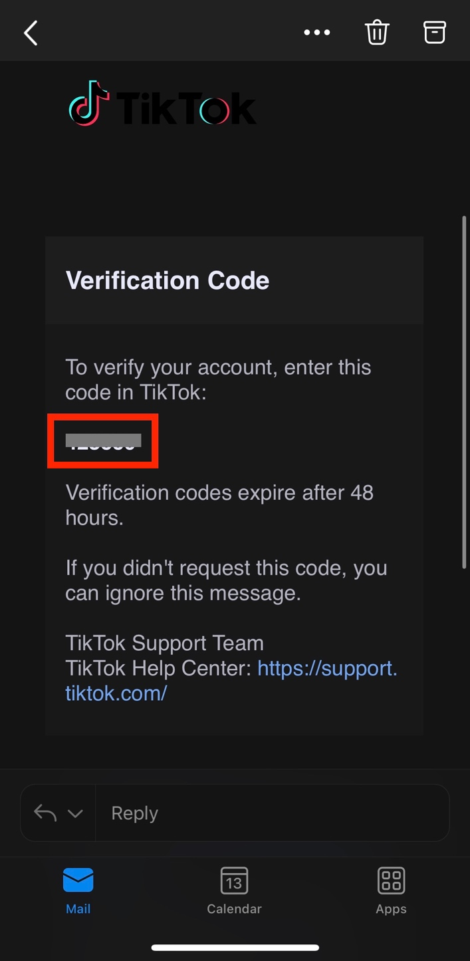

Go back to the TikTok app and enter the verification code.

1. **Download the data**

Once you enter the verification code, your device browser will automatically open. Click on Download.

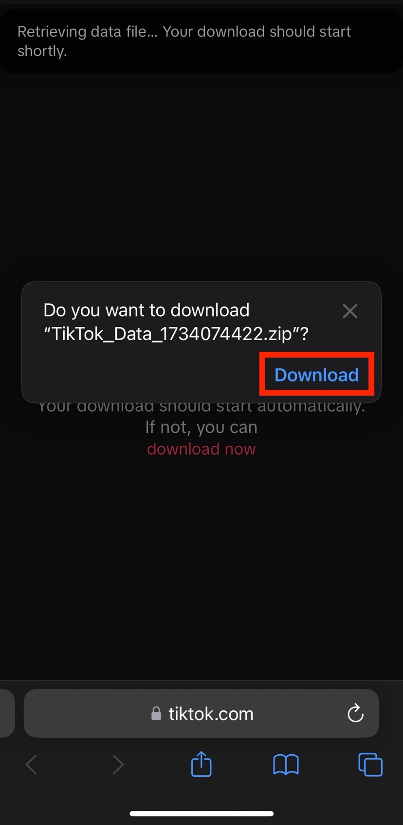

Your download will then start. You can click on the blue arrow on the bottom left, and then Downloads, to make sure that the process has started.

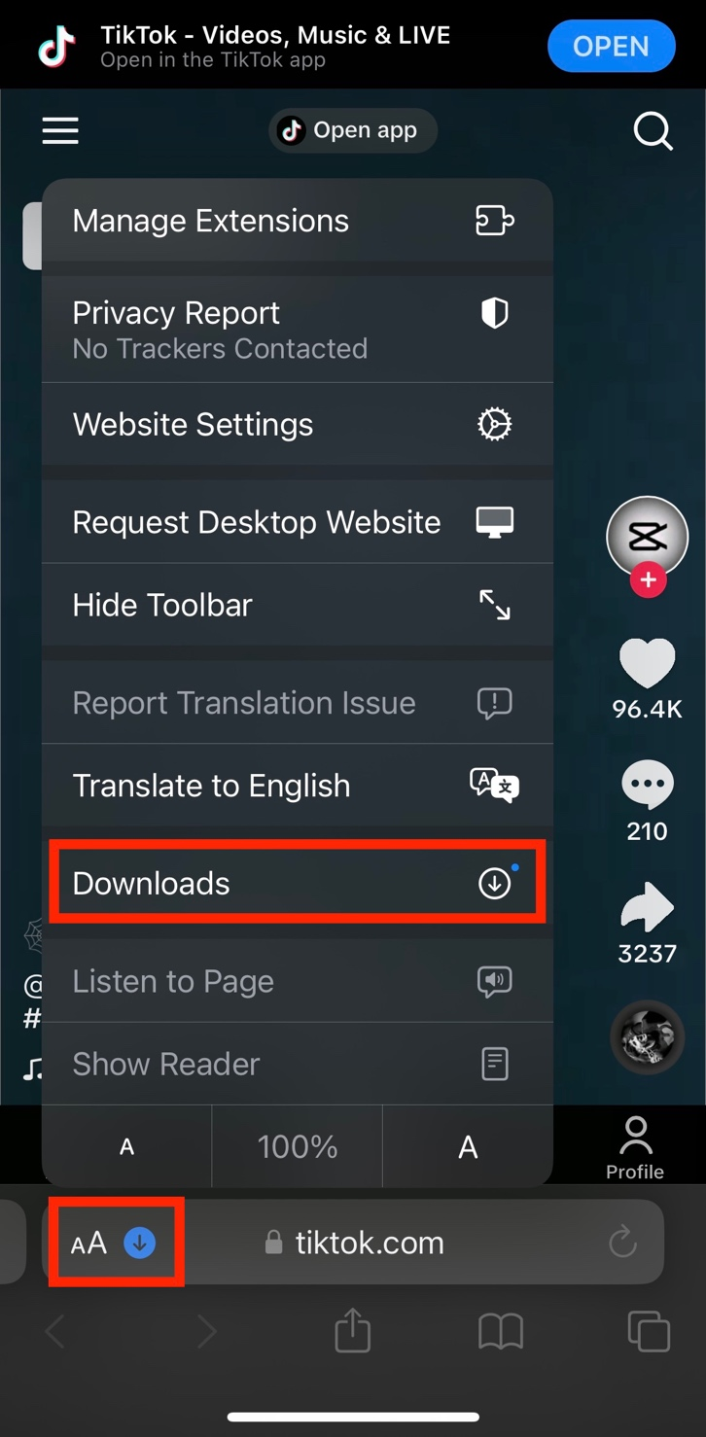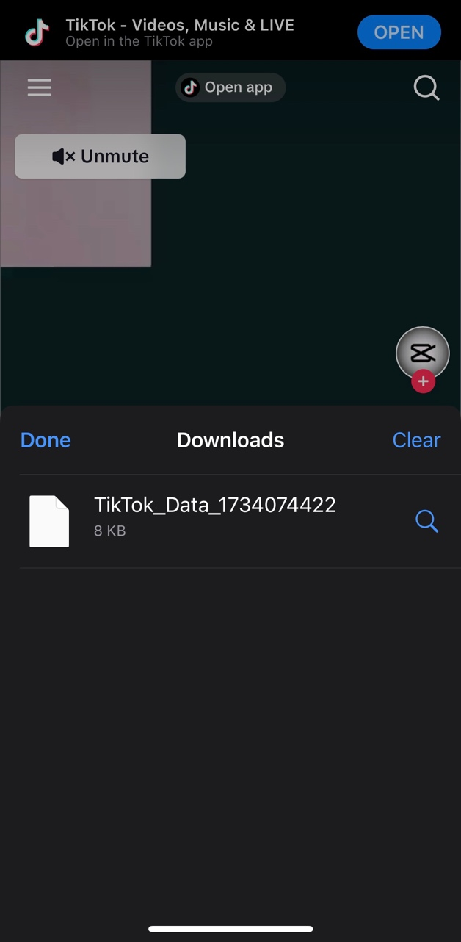

The downloaded information will be a ZIP file. In order to locate it on your device, open your Downloads folder on your device. You can find this through your device’s search bar, or by clicking directly on the ZIP file from your browser.

The Downloads folder should look like this:

