**Data takeout: X (web)**

1. **Sign in to your X account**

Go to <https://x.com> and sign into your account.

1. **Go to the Download an archive of your data page and click on Request archive**

Click on the following link to directly reach the Download an archive of your data page: <https://x.com/settings/download_your_data>.

Then click on Request archive.

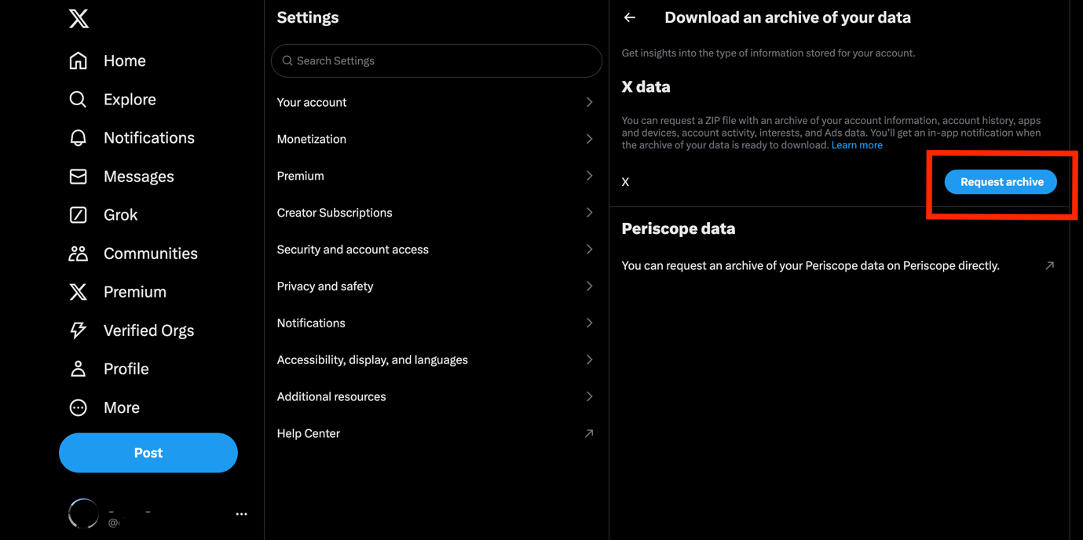

1. **Verify your identity**

You will have to verify your identity in two steps.

First, once you click on Request archive (previous step), the following page will appear and you will have to re-enter your X password.

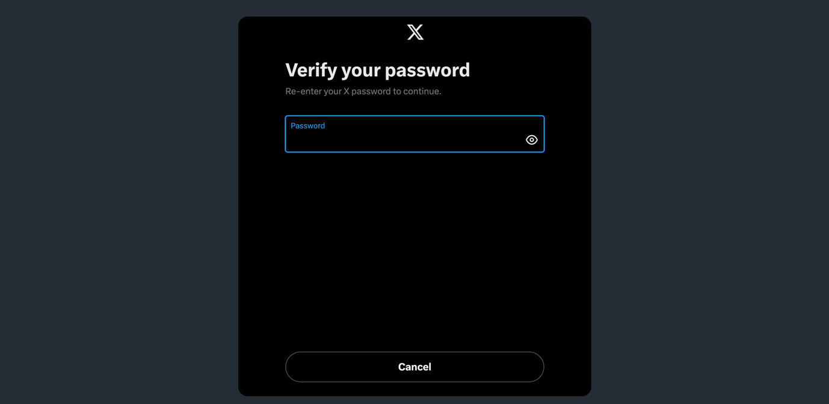

Once you verify your password, the following page will appear, where you will need to enter a verification code.

This code will be sent to you via email by X ([info@x.com](mailto:info@x.com)). This will be on the email you initially used when you signed up on X.

To request the code, click on Send code.

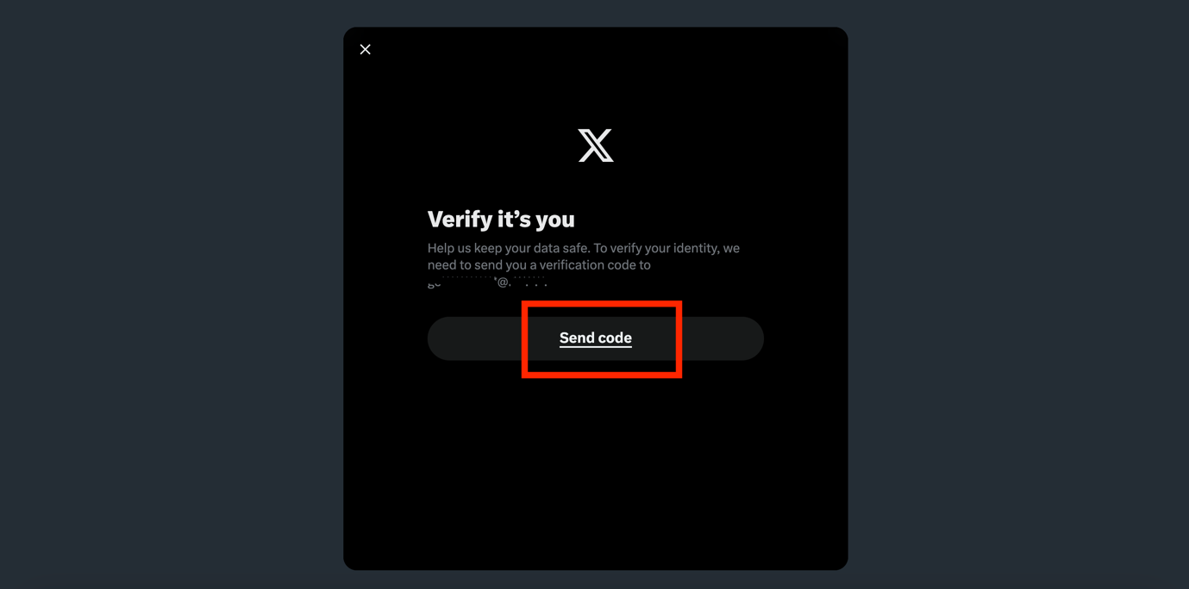

The following page will appear, asking you to enter the verification code.

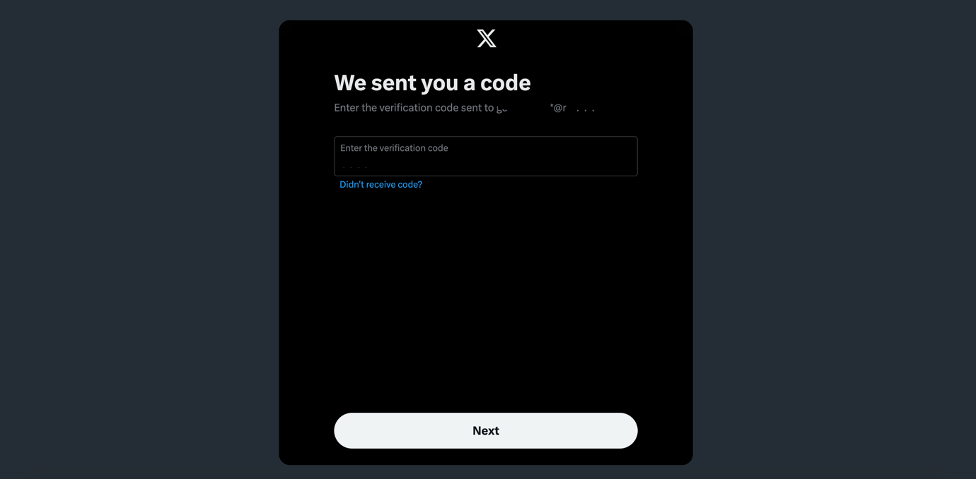

Open your email inbox, and if you do not receive the email from X within a few minutes, make sure to check your Junk Email folder.

In the email, copy the verification code.

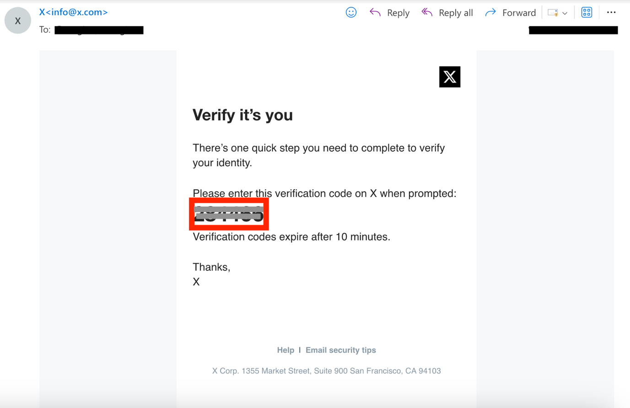

Go back to X and enter the verification code, then click on Next. Note that the verification code is only valid for 10 minutes. If you do not enter it within 10 minutes, you will have to request a new code.

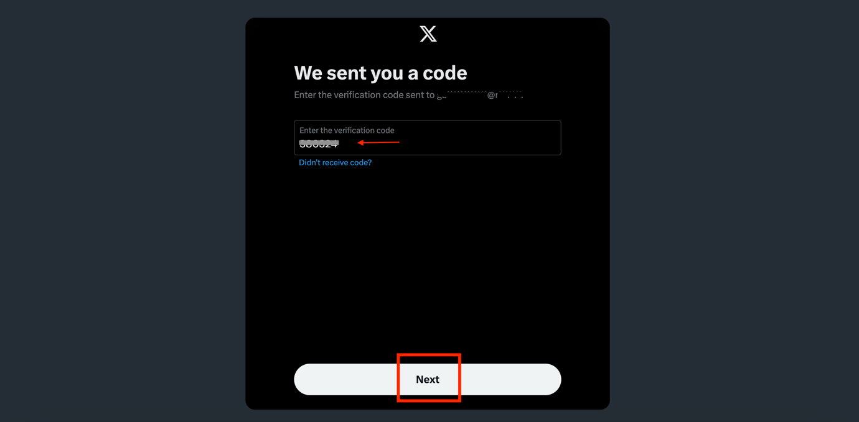

Once you enter the code, X will receive your Request to download your archive. The following page will appear.

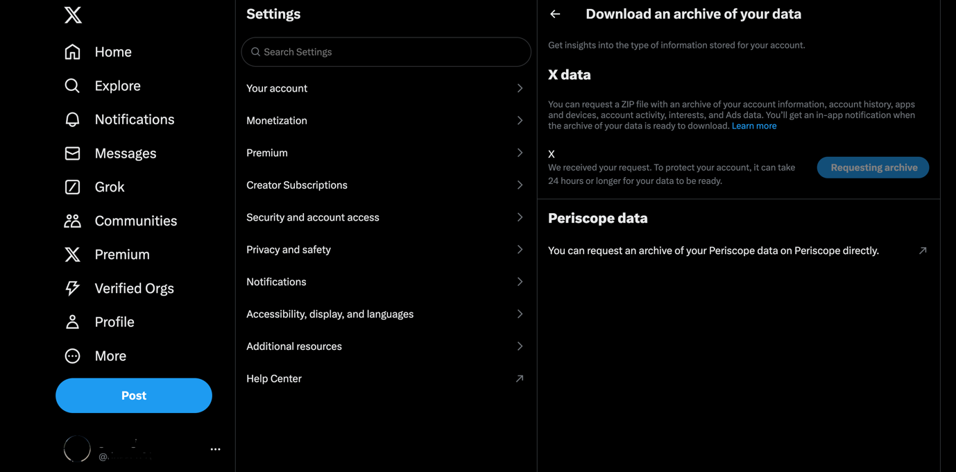

1. **Check your email for the download link and download the data**

You will then have to wait for X to notify you when the archive of your data is ready to download. X will notify you with an in-app notification as well as via email.

Note that this can take 24 hours or longer.

Once you receive the email, click on download.

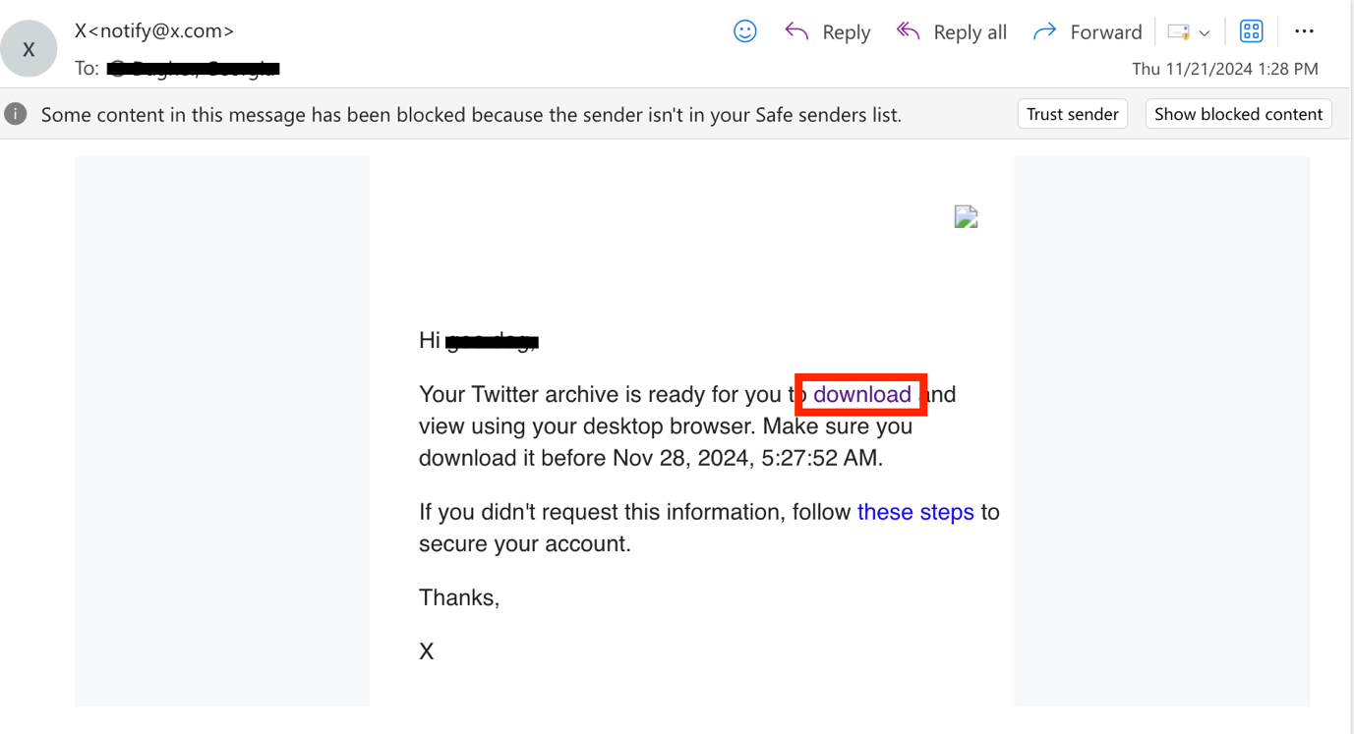

This will open X on your browser again. Click on Download archive. This will start the download process.

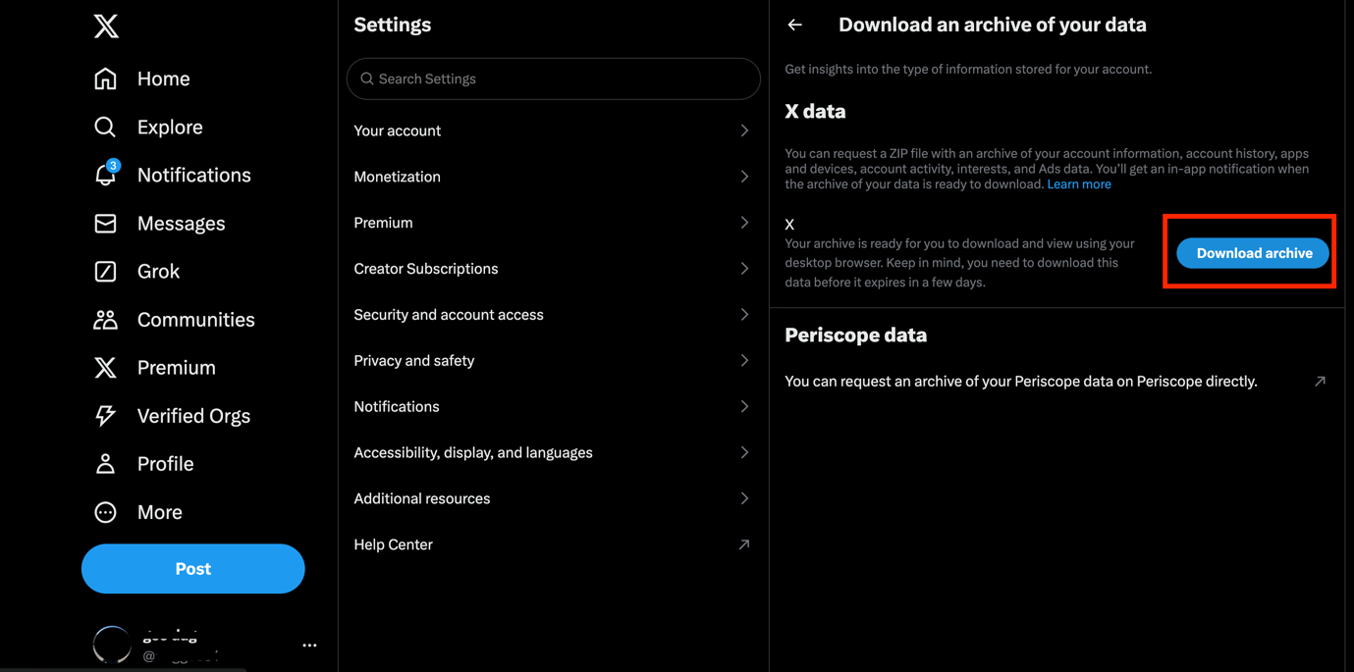

1. **Locate the downloaded file on your device**

The information will be downloaded to your device as a ZIP file and will be saved on your device in the Downloads folder.

**Data takeout: X (app)**

Open the X app and sign in to your account. Then click on your profile on the top left of the screen.

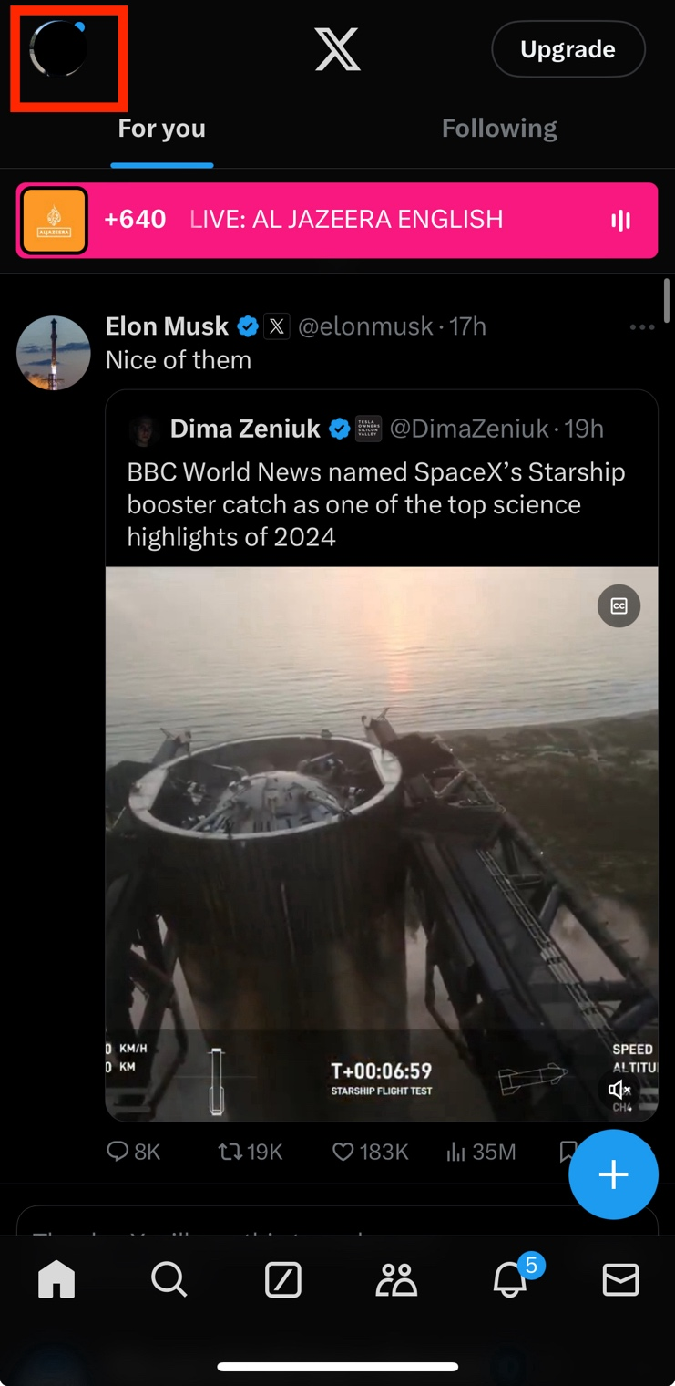

Click on Settings and privacy.

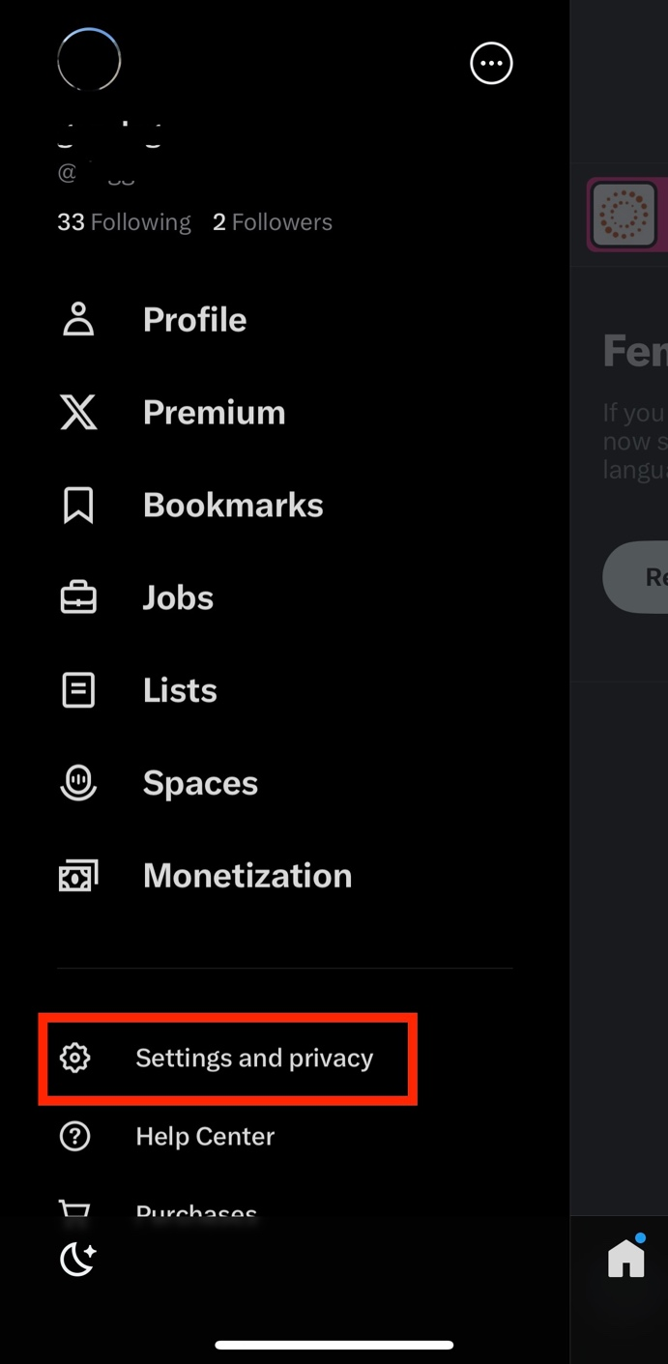

Then click on Your account.

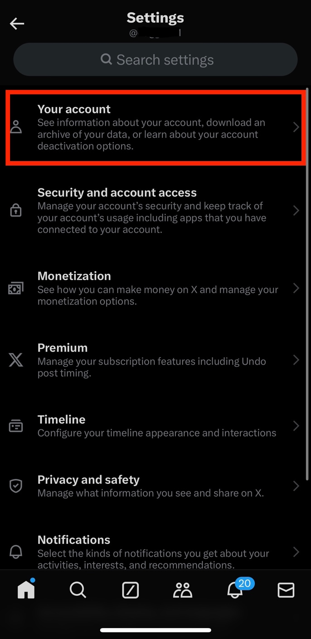

Click on Download an archive of your data.

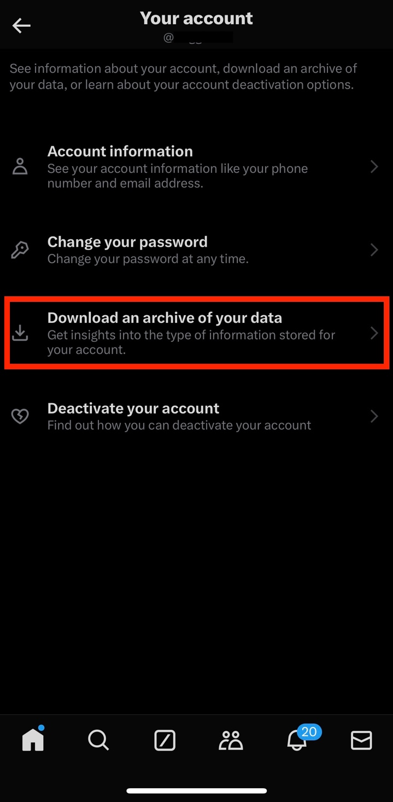

Once you click on Download an archive of your data, X will need you to verify your identity. X will send you a verification code by email.

Click on Send code.

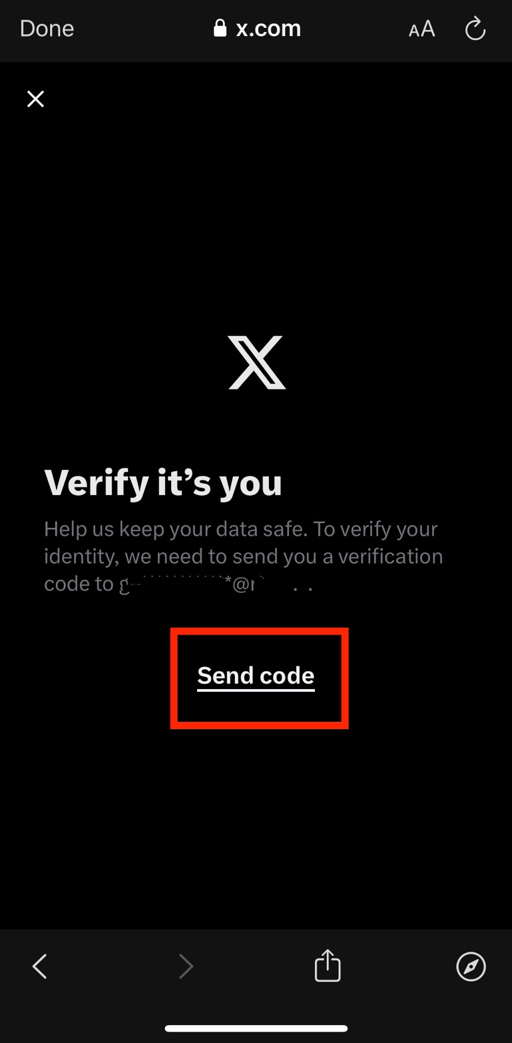

Open your email inbox, and if you do not receive the email from X ([info@x.com](mailto:info@x.com)) within a few minutes, make sure to check your Junk Email folder.

In the email, copy the verification code.

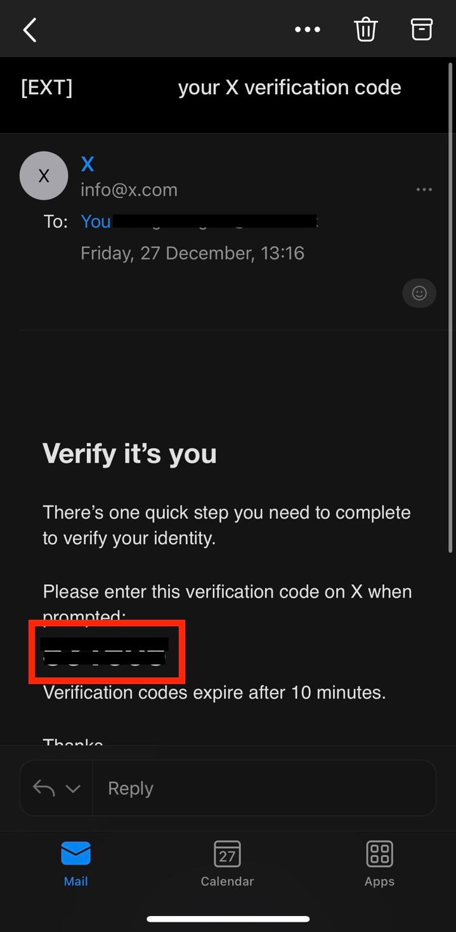

Go back to X and enter the verification code. Then click on Next.

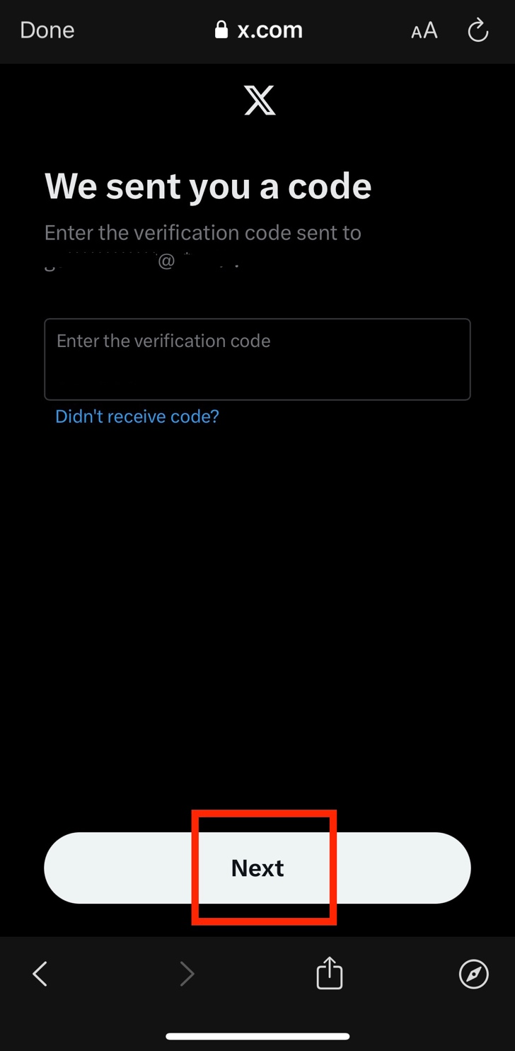

Click on Request archive.

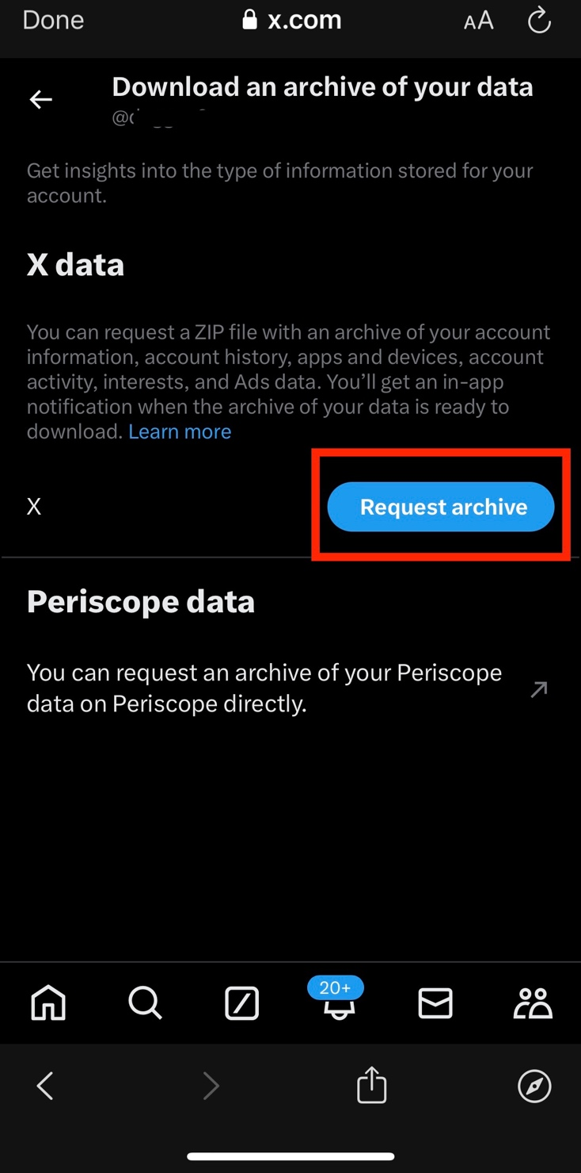

You will then have to wait for X to notify you when the archive of your data is ready to download. X will notify you with an in-app notification as well as via email.

Note that this can take 24 hours or longer.

Once you receive the email, click on download.

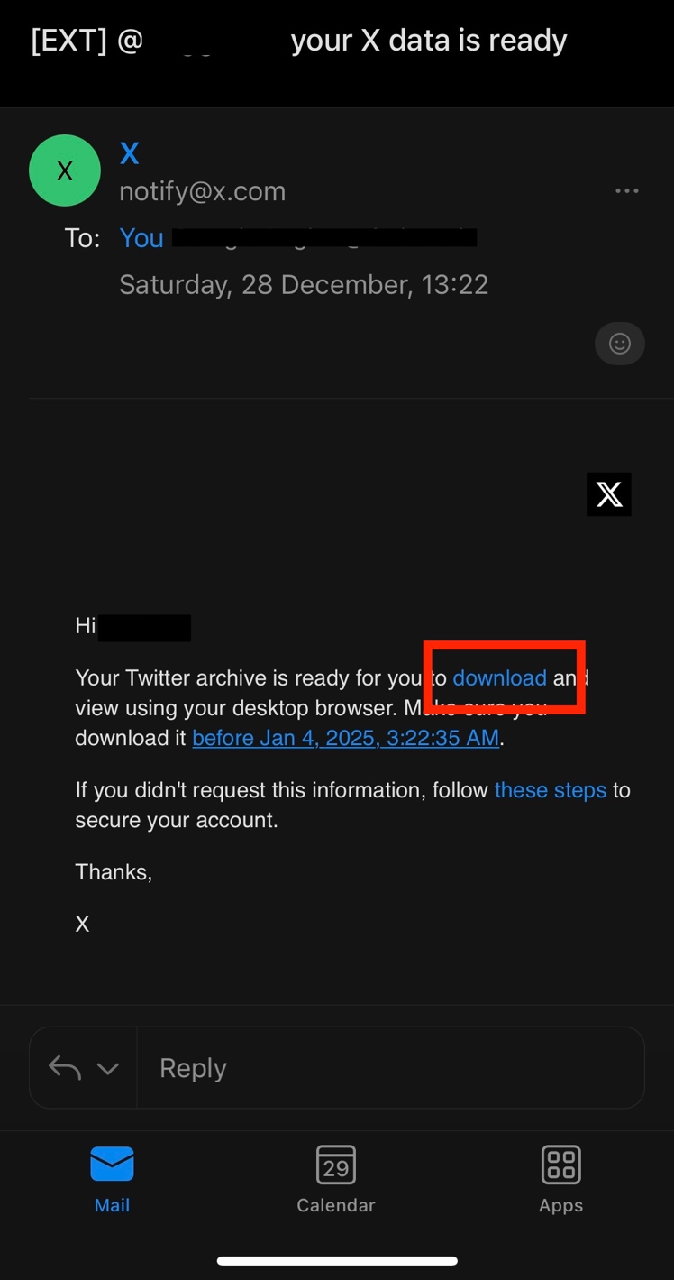

Once you click on download, the page will open automatically on the X app or on your browser. Click on Download archive.

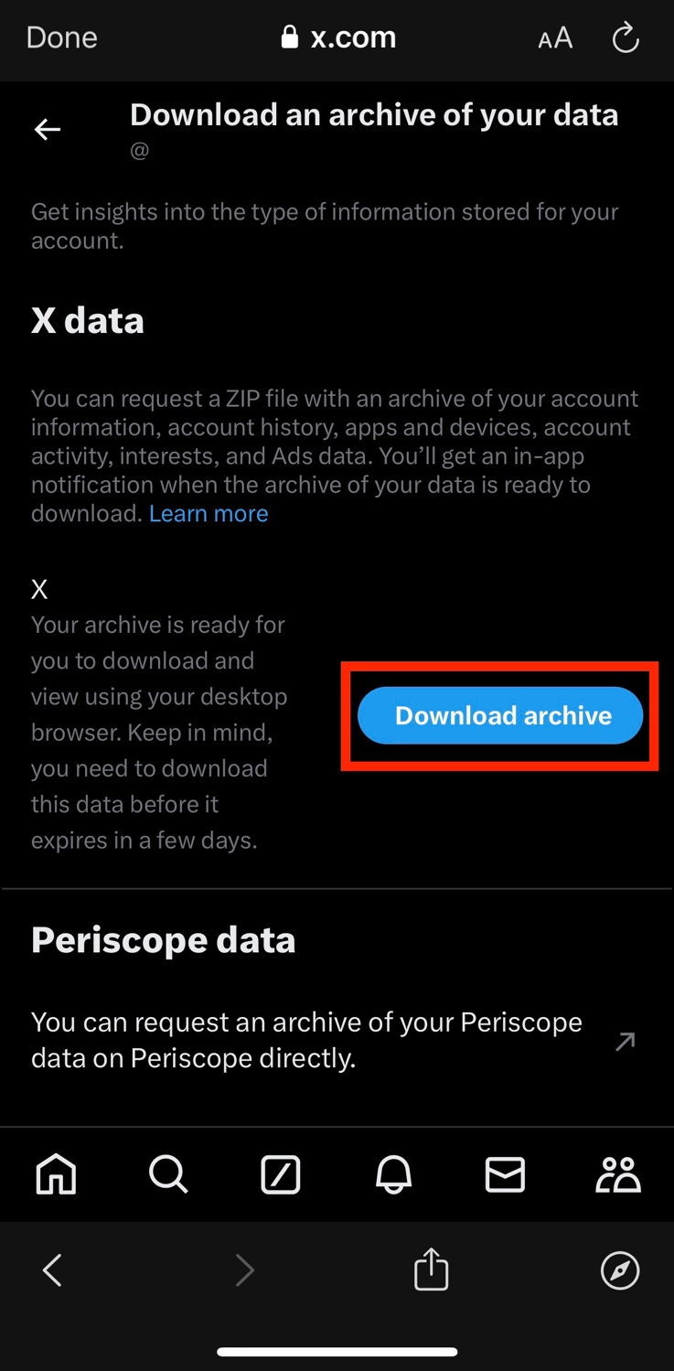

Then click on Get started.



The archive will be downloaded as a ZIP file. In order to locate it on your device, open your Downloads folder on your device. You can find this through your device’s search bar.