**Data takeout: YouTube (web)**

Sign in to your Google account, then go to the Google takeout page: <https://takeout.google.com/>.

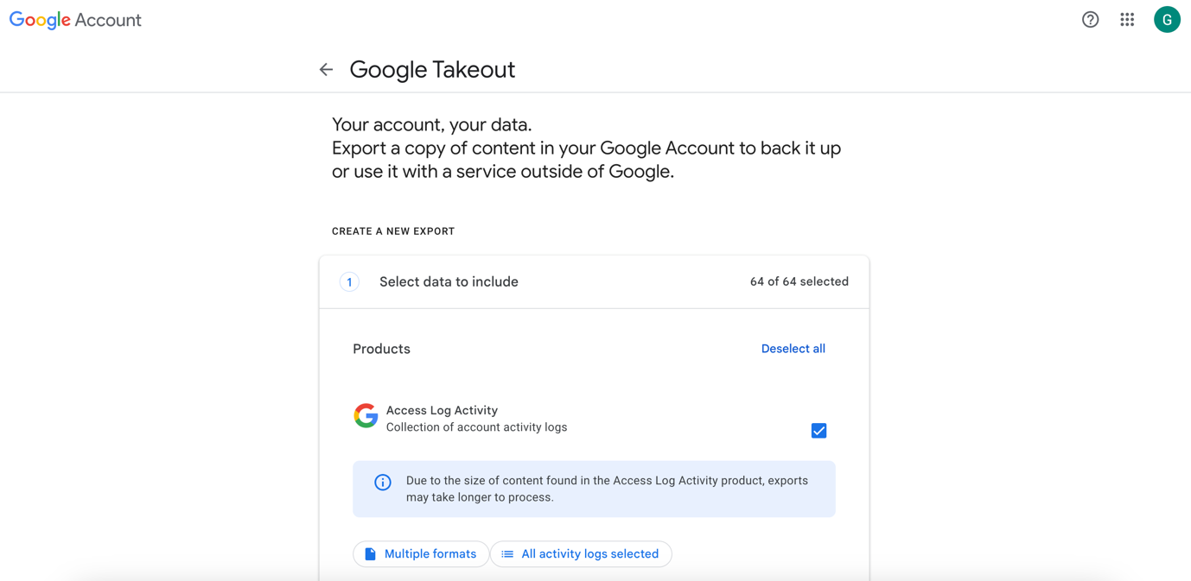

To download your YouTube data only, click on Deselect all.

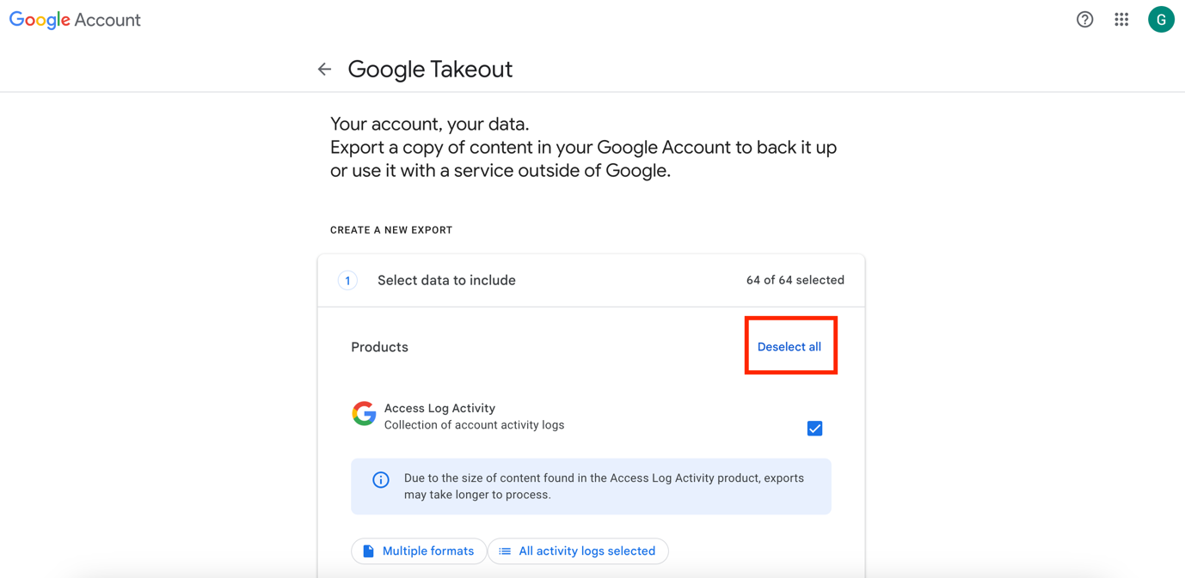

Then scroll down to find the YouTube check, and click on Next steps.

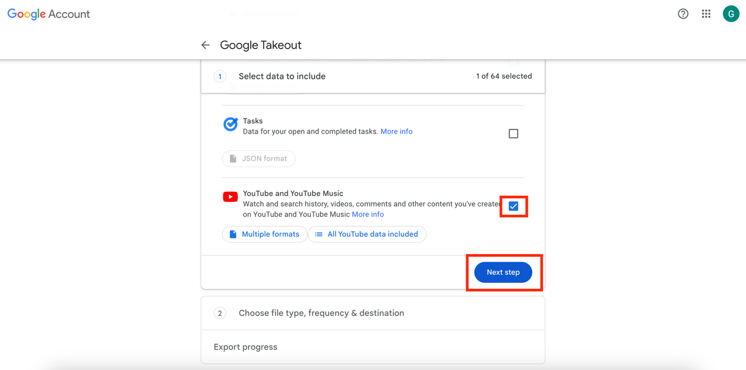

The following will appear:

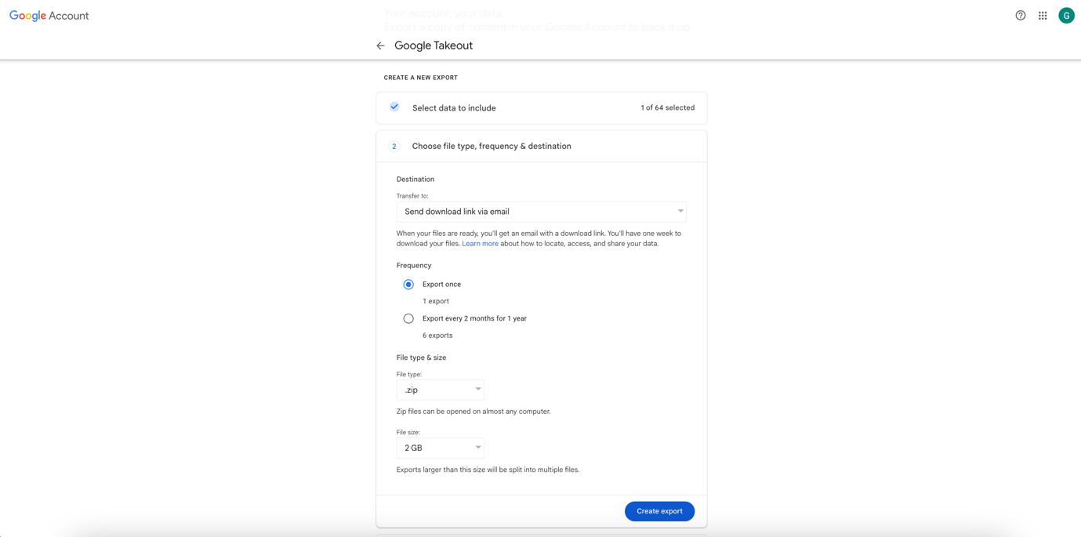

Select the following options:

Transfer to: Send download link via email

Frequency: Export once

File type: .zip

Size: 2 GB (*note: options are 1; 2; 4; 10 – but files larger than 2 GB are split into multiple files*).

Then click on Create export.

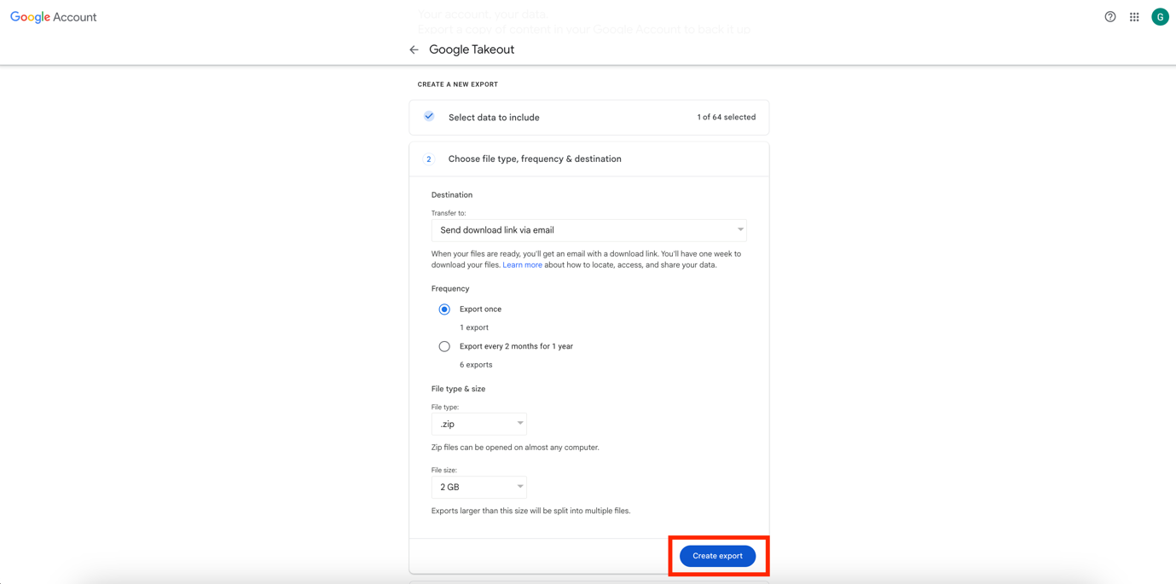

The following page will appear:

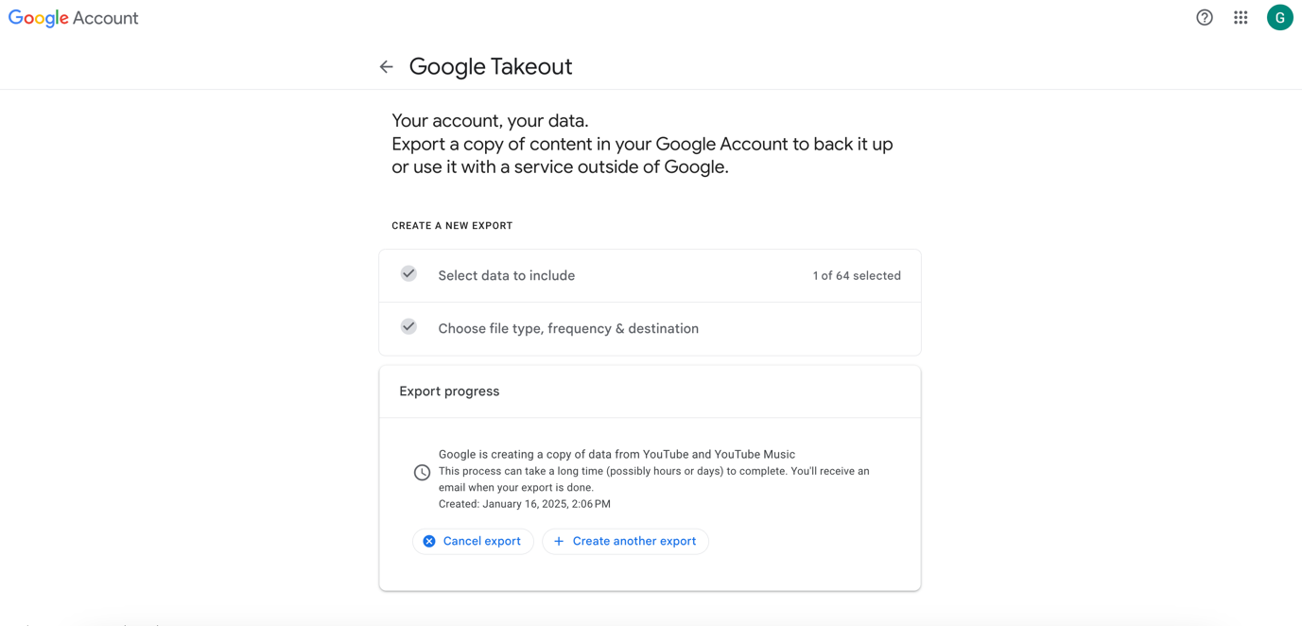

You will receive a confirmation email from Google (no-reply@accounts.google.com), which should look like this:

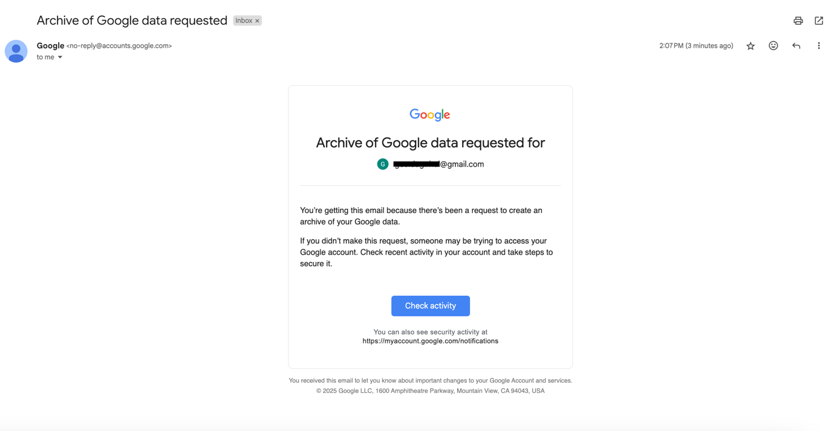

You will then have to wait for your data to be ready and for Google to send you the download link. Note that this could take up to several days.

Once you receive the email (from noreply@google.com), click on Download your files.

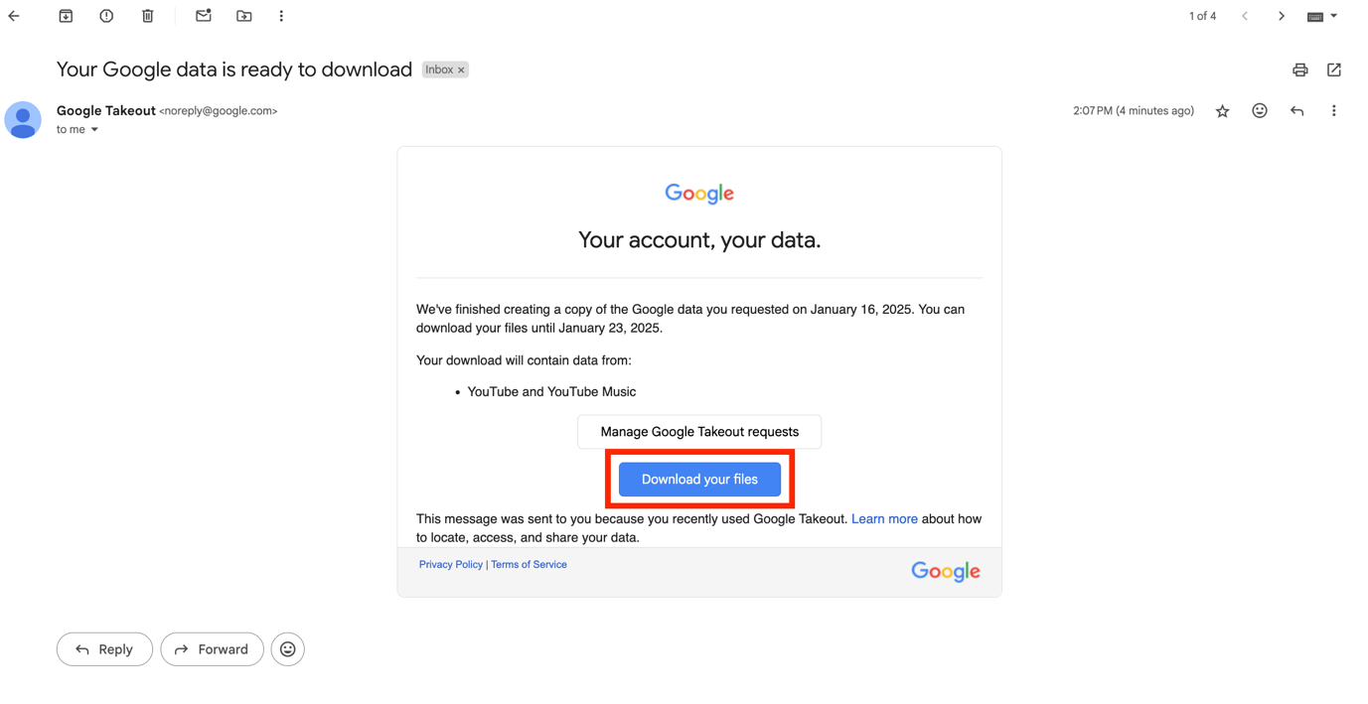

To continue, you will have to enter your password.

Enter your password, then click on Next.

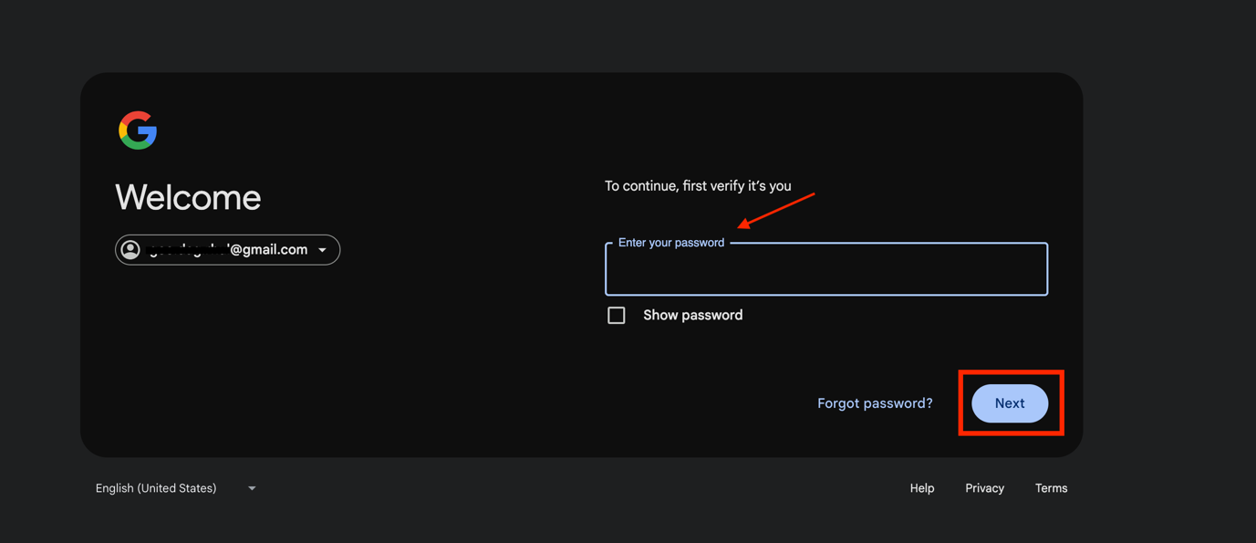

The following page will appear, and the download should start automatically.

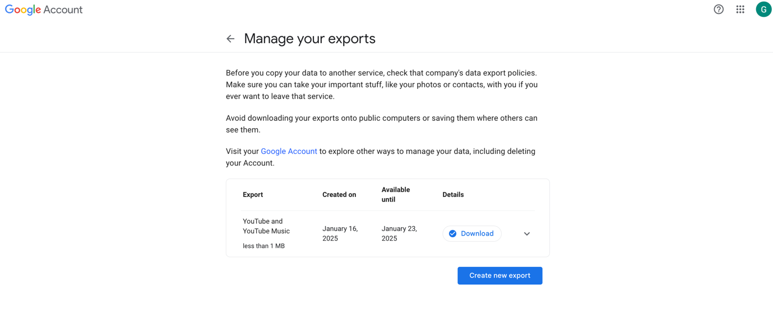

The data will be downloaded as a .zip file and will be saved in your Downloads folder.

**Data takeout: YouTube (app)**

Open the YouTube app on your phone then click on your profile picture at the bottom right of the screen. Then click on **Google Account** at the top of the page.

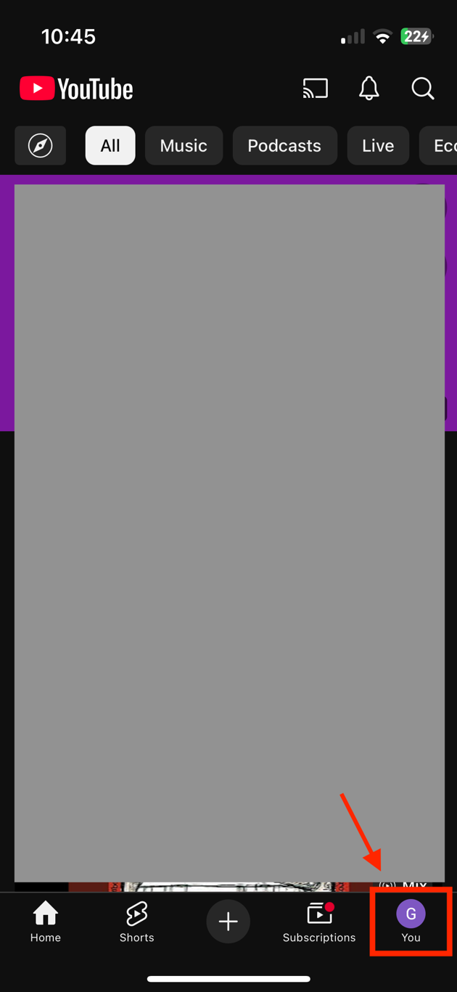 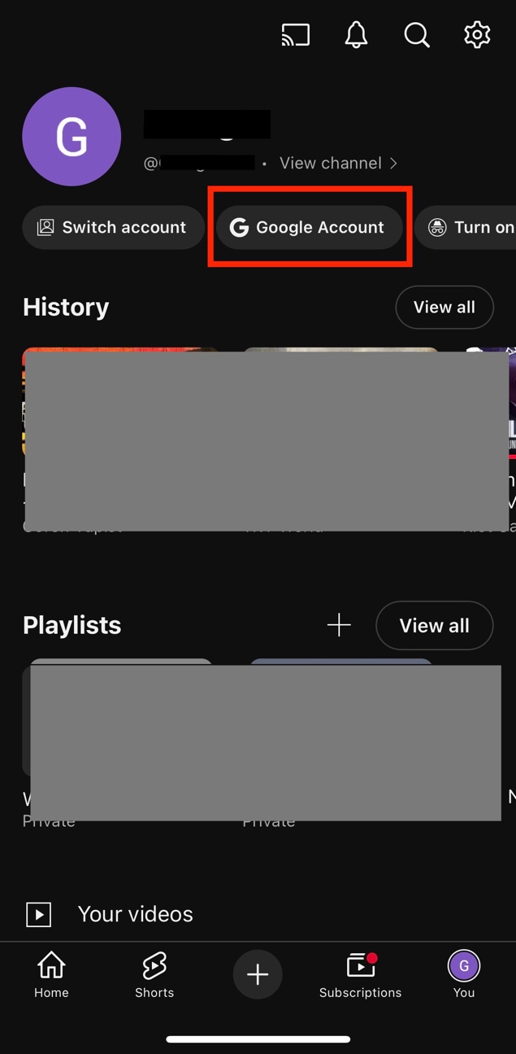

The following page will open. Click on **Data & privacy**.

Then scroll down and click on **Download your data**.

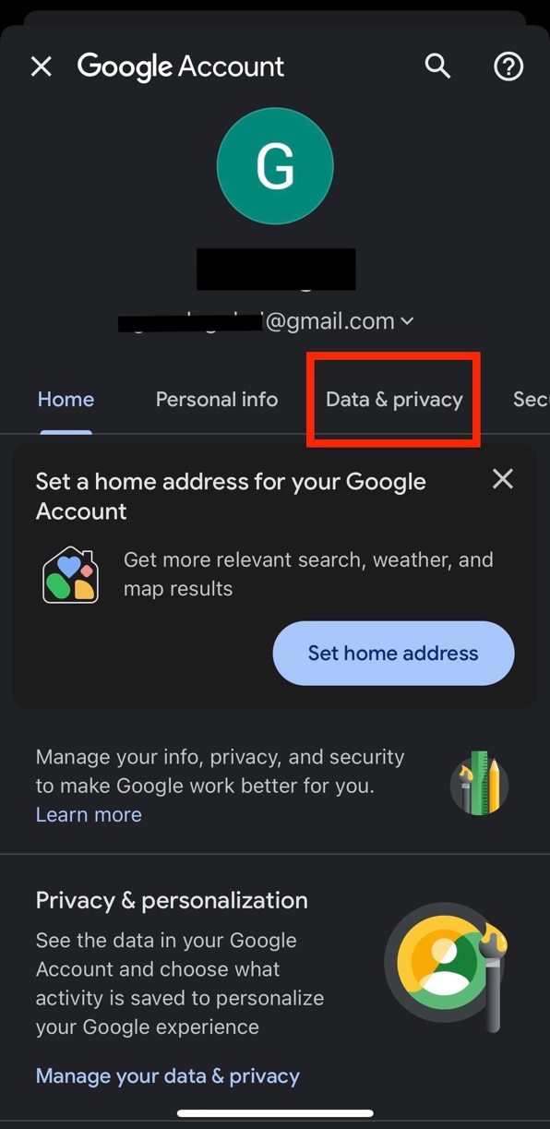 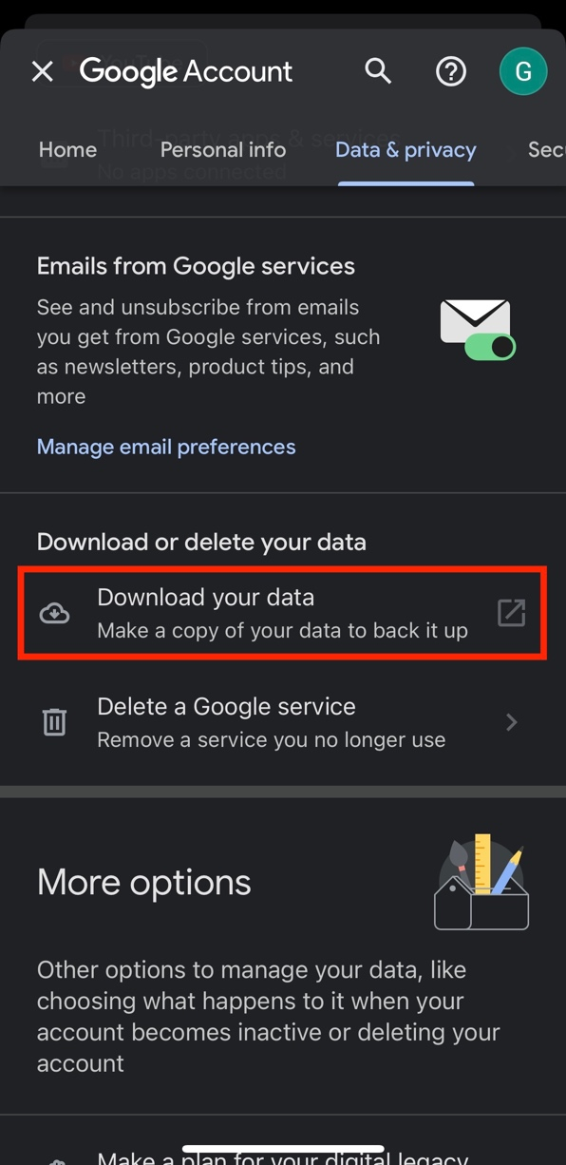

The Google Takeout page will appear. Scroll down and click on **Deselect all**, as we are only requesting your YouTube data.

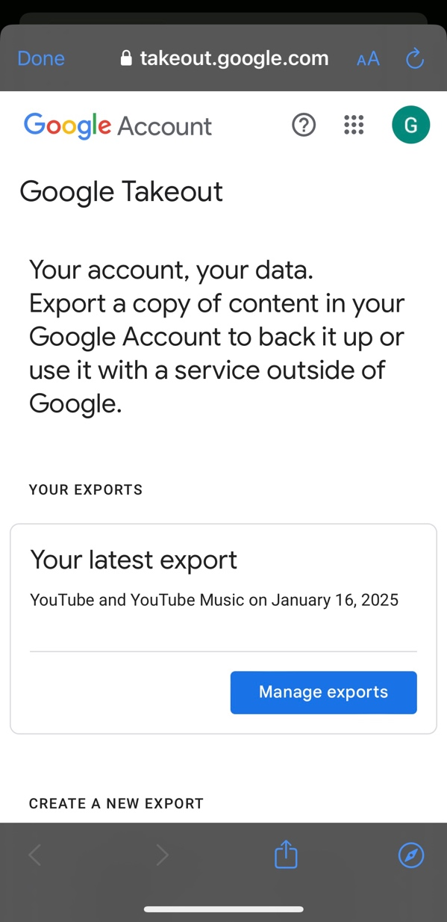 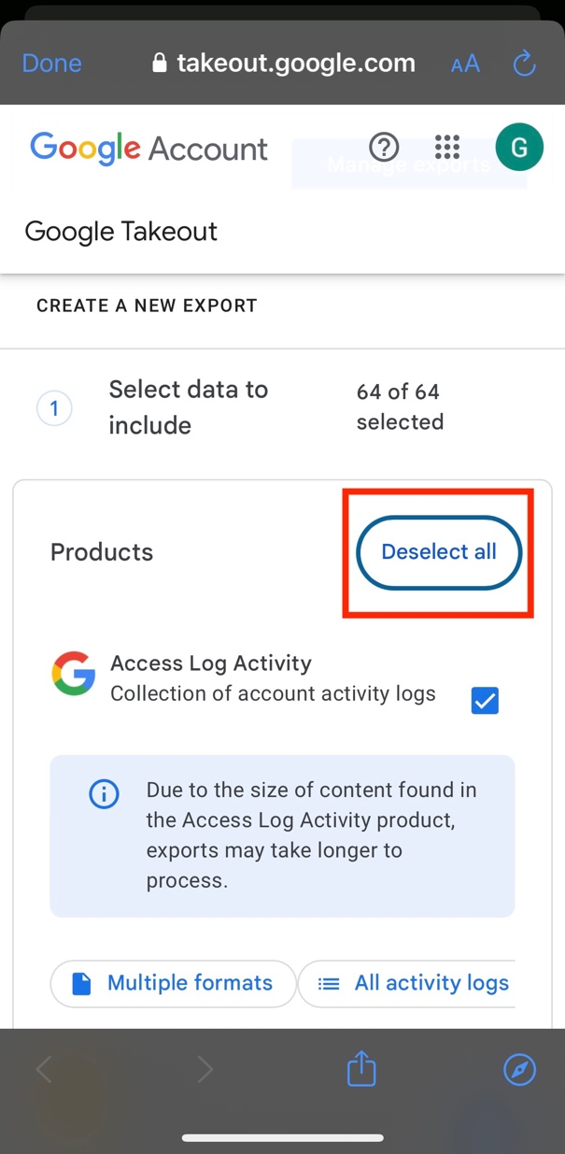

Next, you will have to select the amount and type of data you would like to download. Scroll down and select **YouTube**.

Then click on **Multiple formats**. Once you click on Multiple formats, scroll down and select the format for the **history** file. It will give you two options: HTML or JSON. Select **JSON**.

Then click on OK at the top of the page.

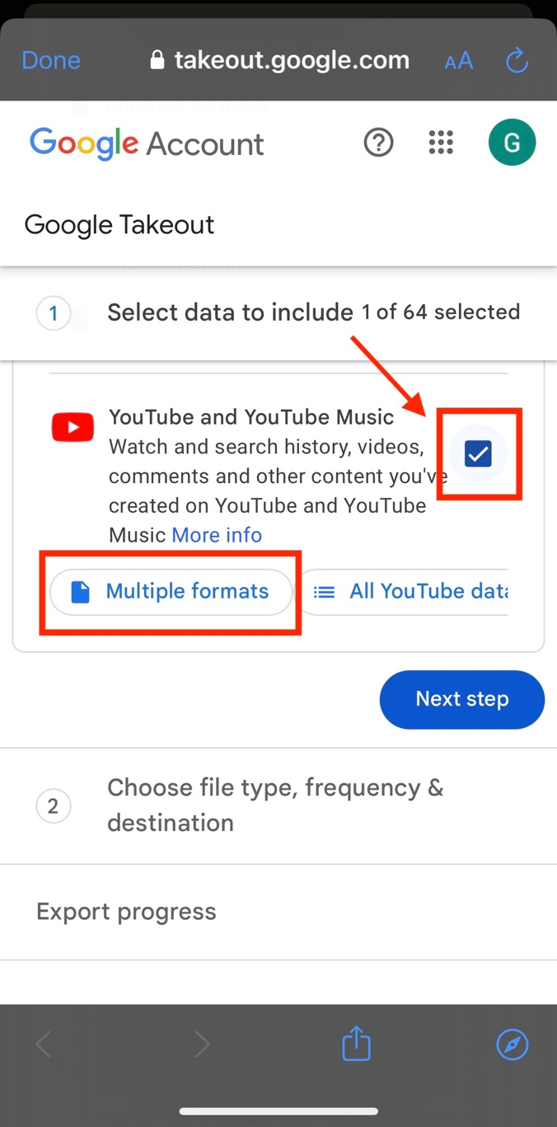 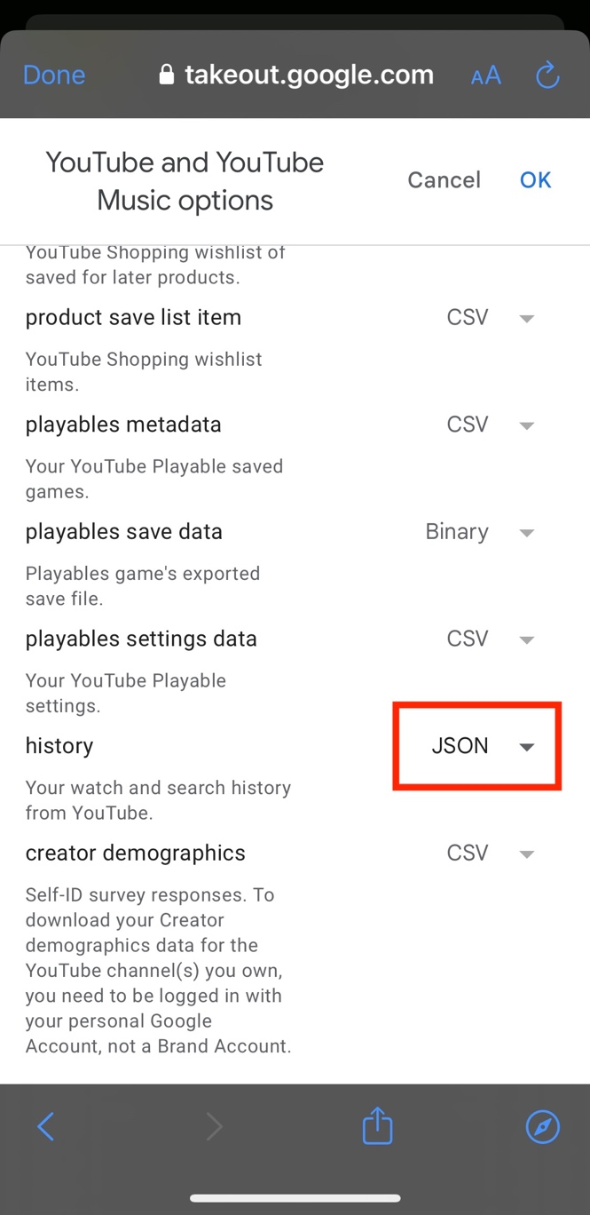

The previous page will appear again. Make sure that the **All YouTube data included** is selected.

(*Note: This might need to be changed, depending on the data you will need for the project*. Would change to: Or click on All YouTube data included and select the type of data – and then give instructions for which data to select).

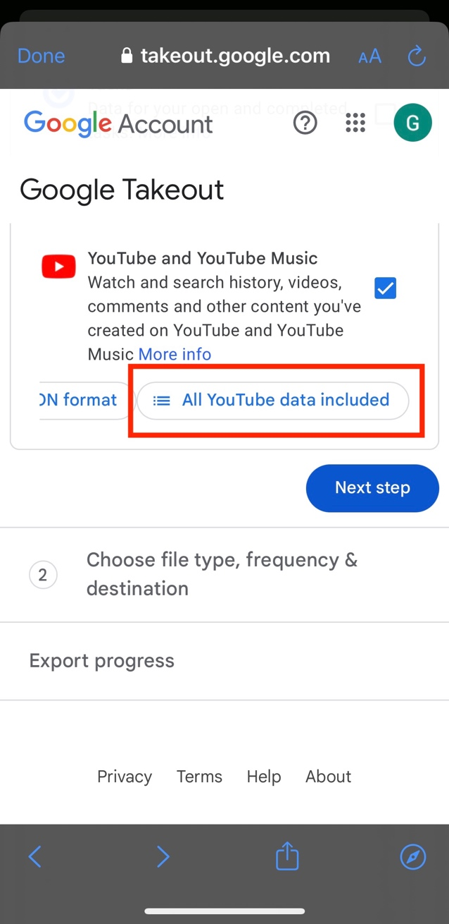 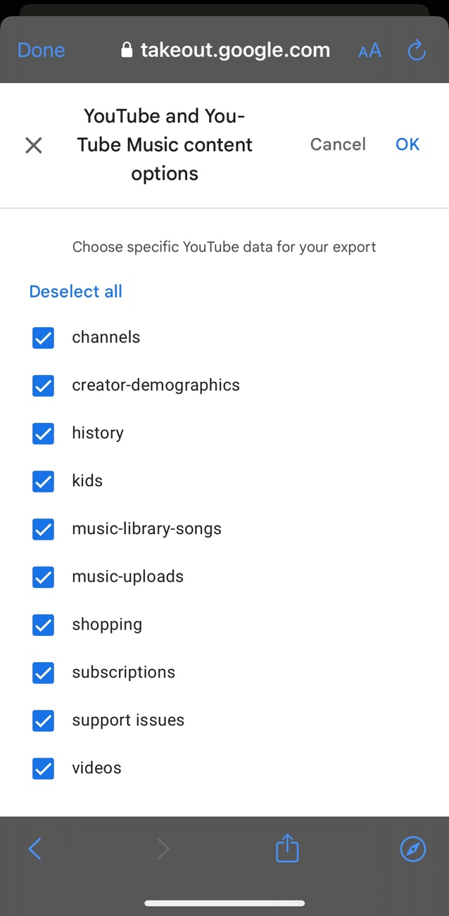

Click on OK at the top of the page then click on **Next step**. You will then need to choose the file type, frequency, and destination.

Select the following:

**Transfer to**: Send download link via email.

**Frequency**: Export once.

**File type**: .zip.

**File size**: 2 GB.

Then click on **Create export**.

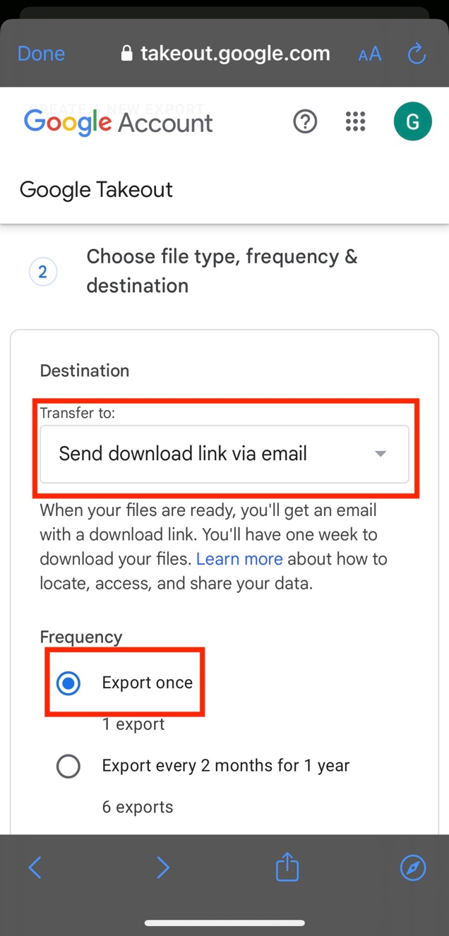 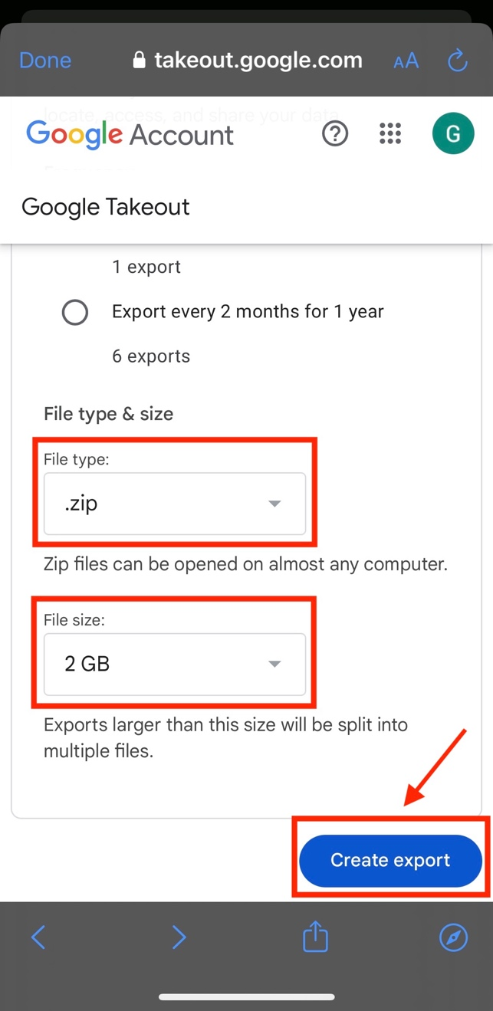

The following page will appear, and you will need to wait for your data to be ready for download.

Once the data is ready, you will receive an email from Google Takeout ([noreply@google.com](mailto:noreply@google.com)). Click on **Download your files**.

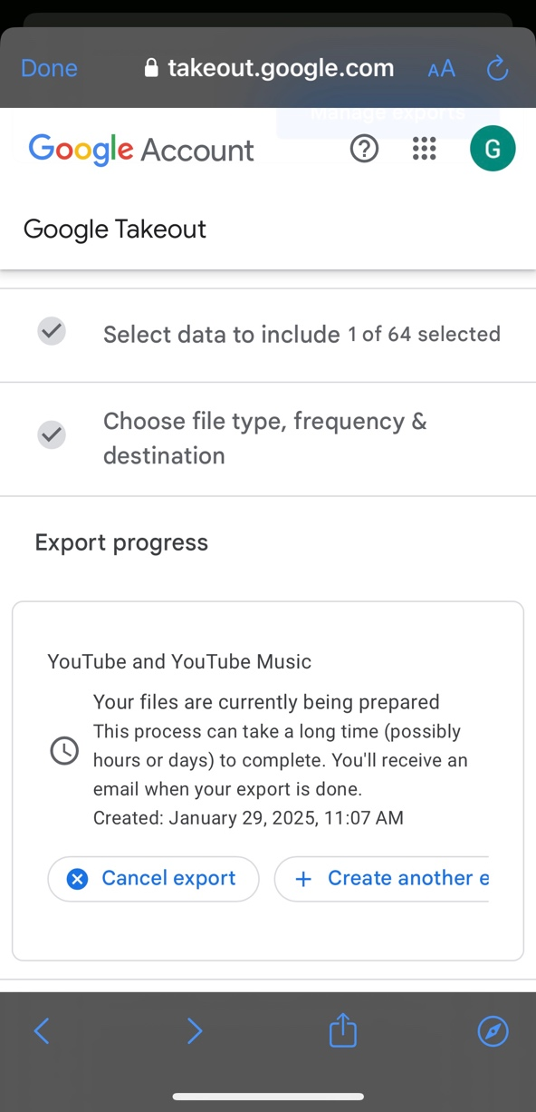 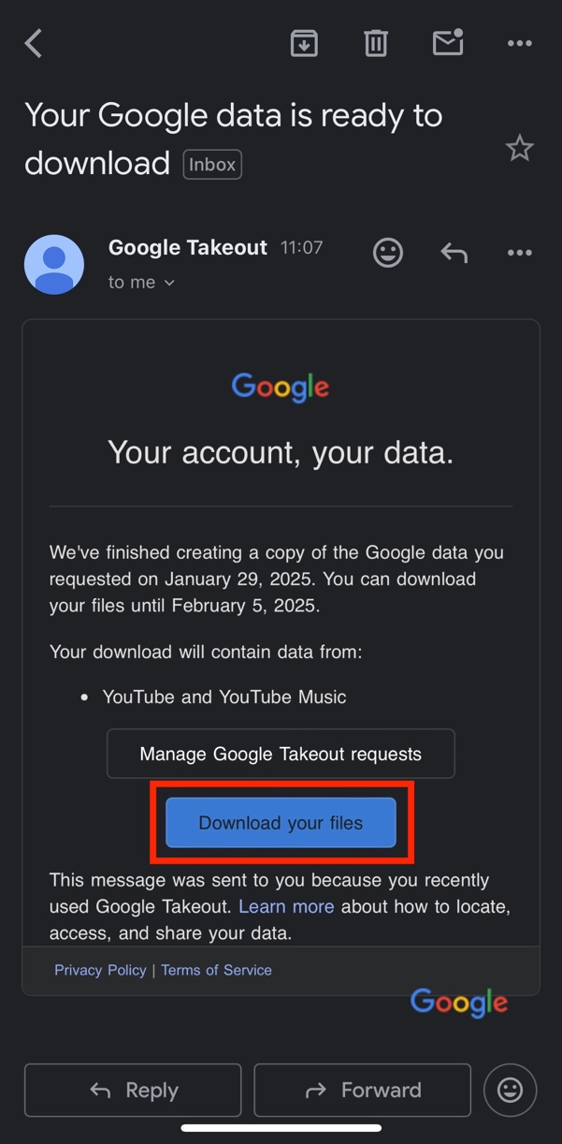

Once you click on Download your files, you might need to sign in again. If so, enter your gmail account and password.

The following page will appear, and click on **Download**.

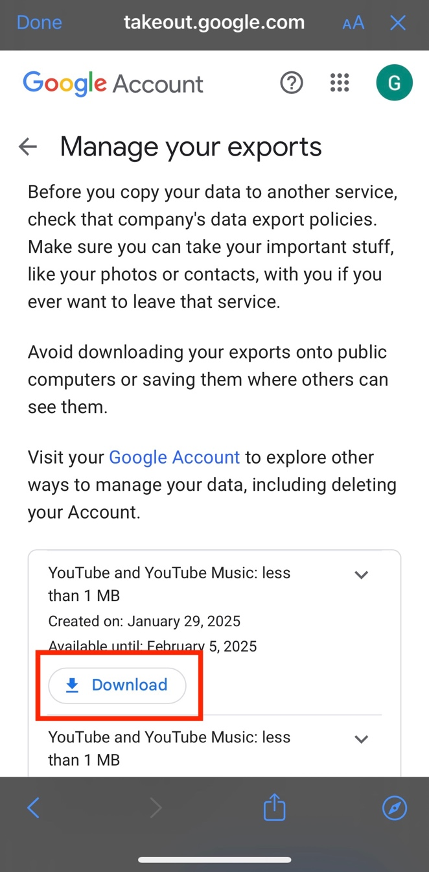 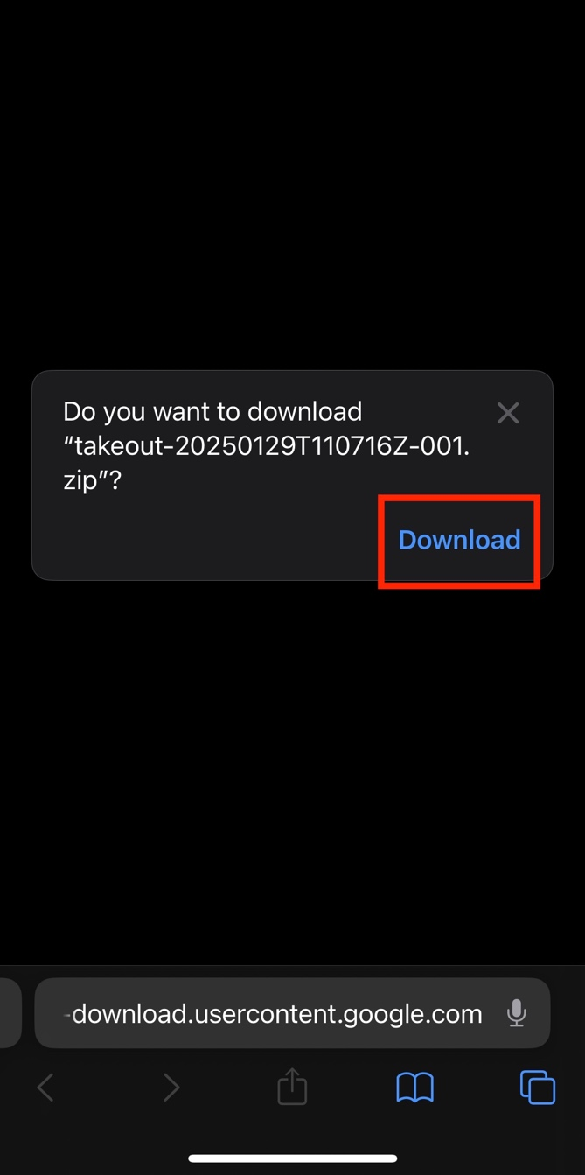

The file will then be downloaded on your device. Once the download is complete, it will be saved on your device in the Downloads folder, which will look like this:

