新aeye平台，按照部门维度查询一周项目时常接口：

* + 按照部门维度查询
    - 数据展示以下内容，展示形式可按照现有控件来展示

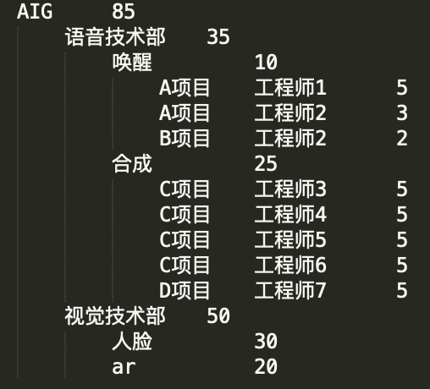

@project.route('/timecostByDepartmentName', methods=['post'])

输入json：（输入时间前端指定）

{

“emailName”：“name1”，

“departmentName”: ”AIG”,

“startDate”: “2019-07-29”,

“endDate”: “2019-08-04”

}

输出json：

{

"emailName":"name1",

"departmentName":"AIG",

"startDate": "2019-07-29",

"endDate": "2019-08-04",

"data": [{

"projectName":"项目A",

"username": "工程师1",

"actuallyQa":1,

"superiorDepartment": "NULL", //父节点的父节点部门，AIG为一级节点无父节点

"parentDepartment":"AIG", //父节点部门，

"departmentName": "自然语言处理",

},

{"projectName":"项目A",

"username": "工程师2",

"actuallyQa":1,

"superiorDepartment": "NULL",

"parentDepartment":"AIG",

"departmentName": "自然语言处理",

},

{"projectName":"项目B",

"username": "工程师1",

"actuallyQa":1,

"superiorDepartment": "AIG",

"parentDepartment":"自然语言处理",

"departmentName": "百度翻译",

}

]

}