Name: Kade McRae Mark _____________________/50

Brief introduction __/3
User Stats/Storyline
User stats are data that impact the gameplay. Such examples of stats would be risk factor and hunger. The storyline would be the main gameplay loop for the game.

Use case diagram with scenario __14

Use Case Diagrams

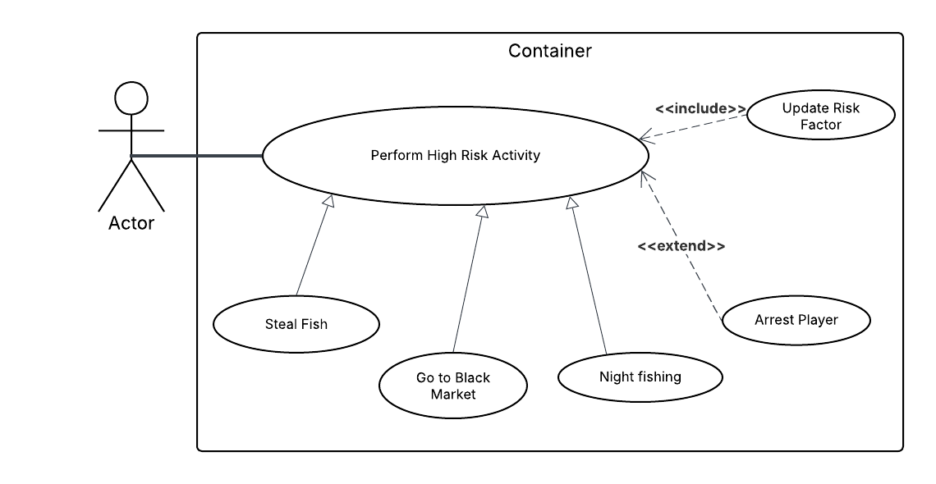

Scenarios
Name: Update Risk Factor
Summary: Describes how the system will adjust the risk level based on the choices made throughout the storyline.
Actors: Player.
Preconditions: The player makes a choice.
Basic sequence:
Step 1: System receives choice data.
Step 2: System calculates new risk factor data by adding the risk factor from the choice onto the current risk factor.
Step 3: System checks risk factor value to see if player can be arrested and checks for data corruption.
Step 4: System updates the UI to show the updated stat.

Exceptions:
1: Risk factor exceeds a certain amount: arrests player.
2: Risk factor data is corrupted: defaults to regular risk factor.
Post conditions: The User Stat database is updated and the new Risk Factor is displayed.
Priority: 2*
ID: C01
*The priorities are 1 = must have, 2 = essential, 3 = nice to have.

Data Flow diagram(s) from Level 0 to process description for your feature _______14

Data Flow Diagrams
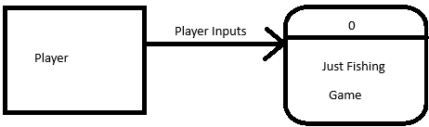
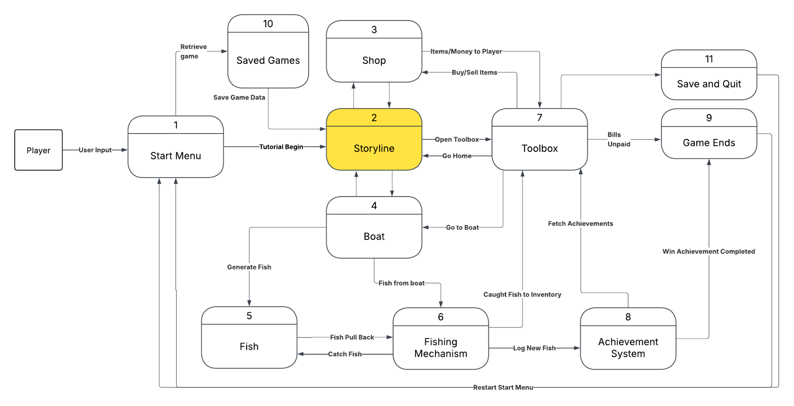
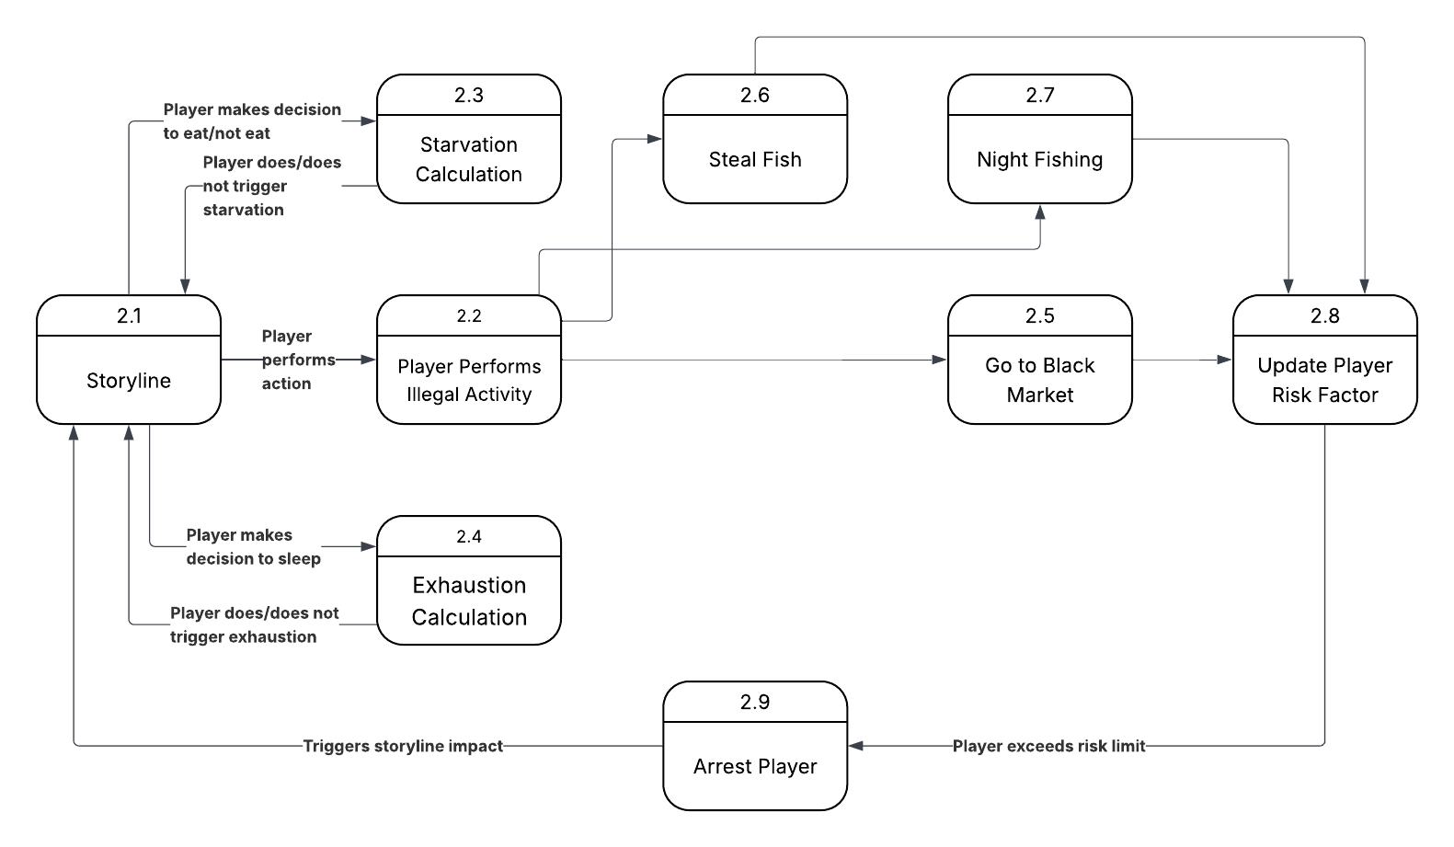

Process Descriptions
Shop NPCs
WHILE Player is interacting with Shop NPC
IF Player selects "Sell Fish"
FOR EACH Fish in Player_Inventory
IF Current_Time < 07:00 PM
CALCULATE Fish_Value based on Rarity and Weight
ADD Fish_Value to Player_Currency
REMOVE Fish from Player_Inventory
LOG Sale_Transaction to Save_Data
ELSE
DISPLAY "Shop is closed. All fish must be sold by 7 PM."
EXIT Loop
END IF
END FOR

ELSE IF Player selects "Buy Item"
DISPLAY available Fishing_Upgrades (Better lures, rods, bait, etc.)
IF Player_Currency >= Item_Price
SUBTRACT Item_Price from Player_Currency
ADD Selected_Item to Player_Inventory/Toolbox
LOG Purchase to Save_Data
ELSE
DISPLAY "Insufficient funds."
END IF

ELSE IF Player selects "Black Market"
DISPLAY Special_Items
EXECUTE "Buy Item" Logic
INCREASE Player_Risk_Factor
END IF
END WHILE

Dialogue/Event Generator/NPCs
WHILE Player is interacting with Shop NPC
IF Player selects "Sell Fish"
FOR EACH Fish in Player_Inventory
IF Current_Time < 07:00 PM
CALCULATE Fish_Value based on Rarity and Weight
ADD Fish_Value to Player_Currency
REMOVE Fish from Player_Inventory
LOG Sale_Transaction to Save_Data
ELSE
DISPLAY "Shop is closed. All fish must be sold by 7 PM."
EXIT Loop
END IF
END FOR

ELSE IF Player selects "Buy Item"
DISPLAY available Fishing_Upgrades (Better lures, rods, bait, etc.)
IF Player_Currency >= Item_Price
SUBTRACT Item_Price from Player_Currency
ADD Selected_Item to Player_Inventory/Toolbox
LOG Purchase to Save_Data
ELSE
DISPLAY "Insufficient funds."
END IF

ELSE IF Player selects "Black Market"
DISPLAY Special_Items
EXECUTE "Buy Item" Logic
INCREASE Player_Risk_Factor
END IF
END WHILE

Sava Data/Game Storage
ON RECEIVE "Read State" request
ACCESS Game_Storage_File
RETURN (Inventory_List, Fish_Catalogue, Achievements, Currency, Boat_Damage, Risk_Factor, Story_Flags)

ON RECEIVE "Write State" request from external process (Shop, Fishing, or Event)
UPDATE Game_Storage_File with incoming data:

IF Data contains "Caught Fish"
UPDATE Fish_Catalogue
IF Fish meets "Achievement" criteria
GENERATE Achievement_Record
ADD Special_Item reward to Inventory
END IF

IF Data contains "Risk Factor"
IF Risk_Factor > Arrest_Threshold
TRIGGER "User Arrested" Game_Over event
END IF
END IF

COMMIT updates to persistent storage

Acceptance Tests ________9
Risk Factor and Arrest Tests
These tests ensure that the “Arrest” exception triggers at exactly the right moment
Examples for Risk Factor and Arrest Tests
Input | Current Risk  (int) | Expected Output | Notes
Steal Fish (+5 risk) | 95 | Risk = 95; State=Free | Normal Case: updates to persistent storage increased but remains below the threshold
Night Fish (+2 risk) | 98 | Risk = 100; State=Arrested | Boundary: Exact threshold reached; triggers Arrest extension
Buy Tools (+10 risk) | 90 | Risk=100;  State=Arrested | Boundary: Risk exceeds 100; should cap at 100 and arrest
Any Action | 100 | State=Arrested | Bad Input: Ensure an already arrested player cannot act

Hunger and Starvation Tests
These focus on the allocation of money and the resulting hunger change.
Examples for Hunger and Starvation Tests
Input (Money for Food) | Current Hunger | Expected Output | Notes
$10 (Daily Req) | 50 | 100 Hunger | Boundary: Minimum met; hunger is stable
$0 | 10 | 0 Hunger | Boundary: No food leads to starvation/death.
$20 (Surplus) | 95 | 100 Hunger | Boundary: Hunger increases but caps at max (100)
-$5 (Error) | 50 | 45 Hunger | Bad Input: System should treat negative input as $0

Sleep and Exhaustion Tests
Since not getting enough sleep in a week can kill the player, you need a test for the cumulative effect.
Examples of Sleep and Exhaustion Tests
Input (Weekly Sleep Hours) | Current Energy | Expected Output | Notes
30 Hours | 100 | 100 Energy | Normal Case: Sufficient sleep maintained
12 Hours | 100 | 20 Energy | Penalty: Significant energy drop for low sleep.
5 Hours | 15 | 0 Energy | Boundary: Extreme exhaustion leads to death

Timeline _________/10

Work items
Task | Duration (hrs) | Predecessor Task(s)
1. Requirements Finalization | 3 | -
2. Logic Design | 8 | 1
3. Risk System Backend | 8 | 2
4. Survival System Backend | 8 | 2
5. UI & HUD Integration | 6 | 3, 4
6. Automated Unity Testing | 6 | 3, 4
7. Balancing & Polish | 4 | 5,6

Pert diagram
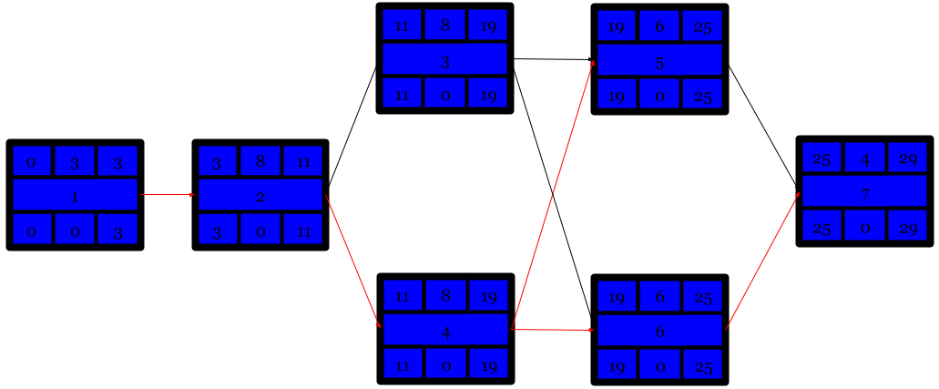

Gantt timeline

1
2 |  |  |  | 1
3 |  |  |  |  |  |  |  |  |  |  |  | 2
4 |  |  |  |  |  |  |  |  |  |  |  | 2
5
6
7
 | 1 | 2 | 3 | 4 | 5 | 6 | 7 | 8 | 9 | 10 | 11 | 12 | 13 | 14 | 15 | 16 | 17

1
2
3
4
5 |  |  | 3,4
6 |  |  | 3,4
7 |  |  |  |  |  |  |  |  | 5,6
 | 18 | 19 | 20 | 21 | 22 | 23 | 24 | 25 | 26 | 27 | 28 | 29

