WATER QUALITY MONITORING SYSTEM WITH AUTO CALIBRATION AND FAULT DETECTION SYSTEM

VIVEK KUMAR PAL
Department of Computer Science
LOVELY PROFESSIONAL UNIVERSITY
Varanasi, India
vivekpalkumar20071101@gmail.com
line 1: 2nd Given Name Surname
line 2: dept. name of organization (of Affiliation)
line 3: name of organization (of Affiliation)
line 4: City, Country
line 5: email address or ORCID
line 1: 3rd Given Name Surname
line 2: dept. name of organization (of Affiliation)
line 3: name of organization (of Affiliation)
line 4: City, Country
line 5: email address or ORCID
line 1: 4th Given Name Surname
line 2: dept. name of organization (of Affiliation)
line 3: name of organization (of Affiliation)
line 4: City, Country
line 5: email address or ORCID

Abstract—Urban water bodies are suffering from degradation that has been accelerated by rapid urbanization, industrial discharge, and inefficient monitoring practices. Traditional methods of water quality assessment rely on manual sampling; hence, data is collected intermittently, pollution detection is delayed, and accuracy is compromised. This project proposes a low-cost automated water quality monitoring system with continuous data acquisition, wireless data transmission, and basic self-maintenance capabilities. The sensor system used in this study is an integrated module of the TDS sensor, Arduino microcontroller, and ESP8266 communication module that enables real-time monitoring. A vibration-based self-cleaning mechanism has been incorporated into the design to reduce measurement errors induced by air bubbles and debris, thus enhancing sensor stability. Experimental results have depicted that the prototype successfully differentiates between water samples of varied quality and reliably transmits readings for external anomaly detection. These results also assure that the developed system overcomes many limitations of the existing low-cost solutions and provides an economical, easily scalable platform that may be enhanced further by machine learning-based validation in the future. This work hence presents a practical, economical approach for the long-term monitoring of urban water bodies
Keywords—component, formatting, style, styling, insert (key words)

Introduction
Urban water bodies are essential for environmental balance, public health, and community well-being. However, rapid urban growth, industrial activities, and pollution are putting immense pressure on these water systems. As a result, many rivers and lakes in cities are deteriorating in quality, affecting both ecosystems and the people who depend on them.
Despite the seriousness of the issue, monitoring of water quality is still mostly carried out through manual checks at irregular intervals. This leads to delays in detecting changes, limited accuracy, and poor understanding of real-time conditions. Without continuous monitoring, harmful changes in water quality often remain unnoticed until they become severe.
These challenges highlight the need for a system that can observe water bodies more regularly, reliably, and efficiently. An improved monitoring approach would help identify problems earlier, support better decision-making, and contribute to protecting urban water resources for the future.

Literature STUDY

A . LITERATURE SURVEY
Previous research on water quality monitoring emphasizes the need for accurate and timely assessment of urban water bodies. Many studies have explored sensor-based systems that measure parameters such as pH, turbidity, and dissolved solids using microcontrollers and wireless modules (Sharma & Patel, 2020).
While these projects demonstrate the usefulness of automated measurement, they often rely on basic data collection without mechanisms to detect incorrect readings or sensor faults (Deshmukh et al., 2021). Other researchers have proposed IoT-based models for real-time transmission of water data, but these systems usually face issues of high cost, limited scalability, or unreliable long-term operation (Iqbal & Rahman, 2022). Advanced industrial platforms like the YSI EXO series offer highly accurate multi-parameter sensing, yet their high price makes them inaccessible for widespread use (Xylem, 2019). Recent works also highlight the growing potential of machine-learning methods for identifying anomalies in environmental data, although practical integration with low-cost hardware remains limited (Li & Kim, 2020).
Parallel to hardware developments, recent literature highlights the growing role of intelligent data processing techniques. Machine-learning models, particularly anomaly detection methods, have shown promise in identifying abnormal readings caused by sensor malfunction or unexpected environmental disturbances, thereby improving data reliability. Despite their potential, many studies report that integrating such models with low-cost microcontrollers is still limited due to hardware constraints, insufficient onboard memory, and the need for external computation.
Overall, the reviewed literature demonstrates that while significant progress has been made in automating water quality monitoring, there remains a notable gap in achieving a system that is accurate, low-cost, scalable, and capable of validating sensor data intelligently. These findings directly support the motivation for the current project, which aims to combine affordable hardware, automated sensing, wireless communication, and machine-learning-based anomaly detection to create a practical and reliable solution suitable for long-term monitoring of urban water bodies.

Reference(Author, Year) | Objective | Methods | Key finding | Limitations
A Sharma, 2020 | Real time monitoring of urban water bodies | Sensor-based monitoring systemsand ,IoT concepts | Benefits of automated measurements for urban water quality | Lacks mechanism for detecting faulty sensor readings
S.Karthik,2021 | Multi sensor water monitoring using embedded systems | Embedded platforms using multiple sensors | Multi-parameter sensing | Limited discussion on long term data collection and sensor reliability
R. Deshmukh,2021 | Analysis of sensor errors in water monitoring systems | Error analysis of sensors outputs, laboratory tests | Identified common error sources | Proposed analysis but few practical mitigation strategies
M. Iqbal, 2022 | Development of low-cost automated systems | Low-cost hardware + IoT for data transmission | Demonstrated affordable real-time systems suitable for deployments | Scalability, log-term reliability and intelligent validation remain limited
Y.Li and H. Kim, 2020 | Machine learning for anomaly detection | ML model based anomaly detection | ML can detect abnormal readings and sensor fault effectively | Integration with low-cost microcontrollers and on=device inference was limited

B.RESEARCH GAPS
- The reviewed literature shows that many existing water monitoring methods still rely on manual sampling, which prevents real-time observation of changing water conditions. This lack of continuous monitoring makes it difficult to detect sudden changes or early signs of pollution. Although some automated systems exist, they are often expensive and not suitable for large-scale or student-level deployment, leaving a gap for affordable and practical solutions.
- Several studies highlight issues with sensor reliability, but very few provide methods to address sensor malfunction caused by debris, bubble formation, or environmental disturbances. Most existing systems collect data but do not check whether the readings are accurate or abnormal. There is limited research on using intelligent techniques, such as anomaly detection, to correct faulty sensor values or notify users about potential problems.
- Another gap observed is the lack of systems that combine long-term monitoring with proactive maintenance support. While monitoring devices are available, they usually do not alert the user when sensors need cleaning or when readings become unreliable. This reduces system lifespan and accuracy over time.
- These gaps—high cost, limited reliability, absence of data validation, and lack of maintenance support—justify the need for a low-cost, continuous, and intelligent monitoring solution. The proposed project aims to address these shortcomings by integrating automated data collection, anomaly detection, and sensor protection mechanisms into a single, scalable system.

METHODOLOGY
The methodology for this project follows a structured and systematic approach to ensure the development of a reliable and efficient monitoring system. The process begins with a detailed requirement analysis to understand the needs of urban water monitoring and identify the limitations of existing solutions. Based on these insights, suitable hardware and software components are chosen by considering factors such as cost, accuracy, durability, and compatibility. After selecting the components, the overall system architecture is designed, followed by the development of the circuit layout and implementation of the core program. Each sensor and module is first tested individually to confirm proper functionality before integrating them into a unified system. Once integrated, the system is used to collect data that is reviewed, processed, and validated to ensure consistent and meaningful output. Throughout this stage, iterative testing, debugging, and refinement are carried out to improve system stability and performance. Finally, the complete prototype is evaluated under real or simulated field conditions to assess its effectiveness and reliability, allowing the final results to support the overall objectives of the project.

VIRTUAL SIMULATION
Virtual simulation plays an important role in understanding how the system functions before creating the physical prototype. In this project, simulation tools are used to design the circuit, arrange the components, and observe how the sensors and modules interact under different conditions. By recreating the system digitally, it becomes easier to verify connections, test basic operations, and identify potential issues early in the development process.
The simulation environment allows the flow of data to be visualized clearly, helping to check whether the readings behave as expected and whether the system responds correctly to changes. This stage also supports safe experimentation, where adjustments can be made without the risk of damaging hardware. Through virtual testing, the design becomes more refined, reliable, and ready for real-world implementation.

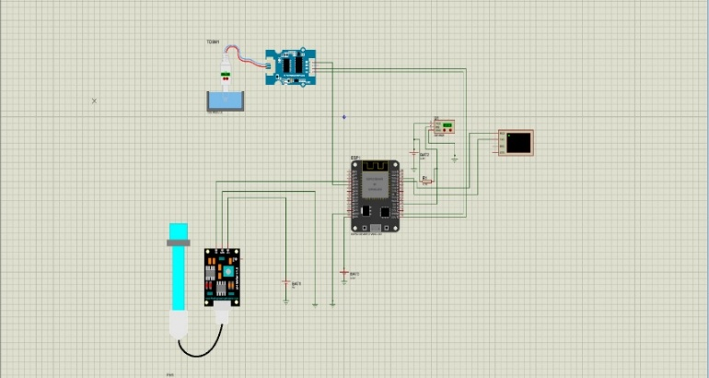

WORKING PROTOTYPE
The working prototype of this project has been developed by assembling all hardware components into a functional system capable of continuously monitoring water quality. The setup includes sensors such as the TDS sensor, which is connected to the Arduino board that serves as the central microcontroller. A Wi-Fi module (ESP8266) is integrated to enable wireless communication between the prototype and an external computer for further data processing, as described in the synopsis. The components are interconnected on a breadboard following the designed circuit layout, ensuring proper power distribution and secure signal connections. A vibrating motor is attached near the sensor to prevent air bubbles and debris from accumulating on the electrodes, thereby improving reading stability—one of the unique features highlighted in the project concept. The programmed Arduino code allows the microcontroller to read sensor values at fixed intervals, transmit the data to the external system, and respond when unusual readings occur. When powered on, the prototype senses the water parameter, processes the raw data, and sends it wirelessly for anomaly detection and validation. During testing, issues such as unstable readings caused by electrode bubbles were observed, which were effectively resolved through the use of the vibration mechanism described in the design.
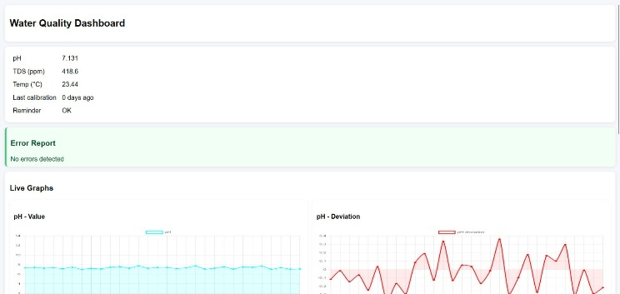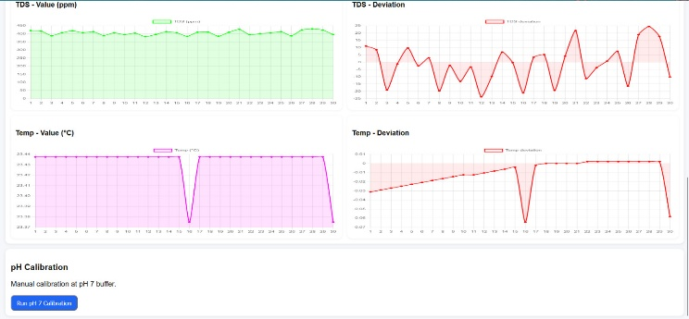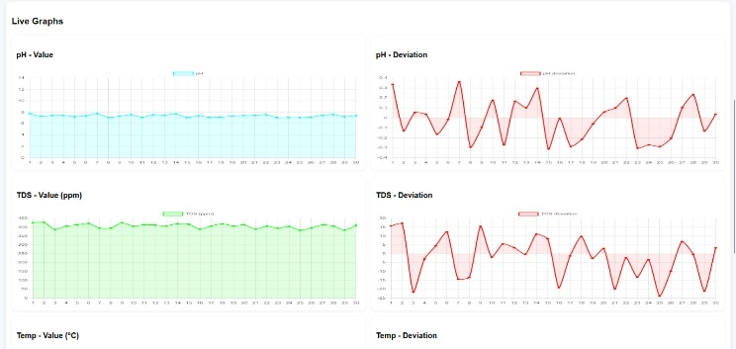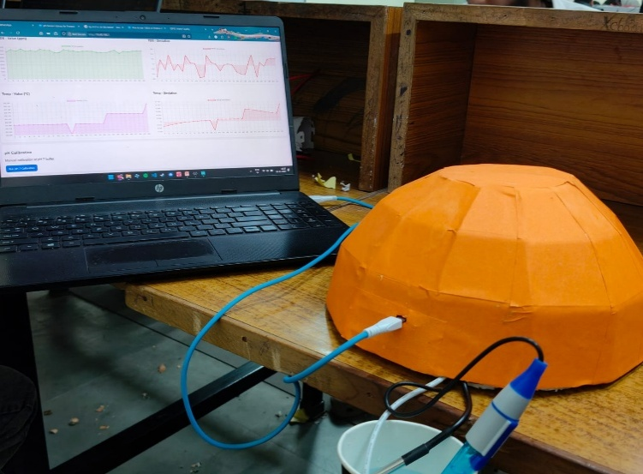

RESEARCH AND DISCUSSIONS
The results obtained from the working prototype show that the system is able to successfully monitor water quality parameters and transmit the readings at regular intervals, as intended in the project objectives. During testing, multiple sets of readings were taken from water samples with different levels of dissolved solids. The values displayed through the serial monitor or external interface showed a consistent change in response to variations in water quality, indicating that the sensor and data acquisition process were functioning correctly. When the sensor was kept in relatively clean water, the readings remained stable within a narrow range, while samples with higher impurity levels produced noticeably higher TDS values. These observations suggest that the prototype can distinguish between different water conditions and respond meaningfully to changes.
At the same time, some fluctuations and noise were observed in the raw sensor data, especially when bubbles or small particles interfered with the sensor surface. The use of the vibrating motor, as proposed in the design, helped to reduce these disturbances by removing air bubbles and debris from the electrodes, leading to more stable readings over time. This supports the idea that sensor protection and maintenance play an important role in long-term monitoring. Although the full machine-learning based anomaly detection model is intended to run externally, the current setup demonstrates that the system can reliably collect and send data for further processing. Overall, the prototype aligns well with the problem statement by automating data collection from water bodies and reducing manual effort. However, the results also highlight limitations, such as dependence on external computation for advanced analysis and the need for further calibration to improve accuracy in diverse real-world environments. These findings indicate that the model is effective as a low-cost, proof-of-concept solution, with clear scope for refinement and scaling in future work.

CONCLUSION
The project successfully developed a low-cost and functional system for monitoring the quality of urban water bodies, effectively addressing the limitations of traditional manual methods. The working prototype demonstrated that continuous data collection, real-time transmission, and basic self-maintenance can be achieved using affordable hardware. Test results showed that the system can detect changes in water conditions and reliably send readings for further analysis, meeting the primary objectives of the project.
The inclusion of a vibration mechanism to reduce sensor interference and the planned integration of anomaly detection represent important improvements over existing approaches. However, some limitations remain, such as occasional sensor fluctuations and the reliance on external processing for advanced analysis. Future work can focus on adding onboard validation, expanding sensing capabilities, and improving calibration for real-world conditions. Overall, the project provides a practical and scalable solution with meaningful potential for environmental monitoring and future enhancement.

ACKNOWLEDGEMENT
We would like to express our sincere gratitude to our project guide and respected ECE professor KUMUD TIWARI and other faculty members for their support, valuable guidance, and encouragement throughout the development of this project. Their insights and suggestions helped us refine our ideas and complete the work effectively. We also thank our department and institution for providing the necessary resources, facilities, and a productive environment that made this project possible. Finally, we appreciate the cooperation and teamwork of all group members, whose dedication and collective effort contributed greatly to the successful completion of this project.

REFERENCES
[1] A. Sharma and N. Patel, “A study on real-time monitoring of urban water bodies,” Environmental Research Letters, 2020.
[2] S. Karthik, K. Prasad, and R. Nair, “Multi-sensor water monitoring using embedded systems,” Advances in Environmental Engineering, 2021.
[3] M. Iqbal and T. Rahman, “Development of a low-cost automated water quality monitoring system,” Journal of Water Informatics, 2022.
[4] R. Deshmukh, S. Pawar, and P. Kale, “Analysis of sensor errors in water monitoring systems,” International Journal of Environmental Technology, 2021.
[5] Y. Li and H. Kim, “Machine learning approaches for anomaly detection in environmental data,” Sensors & Systems Journal, 2020.
[6] R. Singh, P. Gupta, and A. Yadav, “IoT-based smart water quality monitoring,” Proc. National Conf. Smart Technologies, 2019.
[7] Xylem Inc., “YSI EXO water quality monitoring platform,” Technical Documentation, 2019.
[8] G. M. Iodice, TinyML Cookbooks, 2nd ed. O’Reilly Media, 2022.

