Linear Differential Games of Pursuit with Integral Block of Control in its Dynamics
Kirill A. Chikrii, Anna V. Chikrii
April 13, 2002

Abstract

The game problem of bringing a trajectory of dynamic system to the terminal set, which has cylindrical form, is treated. Here the case is analyzed, when controls enter the system equation in integral form. Sufficient conditions for the game termination in some guaranteed time are derived on the basis of the Method of Resolving functions. The result is supported by a model example (see section 4) and is compared with the game “simple motions”.

1. Problem Statement

We consider the dynamical process of the form
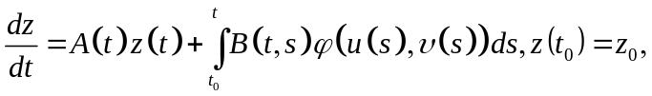 (1)
evolving in condition of conflict. Here the phase vector takes its values in the finite-dimensional Euclidian space 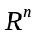; 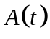 is square matrix, continuously depending on 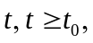 and 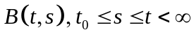 is a matrix function, continuous in all its variables. The block of control is defined by function 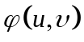, continuous on the direct product of compacts  and . The pair 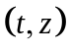 will be referred to as a current state of the process, and 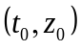 – as its initial state. As admissible controls the players employ Lebesgue-measurable functions 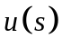 and 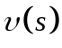 with values in the sets and respectively. By virtue of the above assumptions function satisfies the condition on superpositional measurability and 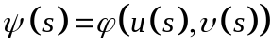 is a bounded measurable function.
In addition, the terminal set, having cylindrical form, is given:
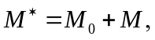 (2)

Here 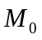 is a linear subspace in and  is a convex compact from , which is the orthogonal complement to in .
One can easy see that in the case 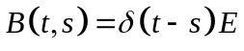, where 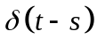 is -function and  is a unit matrix, the conflict-controlled process (1), (2) reduces to ordinary differentional game [1,2,3].
We study the problem of bringing a trajectory of system (1) to the terminal set (2) in a some guaranteed time. In so doing, the first player 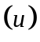 employs quasi-strategies, that is, at each current instant of time he constructs his control in the form
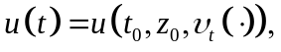

where 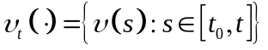, for any control of the second player [1,2,3].

2. Lemma

For any chosen admissible controls of the players solution of system (1) may be presented in the form
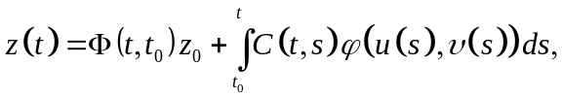 (3)

where 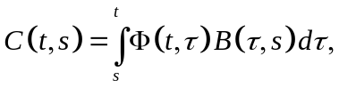 and 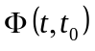 is the fundamental matrix of homogeneous system (1).
Proof. From formula Cauchy [1] as applied to system (1) it follows
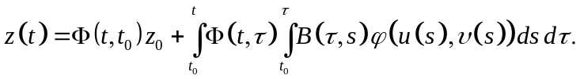

Then, using Fubini theorem [4] we have
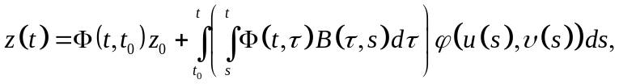

whence follows formula (3).
Denote by the orthoprojector, acting from onto . Let us study the set-valued mappings
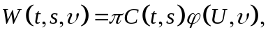

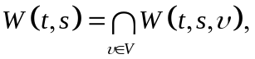

where
In the sequel, Pontryagin’s condition is assumed to hold
(4)

By virtue of the assumptions on parameters of process (1), (2) and condition (4) the mapping 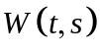 has at least a single measurable selection 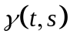 [5]. Fix it and set
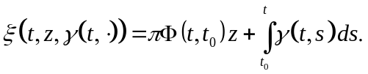

Let us introduce the resolving function by the formula
(5)
Define the set-valued mapping
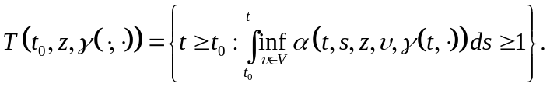 (6)

The properties of similar functions are thoroughly studied in [3]. We only note that 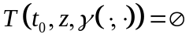, if inequality in (6) fails for finite 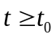.

3. Theorem

Let for the game problem (1), (2) Pontryagin’s condition hold.
Then, if a measurable selection 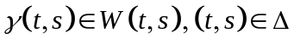 exists such that 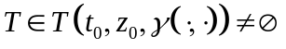 then a trajectory of the process (1) may be brought in a finite time from the initial state to set (2). In so doing the first player employs quasi-strategies.
The proof is conducted by the scheme, presented in [3].
By way of illustration below is given a simple example.

4. Model Example

Let 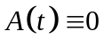, 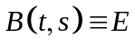, 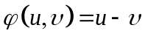, 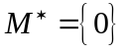, 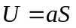, , 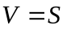, where is a square ball in , centered at the origin. Set 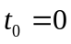.
Thus, a trajectory of the process
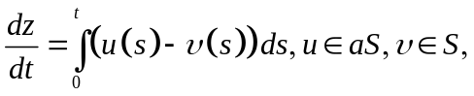

should be brought in a finite time into the origin.
In our case 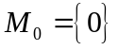 and 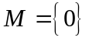 therefore 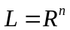 and the orthoprojector is an operator of identical transform and defined by the unit matrix. In the turn, since then 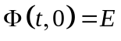.
Then 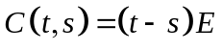 and the following presentation for the set-valued mapping is true
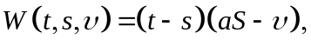

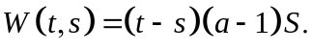

Therefore Pontryagin’s condition holds if 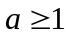 and 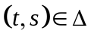. Since 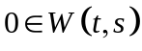, then we can pick 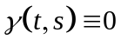. From formula (5) we deduce that function 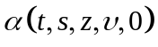 appears as the greatest root of the quadratio equation
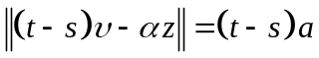

and has the form
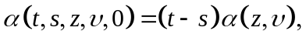

where
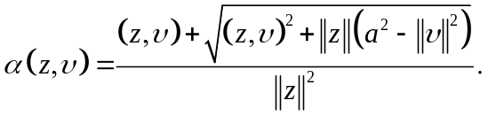

Minimum of function 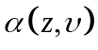 in is furnished by the element 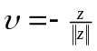. Then
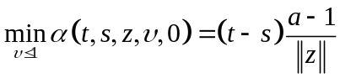

and therefore
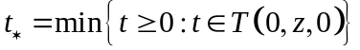

is a root of the equation
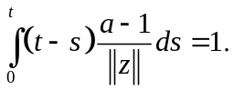

Thus,
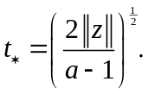

Note [3] that in the case of simple motions
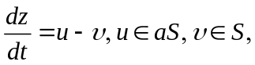

the time of hitting the origin is given by the expression
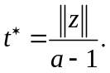

One can easy see that times and differ essentially.

5. References and Notes

[1] N. N. Krasovskii. Game Problems on Motions Encounter, Moscow, Nauka, 1970.
[2] L. S. Pontryagin. Selected Scientific Works, Vol. 2, Moscow, Nauka, 1988.
[3] A. A. Chikrii. Conflict-Controlled Processes, Dordrecht/Boston/London, Kluwer Academic Publishers, 1997.
[4] I. P. Natanson. Theory of Functions of Real Variable, Moscow, Nauka, 1974.
[5] A. D. Ioffe, V. M. Tikhomirov. Theory of Extremal Problems, Moscow, Nauka, 1974.

